Online Library API Architecture
Proof of Concept architecture document for modules/online_library
Document | online_library_architecture.docx
Module | modules/online_library
Status | POC / local development module
Date | June 19, 2026
Primary Runtime | Python 3.13, FastAPI, Uvicorn
Database | PostgreSQL 16.13, database online_library
Purpose | Expose selected non-empty Online Library DB tables as read-only JSON APIs.

1. Executive Summary
The Online Library module is a read-only FastAPI proof of concept that exposes selected tables from the existing PostgreSQL online_library database. It is intentionally simple: it uses explicit SQL queries, returns JSON, and avoids authentication for now so the API can be used as a stable backing layer for MCP tools and agent experiments.
- The module does not own the database schema; it reads from an existing PostgreSQL database.
- Only tables that contained data during implementation were exposed as API endpoints.
- Empty tables such as audit_log, downloads, and reviews were intentionally not exposed.
- The API is intended to sit below modules/online_library_mcp and modules/online_library_agent.

2. Tech Stack
Layer | Technology | Usage
API framework | FastAPI | Defines HTTP endpoints and JSON responses.
Server | Uvicorn | Runs the FastAPI ASGI application locally.
Database driver | psycopg 3 | Connects to PostgreSQL and executes parameterized SELECT queries.
Database | PostgreSQL 16.13 | Stores online library tables and relationships.
Language | Python 3.13 | Implementation runtime.
Testing clients | Swagger UI, Postman, PowerShell Invoke-RestMethod | Manual API validation.

3. Module Scope
In scope for this POC:
- Read-only access to non-empty Online Library tables.
- Simple pagination with limit and offset.
- JSON-safe conversion for UUID, date, datetime, Decimal, and bytea values.
- A health endpoint for database connectivity.
- A /tables endpoint that lists exposed tables.
Out of scope for this POC:
- Authentication and authorization.
- Write operations such as create, update, or delete.
- ORM modeling.
- Business-level joins or domain-specific aggregate endpoints.
- Production-grade connection pooling and observability.

4. Component Overview
File | Responsibility
modules/online_library/api.py | FastAPI app and endpoint definitions.
modules/online_library/config.py | Loads database configuration from environment variables with local defaults.
modules/online_library/db.py | Creates and closes PostgreSQL connections.
modules/online_library/repository.py | Defines exposed tables and executes safe SELECT queries.
modules/online_library/Readme.md | Run instructions and endpoint list.
modules/online_library/sql/schema.sql | Schema snapshot of the inspected database.
modules/online_library/postman/Online_Library.postman_collection.json | Postman collection for manual testing.

5. Runtime Architecture
The module runs as a local FastAPI service on port 8003 and connects to PostgreSQL on localhost:5432.
Client / Browser / Postman
|
| HTTP JSON
v
Online Library FastAPI API
modules.online_library.api:app
|
| repository.py -> db.py
v
PostgreSQL online_library database
|
v
public authors/categories/resources/... tables

6. Request Control Flow
1. Client calls an endpoint, for example GET /resources?limit=20&offset=0
2. FastAPI validates limit and offset query parameters
3. api.py calls repository.fetch_table_rows("resources", limit, offset)
4. repository.py verifies the table is in EXPOSED_TABLES
5. repository.py builds SQL using psycopg.sql.Identifier for safe table/column identifiers
6. db.py opens a PostgreSQL connection with dict_row row factory
7. PostgreSQL executes SELECT * FROM public.resources ORDER BY resource_id LIMIT/OFFSET
8. repository.py converts DB values to JSON-safe values
9. api.py returns a consistent JSON envelope with table, limit, offset, count, and rows

7. PlantUML-Style Sequence Diagram
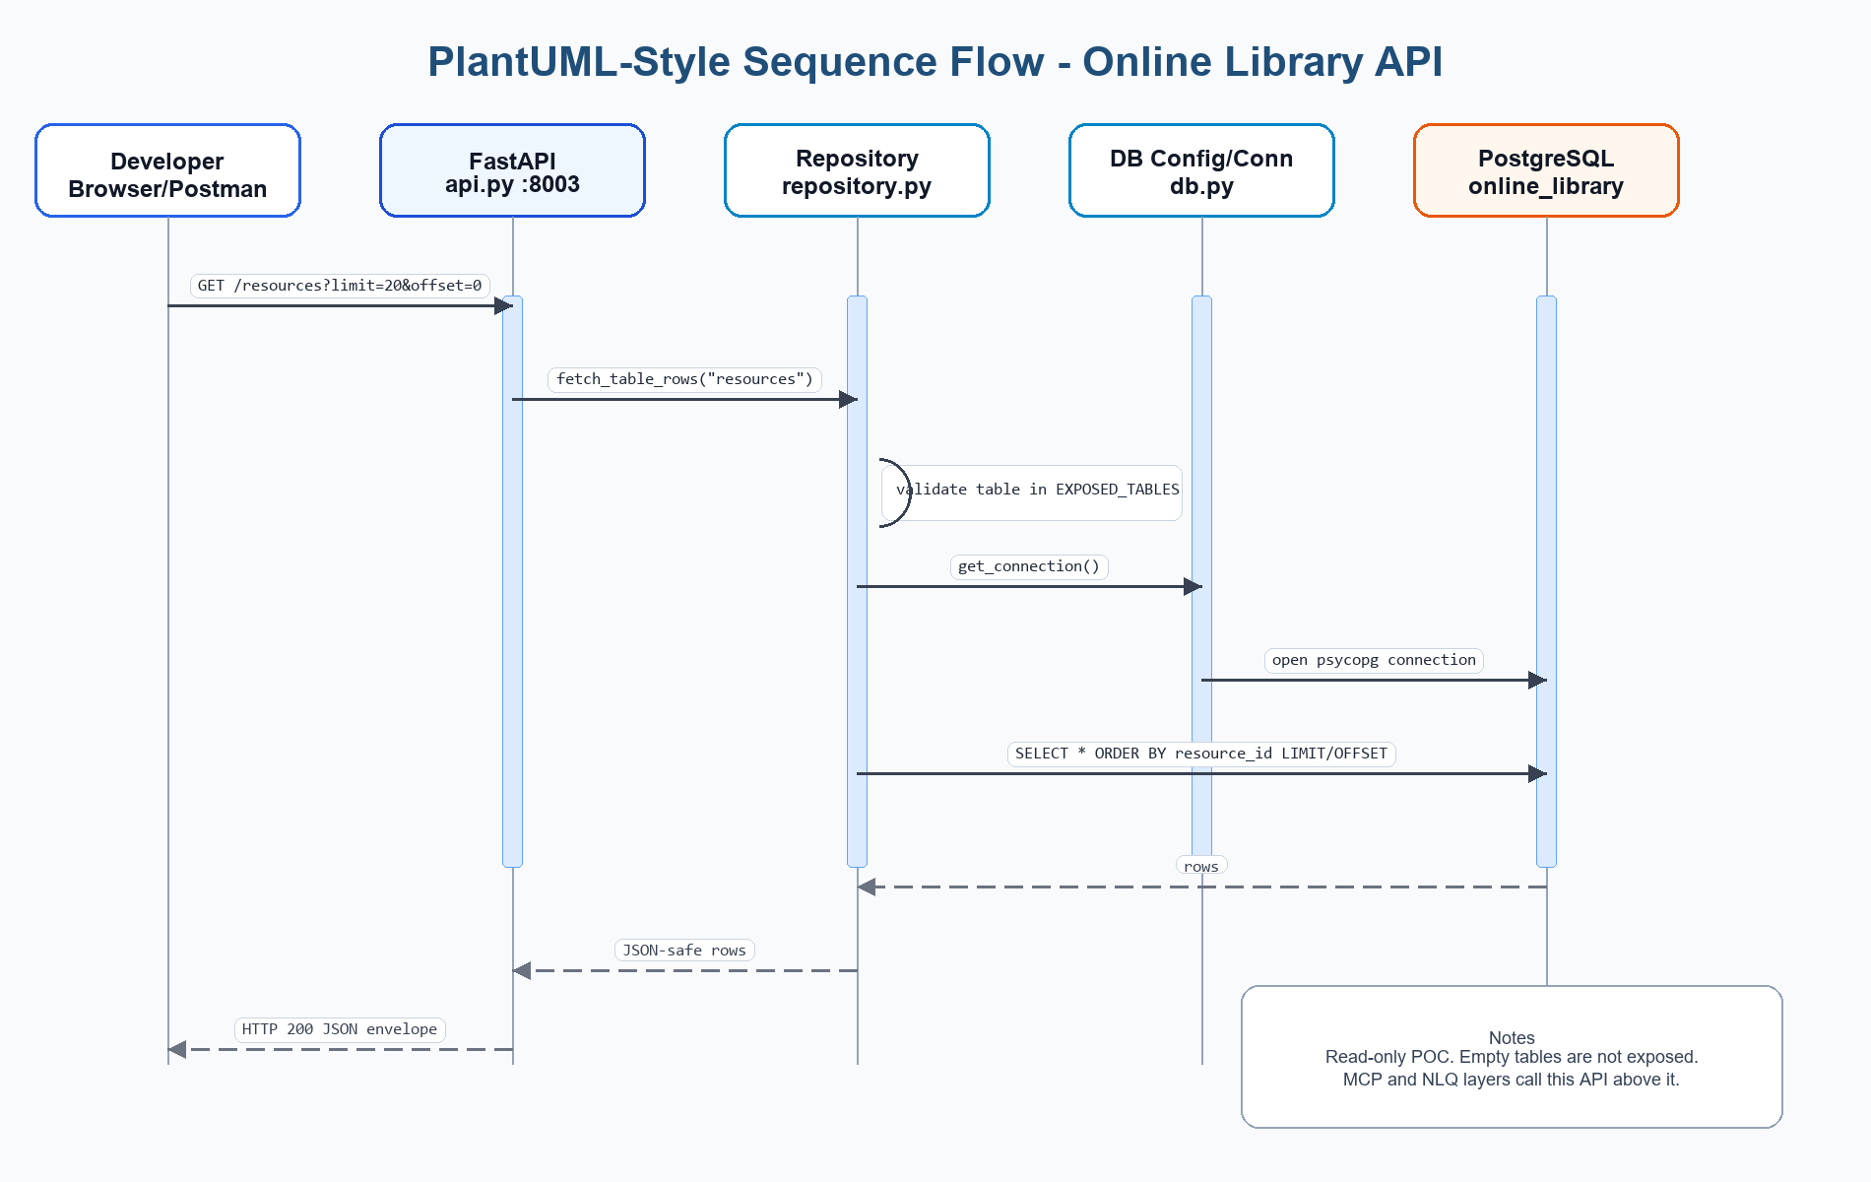
Figure: PlantUML-style sequence flow for GET /resources
The following can be copied into a PlantUML renderer if an image is needed later.

PlantUML Source Code - sequence diagram (collapsed by default)
@startuml
actor Developer
participant "Postman / Swagger UI" as Client
participant "Online Library API
FastAPI :8003" as API
participant "Repository
repository.py" as Repo
participant "DB Connection
db.py" as DBConn
database "PostgreSQL
online_library" as DB
Developer -> Client: Send GET /resources?limit=20&offset=0
Client -> API: HTTP GET /resources
API -> API: Validate limit and offset
API -> Repo: fetch_table_rows("resources", limit, offset)
Repo -> Repo: Check resources in EXPOSED_TABLES
Repo -> DBConn: get_connection()
DBConn -> DB: Open psycopg connection
Repo -> DB: SELECT * FROM public.resources ORDER BY resource_id LIMIT/OFFSET
DB --> Repo: Rows
Repo -> Repo: Convert UUID/date/Decimal/bytes to JSON-safe values
Repo --> API: list[dict]
API --> Client: JSON response
Client --> Developer: Display rows
@enduml

8. C4-Style Architecture View

C4 Context View
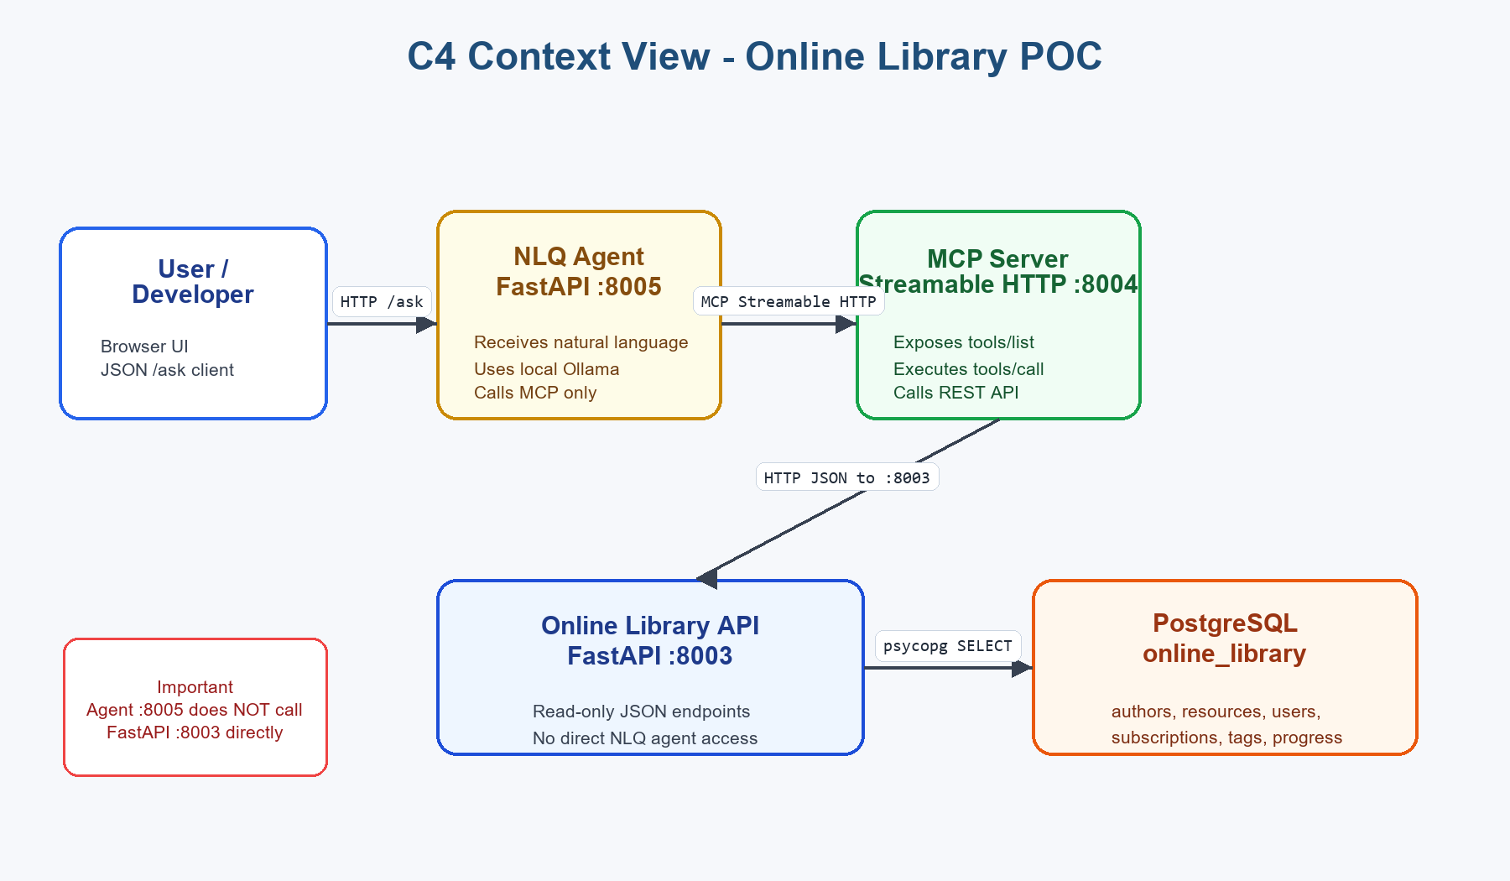
Figure: C4 Context View - NLQ Agent uses MCP; MCP calls Online Library API

C4 Context Source Code (collapsed by default)
System Context
[Developer / API Consumer]
|
| Uses Swagger, Postman, browser, or MCP-backed agent
v
[Online Library API POC]
|
| Reads data through psycopg
v
[PostgreSQL online_library DB]
External / Downstream Consumers:
- modules/online_library_mcp wraps this API as MCP tools
- modules/online_library_agent uses MCP tools for NLQ workflows

C4 Container View
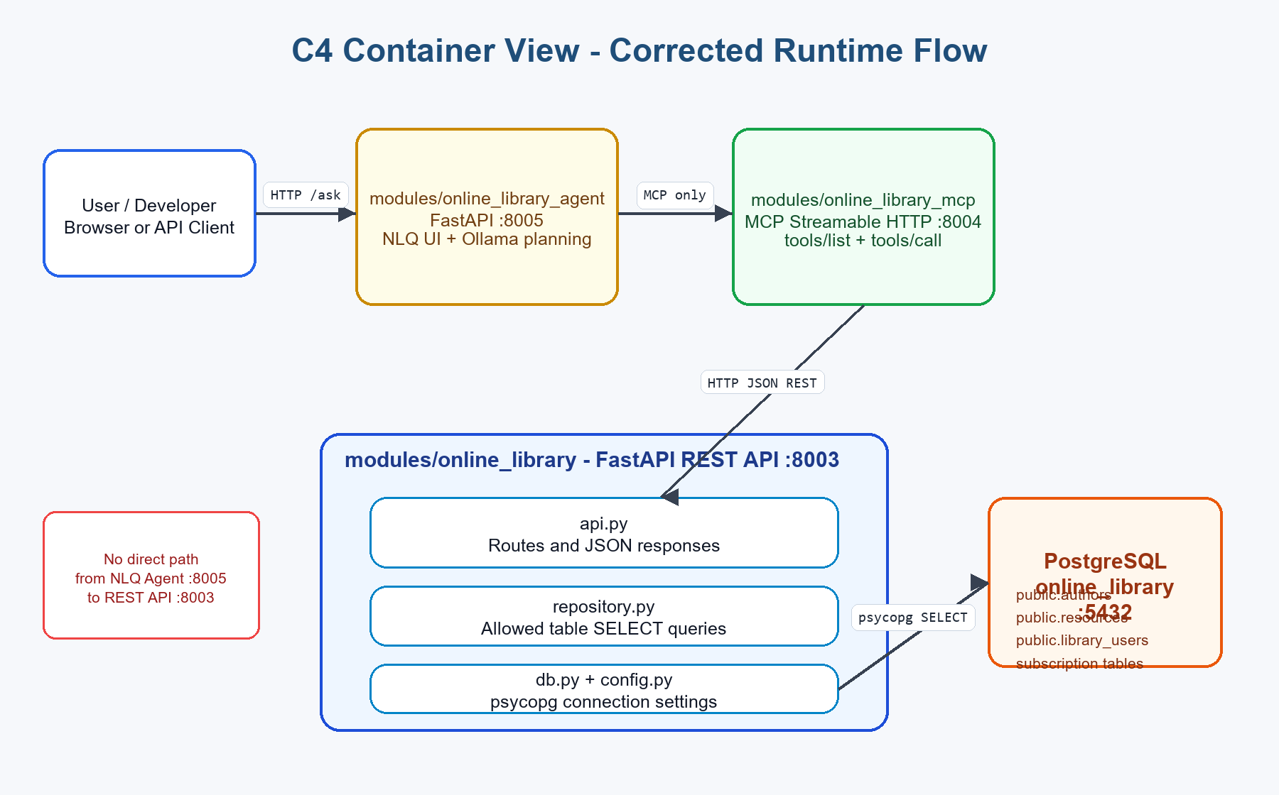
Figure: C4 Container View - Agent :8005 -> MCP :8004 -> REST API :8003 -> PostgreSQL

C4 Container Source Code (collapsed by default)
Container: Online Library API POC
+--------------------------------------------------------+
| modules/online_library |
| |
| api.py |
| - FastAPI routes |
| - pagination validation |
| - JSON envelopes |
| |
| repository.py |
| - allowed table list |
| - SELECT * queries |
| - JSON-safe conversion |
| |
| db.py |
| - psycopg connection handling |
| |
| config.py |
| - env-based DB settings |
+--------------------------------------------------------+
|
v
+--------------------------------------------------------+
| PostgreSQL online_library |
| public.authors, categories, resources, users, etc. |
+--------------------------------------------------------+

9. Exposed Endpoints
Endpoint | Purpose
GET /health/db | Check PostgreSQL connectivity.
GET /tables | List non-empty tables exposed by the API.
GET /authors | SELECT data from public.authors.
GET /categories | SELECT data from public.categories.
GET /library-users | SELECT data from public.library_users.
GET /reading-progress | SELECT data from public.reading_progress.
GET /resource-authors | SELECT data from public.resource_authors.
GET /resource-tags | SELECT data from public.resource_tags.
GET /resources | SELECT data from public.resources.
GET /subscription-rules | SELECT data from public.subscription_rules.
GET /subscription-tiers | SELECT data from public.subscription_tiers.
GET /tags | SELECT data from public.tags.
GET /user-approval-requests | SELECT data from public.user_approval_requests.
GET /user-bookshelf | SELECT data from public.user_bookshelf.
GET /user-subscriptions | SELECT data from public.user_subscriptions.
All table endpoints support:
?limit=20&offset=0

10. Database Exposure Rules
Tables exposed because they contained data during implementation:
- authors
- categories
- library_users
- reading_progress
- resource_authors
- resource_tags
- resources
- subscription_rules
- subscription_tiers
- tags
- user_approval_requests
- user_bookshelf
- user_subscriptions
Tables not exposed because they were empty during implementation:
- audit_log
- downloads
- reviews

11. Configuration
ONLINE_LIBRARY_DB_HOST=localhost
ONLINE_LIBRARY_DB_PORT=5432
ONLINE_LIBRARY_DB_NAME=online_library
ONLINE_LIBRARY_DB_USER=library_user
ONLINE_LIBRARY_DB_PASSWORD=library_pass

12. Local Run And Test
Run command:
.\.venv\Scripts\python.exe -m uvicorn modules.online_library.api:app --reload --port 8003
Useful URLs:
- Swagger UI: http://127.0.0.1:8003/docs
- DB health: http://127.0.0.1:8003/health/db
- Exposed tables: http://127.0.0.1:8003/tables
Validation performed during implementation:
- DB connection succeeded against PostgreSQL 16.13.
- All 13 exposed table endpoints returned HTTP 200 with limit=1.
- Empty-table paths such as /downloads and /reviews returned 404.
- Postman collection JSON was validated.

13. POC Limitations
- No authentication or authorization is implemented.
- User/member data is exposed by read-only endpoints for POC purposes.
- No connection pool is implemented; each request opens a database connection.
- No production logging, tracing, or metrics are implemented.
- Endpoints are table-shaped rather than business-domain-shaped.
- The API exposes SELECT * results, including metadata fields that may not be appropriate for a production client.
- Binary bytea columns are converted to base64 if returned, though current test rows were mostly null.

14. Recommended Upgrades
- Add authentication and role-based authorization.
- Add a connection pool or async database strategy for production workloads.
- Replace raw table endpoints with business-focused endpoints where appropriate.
- Mask or omit sensitive user fields such as email when exposed to agent tools.
- Add request logging, audit logging, and metrics.
- Add automated tests for repository queries and API routes.
- Add OpenAPI examples and stronger response models.
- Add Kubernetes-ready configuration through secrets and config maps.

15. Related Modules
Module | Relationship
modules/online_library_mcp | Wraps this REST API as MCP Streamable HTTP tools.
modules/online_library_agent | Uses the MCP server and local Ollama model to answer natural-language questions.
modules/weather_ai_agent | Separate AI weather POC; useful as a pattern for local LLM configuration.

16. Open Details / Questions
- Should production architecture diagrams include deployment targets such as Docker, Kubernetes, or cloud services?
- Should future architecture documents include screenshots from Swagger, Postman, MCP Inspector, or the NLQ agent UI?
- Should sensitive fields such as user emails be masked in diagrams and examples?
End of Online Library API Architecture POC Document

