Online Library MCP Server Architecture
Proof of Concept architecture document for modules/online_library_mcp
Document | online_library_mcp_architecture.docx
Module | modules/online_library_mcp
Status | POC / local development module
Date | June 20, 2026
Primary Runtime | Python 3.13, MCP Python SDK, FastMCP
Transport | MCP Streamable HTTP, not HTTP+SSE
Endpoint | http://127.0.0.1:8004/mcp
Purpose | Expose Online Library REST API data as MCP tools for agents and MCP clients.

1. Executive Summary
The Online Library MCP module is a Streamable HTTP MCP server that wraps the existing Online Library FastAPI REST API as agent-friendly tools. It does not connect to PostgreSQL directly. Each MCP tool calls the REST API on port 8003 and returns JSON-compatible results to the MCP client.
- Uses current MCP Streamable HTTP transport.
- Avoids the older HTTP+SSE transport.
- Exposes 13 non-empty table endpoints plus tool discovery.
- Uses descriptive tool docstrings so agents can map natural-language requests to tools.
- Designed as the data-access bridge between agents and the Online Library REST API.

2. Tech Stack
Layer | Technology | Usage
MCP server | MCP Python SDK / FastMCP | Registers tools and serves Streamable HTTP on /mcp.
HTTP client | httpx | Calls Online Library REST API endpoints.
API dependency | modules/online_library | Read-only FastAPI API on port 8003.
Transport | MCP Streamable HTTP | Modern MCP transport; no SSE route is used.
Runtime | Python 3.13 | Module implementation runtime.
Manual testing | MCP Inspector | Interactive tool discovery and tools/call testing.

3. Scope
In scope for this POC:
- MCP /mcp endpoint on port 8004.
- tools/list metadata discovery.
- tools/call execution for all non-empty Online Library tables.
- Structured error responses when upstream API calls fail.
- Local MCP Inspector testing support.
Out of scope for this POC:
- MCP authentication.
- Direct PostgreSQL access.
- Write tools.
- Advanced resources/prompts support.
- Production CORS/origin policy.
- Retries and production observability.

4. Component Overview
File | Responsibility
server.py | Creates FastMCP server with stateless_http=True and json_response=True, runs streamable-http transport.
tools.py | Registers 14 MCP tools and descriptive docstrings/input schemas.
client.py | Calls Online Library REST API using httpx and returns JSON/errors.
config.py | Loads API base URL, host, port, and timeout settings.
Readme.md | Run instructions, MCP Inspector settings, and tool discovery explanation.
docs/online_library_mcp_plan.md | Planning and implementation notes.

5. Runtime Architecture

Runtime Flow Summary (collapsed by default)
MCP Client / Agent / MCP Inspector
|
| MCP Streamable HTTP JSON-RPC
v
Online Library MCP Server :8004 /mcp
|
| httpx GET calls
v
Online Library REST API :8003
|
| psycopg SELECT
v
PostgreSQL online_library :5432
The MCP server does not call PostgreSQL directly.

6. Request Control Flow
- MCP client connects to http://127.0.0.1:8004/mcp.
- Client initializes the MCP session.
- Client calls tools/list.
- FastMCP returns tool names, descriptions, and input schemas generated from decorated Python functions.
- Client chooses a tool such as get_library_users.
- Client sends tools/call with limit and offset arguments.
- tools.py validates pagination and selects the upstream REST path.
- client.py calls the Online Library API on port 8003.
- REST API returns JSON rows.
- MCP tool returns the JSON result to the MCP client.

7. PlantUML-Style Sequence Diagram
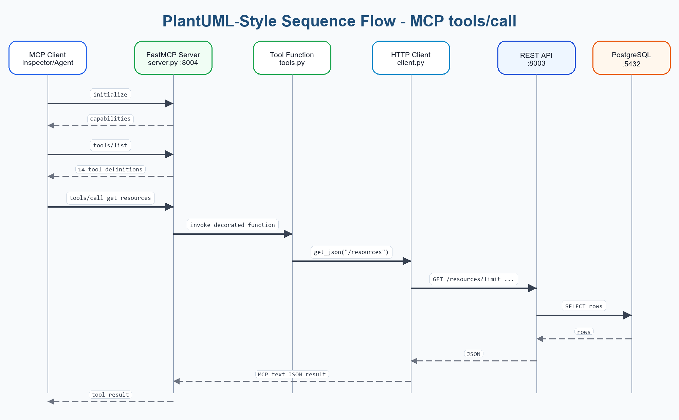
Figure: PlantUML-style sequence flow for MCP tools/call

PlantUML Source Code - MCP tool call flow (collapsed by default)
@startuml
actor "MCP Client" as Client
participant "FastMCP Server
server.py :8004" as Server
participant "Tool Function
tools.py" as Tool
participant "HTTP Client
client.py" as HTTP
database "Online Library API
FastAPI :8003" as API
database "PostgreSQL
online_library" as DB
Client -> Server: initialize
Server --> Client: capabilities
Client -> Server: tools/list
Server --> Client: 14 tool definitions
Client -> Server: tools/call get_resources {limit, offset}
Server -> Tool: invoke decorated function
Tool -> HTTP: get_json("/resources")
HTTP -> API: GET /resources?limit=...&offset=...
API -> DB: SELECT rows
DB --> API: rows
API --> HTTP: JSON envelope
HTTP --> Tool: dict result
Tool --> Server: JSON-compatible result
Server --> Client: MCP tool result
@enduml

8. C4-Style Architecture View

C4 Context View
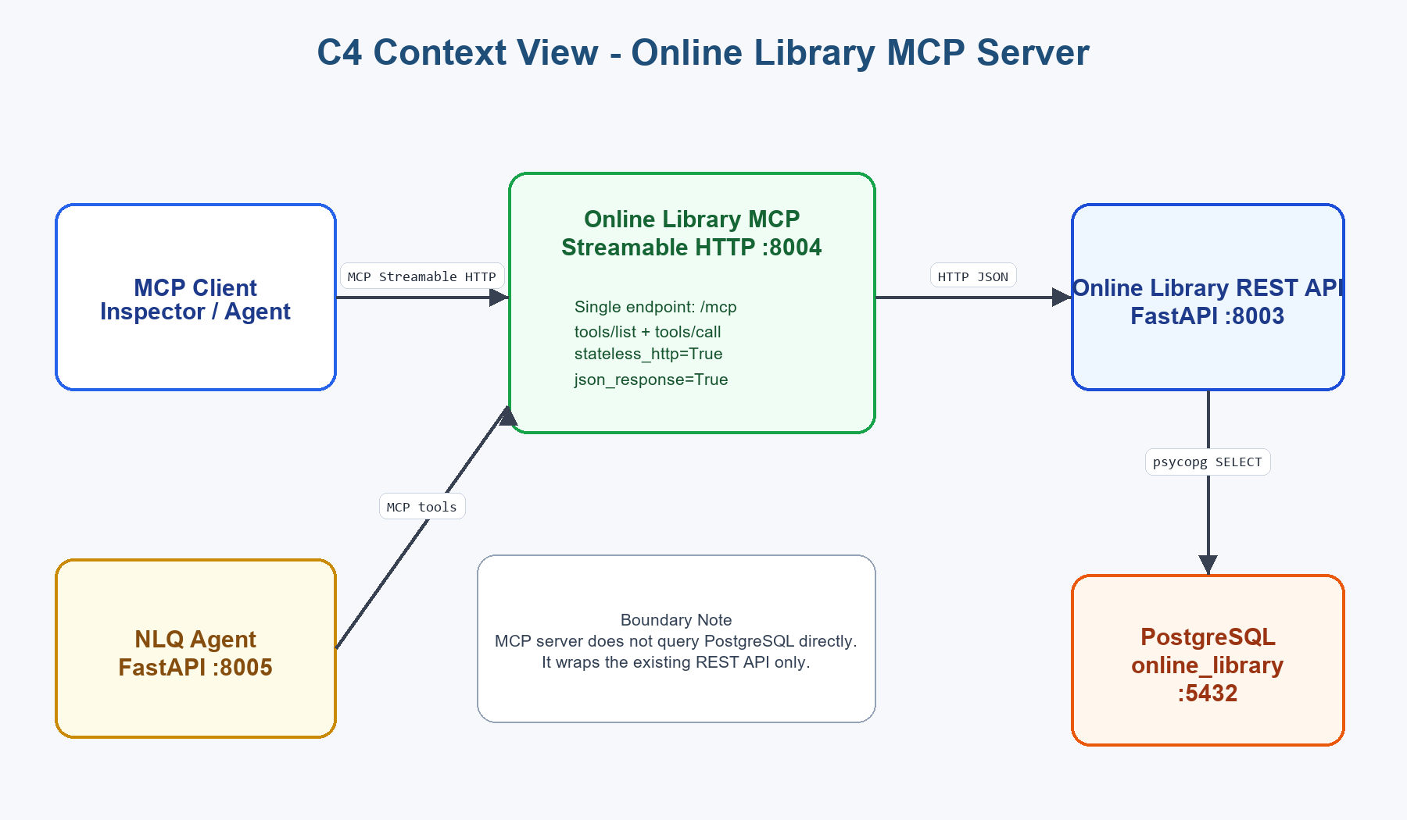
Figure: C4 Context View - Online Library MCP Server

C4 Context Source Code (collapsed by default)
System Context
[MCP Client / Inspector / Agent]
|
| MCP Streamable HTTP JSON-RPC
v
[Online Library MCP Server :8004]
|
| HTTP JSON REST calls
v
[Online Library API :8003]
|
| psycopg SELECT
v
[PostgreSQL online_library :5432]
Related consumer:
[Online Library NLQ Agent :8005] -> [Online Library MCP Server :8004]
Important: MCP server wraps REST API; it does not query PostgreSQL directly.

C4 Container View
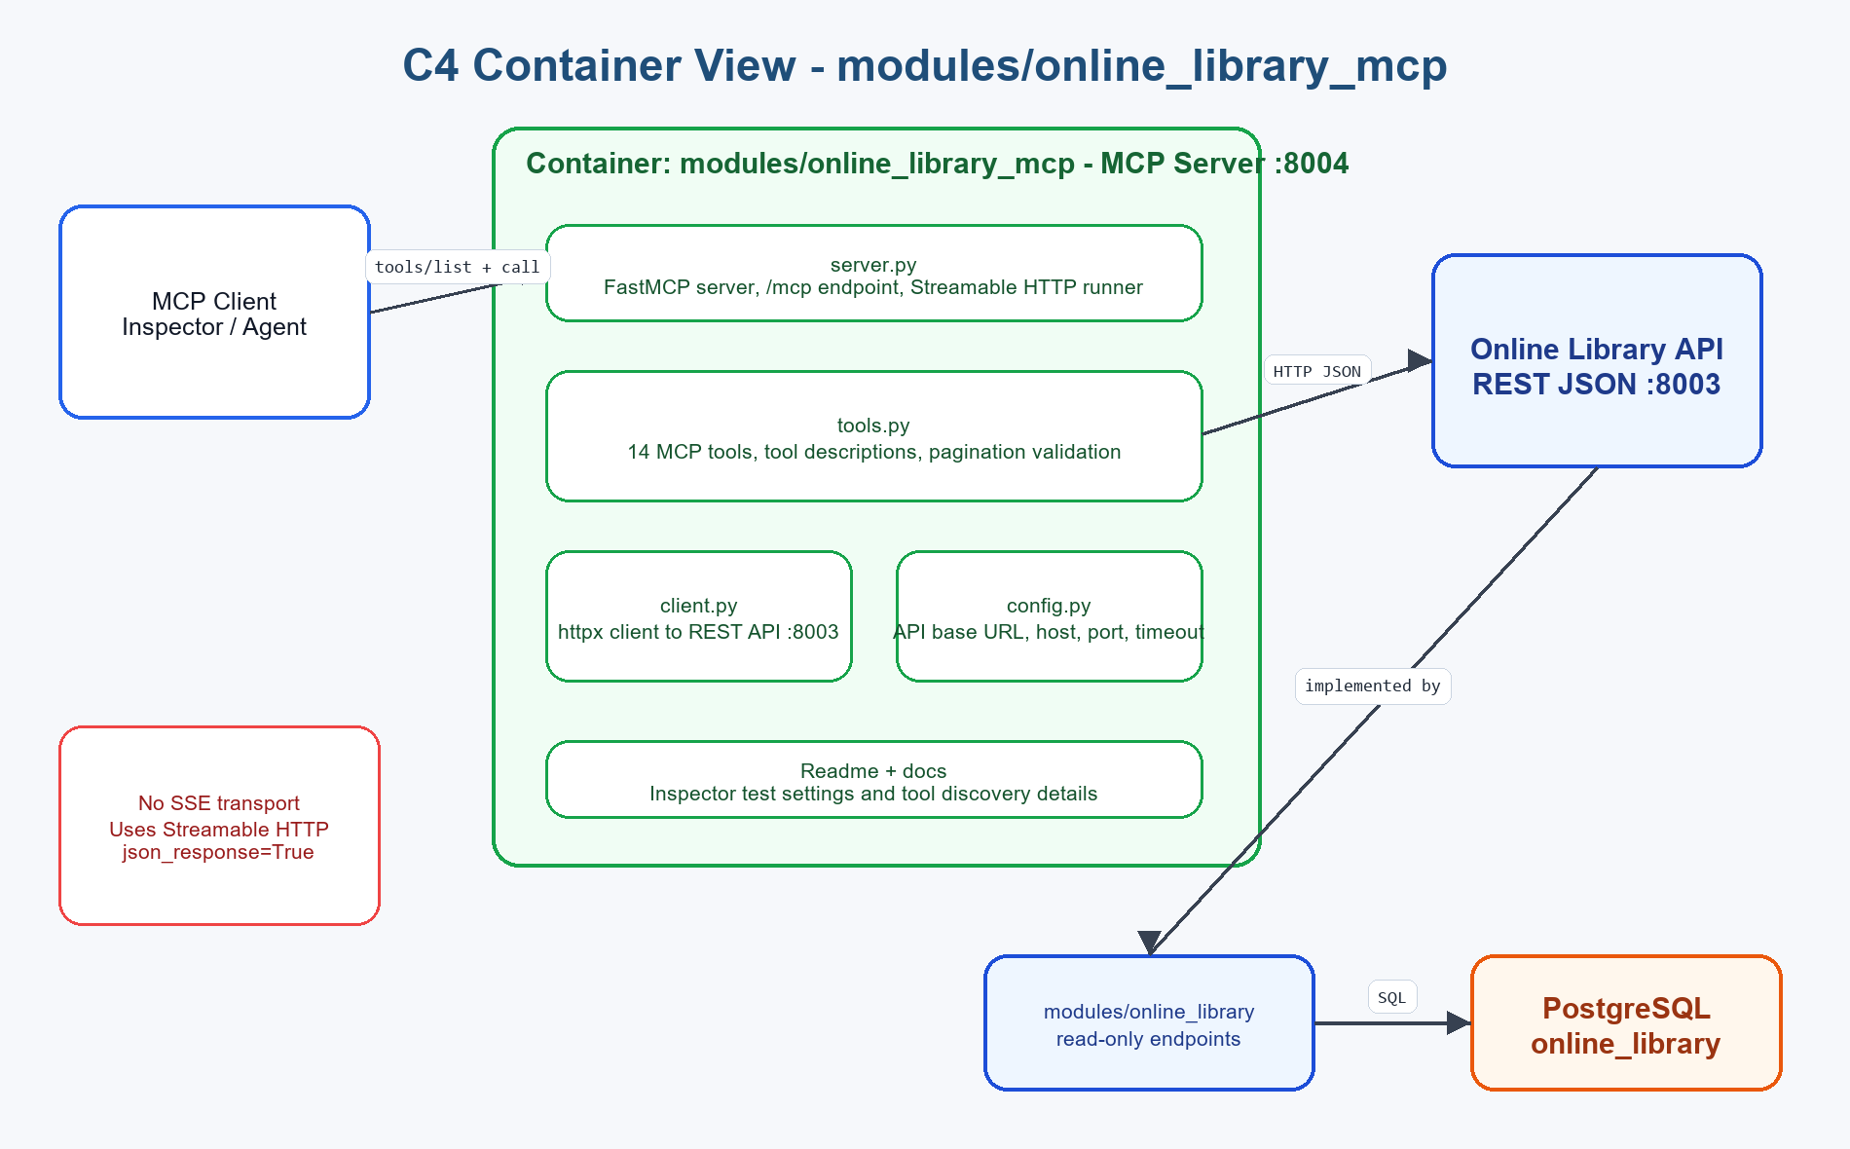
Figure: C4 Container View - modules/online_library_mcp

C4 Container Source Code (collapsed by default)
Container: modules/online_library_mcp
server.py
- FastMCP("OnlineLibraryMCP")
- stateless_http=True
- json_response=True
- streamable_http_path="/mcp"
- mcp.run(transport="streamable-http")
tools.py
- list_available_tables
- get_authors / get_categories / get_resources / ...
- typed input schema from function params
- tool descriptions from docstrings
client.py
- httpx AsyncClient
- calls ONLINE_LIBRARY_API_BASE_URL
- structured upstream error responses
config.py
- ONLINE_LIBRARY_API_BASE_URL
- ONLINE_LIBRARY_MCP_HOST
- ONLINE_LIBRARY_MCP_PORT
- ONLINE_LIBRARY_MCP_TIMEOUT_SECONDS

9. MCP Tools
Tool | Purpose
list_available_tables | Return exposed REST-backed table list.
get_authors | List authors/writers.
get_categories | List categories/genres/sections.
get_library_users | List users, members, patrons, accounts.
get_reading_progress | List reading progress rows.
get_resource_authors | List resource-author relationships.
get_resource_tags | List resource-tag relationships.
get_resources | List books/resources/titles.
get_subscription_rules | List entitlement rules and limits.
get_subscription_tiers | List plans, tiers, membership levels.
get_tags | List tags/topics/keywords.
get_user_approval_requests | List approval request workflow rows.
get_user_bookshelf | List bookshelf/checkout rows.
get_user_subscriptions | List user subscription records.

10. Configuration

Environment Values (collapsed by default)
ONLINE_LIBRARY_API_BASE_URL=http://127.0.0.1:8003
ONLINE_LIBRARY_MCP_HOST=127.0.0.1
ONLINE_LIBRARY_MCP_PORT=8004
ONLINE_LIBRARY_MCP_TIMEOUT_SECONDS=10

11. MCP Inspector Testing
- Start with npx @modelcontextprotocol/inspector.
- Open the browser URL printed by Inspector with MCP_PROXY_AUTH_TOKEN.
- Use URL http://localhost:8004/mcp.
- Set Transport Type to Streamable HTTP.
- Set Connection Type to Via Proxy.
- Initialize, list tools, and call a tool such as get_resources.

12. Local Run And Test

Run Commands (collapsed by default)
.\.venv\Scripts\python.exe -m uvicorn modules.online_library.api:app --reload --port 8003
.\.venv\Scripts\python.exe -m modules.online_library_mcp.server
npx @modelcontextprotocol/inspector
- MCP endpoint: http://127.0.0.1:8004/mcp
- Transport: Streamable HTTP
- Expected tools/list count: 14
- All 13 table tools were validated with limit=1 during implementation.

13. POC Limitations
- No authentication or authorization.
- User data is exposed through tools in this local POC.
- No MCP resources or prompts are implemented yet.
- No retry policy for upstream REST calls.
- No production CORS/origin policy.
- No direct Postman collection because MCP JSON-RPC is better tested with MCP Inspector or SDK clients.

14. Recommended Upgrades
- Add MCP authentication before remote exposure.
- Add tool allowlists or role-based tool access.
- Add MCP resources for schema/docs if useful.
- Mask user email fields before returning to external agents.
- Add metrics for tools/list and tools/call latency.
- Add retries for idempotent upstream GET failures.
- Add automated MCP client tests.
- Package for Docker/Kubernetes if moving beyond local POC.

15. Related Modules
Module | Relationship
modules/online_library | REST API wrapped by this MCP server.
modules/online_library_agent | Consumes this MCP server to answer NLQs.
modules/weather_ai_agent | Separate AI/LLM POC; useful for local model configuration patterns.

16. Open Details / Questions
- Should MCP resources be added later for schema and API documentation?
- Should user-related tools be disabled by default when auth is added?
- Should a dedicated MCP test script be added under the module?
End of Online Library MCP Server Architecture POC Document

