Weather Agent Architecture
Proof of Concept architecture document for modules/weather_agent
Document | weather_agent_architecture.docx
Module | modules/weather_agent
Status | POC / local development module
Date | June 20, 2026
Primary Runtime | Python 3.13, FastAPI, Uvicorn
Weather Retrieval | httpx requests to weather.com with wttr.in fallback
LLM Requirement | None. CrewAI facade exists, but weather lookup is deterministic.
Purpose | Return current weather details for a configurable location through CLI, browser, or JSON API.

1. Executive Summary
The Weather Agent module is a deterministic weather lookup POC. It exposes a command-line interface, a simple FastAPI browser form, and a JSON API. It attempts to read weather.com first and falls back to wttr.in when weather.com is unavailable or does not expose readable current-condition data.
- No LLM API key is required.
- CrewAI is used only as a lightweight agent facade when installed.
- The module depends on external weather websites and network access.
- Default location is Atlanta, GA, US.

2. Tech Stack
Layer | Technology | Usage
API framework | FastAPI | Browser form, POST /weather, GET /api/weather.
Server | Uvicorn | Runs FastAPI locally, commonly on port 8000.
HTTP client | httpx | Fetches weather.com and wttr.in data.
Parsing | Python regex + JSON parsing | Extracts weather.com embedded values and wttr.in JSON fields.
CLI | argparse | Shell entrypoint for city/state/country.
Agent facade | CrewAI Agent optional | Creates a Weather Information Agent object when CrewAI is available.
Runtime | Python 3.13 | Implementation runtime.

3. Scope
In scope for this POC:
- Fetch current weather for city/state/country.
- Return temperature, condition, feels-like temperature, humidity, wind, and source.
- Support CLI execution.
- Support browser form execution.
- Support JSON API execution.
- Fallback from weather.com to wttr.in.
Out of scope for this POC:
- Forecasts, hourly weather, radar, severe alerts, or historical weather.
- LLM reasoning or natural-language generation.
- API key based commercial weather provider.
- Authentication and persistence.
- Production-grade retries, caching, and observability.

4. Component Overview
File | Responsibility
agent.py | WeatherAgent facade and optional CrewAI Agent object.
weather_service.py | Location and WeatherReport dataclasses, weather.com lookup, wttr.in fallback, parsing helpers.
api.py | FastAPI browser form and JSON endpoint.
cli.py | Command prompt entrypoint using argparse.
Readme.md | Setup and run instructions.
docs/weather_agent_plan.md | Planning notes.

5. Runtime Architecture

Runtime Flow Summary (collapsed by default)
Browser / API Client / CLI User
|
| HTTP form, JSON API, or shell command
v
Weather Agent POC
|
v
WeatherAgent facade
|
v
weather_service.get_weather_report()
|
| try first
v
weather.com
|
| fallback when blocked/unreadable
v
wttr.in JSON API
|
v
WeatherReport -> HTML / JSON / CLI output

6. Request Control Flow
- User submits city, state, and country through CLI, browser form, or JSON API.
- api.py or cli.py creates a Location dataclass.
- WeatherAgent.current_weather() calls get_weather_report().
- weather_service.py creates an httpx client with a browser-like user agent.
- The service attempts weather.com first.
- Regex helpers extract temperature, condition, humidity, feels-like, wind speed, and wind direction.
- If weather.com fails or lacks readable data, wttr.in is called with format=j1.
- wttr.in JSON current_condition is parsed.
- A WeatherReport dataclass is returned and rendered as CLI text, HTML, or JSON.

7. PlantUML-Style Sequence Diagram
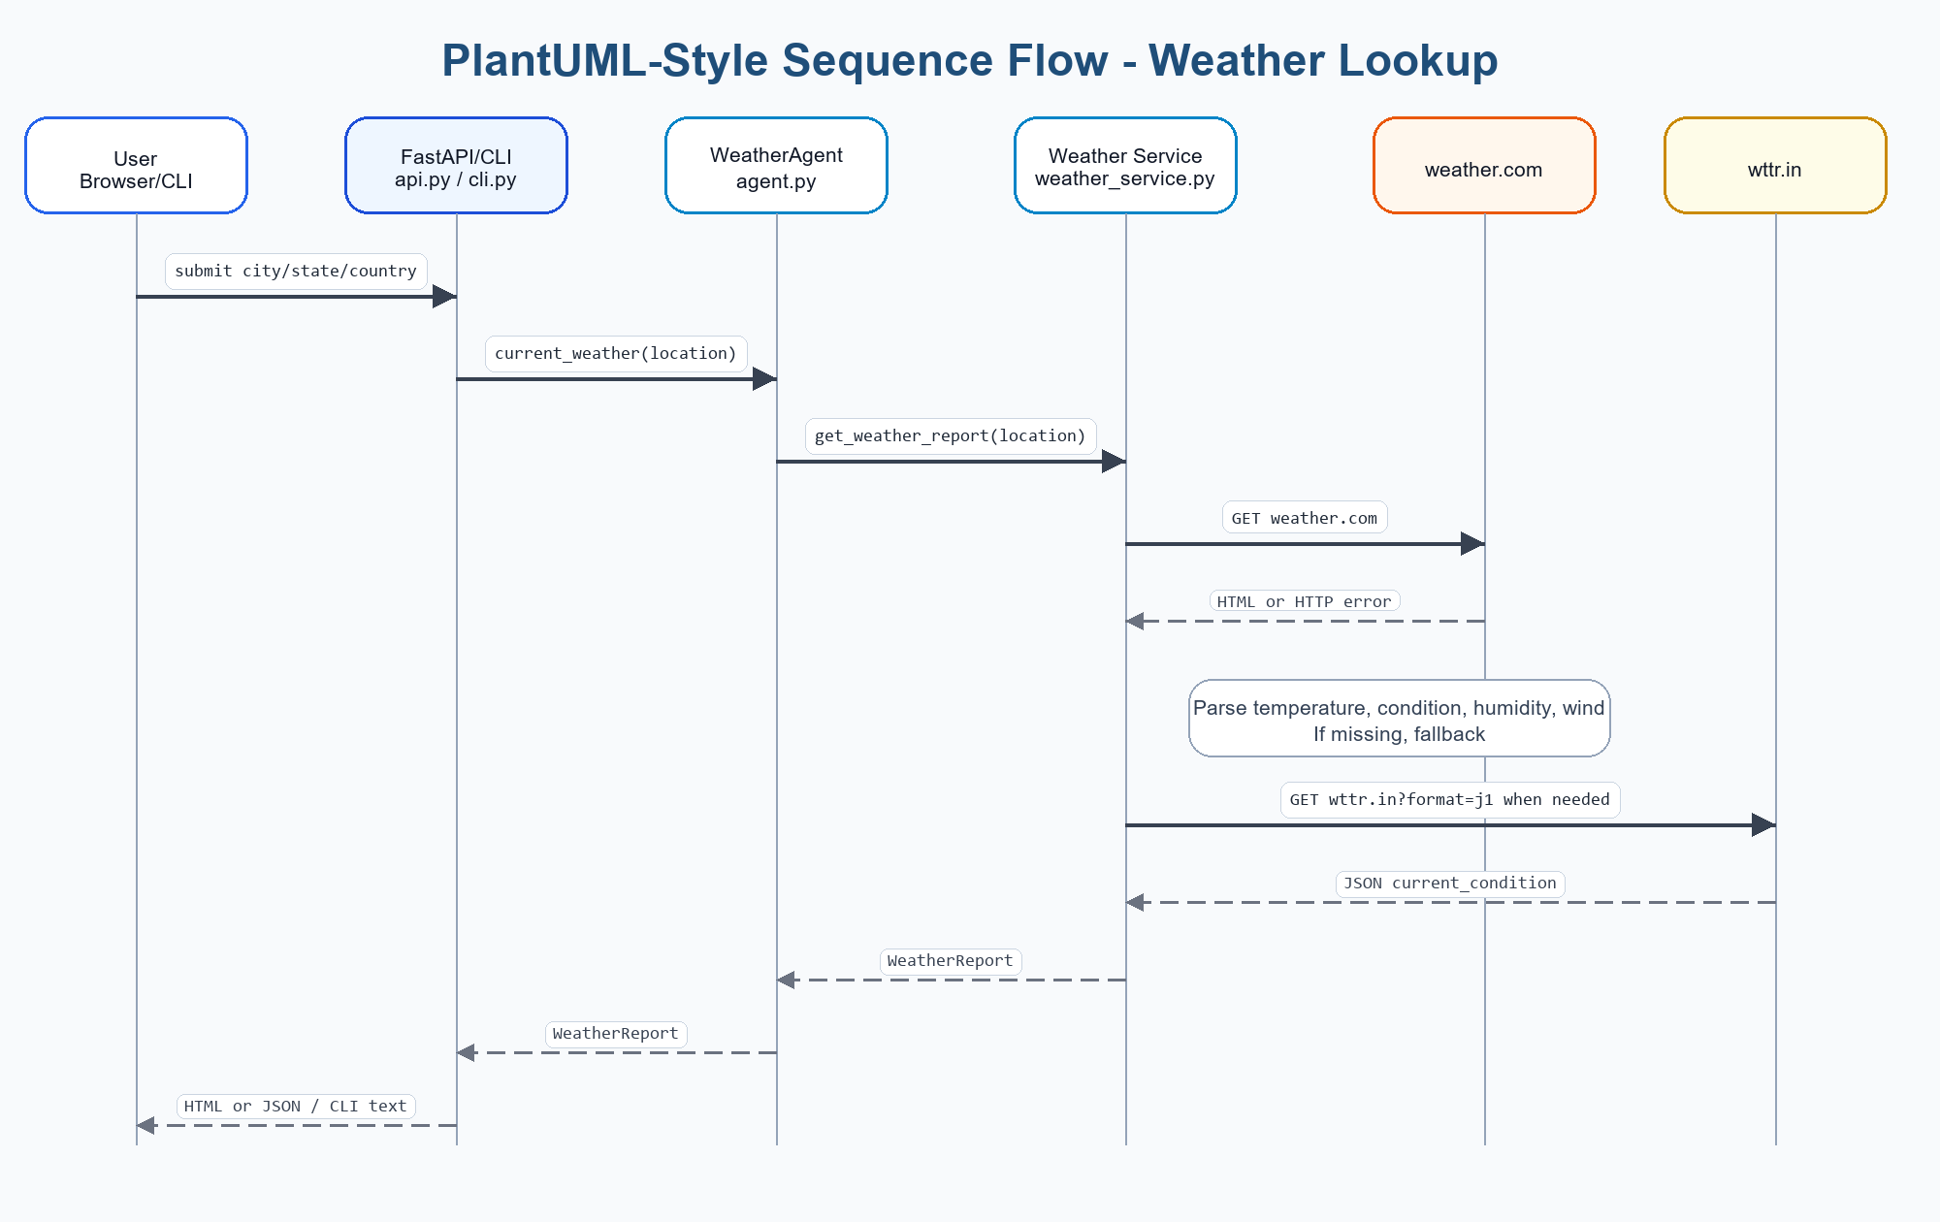
Figure: PlantUML-style sequence flow for weather lookup

PlantUML Source Code - weather lookup flow (collapsed by default)
@startuml
actor User
participant "FastAPI/CLI
api.py / cli.py" as Entry
participant "WeatherAgent
agent.py" as Agent
participant "Weather Service
weather_service.py" as Service
participant "weather.com" as WeatherCom
participant "wttr.in" as Wttr
User -> Entry: city/state/country
Entry -> Agent: current_weather(location)
Agent -> Service: get_weather_report(location)
Service -> WeatherCom: GET /weather/today/l/{location}
WeatherCom --> Service: HTML or HTTP error
Service -> Service: parse embedded weather values
alt weather.com unavailable or unreadable
Service -> Wttr: GET /{location}?format=j1
Wttr --> Service: JSON current_condition
end
Service --> Agent: WeatherReport
Agent --> Entry: WeatherReport
Entry --> User: CLI text, HTML, or JSON
@enduml

8. C4-Style Architecture View

C4 Context View
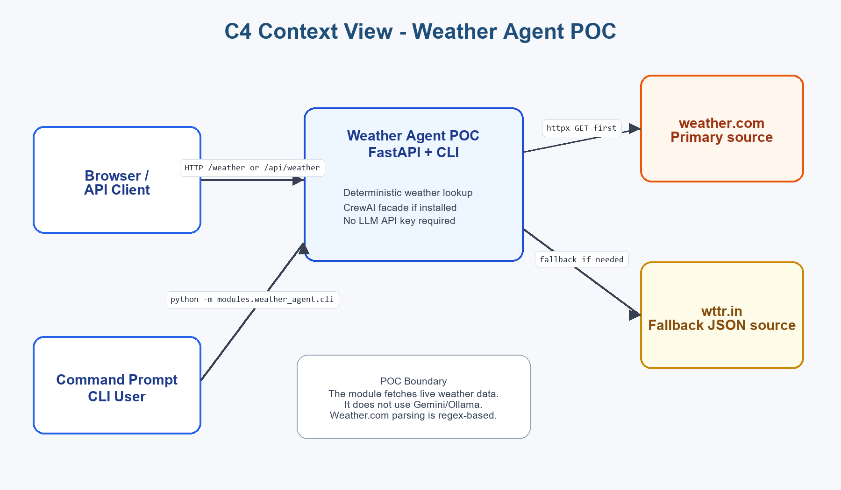
Figure: C4 Context View - Weather Agent POC

C4 Context Source Code (collapsed by default)
System Context
[Browser / API Client] -> [Weather Agent POC]
[Command Prompt CLI User] -> [Weather Agent POC]
[Weather Agent POC]
-> [weather.com primary weather source]
-> [wttr.in fallback weather source]
Notes:
- No database is used.
- No LLM API key is required.
- External network access is required.

C4 Container View
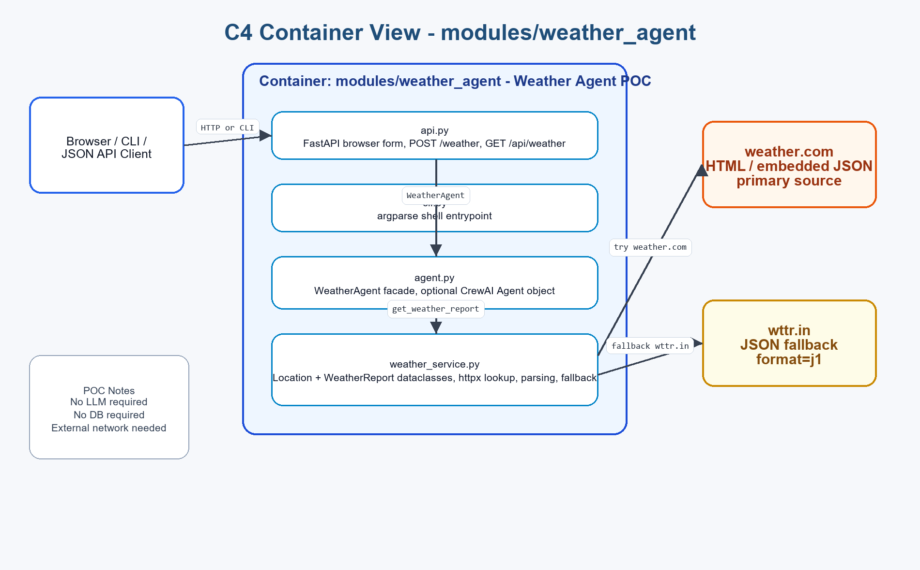
Figure: C4 Container View - modules/weather_agent

C4 Container Source Code (collapsed by default)
Container: modules/weather_agent
api.py
- FastAPI browser form
- POST /weather
- GET /api/weather
cli.py
- argparse command-line entrypoint
- prints WeatherReport fields
agent.py
- WeatherAgent facade
- optional CrewAI Agent object
- current_weather(location)
weather_service.py
- Location dataclass
- WeatherReport dataclass
- httpx client
- weather.com parser
- wttr.in fallback parser
- JSON-safe to_dict output
External systems:
- weather.com
- wttr.in

9. Endpoints And Entrypoints
Endpoint / Command | Purpose
GET / | Render browser form for city/state/country.
POST /weather | Submit browser form and render current weather details.
GET /api/weather?city=&state=&country= | Return WeatherReport as JSON.
python -m modules.weather_agent.cli | CLI default Atlanta lookup.
python -m modules.weather_agent.cli --city Dallas --state TX --country US | CLI custom location lookup.

10. Data Model
Dataclass | Important Fields / Behavior
Location | city, state, country, label, weather_com_path.
WeatherReport | location, temperature_f, temperature_c, condition, feels_like_f, humidity, wind, source, display labels, to_dict().

11. Local Run And Test

Run Commands (collapsed by default)
.\.venv\Scripts\python.exe -m modules.weather_agent.cli
.\.venv\Scripts\python.exe -m modules.weather_agent.cli --city Atlanta --state GA --country US
.\.venv\Scripts\python.exe -m uvicorn modules.weather_agent.api:app --reload
- Browser UI: http://127.0.0.1:8000
- JSON API example: http://127.0.0.1:8000/api/weather?city=Atlanta&state=GA&country=US
- Returned source field shows whether weather.com or wttr.in was used.

12. POC Limitations
- Weather.com parsing depends on page content and regex patterns, so it can break if weather.com changes markup.
- wttr.in fallback is external and can fail, rate-limit, or return unexpected data.
- No caching; each request performs live HTTP calls.
- No retry/backoff strategy beyond the weather.com-to-wttr fallback.
- Location handling is string-based and does not geocode ambiguous places.
- No production logging, metrics, or alerting.
- No forecast or multi-day weather support.

13. Recommended Upgrades
- Use a stable weather API with a documented schema.
- Add geocoding and validation for ambiguous city names.
- Add retry/backoff and timeout tuning.
- Cache recent weather responses by location.
- Add structured logging and metrics.
- Add automated tests for parser fallback behavior.
- Move inline HTML to templates if the UI grows.
- Add richer endpoints for forecast, hourly weather, and alerts if needed.

14. Related Modules
Module | Relationship
modules/weather_ai_agent | Builds on deterministic weather lookup and adds an LLM-generated summary.
modules/online_library_agent | Separate NLQ/MCP/LLM POC with a different domain.
modules/online_library | Separate database-backed REST API POC.

15. Open Details / Questions
- Should the weather module eventually use a commercial weather API instead of scraping/fallback?
- Should a weather MCP tool be created later?
- Should the browser output be styled to match the newer Online Library Agent UI?
End of Weather Agent Architecture POC Document

