Weather AI Agent Architecture
Proof of Concept architecture document for modules/weather_ai_agent
Document | weather_ai_agent_architecture.docx
Module | modules/weather_ai_agent
Status | POC / local development module
Date | June 20, 2026
Primary Runtime | Python 3.13, FastAPI, Uvicorn, CrewAI
LLM Provider | Configurable: Gemini or local Ollama
Default Local Model | Configured through .env, tested with Ollama models such as gemma/mistral variants
Purpose | Fetch live weather observations deterministically, then use an LLM to create a concise natural-language summary.

1. Executive Summary
The Weather AI Agent module is a CrewAI-backed proof of concept that combines deterministic live weather retrieval with an LLM-generated weather explanation. The LLM is not trusted as the source of current weather facts. Instead, current observations are fetched through modules/weather_agent and then passed into a CrewAI task for summarization.
- Supports browser, JSON API, and CLI execution.
- Uses modules/weather_agent as the live weather data source.
- Supports Gemini and local Ollama through environment configuration.
- Includes raw weather summary and AI summary in responses.
- Requires a configured LLM for the final natural-language answer.

2. Tech Stack
Layer | Technology | Usage
API framework | FastAPI | Browser form and JSON endpoint.
Server | Uvicorn | Runs API locally, commonly on port 8002.
Agent framework | CrewAI | Defines Agent, Task, Crew, Process, and LLM.
LLM provider | Gemini or Ollama | Configurable summarization backend.
Weather facts | modules/weather_agent | Deterministic live weather lookup.
HTTP client | httpx indirectly via weather_agent | External weather data retrieval.
Configuration | python-dotenv | Module-local .env support.
Runtime | Python 3.13 | Implementation runtime.

3. Scope
In scope for this POC:
- Accept city/state/country through CLI, browser, or JSON API.
- Fetch live weather facts before invoking the LLM.
- Use CrewAI to generate a concise AI weather summary.
- Support either Gemini or local Ollama provider configuration.
- Return model, weather source, raw weather summary, and AI summary.
Out of scope for this POC:
- Forecasts, alerts, hourly weather, or historical weather.
- Multi-agent planning or delegation.
- Conversation memory.
- Production-grade prompt/version management.
- Production auth, rate limiting, logging, and cost controls.

4. Component Overview
File | Responsibility
agent.py | WeatherAIAgent, CrewAI LLM/Agent/Task/Crew creation, final response assembly.
api.py | FastAPI browser form and JSON endpoint.
cli.py | Command prompt entrypoint with readable errors.
config.py | Loads Gemini/Ollama provider configuration from .env or shell.
models.py | WeatherAIRequest and WeatherAIResponse dataclasses.
weather_tool.py | Adapter that fetches deterministic weather facts from modules.weather_agent.
Readme.md | Run/configuration instructions.
docs/ | Planning, prompt, Docker/local LLM, and Kubernetes notes.

5. Runtime Architecture

Runtime Flow Summary (collapsed by default)
Browser / CLI / API Client
|
v
Weather AI Agent :8002 or CLI
|
| fetch live observations first
v
modules/weather_agent deterministic lookup
|
| weather.com first, wttr.in fallback
v
Live weather source
|
v
Raw weather summary
|
| CrewAI Task + configured LLM
v
Gemini or local Ollama
|
v
AI weather summary returned to user

6. Request Control Flow
- User submits city/state/country through CLI, browser form, or JSON API.
- WeatherAIRequest is created.
- WeatherAIAgent loads LLM configuration from .env.
- CrewAI LLM and Agent are constructed.
- fetch_current_weather() converts the AI request into a weather_agent Location.
- modules.weather_agent.weather_service fetches live observations.
- summarize_weather_report() converts the report into compact text.
- A CrewAI Task is created with strict instructions to use only supplied observations.
- Crew runs sequentially and calls the configured LLM.
- WeatherAIResponse returns location, source, raw summary, AI summary, and model.

7. PlantUML-Style Sequence Diagram
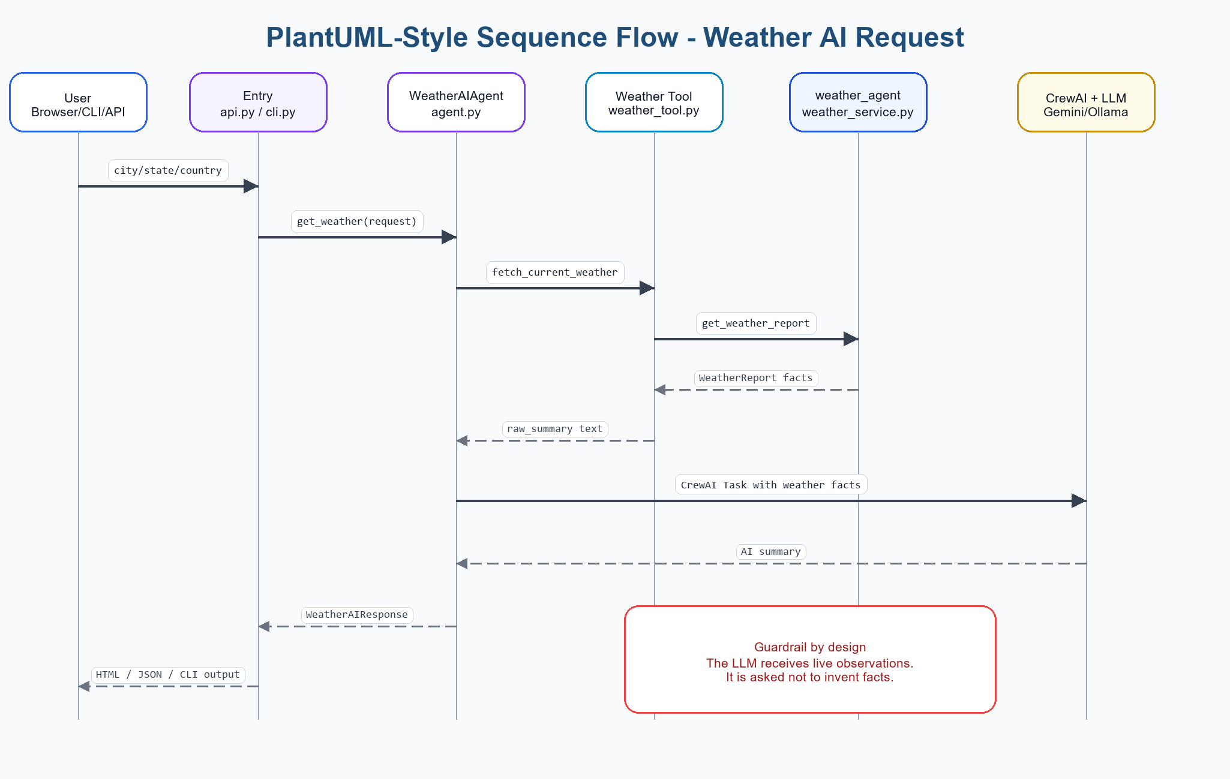
Figure: PlantUML-style sequence flow for Weather AI Agent request

PlantUML Source Code - Weather AI flow (collapsed by default)
@startuml
actor User
participant "API/CLI
api.py / cli.py" as Entry
participant "WeatherAIAgent
agent.py" as Agent
participant "Weather Tool
weather_tool.py" as Tool
participant "Weather Service
modules/weather_agent" as Weather
participant "CrewAI + LLM
Gemini/Ollama" as LLM
User -> Entry: city/state/country
Entry -> Agent: get_weather(request)
Agent -> Tool: fetch_current_weather(request)
Tool -> Weather: get_weather_report(location)
Weather --> Tool: WeatherReport facts
Tool --> Agent: raw weather summary
Agent -> LLM: CrewAI task with supplied observations only
LLM --> Agent: concise AI weather summary
Agent --> Entry: WeatherAIResponse
Entry --> User: HTML, JSON, or CLI output
@enduml

8. C4-Style Architecture View

C4 Context View
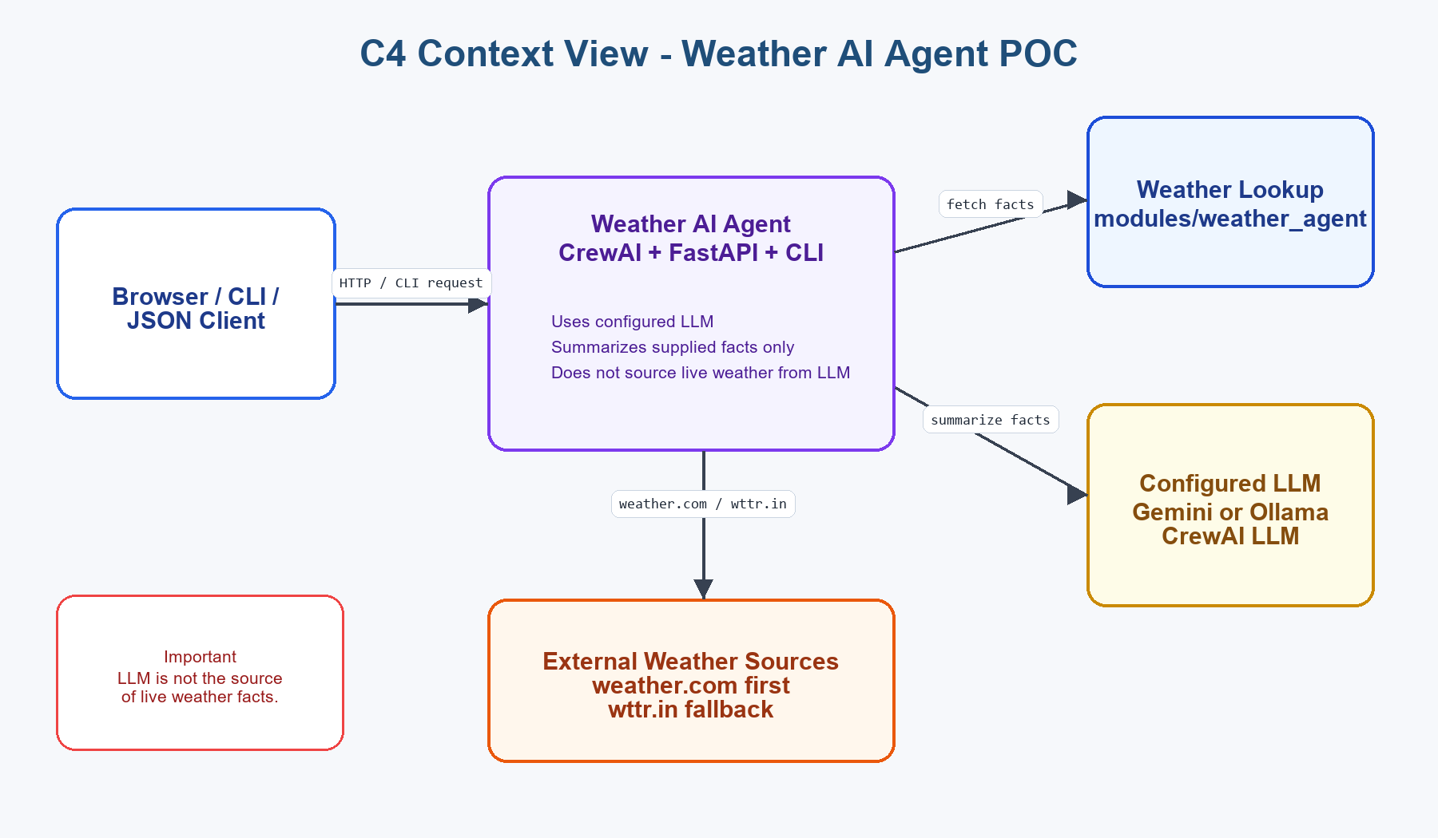
Figure: C4 Context View - Weather AI Agent POC

C4 Context Source Code (collapsed by default)
System Context
[Browser / CLI / API Client] -> [Weather AI Agent]
[Weather AI Agent] -> [modules/weather_agent deterministic lookup]
[modules/weather_agent deterministic lookup] -> [weather.com / wttr.in]
[Weather AI Agent] -> [Configured LLM: Gemini or local Ollama]
Important:
- The LLM does not source live weather.
- Live facts are fetched before the LLM is called.
- The LLM summarizes supplied observations only.

C4 Container View
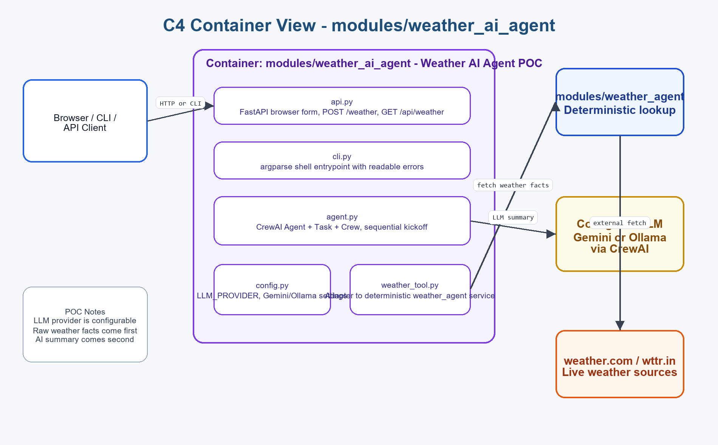
Figure: C4 Container View - modules/weather_ai_agent

C4 Container Source Code (collapsed by default)
Container: modules/weather_ai_agent
api.py
- FastAPI browser form
- POST /weather
- GET /api/weather
cli.py
- argparse CLI entrypoint
- error handling for configuration/runtime failures
agent.py
- load_llm_config()
- CrewAI LLM, Agent, Task, Crew
- get_weather(request)
config.py
- LLM_PROVIDER gemini/ollama
- GEMINI_API_KEY / GEMINI_MODEL
- OLLAMA_MODEL / OLLAMA_BASE_URL
weather_tool.py
- fetch_current_weather()
- summarize_weather_report()
- depends on modules/weather_agent
External systems:
- modules/weather_agent
- weather.com / wttr.in through weather_agent
- Gemini API or local Ollama

9. Endpoints And Entrypoints
Endpoint / Command | Purpose
GET / | Render browser form for city/state/country.
POST /weather | Submit browser form and render AI weather summary.
GET /api/weather?city=&state=&country= | Return AI weather response as JSON.
python -m modules.weather_ai_agent.cli | CLI default Atlanta request.
python -m modules.weather_ai_agent.cli --city Dallas --state TX --country US --verbose | CLI custom location with CrewAI verbose output.

10. Configuration

Environment Values (collapsed by default)
# Ollama local mode
LLM_PROVIDER=ollama
OLLAMA_MODEL=mistral:latest
OLLAMA_BASE_URL=http://127.0.0.1:11434
# Gemini mode
LLM_PROVIDER=gemini
GEMINI_API_KEY=your-gemini-api-key
GEMINI_MODEL=gemini-2.5-flash

11. Local Run And Test

Run Commands (collapsed by default)
.\.venv\Scripts\python.exe -m modules.weather_ai_agent.cli
.\.venv\Scripts\python.exe -m modules.weather_ai_agent.cli --city Dallas --state TX --country US
.\.venv\Scripts\python.exe -m uvicorn modules.weather_ai_agent.api:app --reload --port 8002
Invoke-RestMethod "http://127.0.0.1:8002/api/weather?city=Atlanta&state=GA&country=US"
- Browser UI: http://127.0.0.1:8002
- Ollama must be running for LLM_PROVIDER=ollama.
- Gemini API key must be configured for LLM_PROVIDER=gemini.
- The weather_source field shows where facts came from.

12. POC Limitations
- Requires a configured LLM for final summary.
- Local Ollama models can be slow on laptop hardware.
- CrewAI/LiteLLM/provider behavior can vary by installed package versions.
- Weather facts still depend on external weather.com/wttr.in availability.
- No structured validation of the final AI text.
- No caching of weather or LLM results.
- No production auth, rate limiting, tracing, or cost controls.

13. Recommended Upgrades
- Add deterministic fallback summary when LLM is unavailable.
- Add response validation or structured output mode for AI summary.
- Add retries and timeouts around LLM calls.
- Cache weather observations for short windows.
- Add prompt versioning and tests with mocked LLM output.
- Add provider-specific config docs for Ollama, Gemini, and future vLLM/OpenAI-compatible servers.
- Improve UI styling to match the newer Online Library Agent style.

14. Related Modules
Module | Relationship
modules/weather_agent | Provides deterministic live weather facts used by this AI module.
modules/online_library_agent | Separate NLQ/MCP/LLM POC using local Ollama and MCP tools.
modules/online_library_mcp | Separate MCP Streamable HTTP POC.

15. Open Details / Questions
- Should local Ollama be the default documented provider instead of Gemini?
- Should final AI responses include developer diagnostics like model, provider, temperature, and timing?
- Should a Weather MCP server be added later so weather can be used by other agents?
End of Weather AI Agent Architecture POC Document

