My-Agent-Poc
Current Architecture and CI/CD Deployment Design
Python / FastAPI • RAG • Keycloak • PostgreSQL + pgvector • Ollama • Docker • Kubernetes • Jenkins

Validated baseline
Jenkins build #1 successfully deployed all five pipeline services with image tags ending in Git SHA 906adb0. Health checks passed for ingest, search, answer, online-library database connectivity, and secure-api.

Document status | Current-state architecture baseline
Repository | My-Agent-Poc
Primary branch | master
Validated build | Jenkins build #1 / Git SHA 906adb0
Date | September 14, 2026

Contents
- 1. Executive Summary
- 2. Scope and Architecture Boundaries
- 3. Project Module Inventory
- 4. Runtime Architecture
- 5. RAG Functional Architecture
- 6. Kubernetes Deployment Architecture
- 7. CI/CD Pipeline Architecture
- 8. Build, Image, and Deployment Traceability
- 9. Configuration and Dependency Model
- 10. Security Architecture
- 11. Operational Monitoring and Validation
- 12. Image / Rollout Retention and Cleanup
- 13. Current Gaps and Recommended Next Steps
- 14. Appendix - Ports, Health Checks, and Key Commands

1. Executive Summary
My-Agent-Poc is a Python-based proof-of-concept platform combining Retrieval-Augmented Generation (RAG), structured online-library services, authentication/authorization, and agent experiments. The repository intentionally contains more modules than the currently automated deployment pipeline.
The current Jenkins/Kubernetes pipeline deploys five FastAPI services into a local Docker Desktop Kubernetes cluster: RAG Ingest, RAG Search, RAG Answer, Online Library, and Secure API Gateway. PostgreSQL/pgvector, Keycloak, and Ollama remain host-side dependencies reachable from pods through host.docker.internal.
Key architectural characteristic
The browser/client is intended to enter through Secure API (:8010). Secure API validates Keycloak JWTs and routes calls to internal services. The RAG services communicate with each other through Kubernetes Service DNS, while host-side dependencies remain outside the cluster.

2. Scope and Architecture Boundaries

2.1 Current automated deployment scope
Module | Runtime | Port | Docker | K8s/Jenkins | Primary responsibility
rag-ingest-service | FastAPI | 8000 | Yes | Yes | Document ingestion, chunking, embeddings, indexing
rag-search-service | FastAPI | 8001 | Yes | Yes | Hybrid/vector/graph retrieval and admin search operations
rag-answer-service | FastAPI | 8002 | Yes | Yes | Grounded answer generation using retrieved context
online_library | FastAPI | 8003 | Yes | Yes | Structured catalog/database API
secure_api | FastAPI | 8010 | Yes | Yes | Authentication boundary, RBAC, routing, unified API/UI

2.2 Implemented repository modules outside the current five-service pipeline
Module | Technology | Current deployment status
angular-ui | Angular | Frontend implementation and documentation; not currently built/deployed by root Jenkins pipeline.
online_library_mcp | Python / MCP | MCP tool server on planned/local port 8004; currently host/local startup model.
online_library_agent | Python / FastAPI | Natural-language library agent on planned/local port 8005; uses MCP + Ollama.
weather_agent | Python | Deterministic weather-agent demonstration.
weather_ai_agent | Python | LLM-assisted weather-agent demonstration.

Scope discipline
This document describes these additional modules as implemented repository capabilities, but does not represent them as part of the currently validated Kubernetes/Jenkins deployment.

3. Project Module Inventory
The repository is organized as a modular POC. The core deployment is service-oriented, with each runtime service owning its own application code, tests, Dockerfile, and where applicable Kubernetes manifests.
Path | Purpose
modules/rag-ingest-service | FastAPI service, workers, repositories, graph_rag, SQL schemas, tests, Dockerfile
modules/rag-search-service | FastAPI service, retrieval/ranking pipeline, repositories, tests, Dockerfile
modules/rag-answer-service | FastAPI answer APIs, context/prompt/faithfulness services, tests, Dockerfile
modules/online_library | Catalog API, DB/repository layer, SQL, tests, Dockerfile
modules/secure_api | Authentication gateway, routing, UI/API, tests, Dockerfile
k8s/ | Namespace plus ConfigMap/Service/Deployment manifests for five pipeline services; Secure API also has Secret manifest
scripts/ | Port-forwarding, kubeconfig preparation, CI/CD test helpers, packaging and image cleanup utility
Jenkinsfile | Cumulative five-service CI/CD pipeline

4. Runtime Architecture
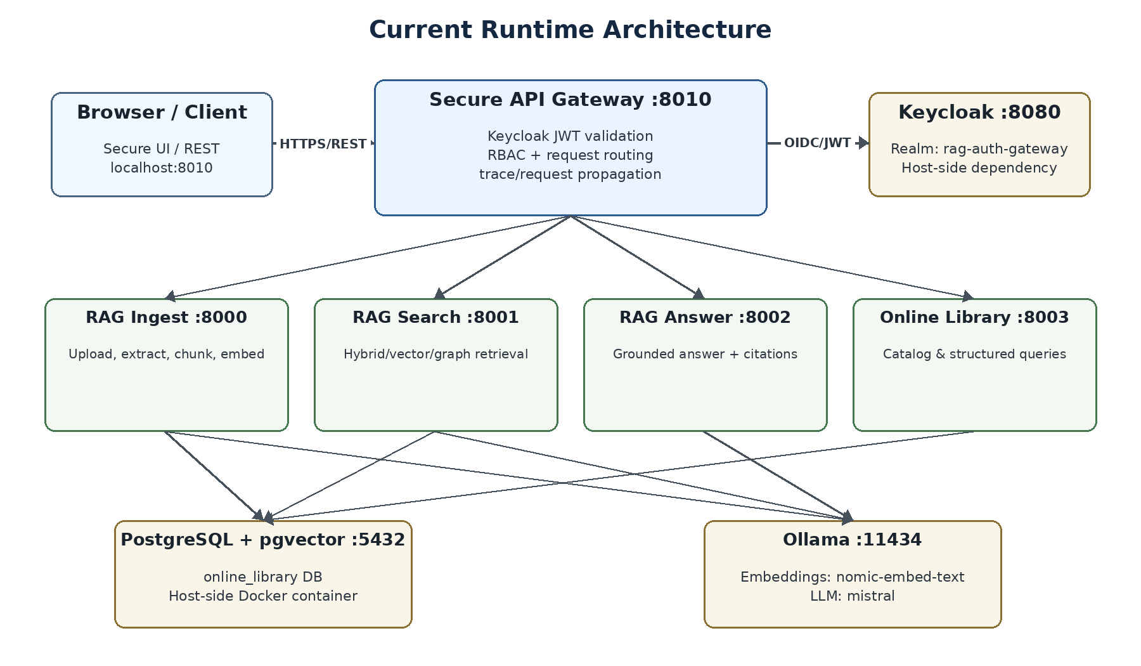

4.1 Runtime interaction model
Secure API is the primary external boundary. It is configured to call the four cluster services through Kubernetes service names: rag-ingest-service:8000, rag-search-service:8001, rag-answer-service:8002, and online-library:8003. It reaches Keycloak and other non-cluster local dependencies through host.docker.internal.
Source | Target | Connectivity | Purpose
Browser / client | Secure API | HTTP/REST | Primary user/application entry point
Secure API | Keycloak | OIDC/JWT | Authentication, token validation, role context
Secure API | RAG services | K8s Service DNS | Protected routing / internal API calls
Ingest/Search/Online Library | PostgreSQL + pgvector | TCP 5432 via host.docker.internal | Persistent relational/vector data
Ingest/Search/Answer | Ollama | HTTP 11434 via host.docker.internal | Embeddings and local LLM inference
Answer | Search | HTTP via rag-search-service:8001 | Retrieve context before generation

5. RAG Functional Architecture
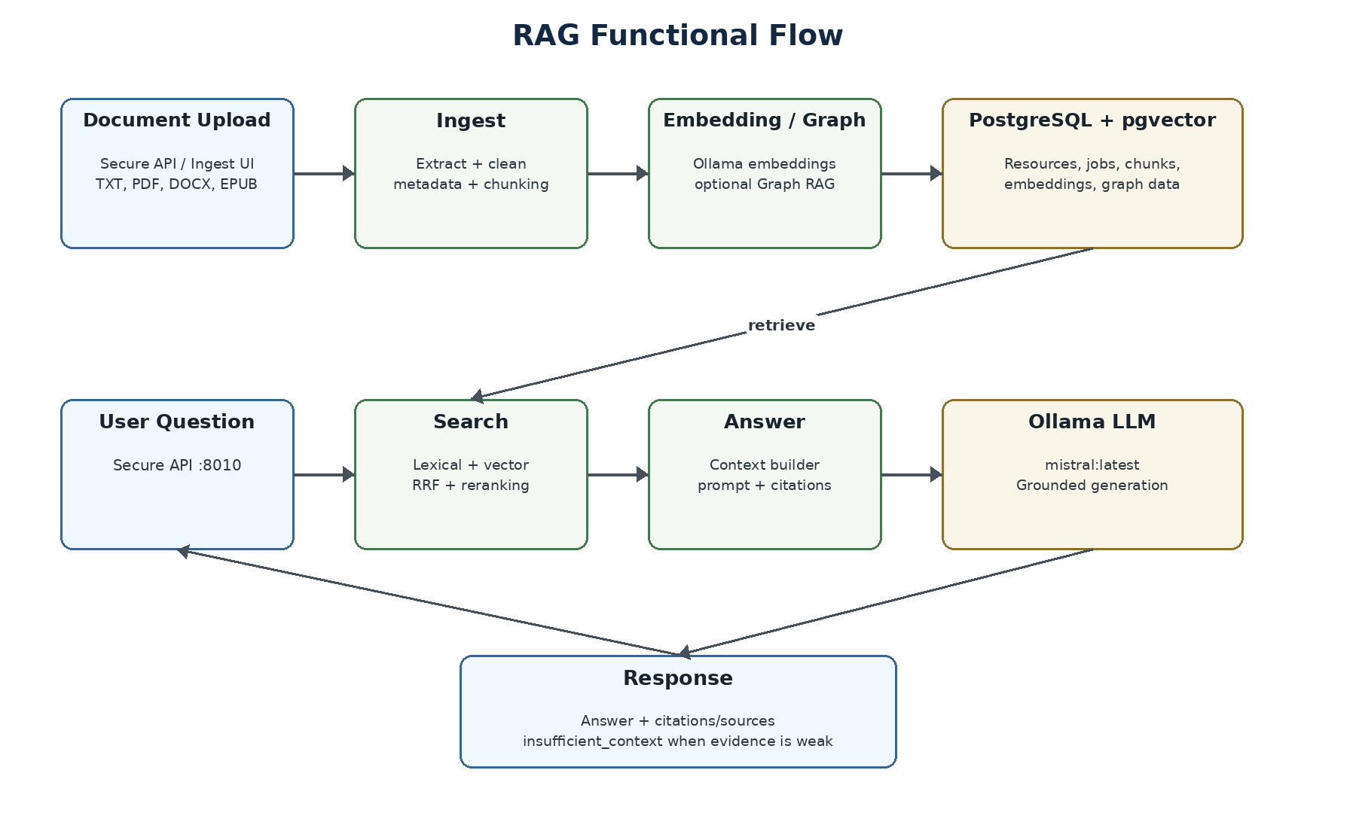

5.1 Ingestion path
- Validate and accept supported documents.
- Extract text and document metadata.
- Apply cleanup, page markers, chunking, and chunk-quality handling.
- Generate embeddings through Ollama using nomic-embed-text; optionally generate Graph RAG structures.
- Persist jobs, resources, chunks, embeddings, and graph data in PostgreSQL/pgvector.

5.2 Search and answer path
- Search preprocesses the query and can combine lexical, vector, hybrid, graph, or combined retrieval.
- Hybrid search supports oversampling, reciprocal-rank fusion, reranking, quality checks, filters, and snippets.
- Answer calls Search, builds bounded source-ranked context, and invokes the configured LLM.
- Answer returns citations/sources and can return insufficient_context when evidence does not support the question.

6. Kubernetes Deployment Architecture
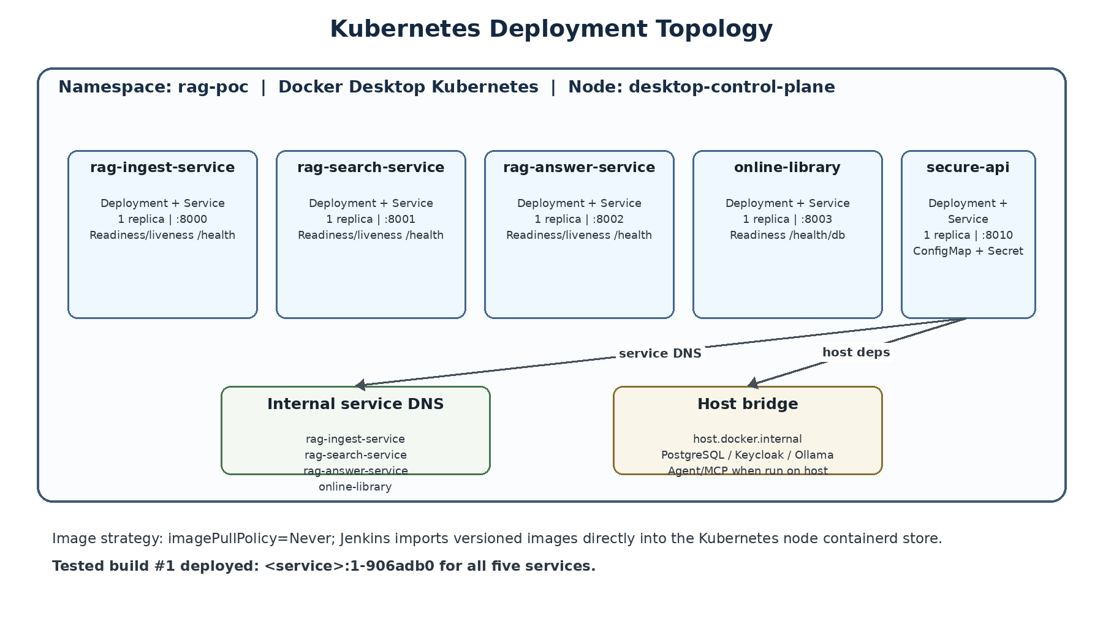

6.1 Cluster model
Area | Current value | Notes
Cluster | Docker Desktop Kubernetes | Local development cluster
Node/container | desktop-control-plane | Jenkins imports images directly into its containerd store
Namespace | rag-poc | All five current services
Replica strategy | 1 replica per service | POC sizing
Image policy | imagePullPolicy: Never | No external registry in current flow
Config | ConfigMaps | Runtime URLs, models, DB settings, search tuning
Secret | secure-api Secret | Gateway secret material

6.2 Health and resource controls
Deployment | Readiness | Liveness | CPU/Mem request | CPU/Mem limit
rag-ingest-service | /health | /health | 150m / 256Mi | 1000m / 1Gi
rag-search-service | /health | /health | 100m / 128Mi | 750m / 768Mi
rag-answer-service | /health | /health | 100m / 128Mi | 500m / 512Mi
online-library | /health/db | TCP :8003 | 50m / 64Mi | 500m / 256Mi
secure-api | /health | /health | 100m / 128Mi | 500m / 512Mi

Manifest consistency gap
revisionHistoryLimit: 3 is present in the Ingest, Search, Answer, and Secure API deployment manifests in the reviewed archive. The Online Library deployment does not yet contain the same setting and should be aligned if the intended policy is uniform across all five services.

7. CI/CD Pipeline Architecture
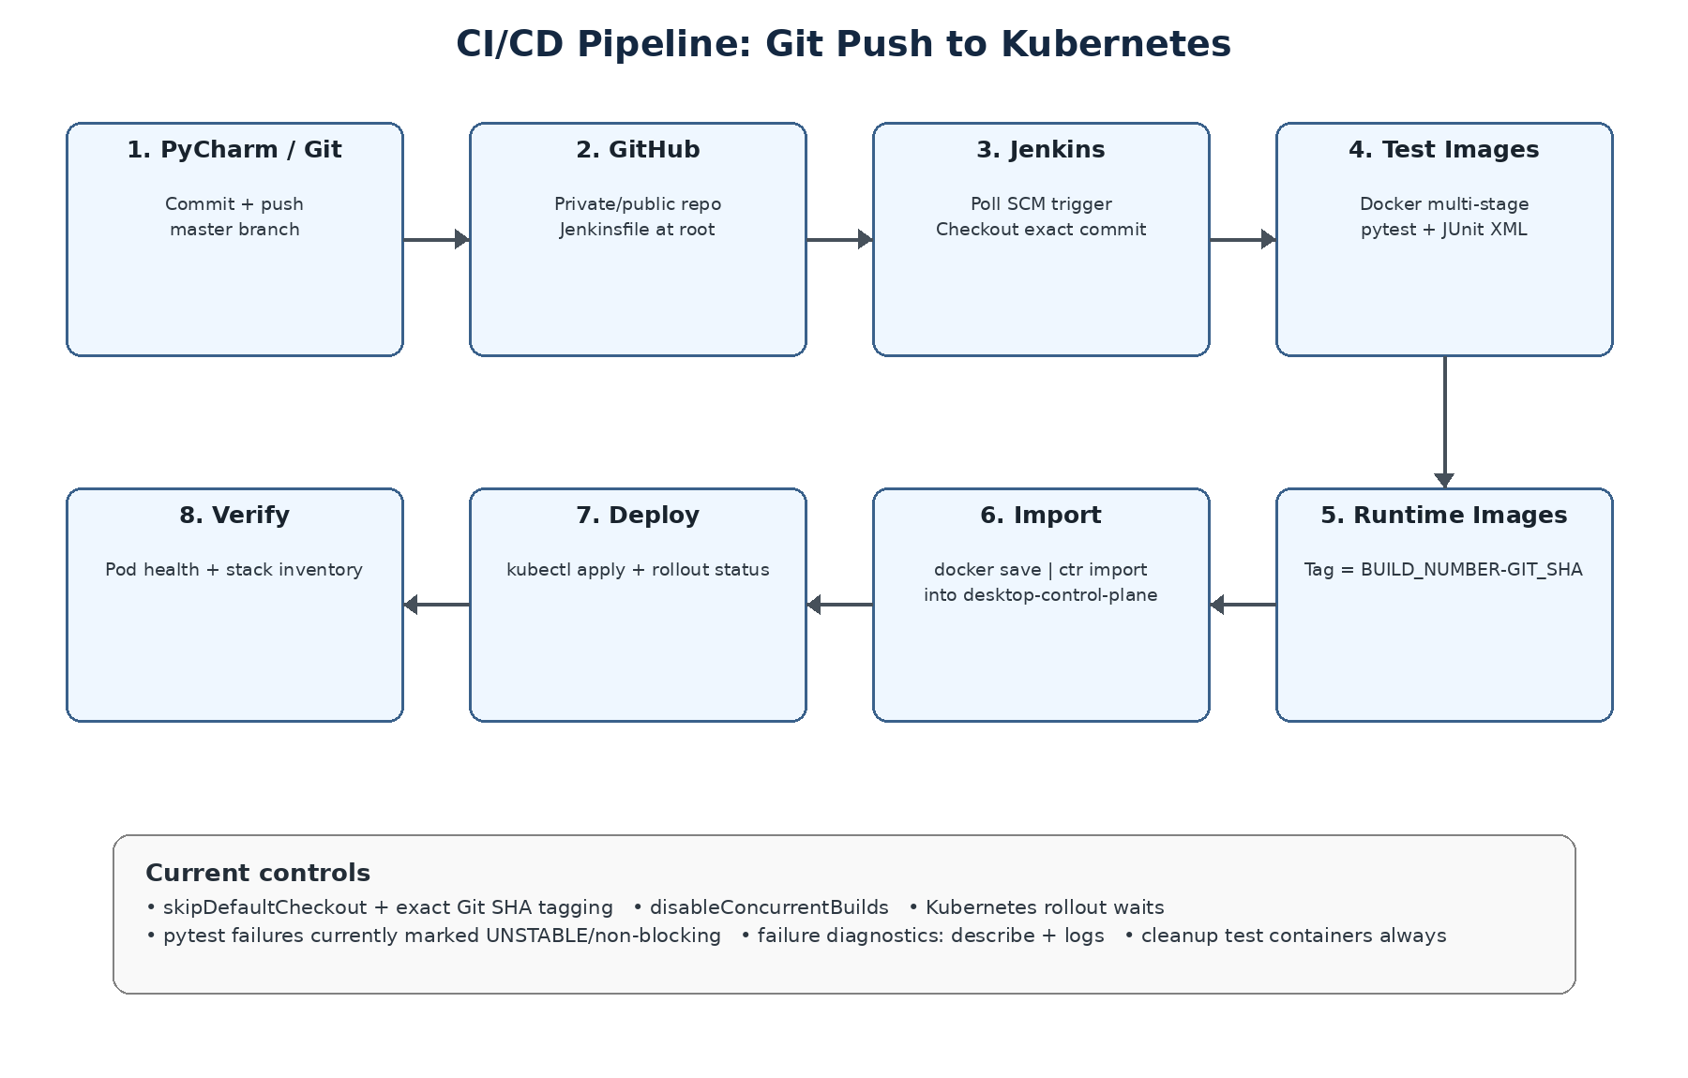

7.1 Trigger and source control
A Jenkins Pipeline job points to the GitHub repository and root Jenkinsfile. Poll SCM is used for the local POC so Jenkins can detect repository changes without requiring GitHub to call a localhost webhook endpoint. A push to master causes Jenkins to check out the exact commit and derive a seven-character Git SHA.

7.2 Per-service pipeline pattern
Step | Mechanism | Outcome
Build test image | docker build --target test | Creates isolated test runtime
Run pytest | docker run test image | JUnit XML copied into Jenkins workspace
Build runtime image | docker build --target runtime | Creates deployable FastAPI image
Tag image | <service>:<BUILD_NUMBER>-<GIT_SHORT> | Immutable traceability for the POC
Import image | docker save | docker exec desktop-control-plane ctr ... import | Makes image available to K8s without registry
Apply config/service | kubectl apply | Updates runtime config and Service
Deploy | Replace __IMAGE__ then kubectl apply | Deployment uses the exact versioned image
Rollout verification | kubectl rollout status | Waits for Ready state
Health verification | kubectl exec + localhost health call | Checks app inside running pod

7.3 Pipeline controls
- skipDefaultCheckout(true): avoids duplicate checkout; explicit checkout scm is used.
- timestamps(): adds time information to build output.
- disableConcurrentBuilds(): prevents overlapping deployments from the same job.
- Tests are currently wrapped with catchError and can mark stages UNSTABLE while allowing deployment to continue. This was useful during POC development but is a future hardening item.
- Failure post-action collects get all, deployment descriptions, and the last 100 log lines for all five services.
- Always post-action removes temporary test containers.

8. Build, Image, and Deployment Traceability
The pipeline derives IMAGE_TAG = BUILD_NUMBER-GIT_SHORT. This gives direct traceability from Jenkins execution to the Git commit and deployed Kubernetes image.
Build #1 + Git SHA 906adb0 => IMAGE_TAG = 1-906adb0
Deployment | Validated image
rag-ingest-service | rag-ingest-service:1-906adb0
rag-search-service | rag-search-service:1-906adb0
rag-answer-service | rag-answer-service:1-906adb0
online-library | online-library:1-906adb0
secure-api | secure-api:1-906adb0

Validated outcome
git rev-parse --short HEAD returned 906adb0, and every deployed Kubernetes workload reported an image tag ending in 1-906adb0. This demonstrates source-to-runtime traceability for the validated build.

9. Configuration and Dependency Model
Dependency | Address | Placement | Notes
PostgreSQL/pgvector | host.docker.internal:5432 | Host Docker container | online_library DB; also test DB during CI tests
Ollama | host.docker.internal:11434 | Host process | nomic-embed-text embeddings; mistral answer/generation
Keycloak | host.docker.internal:8080 | Host Docker container | Realm rag-auth-gateway; secure gateway authentication
RAG internal calls | Kubernetes Service DNS | Inside rag-poc | No host round-trip for core service-to-service routing
Online Library API | http://online-library:8003 | Inside rag-poc | Secure API now uses cluster DNS
Library MCP / Agent | host ports 8004 / 8005 when started | Outside current K8s pipeline | Implemented modules but not part of validated five-service deployment

9.1 Current model settings
Capability | Provider / model
Embeddings | Ollama / nomic-embed-text / dimension 768
Answer LLM | Ollama / mistral:latest
Ingest LLM functions | Ollama / mistral:latest

10. Security Architecture
Secure API is the current application security boundary. It integrates with Keycloak and performs authentication and role-aware access control before routing protected requests downstream.
Concern | Mechanism | Current implementation
Authentication | Keycloak OIDC/JWT | Realm rag-auth-gateway
Authorization | Gateway role checks | Admin/user/search/ingest-oriented roles described in project docs
Token validation | JWKS-based validation | Keycloak URL from ConfigMap
Internal routing | Gateway to Kubernetes Services | Avoids exposing internal service discovery to the browser
Secrets | Secure API Secret + ConfigMap separation | POC; review secret handling before production
CORS | Configured origins | localhost UI/API origins
Trace context | traceparent / X-Trace-Id / request IDs | Propagated across service boundaries

POC security caveat
The architecture is appropriate for a local POC, but production hardening would require external secret management, TLS, network policies, stronger audience validation, hardened service-to-service authentication, and removal of plaintext development credentials from manifests/configuration.

11. Operational Monitoring and Validation

11.1 Pre-flight validation
The pre-flight checks validate Git/GitHub reachability, Docker Engine, Kubernetes API and node readiness, Jenkins container access to Docker and Kubernetes, plus PostgreSQL, Keycloak, and Ollama availability.

11.2 During a deployment
kubectl -n rag-poc get pods -w
kubectl -n rag-poc get deployments -w
The successful build demonstrated a standard rolling replacement: new Online Library and Secure API pods moved from Pending → ContainerCreating → Running → Ready, followed by termination of the previous pods.

11.3 Post-deployment health checks
Service | Port-forwarded health URL | Validated result
Ingest | http://localhost:8000/health | {"status":"ok","service":"rag-ingest-service"}
Search | http://localhost:8001/health | {"status":"ok","service":"rag-search-service"}
Answer | http://localhost:8002/health | {"status":"ok","service":"rag-answer-service"}
Online Library | http://localhost:8003/health/db | DB status ok
Secure API | http://localhost:8010/health | {"status":"UP"}

12. Image / Rollout Retention and Cleanup
The project currently has multiple places where deployment history or image data can accumulate. They should be treated separately.
Location | What accumulates | Current reviewed behavior
Kubernetes ReplicaSets | Deployment rollout history | revisionHistoryLimit: 3 on four reviewed manifests; Online Library alignment pending
Host Docker image store | Jenkins test/runtime images | cleanup-old-cicd-images.ps1 exists; dry-run by default; reviewed version defaults Keep=2
Kubernetes node containerd | Imported runtime images | Reviewed cleanup script can enumerate/remove imported service images when -Execute is used
Docker build cache | Intermediate build layers | No automatic prune stage in reviewed root Jenkinsfile

Recommended target policy
Keep the currently deployed image plus three prior tagged images per service (four total), retain three Kubernetes ReplicaSet revisions, run cleanup only after successful deployment/verification, and avoid aggressive docker system prune -a. Containerd cleanup should be conservative because images are imported directly into the cluster node.

The repository cleanup script is a useful starting point, but the reviewed Jenkinsfile does not yet invoke it automatically. If the newer Codex change is applied after this baseline, update this architecture document to reflect the final Keep=4 post-success cleanup behavior.

13. Current Gaps and Recommended Next Steps
Area | Current state | Recommendation | Priority
Blocking CI tests | Current pytest stages can continue as UNSTABLE | After the pipeline is stable, fail the pipeline before deployment when required tests fail. | High
Online Library revision history | No revisionHistoryLimit in reviewed deployment manifest | Add revisionHistoryLimit: 3 for consistency. | Medium
Image cleanup integration | Cleanup utility exists but reviewed Jenkinsfile has no cleanup stage | Run safe retention cleanup only after successful full-stack verification. | Medium
Agent/MCP/UI deployment | Modules exist outside five-service K8s pipeline | Decide whether they remain host-side experiments or become independently containerized/deployed. | Medium
Secrets/config hardening | Development credentials and host dependencies are POC-oriented | Externalize secrets and introduce production-grade config/security before non-local deployment. | High
Observability | Health/logging and trace IDs exist; full metrics/tracing stack not part of current pipeline | Add Prometheus/Grafana/OpenTelemetry/Loki when moving beyond POC. | Medium
Registry strategy | Images imported directly into node containerd | For shared environments, use an image registry and immutable digest promotion. | Future

14. Appendix - Ports, Health Checks, and Key Commands

14.1 Port map
Port | Component | Current placement
8000 | RAG Ingest | K8s + port-forward
8001 | RAG Search | K8s + port-forward
8002 | RAG Answer | K8s + port-forward
8003 | Online Library | K8s + port-forward
8010 | Secure API | K8s + port-forward
8080 | Keycloak | Host Docker
5432 | PostgreSQL/pgvector | Host Docker
11434 | Ollama | Host process
8004 | Online Library MCP | Local/host when started
8005 | Online Library Agent | Local/host when started

14.2 Useful validation commands
git rev-parse --short HEAD
kubectl -n rag-poc get pods
kubectl -n rag-poc get deployments
kubectl -n rag-poc get services
kubectl -n rag-poc get pods -w
kubectl -n rag-poc get events --sort-by=.lastTimestamp
kubectl -n rag-poc logs deployment/<service> --tail=200
.\scripts\start-port-forwards.bat
.\scripts\cleanup-old-cicd-images.ps1 # dry run

14.3 Image traceability command example
kubectl -n rag-poc get deployment rag-search-service -o jsonpath="{.spec.template.spec.containers[0].image}"
Expected pattern: rag-search-service:<Jenkins build number>-<Git short SHA>.
Architecture baseline statement: This document reflects the reviewed source archive plus the successfully validated build #1 runtime behavior. Modules or cleanup changes added after this baseline should be incorporated into a subsequent revision rather than assumed to be deployed.

