Local Mistral vs Cloud OpenAI API
Decision Guide, Cost Comparison, and Recommended Architecture
Use case: Python AI agents that parse input text and present it neatly
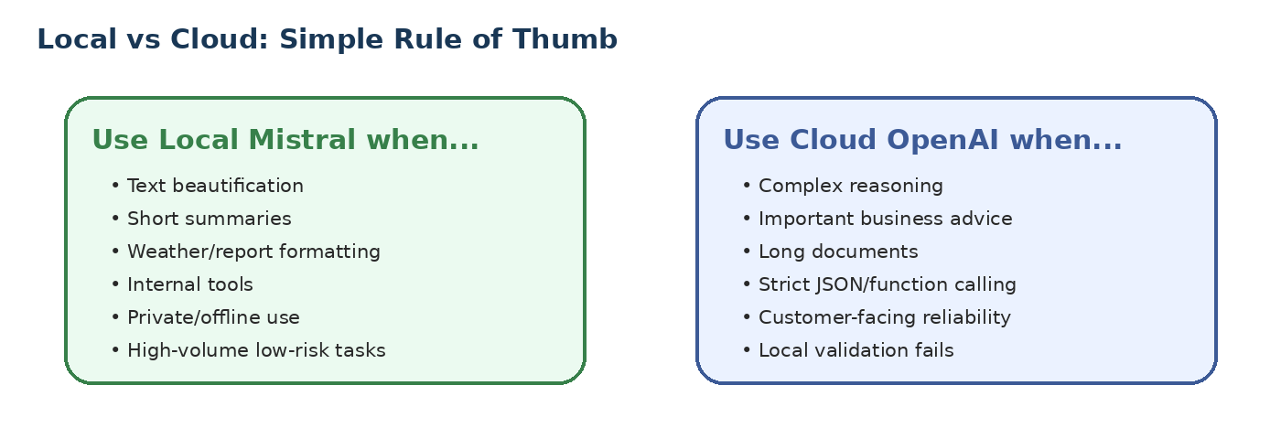
Executive recommendation
For simple text beautification, weather-response formatting, email polishing, short summaries, and internal response cleanup, use local Ollama with mistral:latest as the default. Add OpenAI API as an optional fallback for complex reasoning, important business recommendations, long documents, or when local output fails validation.

1. Your Requirement
You are using Ollama locally from Python-based AI agents. Your current requirement is not deep reasoning or complex planning. The requirement is mainly:
- Parse input text.
- Beautify and present the response neatly.
- Turn raw weather or business data into readable text.
- Possibly summarize, polish, or format small responses.
Tutor-style explanation
Think of the local LLM as a smart language formatter. It does not need to be a top reasoning model if the job is only to convert rough input into clean, professional output. For this kind of task, model speed, simplicity, and low operating cost matter more than deep intelligence.

2. Why Local Mistral Is a Good Fit
Ollama lists Mistral as a 7B parameter model available in instruct and text-completion forms, which makes it a practical local model for lightweight language generation and formatting tasks. For your use case, the smaller footprint is an advantage rather than a limitation.
- Fast enough for interactive response beautification.
- No per-token billing once the model is downloaded.
- Data stays on your laptop or in-house server.
- Works without internet access after model setup.
- Simple to integrate using Ollama APIs from Python.
Use case | Local Mistral suitability | Reason
Weather response formatting | Excellent | Small input, short output, no reasoning needed.
Email polishing | Excellent | Mainly tone, grammar, and structure.
Short summary | Good | Works well when source text is small and clear.
Simple JSON extraction | Good with validation | Use schema validation and retry logic.
Financial analysis / business recommendation | Use cloud or validate carefully | Accuracy and reasoning matter more.
Long document analysis | Cloud preferred | Requires stronger context handling and reliability.

3. When Cloud OpenAI API Is Better
Cloud LLMs are not always necessary, but they are valuable when the task requires reliability, reasoning depth, structured output quality, or scale without managing hardware.
- Complex reasoning and multi-step decision making.
- Important customer-facing or owner-facing recommendations.
- Long document understanding and comparison.
- Strict JSON or function calling where failures are costly.
- High concurrency where laptop/server capacity becomes a bottleneck.
- Fallback path when local model output fails validation.
Area | Local Ollama + mistral:latest | OpenAI API / Cloud LLM
Cost model | No token bill; pay hardware/electricity/maintenance. | Pay per input and output token.
Privacy | Data stays in-house. | Data is sent to provider API.
Latency | Very fast if model is already loaded and fits memory. | Network latency, but strong serving infrastructure.
Quality | Good for simple text tasks. | Better for complex reasoning and difficult instructions.
Scale | Limited by local hardware. | Provider scales infrastructure.
Operations | You manage Ollama, models, memory, hardware. | Provider manages infrastructure.
Best use | Internal tools, offline/private workloads, high-volume simple formatting. | Production reliability, complex tasks, enterprise-facing workflows.

4. Rough Cloud Token Costing
The estimates below use a simple text-formatting request assumption: 500 input tokens and 250 output tokens. Actual usage will change depending on prompt size, system instructions, examples, and output length.
Model | Input / 1M | Output / 1M | Cost / request | 10k req/mo | 100k req/mo | 1M req/mo
GPT-5.4 nano | $0.20 | $1.25 | $0.000412 | $4.12 | $41.25 | $412.50
GPT-5.4 mini | $0.75 | $4.50 | $0.001500 | $15.00 | $150.00 | $1,500.00
GPT-5.4 | $2.50 | $15.00 | $0.005000 | $50.00 | $500.00 | $5,000.00
GPT-5.5 | $5.00 | $30.00 | $0.010000 | $100.00 | $1,000.00 | $10,000.00
Interpretation: for simple formatting, the cheapest cloud nano model is often inexpensive at low volume. But if you already have a capable laptop/server and the task is simple, local Mistral can still be attractive because the marginal token cost is zero and data remains local.
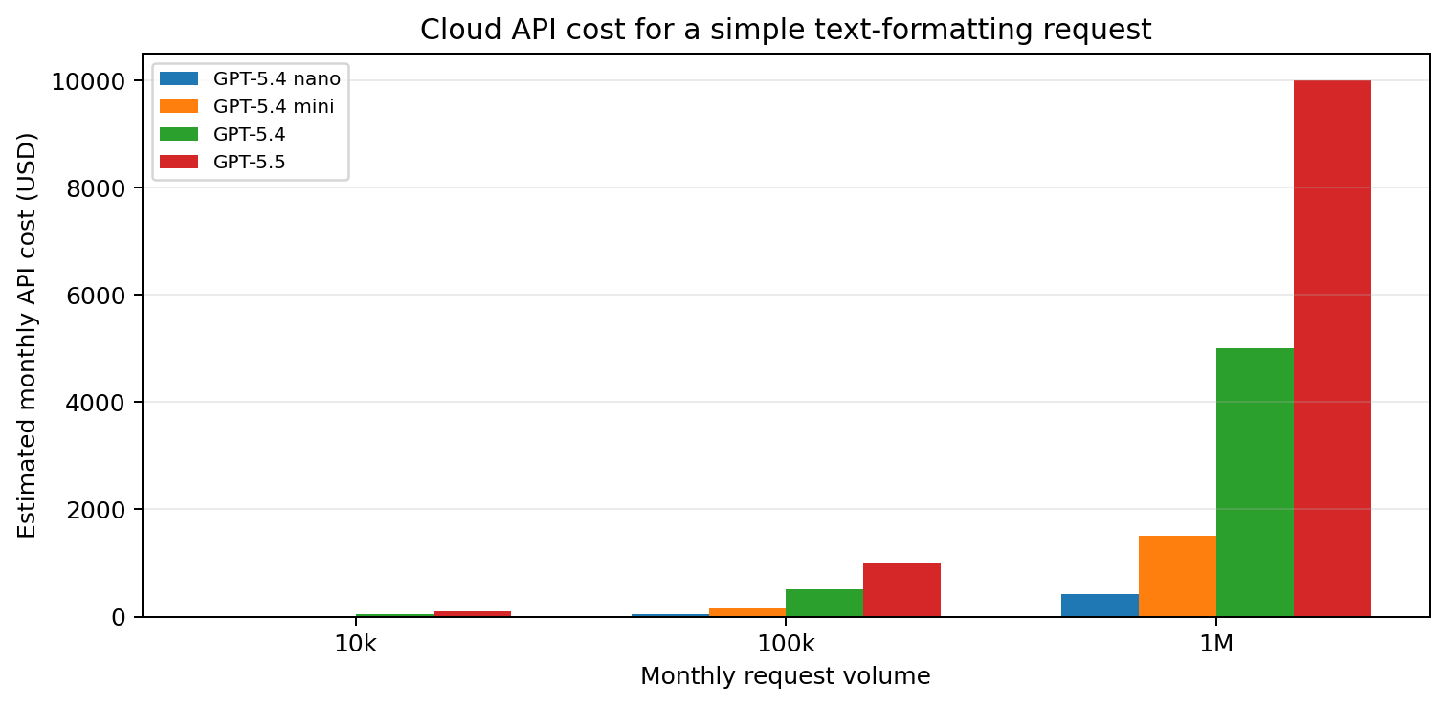

5. Local Hosting Costing
Local hosting has a different cost model. Instead of per-token billing, you pay for hardware, electricity, administration, and reliability work. If you run on your existing Windows laptop, the cost is mainly electricity and the performance limit is your laptop RAM/VRAM/CPU/GPU.
Hosting option | Unit cost | Monthly estimate | Good for | Comment
Existing Windows laptop | Already owned | Incremental electricity only | Personal/internal development | Best starting point.
Office desktop with GPU | One-time purchase | Electricity + maintenance | In-house shared tool | Good if privacy and steady usage matter.
Cloud GPU RTX A5000 | $0.27/hr | ~$65/mo at 8 hrs/day; ~$194/mo at 24x7 | Hosted local/open-source model | Useful only when volume or concurrency justifies it.
Cloud GPU L4 | $0.39/hr | ~$94/mo at 8 hrs/day; ~$281/mo at 24x7 | Hosted local/open-source model | Useful only when volume or concurrency justifies it.
Cloud GPU RTX 3090 | $0.46/hr | ~$110/mo at 8 hrs/day; ~$331/mo at 24x7 | Hosted local/open-source model | Useful only when volume or concurrency justifies it.
Cloud GPU RTX 4090 | $0.69/hr | ~$166/mo at 8 hrs/day; ~$497/mo at 24x7 | Hosted local/open-source model | Useful only when volume or concurrency justifies it.
Important cost insight
For low-to-medium request volume, OpenAI API can be cheaper than renting a dedicated GPU. Local laptop Ollama is cheapest when the laptop is already available and the workload is internal. Dedicated GPU hosting makes sense only when volume, privacy, or latency justifies the infrastructure.

6. Recommended Hybrid Architecture
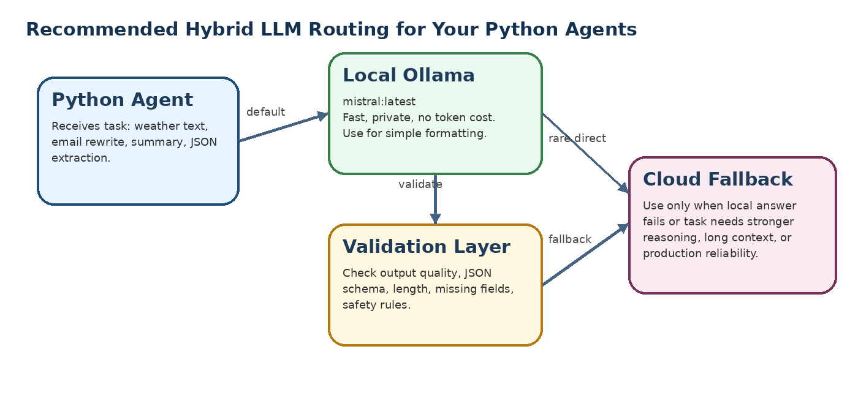
Recommended routing logic:
Task type | Default model | Fallback
Beautify text / grammar correction | Local mistral:latest | Cloud only if response is poor.
Weather response formatting | Local mistral:latest | Cloud rarely needed.
Simple summaries | Local mistral:latest | Cloud if input is long or ambiguous.
JSON extraction | Local mistral:latest + schema validation | Cloud if JSON validation fails.
Business analysis / financial advice | Cloud model | Local only for draft wording.
Long document processing | Cloud model | Use local only for small chunks.

7. Practical Python Agent Configuration
Suggested environment setup for the current use case:
Purpose | Setting
Default local model | OLLAMA_MODEL=mistral:latest
Memory safety on laptop | OLLAMA_MAX_LOADED_MODELS=1
Keep model warm briefly | OLLAMA_KEEP_ALIVE=5m
Pseudo-code routing example:
if task in ["beautify", "format_weather", "simple_summary"]:
result = call_ollama("mistral:latest", prompt)
if validate(result):
return result
return call_openai("gpt-5.4-nano", prompt)
if task in ["complex_reasoning", "financial_analysis", "long_document"]:
return call_openai("gpt-5.4-mini", prompt)

8. Final Recommendation for Your Current Use Case
Recommended default
Use local Ollama with mistral:latest as the default engine for parsing input text and presenting it nicely. Add OpenAI API only as a fallback or premium path. This gives you speed, privacy, and low operating cost while preserving the option to use a stronger cloud model when the task becomes complex.
Decision point | Recommendation
Internal text beautification | Local Mistral
Simple weather response formatting | Local Mistral
Data privacy required | Local / in-house
High accuracy business recommendation | OpenAI cloud
Long context / large documents | OpenAI cloud
Production MVP | Local first + cloud fallback
High-volume SaaS | Benchmark both: local hosting vs cloud tokens

9. Reference Sources Used
Source | URL | Purpose
OpenAI API Pricing | https://developers.openai.com/api/docs/pricing | Used for current per-1M-token pricing examples.
OpenAI GPT-5 model documentation | https://developers.openai.com/api/docs/models/gpt-5 | Used for the token-pricing model and quick comparison context.
Ollama Mistral library page | https://ollama.com/library/mistral | Used for Mistral model details.
RunPod GPU pricing | https://www.runpod.io/pricing | Used for rough GPU hosting prices.
Note: Pricing and model availability change frequently. Re-check provider pricing pages before final production budgeting.

