Mistral on EC2 vs OpenAI API
Side-by-side cost, latency, concurrency and Kubernetes deployment comparison
Recommended local model | mistral:latest / mistral:7b | Best fit for short text parsing, beautification, formatting and simple summaries.
Recommended EC2 VM | g6.2xlarge | 1 NVIDIA L4 GPU, 8 vCPU, 32 GiB RAM; good starting size for Mistral 7B Q4.
Recommended cloud baseline | OpenAI low-cost nano model | Use for fallback, complex inputs, higher accuracy, or when you do not want to operate GPU infra.

Important conclusion: For average requests below 1K tokens, OpenAI nano pricing can be cheaper than running a 24/7 GPU VM. EC2-hosted Mistral becomes attractive when privacy matters, fixed cost is preferred, request size approaches 5K tokens, or traffic is high and steady enough to justify GPU infrastructure.
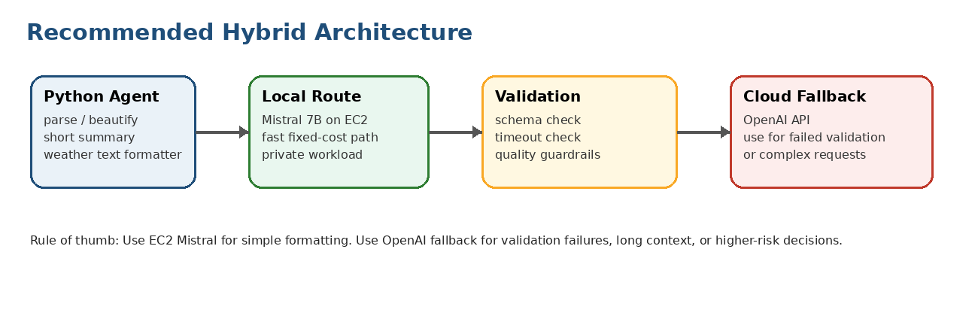

1. Assumptions used for this comparison
Area | Assumption | Why this matters
Task type | Parse input text and present nicely; no deep reasoning required | This is a good fit for a compact model like Mistral 7B.
Average request size | 700 input tokens + 300 output tokens = about 1K tokens/request | Used for the main cost table.
Maximum request size | Up to 5K tokens/request, but usually under 1K | A separate worst-case note is included.
Local model | Ollama mistral:latest / mistral:7b, 7.25B parameters, Q4_K_M, about 4.4 GB | Small enough for efficient GPU serving.
EC2 VM | g6.2xlarge, 8 vCPU, 32 GiB RAM, NVIDIA L4 GPU | A practical starting production VM for Mistral 7B.
EC2 cost | $0.9776/hour, about $703.87/month at 24x7 usage | This is fixed monthly infrastructure cost before storage, data transfer, monitoring, and engineering time.
OpenAI model cost baseline | gpt-5.4-nano style low-cost model: $0.1/1M input tokens and $0.625/1M output tokens | Used to estimate API cost for simple formatting workloads.
Capacity assumption | One EC2 Mistral pod safely handles about 50K requests/day at ~1K tokens/request | Conservative planning number; benchmark before production SLA.

2. Side-by-side cost and latency comparison
Note: Your list repeated 10,000 twice; I treated the second repeated row as 100,000 hits/day because that is the natural scale step between 50,000 and 1,000,000.
Hits/day | EC2 pods needed | EC2 monthly cost | EC2 latency estimate | OpenAI monthly cost (~1K tokens/request) | OpenAI latency estimate | Comment
10,000 | 1 | $703.87 | 1.5-4 sec | $77.25 | 0.5-3 sec typical API range | EC2 underused; OpenAI likely cheaper and simpler.
20,000 | 1 | $703.87 | 1.5-4 sec | $154.50 | 0.5-3 sec typical API range | EC2 underused; OpenAI likely cheaper and simpler.
50,000 | 1 | $703.87 | 2-6 sec near peak | $386.25 | 0.5-3 sec typical API range | One GPU pod is reasonable; benchmark peak load.
100,000 | 2 | $1,408 | 2-6 sec with 2 pods | $772.50 | 0.5-3 sec typical API range | Use load balancer and queue metrics.
1,000,000 | 20 | $14,077 | 2-8 sec with autoscaling | $7,725 | 0.5-3 sec typical API range | Requires GPU node group, HPA/KEDA, monitoring and warm capacity.
2,000,000 | 40 | $28,155 | 2-8 sec with autoscaling | $15,450 | 0.5-3 sec typical API range | Requires GPU node group, HPA/KEDA, monitoring and warm capacity.
3,000,000 | 60 | $42,232 | 2-8 sec with autoscaling | $23,175 | 0.5-3 sec typical API range | Requires GPU node group, HPA/KEDA, monitoring and warm capacity.

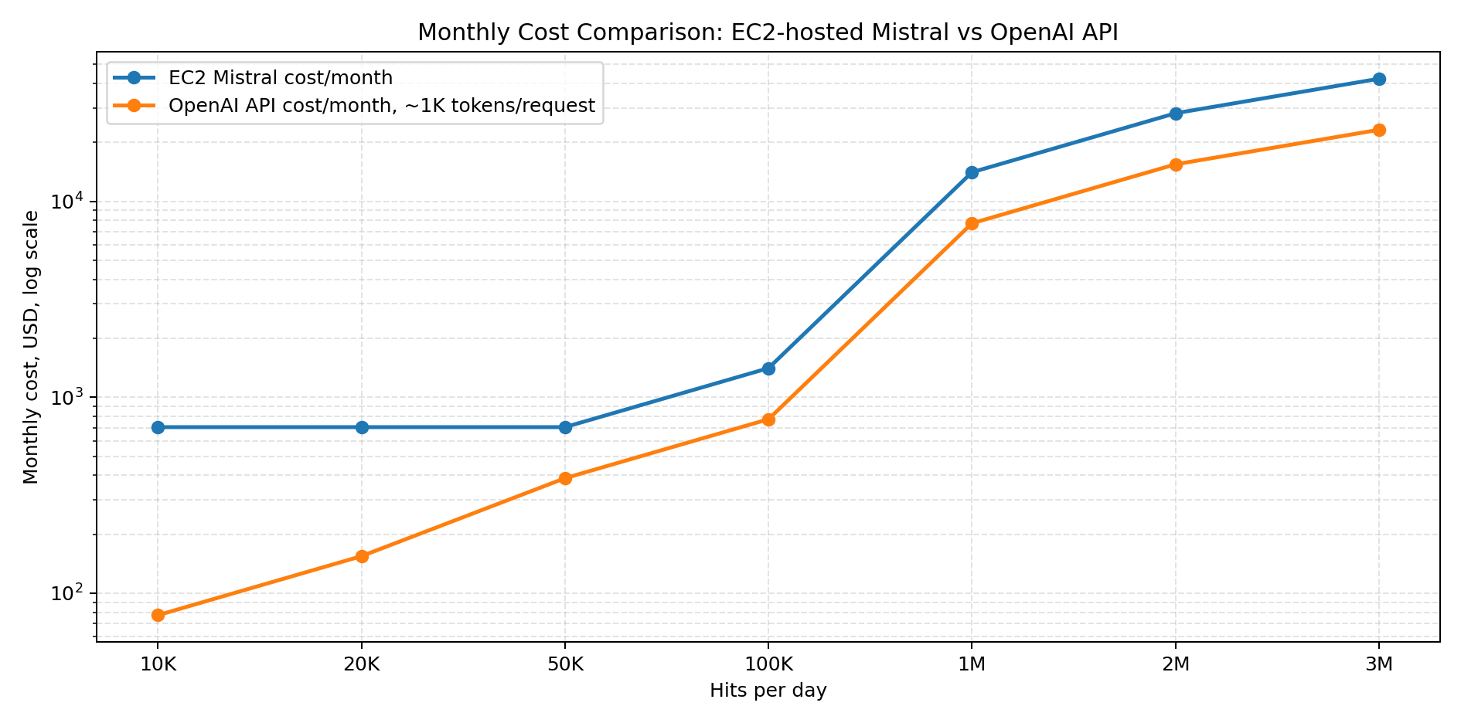

3. If requests are closer to the 5K-token maximum
Interpretation: If requests are consistently closer to 5K tokens, OpenAI API cost increases roughly 5x. EC2 cost also may increase because throughput per GPU drops; assume 10K-20K requests/day per pod until benchmarked for long requests.
Hits/day | OpenAI monthly cost at ~1K tokens/request | OpenAI monthly cost at ~5K tokens/request | EC2 implication for 5K requests
10,000 | $77.25 | $386.25 | Possibly 1 pod, but test parallelism and latency.
20,000 | $154.50 | $772.50 | Possibly 1 pod, but test parallelism and latency.
50,000 | $386.25 | $1,931 | May need 2-4 pods depending on output length.
100,000 | $772.50 | $3,862 | Likely needs multiple pods and autoscaling.
1,000,000 | $7,725 | $38,625 | Treat as a GPU inference platform, not a single VM.
2,000,000 | $15,450 | $77,250 | Treat as a GPU inference platform, not a single VM.
3,000,000 | $23,175 | $115,875 | Treat as a GPU inference platform, not a single VM.

4. Concurrency and throughput estimate for one g6.2xlarge pod
Metric | Recommended starting value | Notes
Active concurrent generations | 4 | Start with OLLAMA_NUM_PARALLEL=4 for short requests. Reduce to 2 for larger context windows.
Queue depth | 512 | Start with OLLAMA_MAX_QUEUE=512, then scale when queue grows.
Safe planning throughput | 30K-50K requests/day per pod | Assumes short formatting requests around 1K tokens total.
High-load optimized throughput | 75K-150K requests/day per pod possible | Possible only after measuring real tokens/sec, prompt size, and latency tolerance.
Long request throughput | 10K-20K requests/day per pod | Use this conservative range when many requests approach 5K tokens.
Recommended Ollama environment settings:
OLLAMA_MODEL=mistral:latest
OLLAMA_MAX_LOADED_MODELS=1
OLLAMA_NUM_PARALLEL=4
OLLAMA_MAX_QUEUE=512
OLLAMA_KEEP_ALIVE=30m
OLLAMA_FLASH_ATTENTION=1

5. Kubernetes / pods / autoscaling recommendation
Question | Recommendation
Can it run in Kubernetes? | Yes. Run one Ollama/Mistral inference pod per GPU-backed node or one GPU per pod.
Can it autoscale? | Yes, but GPU scaling is slower than CPU/web scaling because nodes and models must warm up. Keep at least one warm pod.
Best scaling metrics | Queue length, p95 latency, GPU utilization, request timeout rate, and tokens generated per second.
Pod resource request | Request one GPU, for example nvidia.com/gpu: 1, and pin one model per pod for predictable memory.
Model loading strategy | Pre-pull the model into the image or use an init container / persistent volume cache. Avoid cold model downloads at startup.
Production pattern | API Gateway -> Load Balancer -> Mistral service -> model pods; fallback to OpenAI if timeout or validation fails.

6. Decision matrix
Situation | Better choice | Reason
Development and local testing | Laptop Ollama + Mistral | Free to experiment and fast enough for prompt tuning.
Production under 20K hits/day, 1K tokens/request | OpenAI API | Likely cheaper and much simpler than a 24/7 GPU VM.
20K-50K hits/day with privacy requirement | EC2 Mistral | Fixed cost and data stays inside your environment.
Requests often close to 5K tokens | EC2 Mistral becomes attractive | Cloud token cost rises roughly with token volume.
Customer-facing SLA with unknown traffic | OpenAI API or hybrid | Less operational burden and easier scaling.
Need deterministic JSON / strict format | Hybrid | Local first, validate, fallback to OpenAI when validation fails.
Complex reasoning or business advice | OpenAI stronger model | Mistral 7B is not ideal for deep reasoning.

7. Recommended architecture for your Python agents
Recommended path: Use local Mistral for the normal fast path, and keep OpenAI as fallback for validation failures, complex requests, or higher-risk responses.
Routing rule: If the request is simple formatting and below ~5K tokens, send to Mistral. If it times out, fails schema validation, produces poor output, or requires reasoning, send to OpenAI.
Request -> Mistral on EC2 -> Validate -> Return if good -> Fallback to OpenAI if bad/timeout/complex

8. Sources and notes
• OpenAI API Pricing page, current model token pricing and tool pricing: https://developers.openai.com/api/docs/pricing
• Ollama Mistral 7B page, model size, quantization and v0.3/latest notes: https://ollama.com/library/mistral:7b
• AWS EC2 G6 instance family page, NVIDIA L4 GPU family details: https://aws.amazon.com/ec2/instance-types/g6/
• Vantage AWS EC2 g6.2xlarge price/spec page used for simple on-demand monthly estimate: https://instances.vantage.sh/aws/ec2/g6.2xlarge
• Ollama FAQ, concurrency, queue, keep-alive, and GPU loading behavior: https://docs.ollama.com/faq
Caution: All costs are approximate planning numbers. Actual OpenAI costs depend on exact input/output tokens, selected model, cached tokens, batch/flex/priority mode, region/data residency, and tool calls. Actual EC2 costs depend on AWS region, reserved/spot pricing, EBS, data transfer, monitoring, load balancers, engineering time, and autoscaling behavior.

