TECHNICAL PROJECT REPORT

# Title of Invention / Project: Water Dispenser

# Team Members / Inventors:

|  |  |  |  |  |  |
| --- | --- | --- | --- | --- | --- |
| **S.No.** | **Name** | **Department** | **Designation** | **Mobile** | **E-Mail** |
| 1. | Gaurav  Sharma | CSE(MC) | Student | 9425723617 | kvsgaurav@gmail.com |
| 2. | Ujjwal singh | CSE(MC) | Student | 8887149859 | Ujjwalcu.mc@gmail.com |
| 3. | Arham | CSE(MC) | Student | 8847539318 | arhamaggarwal102@gmail.com |
| 4. | Vishal | CSE(MC) | Student | 6397963717 | [Vishuchaudhary1742000@gmail.com](mailto:Vishuchaudhary1742000@gmail.com) |
| 5. |  |  |  |  |  |
| 6. | Khushal Thakur | ECE | Mentor | 9646030764 | khushal.thakur@cumail.in |
| 7. | Anshul Sharma | ECE | Mentor | 9478697475 | anshulsharma.ece@cumail.in |
| 8. | Kiran Jot Singh | ECE | Mentor | 9463909689 | kiranjotsingh.ece@cumal.in |
| 9. | Divneet Singh Kapoor | ECE | Mentor | 9878422653 | divneet.ece@cumail.in |

Section – 1 (IPR Related)

# Problem we are solving:

We see in our daily life that calculation of huge distance of field is too frusteded by meter tape when field is very large. We see in our daily life that calculation of huge distance of field is too frusteded by meter tape when field is very large.But with our project the person simply hold the stick in his hand and walk in that particular plane to calculate the length of the field which he/she desire to .

# Brief Abstract (500 words):

We see in our daily life that calculation of huge distance of field is too frusteded by meter tape when field is very large.

But with our project the person simply hold the stick in his hand and walk in that particular plane to calculate the length of the field which he/she desire to .

Our product is having a simple and easy to handle the flexible wheel which calculate the distance for you. In our project we have I.R. Sensor which calculate the no of the rotation of the wheel. The wheel having the circumference of 10 cm and so100/10 give 10 . so to calculate the no of we can easily calculate the distance by the wheel of the field.

component in our project . the ir sensor which calculate the no of rotation.The wheel which is used to give input to the ir by it's no of revolution.The stick wich makes the body of the complete product.The arduino which brain of the project and do the all logical part and all the other control part.The blue tooth which give data to smart phone to diplay the distance.

We no need any inch tape or rope to calculate the distance. we can do it by simply walking.

# Existing state-of-the-art and Drawbacks in existing state-of-the-art

(*Brief background of the existing knowledge*)

|  |  |  |
| --- | --- | --- |
| **S. No.** | **Existing state of art** | **Drawbacks in existing state of art** |
| 1 | Distane display on the lcd. | It doesn’t send any message to the phone. |

# Additional modifications that you can propose to improve upon drawbacks

*(List down the features)*

* Feature 1: we use Bluetooth module to send data to the phone.
* Feature 2: this send data can be use for any further reference.

Advantages

(*List down the advantages, if each feature is incorporated)*

* Adv 1 Person don’t need any repetition by the small tape to measure the distance.
* Adv 2 Easy the use and comfortable while walking.
* Adv 3 Can calculate any measure of distance while walking.

# Block Diagram

(*Functional diagram depicting the flow of information in your system. Do not define exact components, only use generic terms. Must include modifications as well.)*

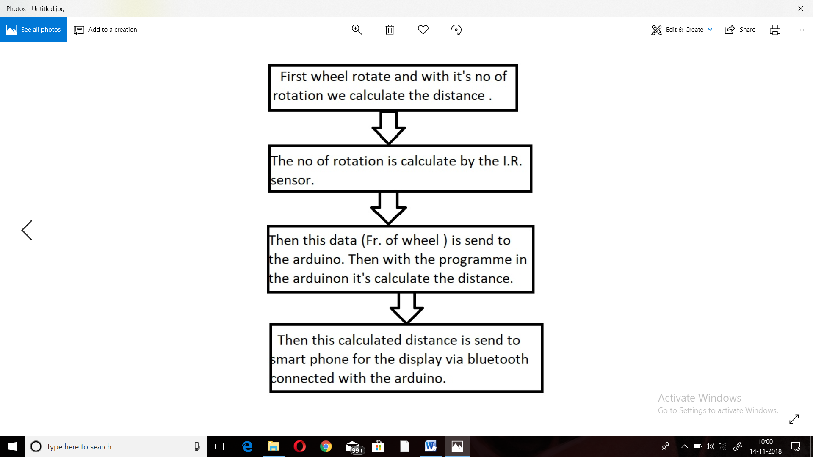

Section – 2 (Real Project)

# Materials

(*List down the Components, Equipment, etc. actually used in the project*)

COMPONENTS QUANTITY

Arduino uno 1 piece I.R. Sensor 1 piece

Bluetooth module 1 piece of each Wheel (1 pcs) 1 piece

Stick 2 piece Connecting wires 12 pieces

# Circuit Diagram

(*Fully functional circuit diagram with exact connections. Can use Fritzing/Proteus*)

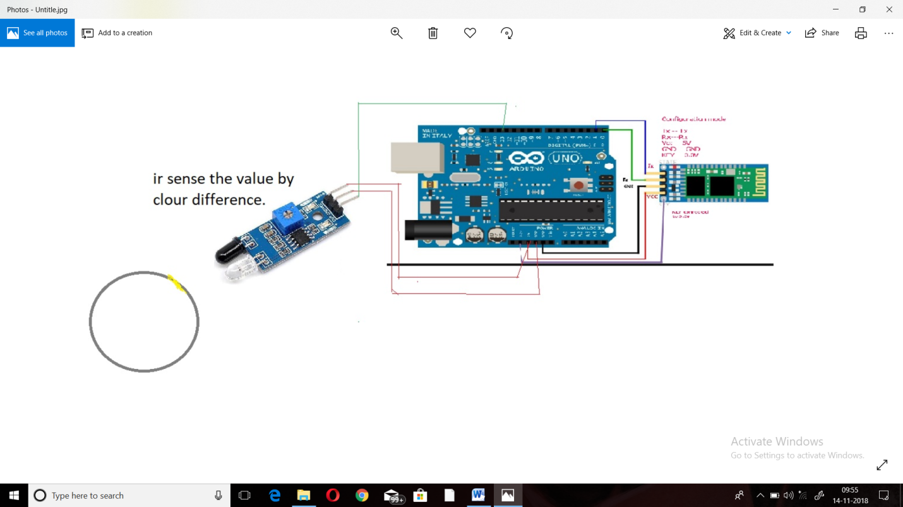

# Steps of Circuit Completion

(*Bifurcate the circuit completion in steps, specify with photographs, leading to final project*)

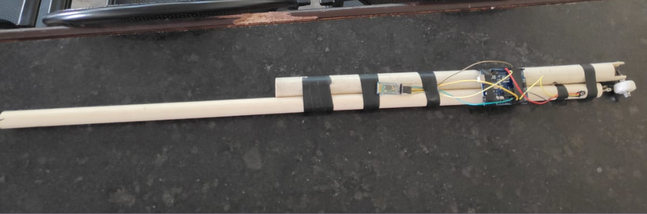

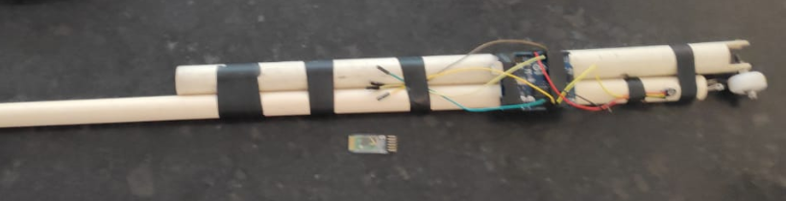

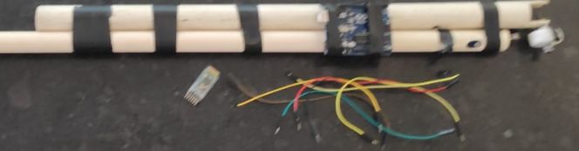

Step 1- Connect Vcc, grd, out, of I.R. sensor to 5v, Gnd, pin 13, of arduino respectively.

Step 2- - Connect Vcc, grd, R.X.,T.X. of Bluetooth to 5v, Gnd, pin 10 T.X.,11 R.X., of arduino respectively.

Step 3- Connect arduino to power sources.

# Program Code

(*Link of your Github project*)