# Create Employee

Create employee is simple project contains 2 forms. One for create employee and other is to show employees list. To build UI, we used angular and bootstrap. Django used as backend service. Created RestAPI using Django rest-framework. Angular can interact with this rest services to insert and retrieve data from backend.

**UI:** Angular and Bootstrap

**Backend:** Django

### Get list of employees (RestAPI)

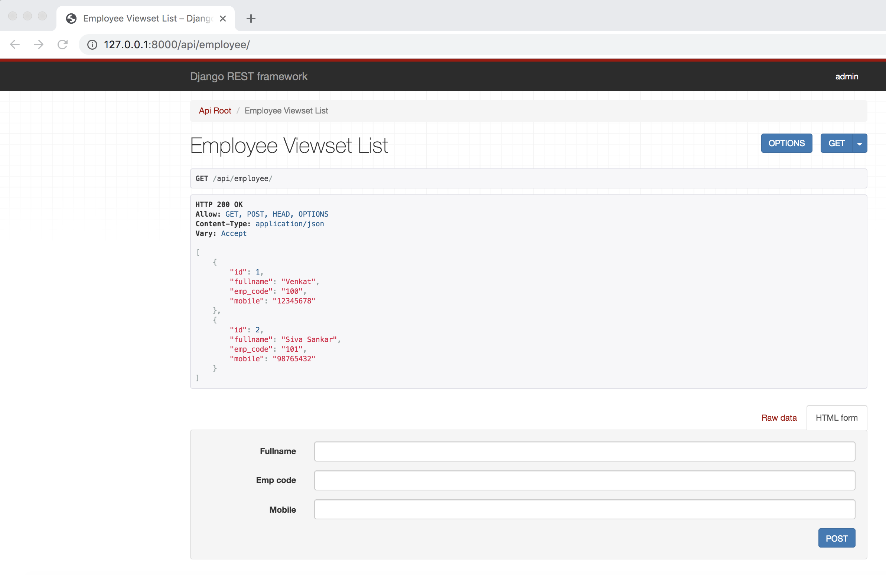

### Get specific employee with ID

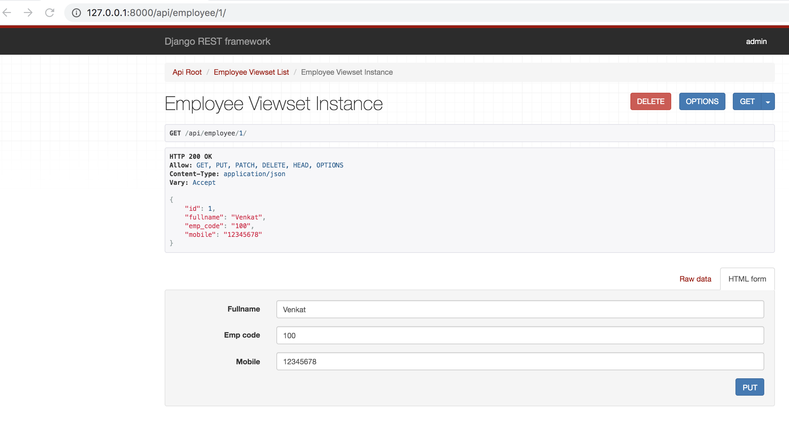

## Admin interface

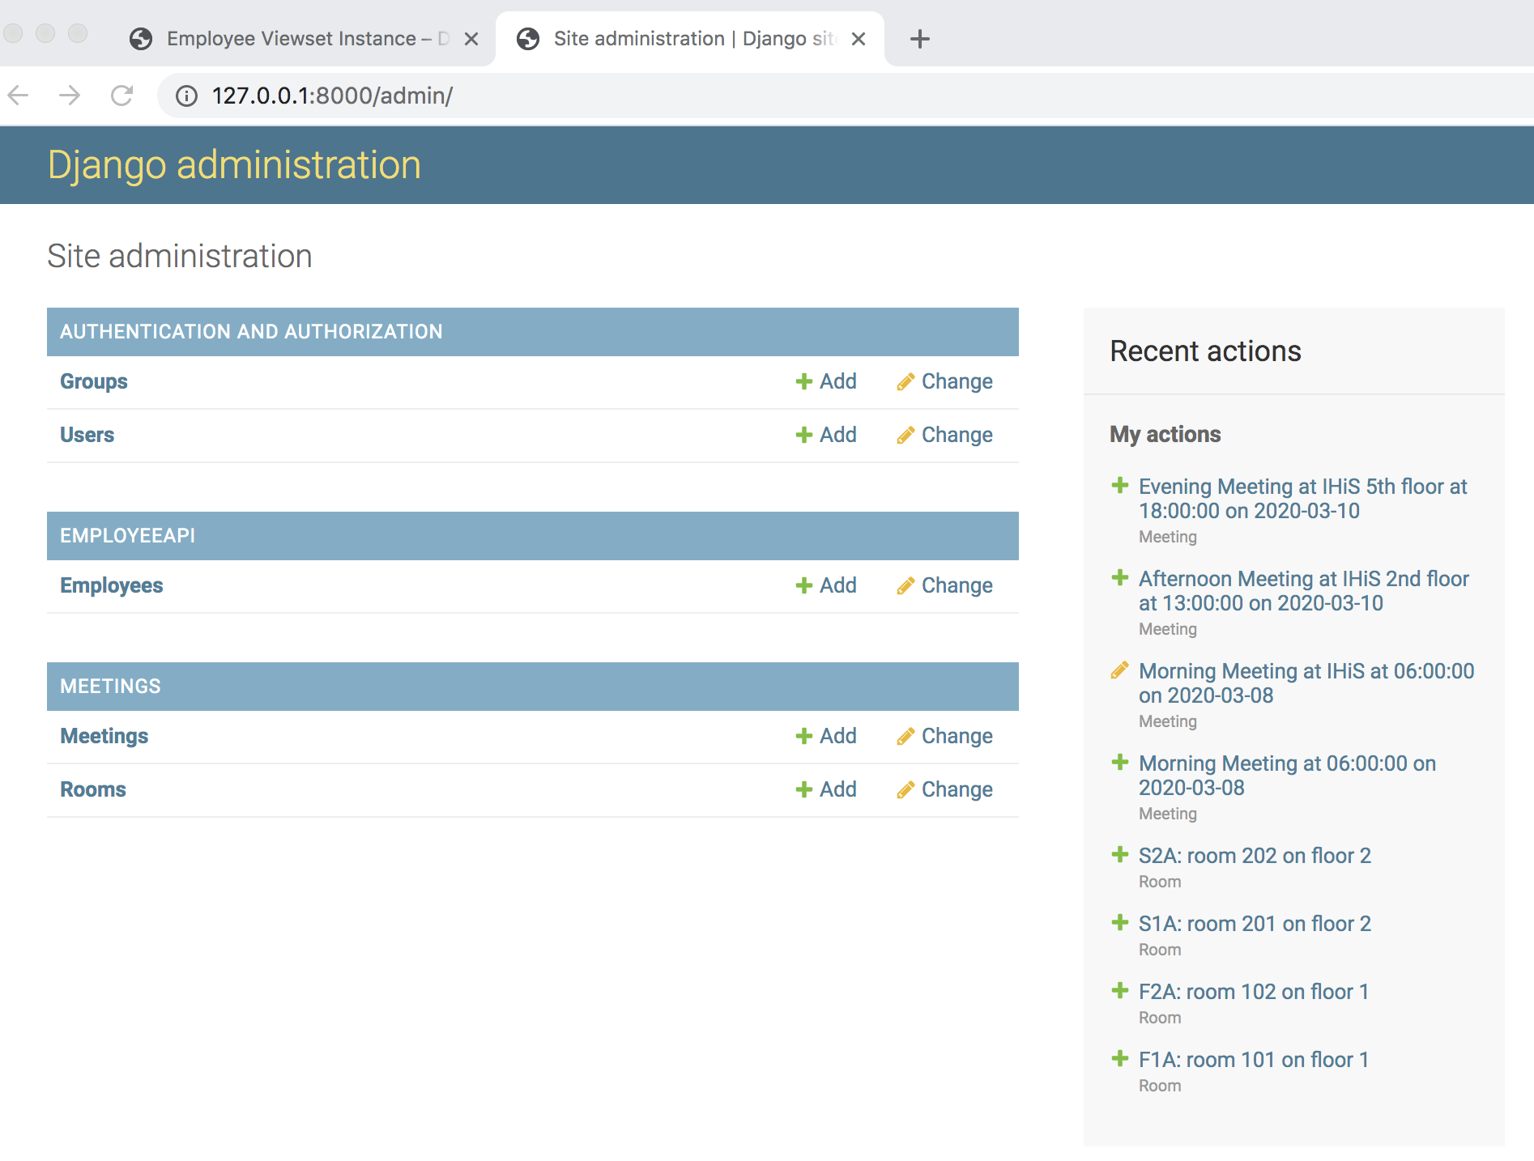

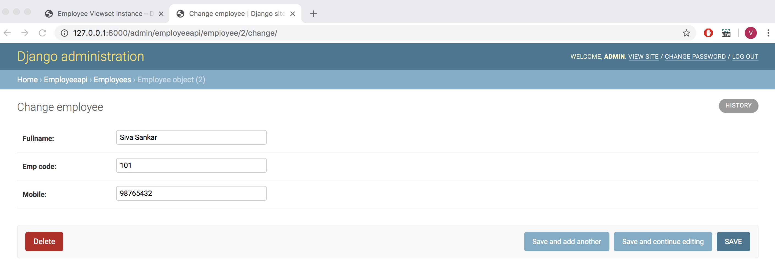

## Create new employee

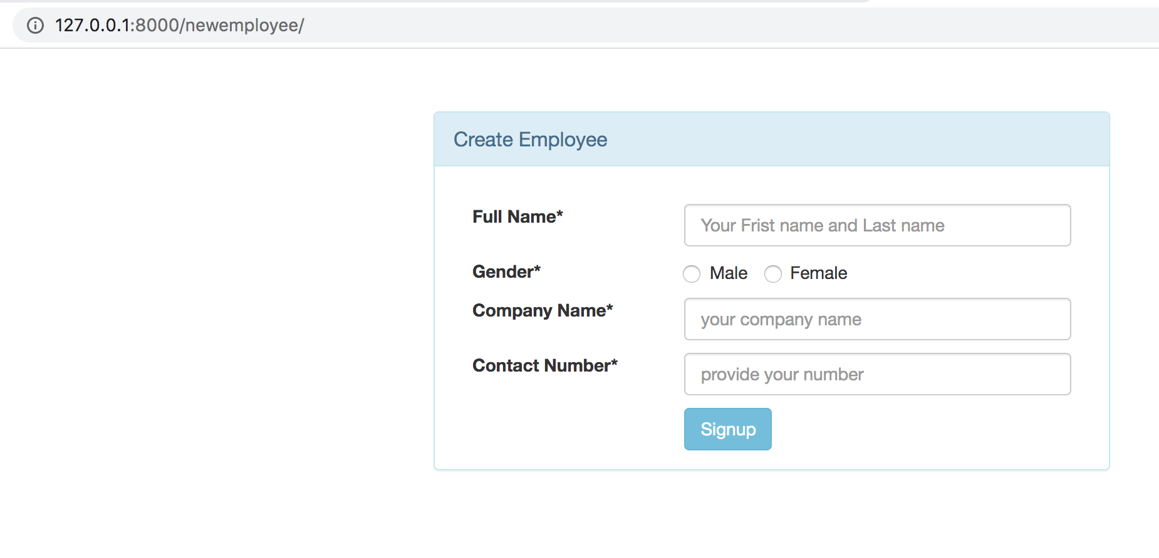

## Show list of employees

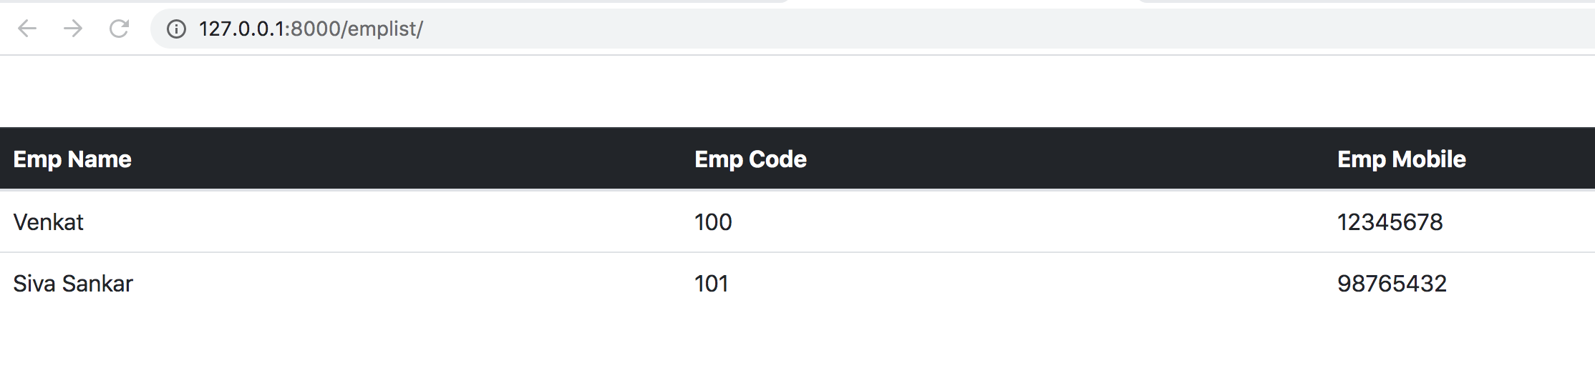

## Project structure

