Certification Project – DevOps

Solution -

I used GCP (Google Cloud Platform) for VM instances. I created a new project in GCP and set firewall rules.

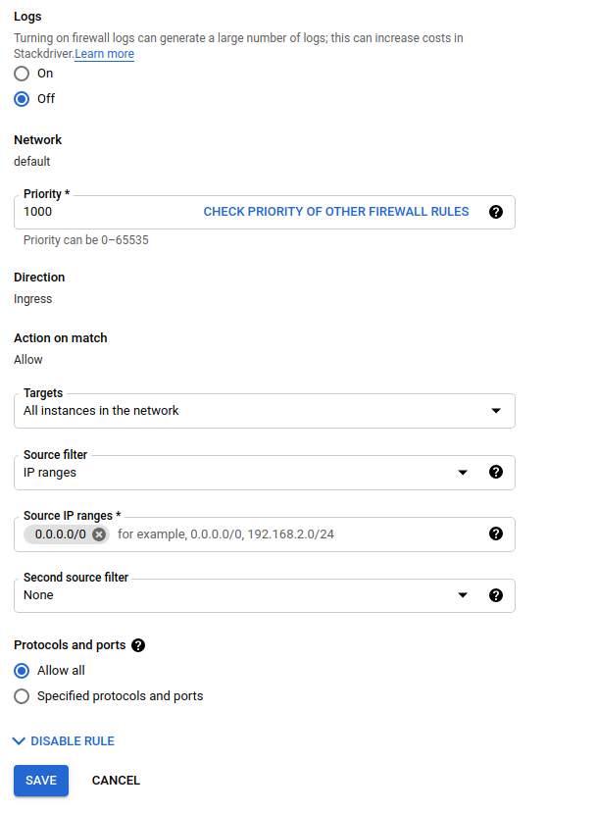

I created 3 VM instances in this project, e2-medium (2 vCPUs, 4 GB memory), ubuntu-1804-bionic-v20201211a, size – 10GB
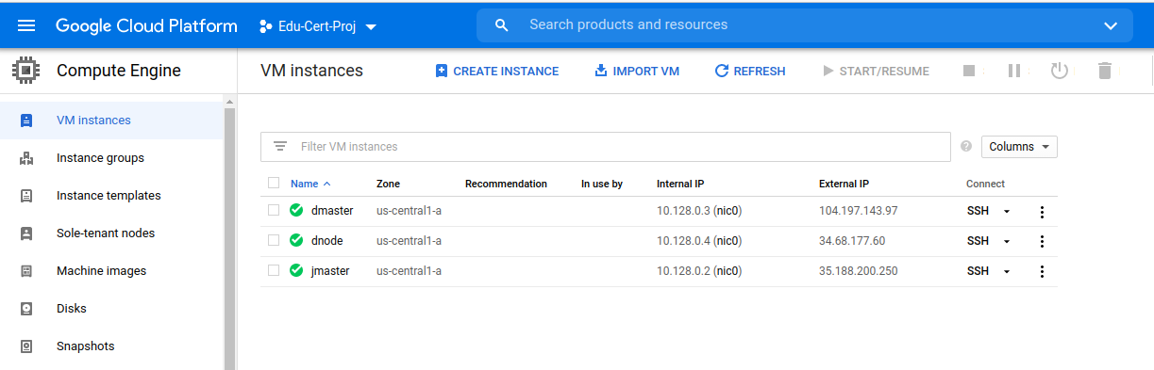

1st Instance – jmaster
logged in to jmaster using ssh as a root user and installed java, jenkins, docker and ansible
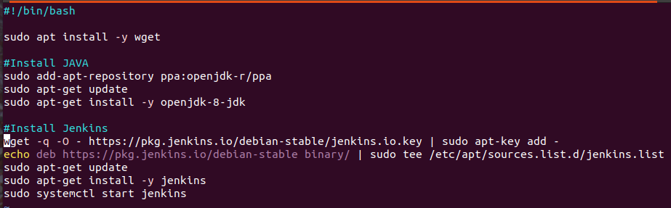

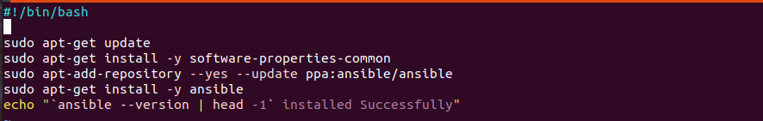

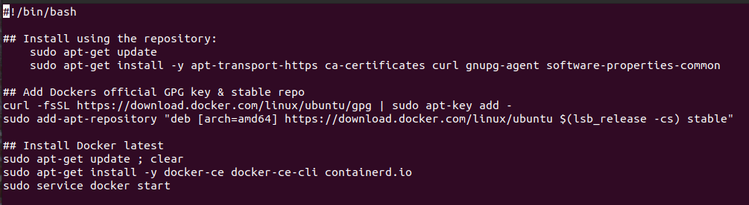

In jenkins created 2 new jobs “mypackage” & “deployq”

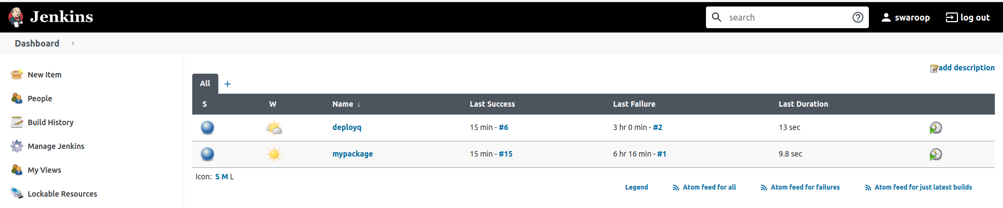

In “mypackage” job, first fetch the php website from https://github.com/kvswp/projCert,
add jenkins user to docker group and sudoers
then create a dockerfile and generate image,
after that push that image to dockerhub “kvswp/website”w
p/website

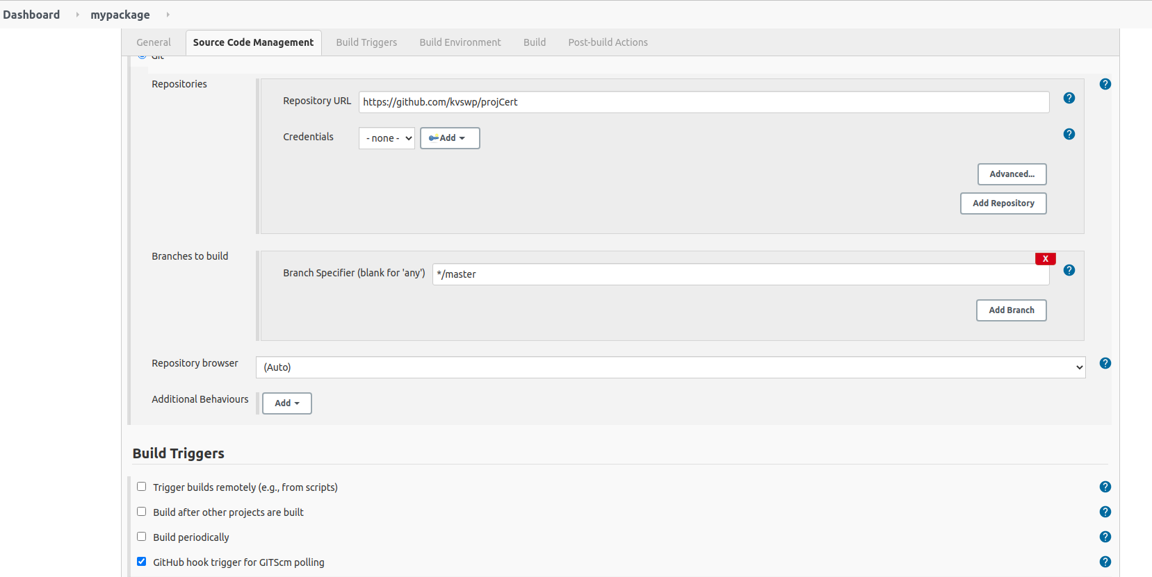
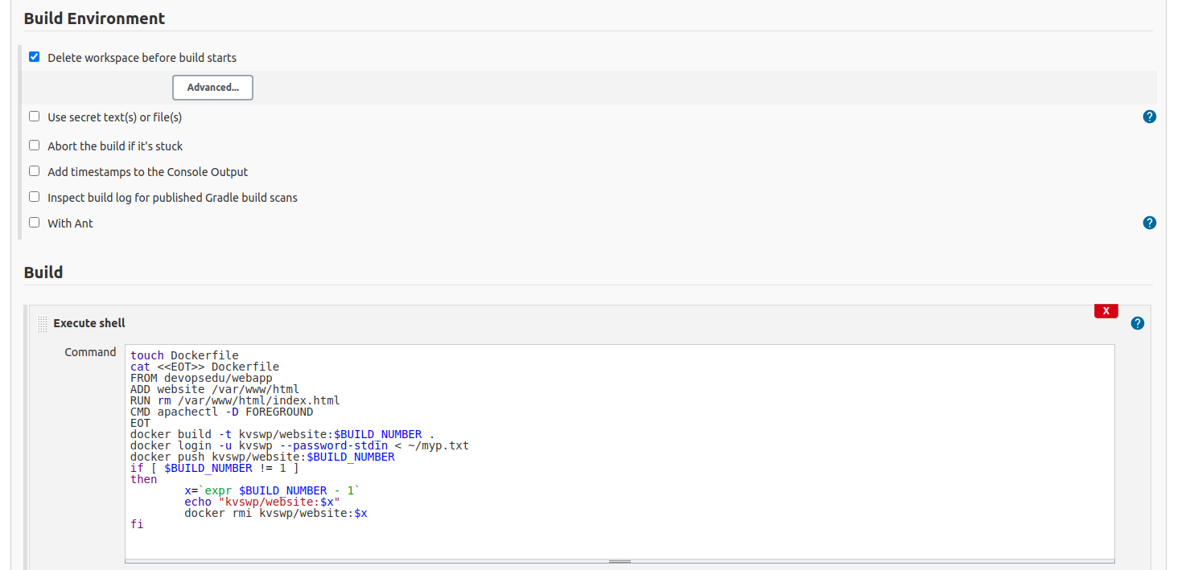

once the docker image available in dockerhub, login to both Vms and setup a user on both instances, so that

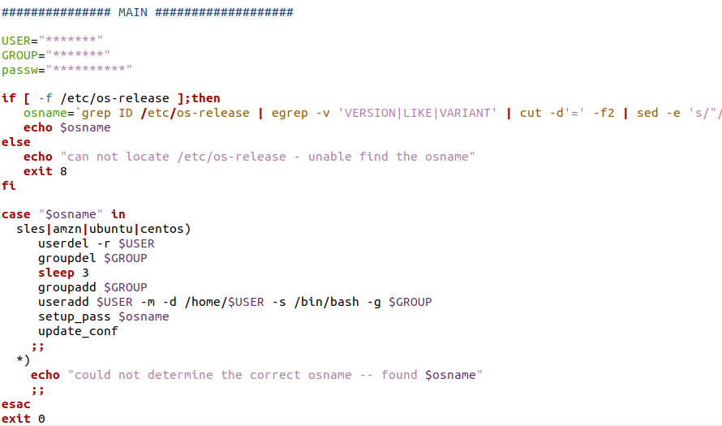

configure ansible in jmaster VM instances
vi /etc/ansible/hosts
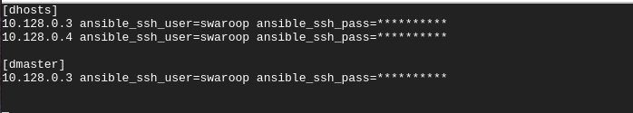
vi /etc/ansible/ansible.cfg
host_key_checking = False

Created playbooks for installing java and docker on 2 VM instances

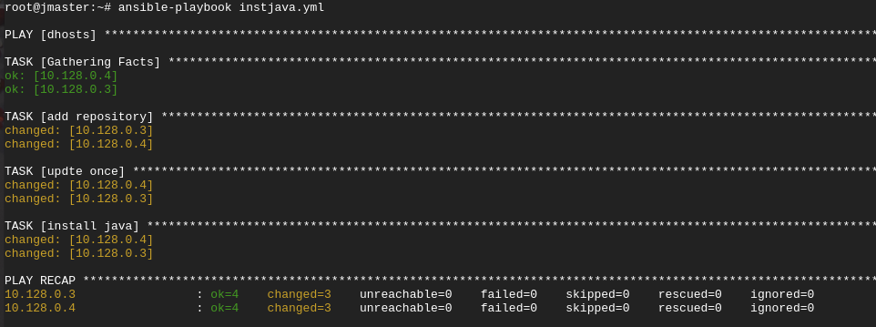

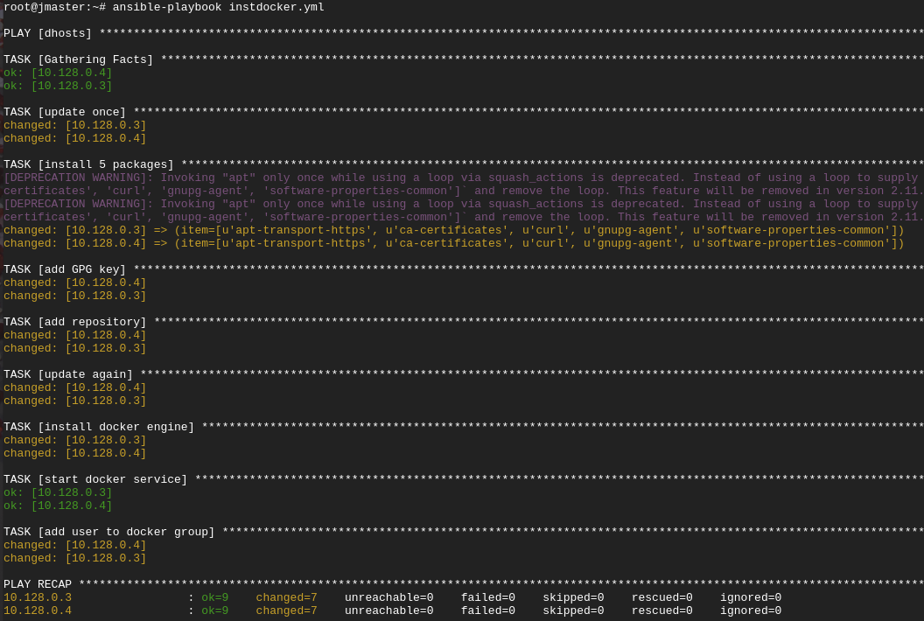

login to “dmaster” VM instances, and initialize it as swarm manager

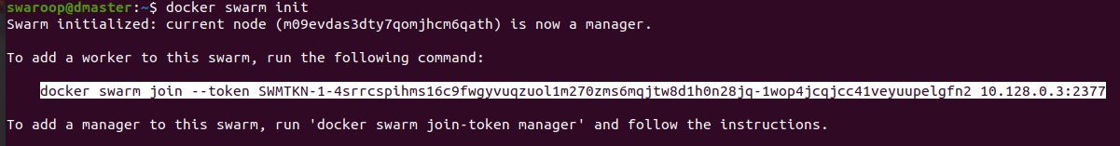
login to “dnode” VM instance and run swarm join

verify it on “dmaster” instances
create a deploy directory under /opt in “jmaster” VM instance, and chage the ownership to jenkins user

install following jenkins plugins – ansible, build with parameter & parameterized trigger

under /opt/deploy create a ansible playbook for website app deployment

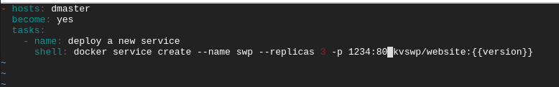
modify mypackage job
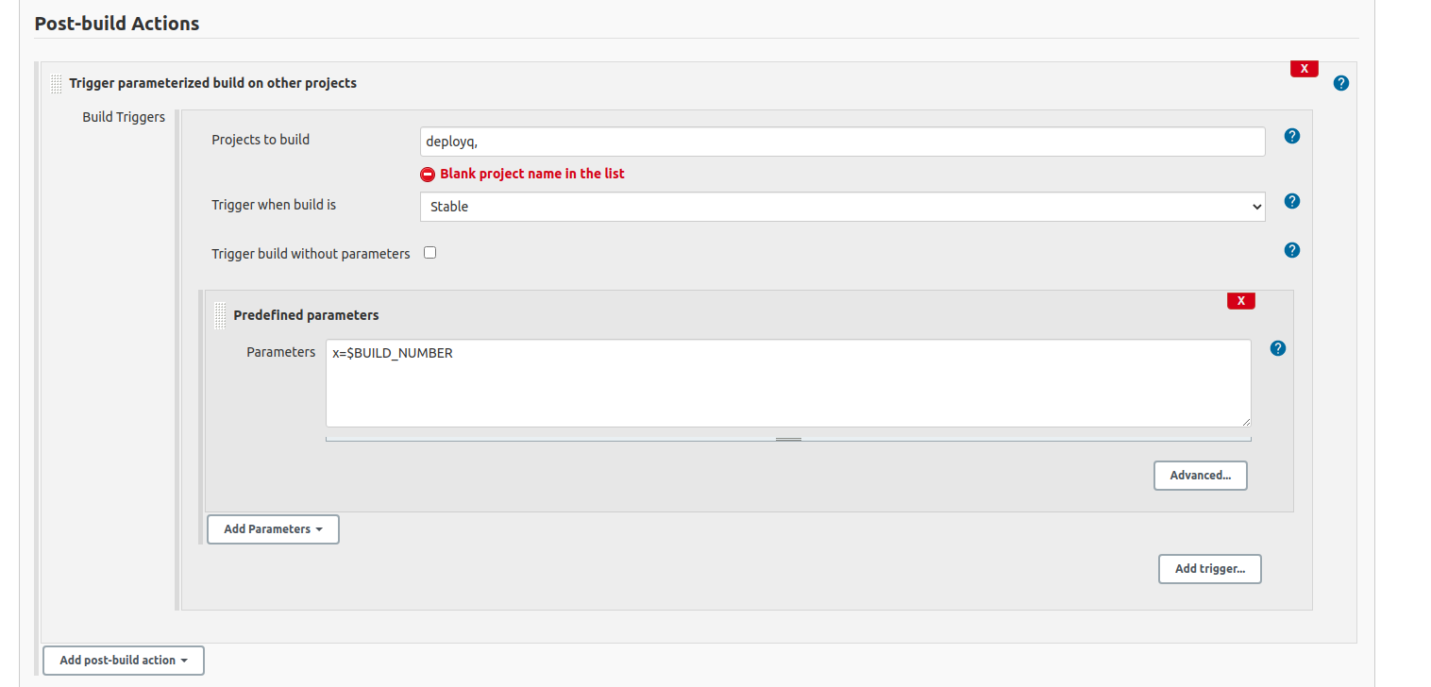
Configure deployq job
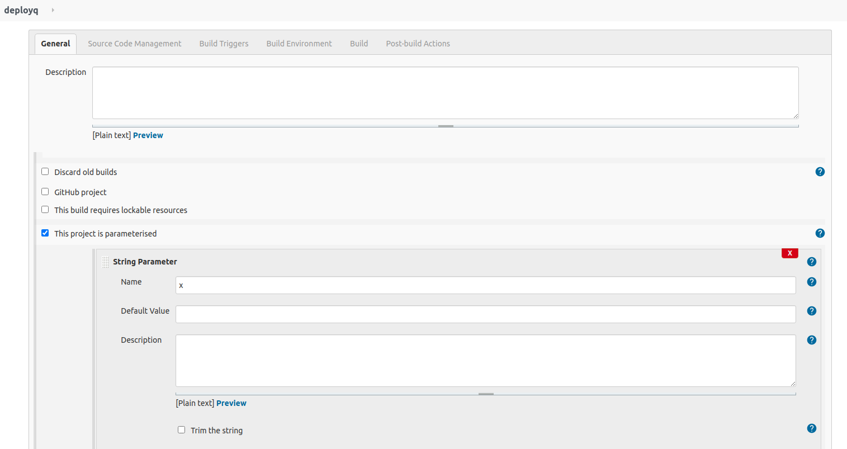
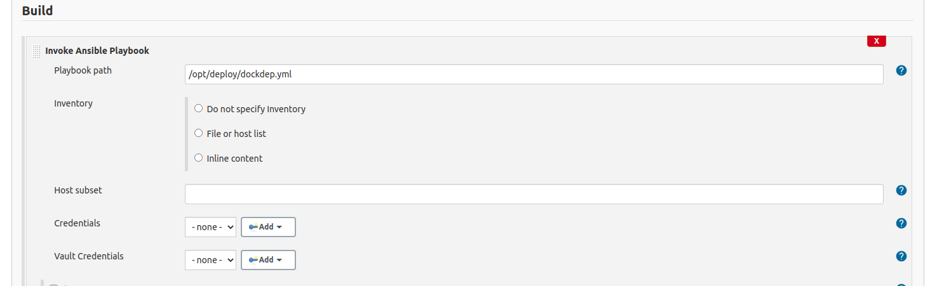

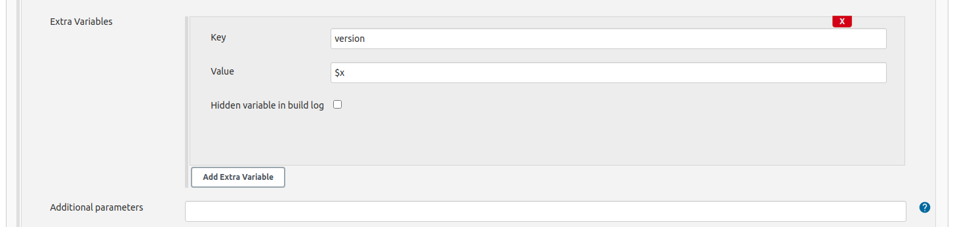

As complete setup us in place, i validated this by making changes in https://github.com/kvswp/projCert/blob/master/website/readme.md, mypackage job triggerd followed by deployq


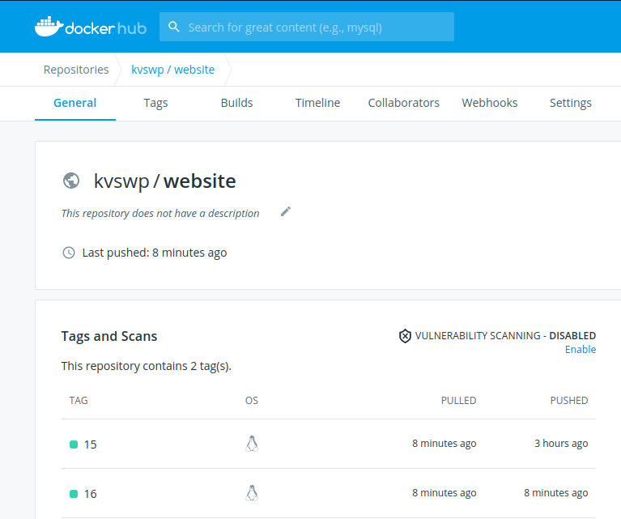

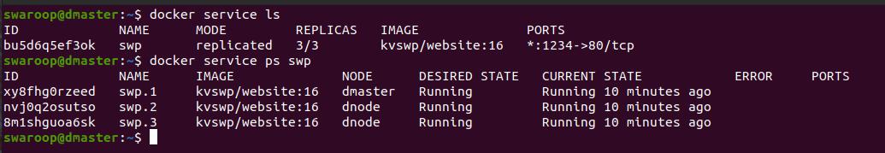
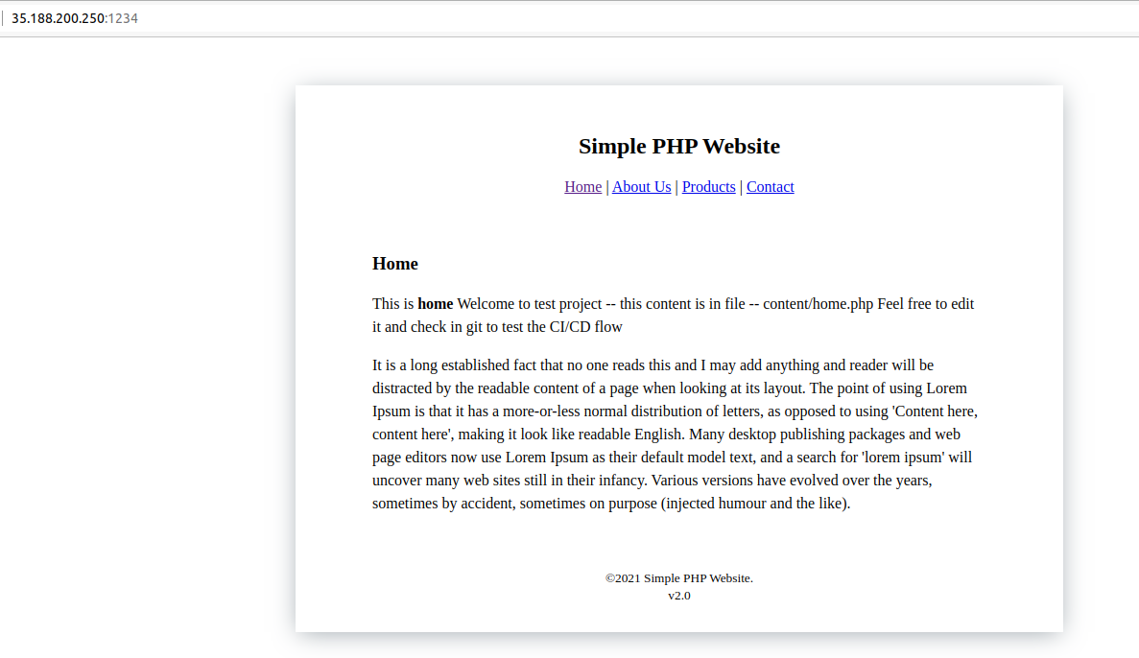

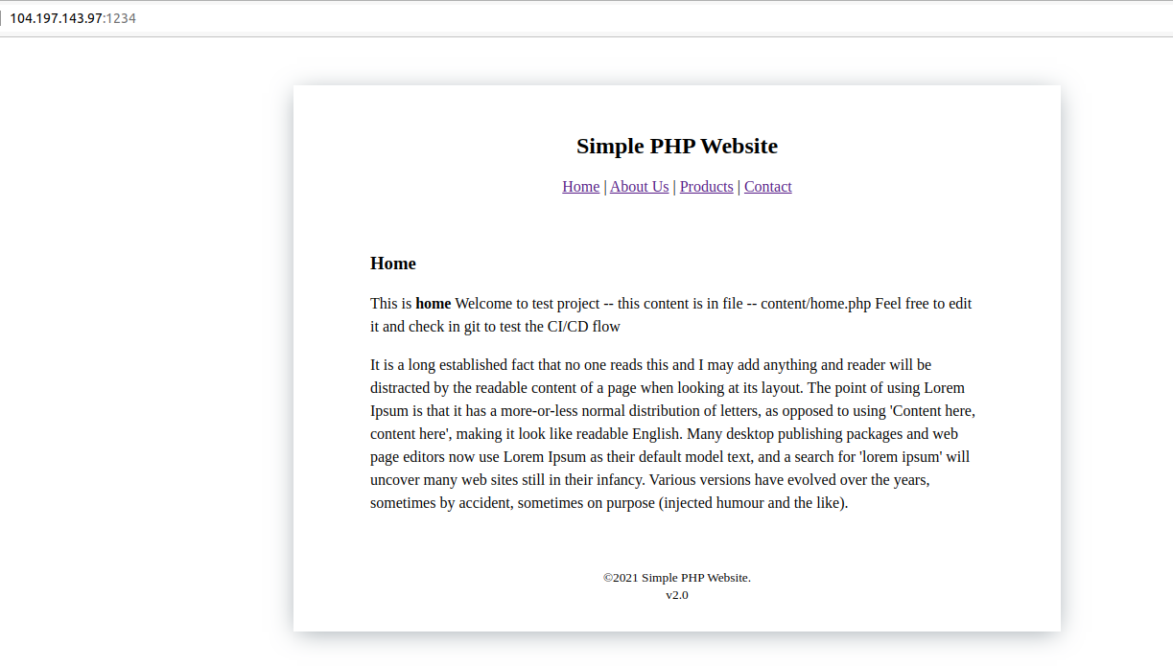
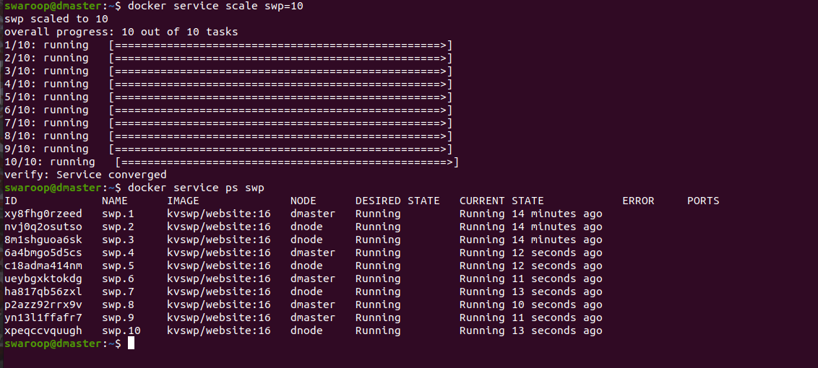

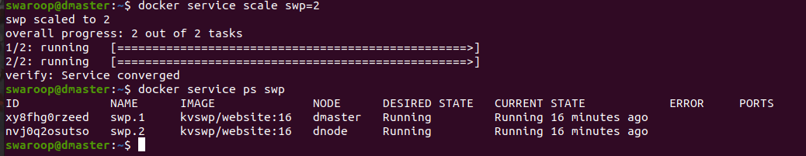
I deployed php app using docker service using jenkins as automation server, and used ansible for configuration management. I able to access the deployed app over the browser, i able to scale up and scale down the app based on requirement .

