Schlick 1
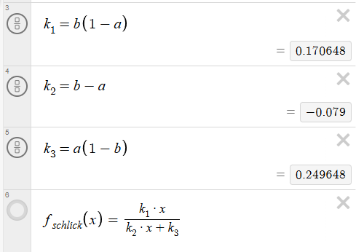
a | b | Result
a = 0 | b = 0 | Linear
a = 0 | 0 < b < 1 | 1
a = 0 | b = 1 | 1
0 < a < 1 | b = 0 | 0
0 < a < 1 | 0 < b < 1 | f_schlick(x)
0 < a < 1 | b = 1 | 1
a = 1 | b = 0 | 0
a = 1 | 0 < b < 1 | 0
a = 1 | b = 1 | Linear

Schlick 2
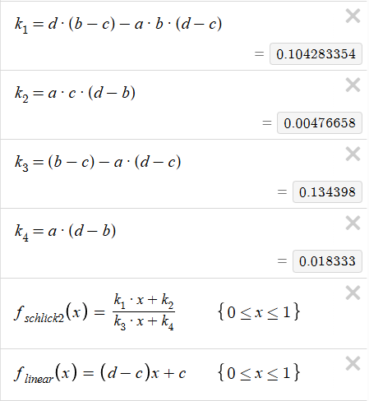
We define the following constraint for b, c, and d:
$$c≤b≤d$$
This makes the edge case handling for Schlick2 like Schlick1.
a | b | Result
a = 0 | b = c | Linear
a = 0 | c < b < d | d
a = 0 | b = d | d
0 < a < 1 | b = c | c
0 < a < 1 | c < b < d | f_schlick2(x)
0 < a < 1 | b = d | d
a = 1 | b = c | c
a = 1 | c < b < d | c
a = 1 | b = d | Linear

