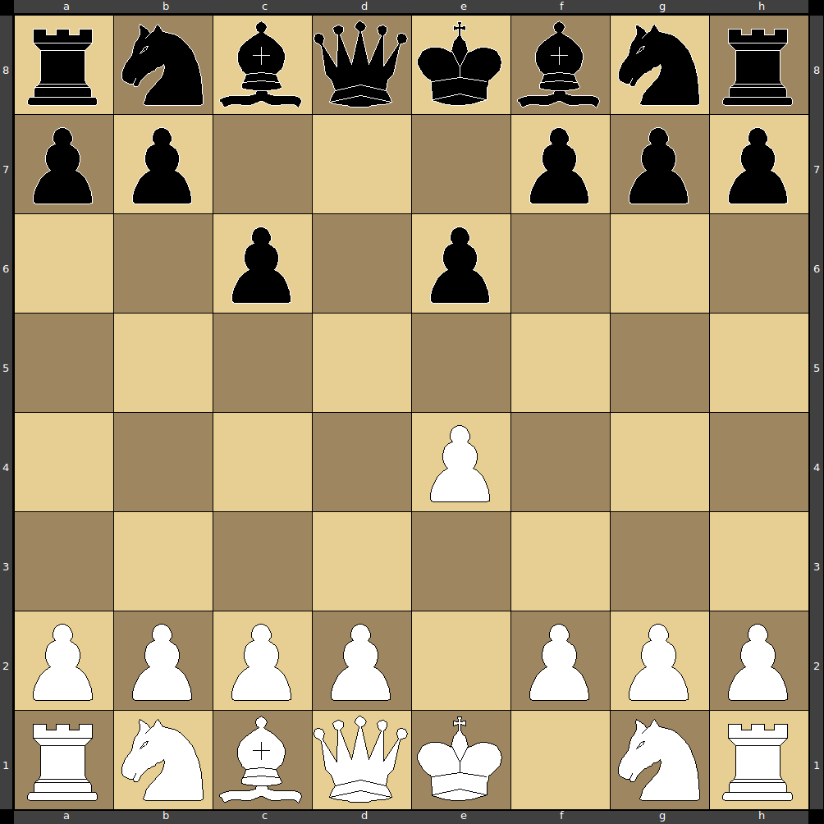
Chess issue
8 moves are done (4 steps by each player). Reproduce the flow of the game.

