Deadly Sea Battle (DSB) — AI competition
DSB program is aimed to find the best algorithms available for humans for placing and shooting boats in classic “sea battle” game. AI algorithms compete against each others to find the most optimal way for defeating your enemy in this game. Approaches like neural networks cannot be recognized by humans and are out of the scope.

Sea battle game classic rules
Classic “Sea battle” rules are:
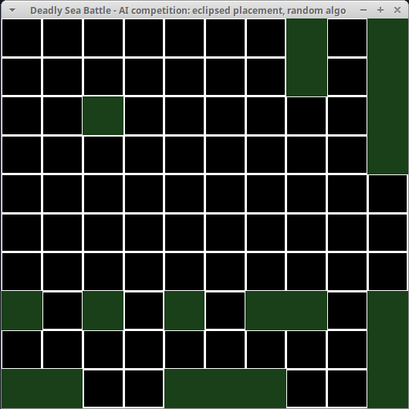
Figure 1: Example of boats placement with classical rules
1. Field size is 10x10
2. There are 10 boats on the field for each player:
- One 4-sized
- Two 3-sized
- Three 2-sized
- Four 1-sized
3. Boats are placed without inter-crossing and “no adjacent boats” rule must be satisfied.

4. Each player choose the location for shooting on his/her turn, the result of each shoot is one of:
- Missed
- Harmed a boat
- Completely killed a boat
5. The game is won when all boats are killed

Possible deviations to classic rules
DSB program is able to operate with field of larger size (up to 58x58) – this is quite useful to test newly developed algo. However the size is always square (width=height).
Currently different amount of boats and non-classic shoots (like shooting all cells in a raw/column) are not supported.

Coords notation
Coordinates of cells on the field are the pair of two non-negative integers (x,y) where x is horizontal location counted from the left to right, y is the vertical location from the top to bottom. Coordinates start from 0, so (0,0) is a left-top corner and (9,0) is the right-top corner of 10-sized field.

AI competition rules
There are two types of AI (computer-driven algorithms):
- Boats placement AI (placement) – the manner of all boats distribution over the empty field of given size to survive enemy fire for the most possible shots
- Boats shooting AI (algo) – the way of choosing the next shooting cell in the most efficient way to kill all enemy boats in the least possible shots
Single match is played as a half of classic sea battle game (only one field with boats, placement AI distributes them in the beginning of the match and shooting AI tries to defeat all boats I the fastest way). Specified AIs pair (placement/algo) play very many matches against each other in a row to get a statistics metric. Currently the only metric of AI efficiency in the match is: average amount of shots to kill all boats on the field. The more faster all boats are killed in average - the better is shooting algorithm and the worse is the placement. ‘Amount of shots to win’ can change in the range [20..100] for standard 10x10 field (20 is the total amount of all boats’ cells required to be killed for win, 100 is the total amount of field’s cells for the most unlucky scenario), so the average is a floating-point value in the same range. For the purpose of more precise statistics we have a distribution of “Amount of shots to win” across all matches showed in the end of the program (Figure 2).
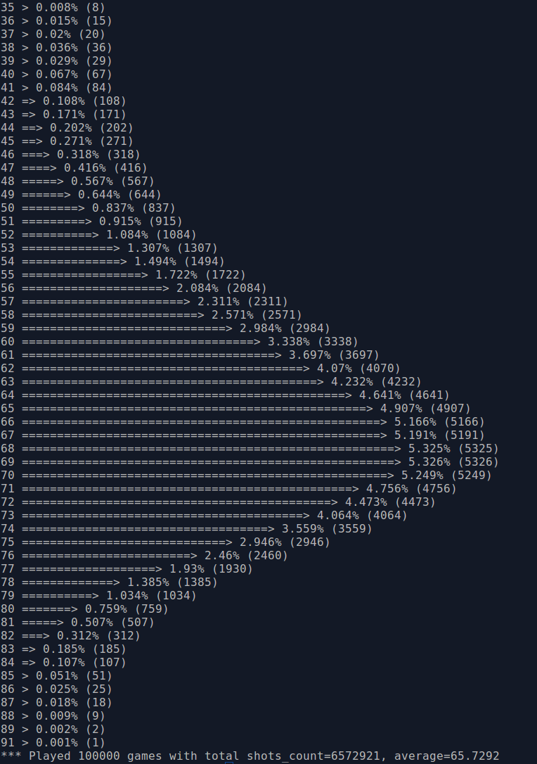
Figure 2: Distribution of amount of shots across all matches, random shooting algorithm
However certain pairs of placement/algos AIs can give extremal results (for poor placement the shooting AI can win too fast and for poor shooting the placement AI can survive very long). Thus to avoid fake results we use special averaging method:
- Placement AI is scored as the worst scenario over all possible average results of shooting algo (minimal amount of [shots per shooting algo in average to kill all boats])
- Shooting AI is scored as the worst scenario over all possible placement AIs (maximal amount of [average survived shots per placement algo])
 | Algo1 | Algo2 | Algo3 | The worst case for placement (score)
Placement1 | N11 | N12 | N13 | Min(N1i), i=1..3
Placement2 | N21 | N22 | N23 | Min(N2i), i=1..3
Placement3 | N31 | N32 | N33 | Min(N3i), i=1..3
The worst case for algo (score) | Max(Ni1), i=1..3 | Max(Ni2), i=1..3 | Max(Ni3), i=1..3
The best algo has the minimal score (it shoots all boats faster for the worst-case placement), the best placement has the maximal score (it survived more longer with the worst-case shooting).
To run competition of the all available algos and placements you need to run ‘dsb’ program with all possible pairs of –algo/--placement parameters. To ease this step, special wrapper-script is provided, see ‘competition’ sub-directory.

Command-line parameters
There are two main modes of running DSB program:
- Running in visualization mode to see how placement/algo AIs works
- Running in silent mode with specified amount of matches to play to gather statistics
The 1st mode (visualization) is run by default. You can use --visual and --visual-type parameters to tune visualization (graphics/console) and type of shown details (combined/split). Specify also --delay parameter to change the speed of the game visualization.
The 2nd mode is activated by passing “--visual none” parameter. In this mode you can also use following parameters:
- “--num” to change amount of played matches (useful to improve statistics)
- “--seed” to run re-enterable series of matches
Common command-line parameters (for both visualized and silent modes) are:
- --algo can specify used shooting algorithm AI
- --placement can specify used placement AI
- --custom-params can be optionally passed to change parameters of used placement/algo
To give the list of available placement/algos and possible custom params, run “./dsb –help”.

Placement AIs

Random placement
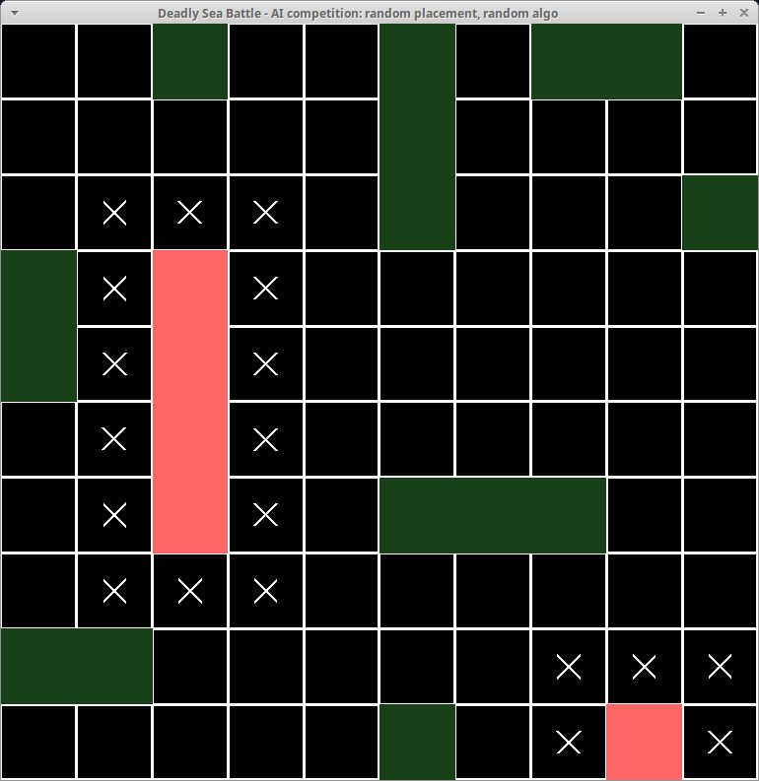
Figure 3: Eclipsing factor of killed boats (cells with crosses)
Nothing special here, boats are distributed randomly over the field. The only issue is that required conditions of game rules must be met: no two boats are inter-crossed and adjacent to each other.

Eclipsed placement
Here boats are placed to minimize total eclipse factor of the boats.
Eclipsing occurs due to the rule of “no adjacent boats on the field”. Whenever boat is killed all unknown cells around it become impossible (eclipsed) for other boats location due this rule. Thus no need to shoot them (visualized as a ‘cross’). Eclipsing factor reduces the amount of cells to be shot in the match, the greater eclipse factor is – the less shots are needed in the future to kill all boats and win. Eclipsing factor is minimized by placing the boat near the field border or next to another boat.
If a boat is the next to the border, eclipse doesn’t have so large effect because it partially propagates outside of the field (note on Figure 3- 1-sized killed boat has only 5 eclipsed cells; it would have 8 eclipsed cells for the boat in the middle of the field/sea).
Nearby boats also reduces the eclipse factor: if one of the boats is already killed, eclipse factor of the other boat propagates to already eclipsed cells by killed boat so it makes less eclipse in total (less cells with a cross) when both boats are killed.
Eclipsed algo calculates convolution of the boat margin with borders and margin from already placed boats and choose locations with maximal value of the convolution. The more value has convolution the less eclipse factor is produced so the less cells are out of the game after this boat death.
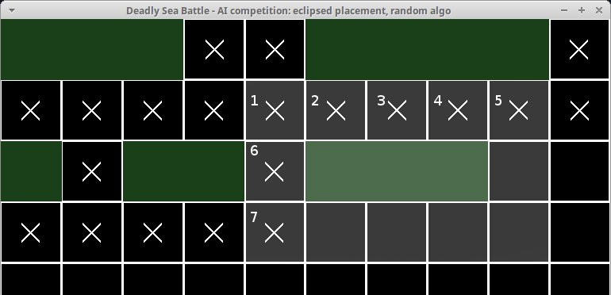
Figure 5: Calculation of eclipse convolution - margin is intersected with eclipse of already placed boats in 7 cells
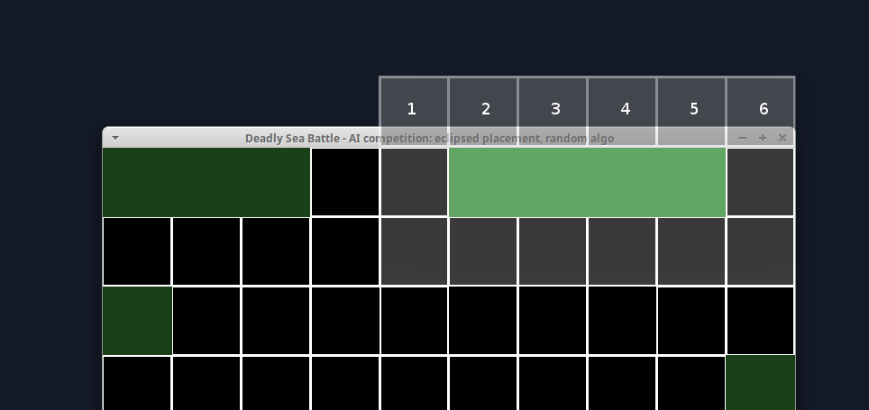
Figure 4: Calculation of eclipse convolution – margin is intersected with field border in 6 cells

Shooting algorithms

Minimal requirements for all algos
Following cells cannot be chosen by shooting algo:
- locations already been shoot before (Missed/Harmed/Killed)
- locations eclipsed by already killed boat (unknown cells adjacent to killed boats)

Dummy algo
Each cell of the field are scanned line by line (first line is from top-left corner to top-right, then next line from left to right and so on). Cell is chosen if it satisfies the minimal requirements.
Obviously, this algorithm is very weak. To survive the longest time, placement algorithm can put 1-sized boat at the bottom-right corner of the field so dummy algo has to try every possible cell of the filed.

Random algo
Next shot location is chosen randomly from the list of possible locations (that satisfy minimal requirements).

field-mask algo
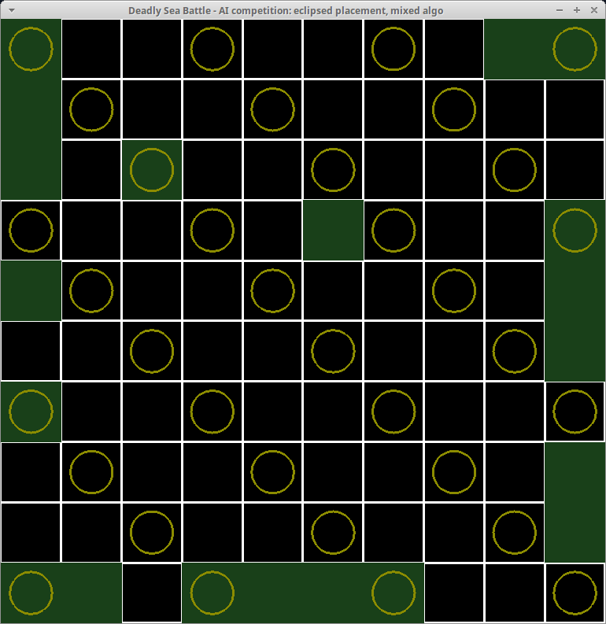
Figure 6: field mask 3x3 example - all tiers together
The main idea of this algorithm is following:
- Use pre-defined field mask to kill all 3- and 4-sized boats (and possibly some others). After the death of large boats due eclipsing factor we have much less cells to shoot. Then use any other algorithm (like random or eclipsed) to kill remained boats.
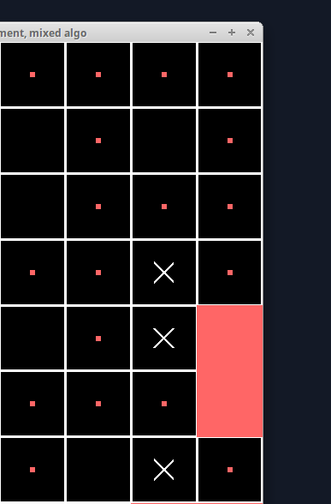
Figure 7: example of decreased eclipse - some cells around the boat were already shot before so they are not eclipsed
- Field-mask is chosen in such way that all 3- and 4-sized boats will be located (it is not possible to put such long boat without intersection with field mask). This can be done by using 3x3 diagonal stencil and tiling over whole field (see Figure 6). To avoid predictability of the field mask it can be distorted (shifted, rotated) – this is done to avoid disclosing due known shooting location so placement AI can replace small boats to resist.
- Cells of filed mask are divided into few tiers (two or three) to shoot the most possible cells of the mask in the first order. Algorithm choose random 1st-tier location at the first order, if no such then random 2nd-tier location and so on until all field mask is shot. This is done also to maximize eclipsing factor of detected boats: adjacent cells shot by algo will produce less eclipse because one of the missed cells will be not marked as eclipsed.
See Fugure 7 for example - eclipse factor for this 2-sized boat might be 6 cells in good case, but three adjacent cells are already shot/missed before so eclipse factor is only 3.
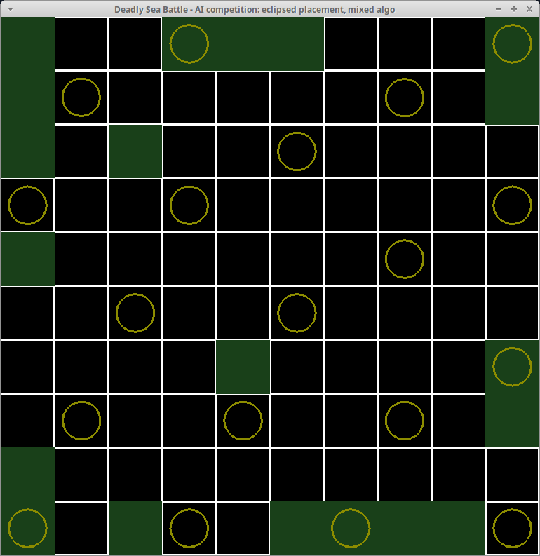
Figure 8: tiering of field mask - subset of field mask is assigned to tiers to avoid decreased eclipse due adjacent shots by field mask

eclipsed algo
Eclipsed algorithm of shooting is inspired as a counter-action to eclipsed placement AI to shoot most probable locations used by placement. Placement algorithm picks up locations with the bigger eclipsing factor so we can predict such locations having current map of killed boats.
Eclipsed algo calculates “eclipsed score map”. Each score is the sum of all eclipsing factors for all possible placements of all remained boats that includes this cell.
On the very 1st shot we have no any details about any boats so all boats are counted: one 4-sized boat, two 3-sized boats, three 2-sized and four 1-sized.
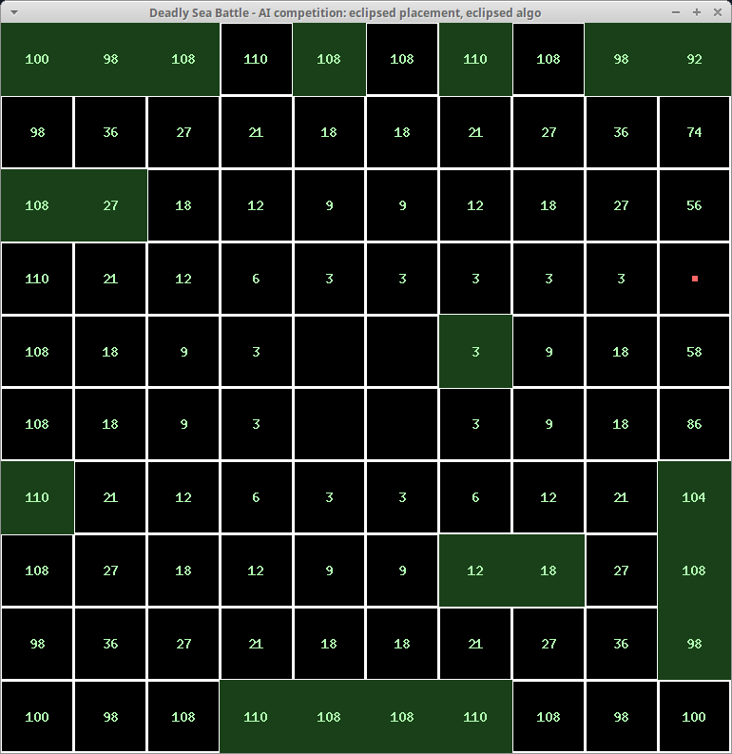
Figure 9: Eclipsed score map after the 1st shot
Let’s review the example – score=100 of the all fields’ corners are the sum of scores for cases:
- One 4-sized boat (both vertical and horizontal) with eclipse factor 8: 1x2x8=16
- Two 3-sized boats (both vertical and horizontal) with eclipse factor 7: 2x2x7=28
- Three 2-sized boats (both vertical and horizontal) with eclipse factor 6: 3x2x6=36
- Four 1-sized boats (they don’t have direction) with eclipse factor 5: 4x5=20
Placing the boat in the very middle of the field does not give any eclipse for the boat of any size, so we have 2x2 area with no eclipse score (0 score) in the center of the field (see Figure 9).
For cells with score=3 (see Figure 9) the only possible placement with eclipse is to put the 4-sized boat to touch the border so eclipse factor will be 3; it is only one such boat, more small boats cannot touch the border and intersect with central cell.
As we can see, the maximal eclipse score on the 1st shot is 110 (4th cell near the border from the any side). This is because we have many possible placements that cross this cell: for example with location (3,0) 4-sized boat has 4 vertical possible positions here and one vertical position while location (0,0) has only one vertical and one horizontal position.
Please note:
- Eclipsed score of the cell near ‘missed’ location is significantly less because we have much less possible positions of remained boats with ‘no boat can be here’ restriction by missed cell (see missed cell (9,3) on Figure 9). So eclipsed algorithm automatically produces good distribution of the shots over the empty field.
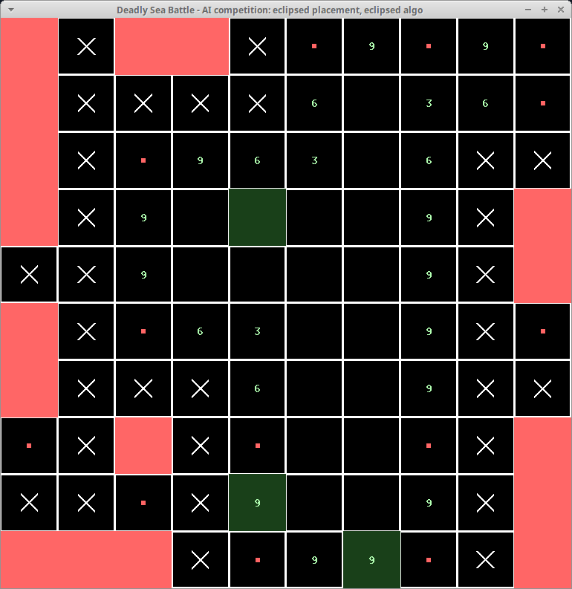
Figure 10: example of eclipse score map on the late stage of the game - only three 1-sized boats are remained so scores are counted only for them (lower values)
- After the death of some boats eclipsed score gets lower because killed boat does not counted in possible placements any more; for example when 4-sized boat is killed in one corner, score of the other corners will be lowered by 16 (eclipsed factor 8 of 4-sized boat, both vertical and horizontal).

mixed algo
Mixed algo is not a stand-alone logic but the mix of the rest of algorithms. Currently it works as below:
- Use field-mask algo to kill all 3- and 4-sized boats
- Use eclipsed algo to guess location of the survived 2- and 1-sized boats (until we have eclipsed locations).
- Use random algo otherwise.

