# Experience

This section provides an overview of BCT, including our managed services experience, client references, work with housing authorities, proposed approach and key personnel.

BCT Overview

Established in 1999, BCT has solidified its reputation as a **premier provider of digital transformation solutions, extending its expertise to over 50 countries** across diverse regions including North America, the Middle East, Africa and Asia. Our commitment to driving innovation is reflected in our outcome-based business models and robust digital platforms, positioning us as a reliable partner for more than 2,200+ clients, among which are Fortune 500 enterprises.



BCT prides itself on a **strong team of 4,500+ associates** whose deep technical knowledge and industry-specific domain expertise enable us to tailor solutions across key sectors such as Government, Banking & Financial Services, Oil & Gas, Government, Telecom, Power, Retail and Supply Chain/Logistics. Our strategy of collaborative innovation has led us to forge partnerships with global tech leaders including Microsoft, Oracle, IBM, TEMENOS, Single Store and TIBCO, enhancing our ability to offer unparalleled value to our clients.

Our unwavering commitment to quality is demonstrated by our attainment of **CMMI Level 5 and certification in ISO 9001, ISO 14001, ISO 20000 and ISO 27001**, which underscores our dedication to excellence in service delivery, environmental management, information security and IT service management

BCT Experience in Public Sector

BCT has a strong presence in public sector/e-Government space and helped many cities worldwide to make a space for themselves in the list of the best e-governed cities of the world. BCT has played a pivotal role in large e-Government programs across multiple countries offering Managed Services, e-Payment, Integrated Payment Hub, Payment Aggregation, Integrated Revenue Management, Business Licensing, Citizen Services, Managed services of citizen contact center. With rich experience in implementation, upgrade and support our specialists conceptualize, develop, deliver and operate the best-in-class governance solutions which promote efficiency, transparency and enable “smart governance”.

| Customers | Description |
| --- | --- |
| Housing Authority of City of Los Angeles | BCT is engaged with HACLA to provide application managed services which includes core application development, application enhancement, cross functional services, service desk, infrastructure services, network and end user computing. |
| Houston Public Works | BCT assisted Houston PWE and has worked with them since 2011 in architecture, installation and configuration, design, development, deployment and support of their core enterprise systems such as utility billing, GIS, and other applications by establishing a ‘standards-based Middleware’ platform and integrated the systems in a seamless manner |
| Department of Health, NY | BCT engaged with NY Department of Health in delivering enterprise integration services for their core enterprise applications |
| Cook County Health | BCT assisted in the migration of database for Cook County Hospital’s Cerner Hospital Management System. |
| University of Alabama | BCT has been engaged with University of Alabama Birmingham School of Medicine for many years and in a number of critical IT initiatives including application and infrastructure managed services, development, testing and quality assurance, production support, etc. |
| City of Chandler | BCT assisted the City of Chandler, AZ in designing an enterprise integration architecture for seamlessly integrating all the City’s Information Systems using a standards-based middleware platform. |

Recent Wins & Qualified projects:

*BCT has recently been awarded a contract by the City of Houston to provide IT Professional and Consulting Services. The scope of these services includes offering MSP basic support for server, storage, data center, network services, and voice. Additionally, BCT will provide staff augmentation services to meet the city's IT needs*

*BCT was shortlisted by the State of Louisiana as one of the approved IT vendors for the Statewide IT Staff Augmentation Services Contract.*

*We are proud to be among the select few qualified across all categories, enabling us to participate in all upcoming task order opportunities*

*BCT was recently shortlisted by Oakland County, MI as as an approved IT vendor for the IT Staff Augmentation Services Contract.*

*We are pleased to share that we have been qualified across all categories, giving us the opportunity to participate in all forthcoming task orders*

BCT’s Experience in Managed Services

BCT embarked on its managed services journey 15 years ago. Since then, we have continually enhanced our service delivery, establishing ourselves as a transformation partner rather than merely a delivery channel. This commitment is reflected in the enduring relationships we have cultivated with our partners.

Our dedicated team of over 400 certified professionals is committed to monitoring, managing and maintaining mission-critical enterprise applications, infrastructure and technology stacks. We support both on-premises and cloud environments, ensuring seamless operations for our customers. By providing 24/7 IT portfolio and asset management, we have developed a comprehensive range of competencies that encompass the entire enterprise IT stack.

BCT’s Representative Clientele - Managed Services

BCT has a proven track record of delivering end-to-end managed IT services to a diverse range of public and private sector clients. Our clientele includes government agencies, Fortune 500 companies and mid-sized enterprises across industries such as public sector/government, utilities, transportation, education Biotech, retail and financial services. We provide comprehensive support encompassing infrastructure management, application support, cloud operations, cybersecurity and end-user services—tailored to each client’s operational and compliance needs. Our long-standing engagements reflect our commitment to service excellence, innovation and measurable outcomes.

|  |  |  |  |  |  |  |  |  |  |  |  |  |  |  |  |  |  |  |  |
| --- | --- | --- | --- | --- | --- | --- | --- | --- | --- | --- | --- | --- | --- | --- | --- | --- | --- | --- | --- |
| Client | Duration | | EUC | | COTS App | | Infra | | Database | | Cloud Support | | Network | | Security | | Platform/VDI/VM | | Service Desk |
| The Housing Authority of City of Los Anegeles | 3+ | ✓ | | ✓ | | ✓ | | ✓ | | ✓ | | ✓ | | ✓ | | ✓ | | ✓ | |
| Ministry of Justice | 7+ | ✓ | | ✓ | | ✓ | | ✓ | | ✓ | | ✓ | | ✓ | | ✓ | | ✓ | |
| Dubai Health Authority | 3+ | ✓ | |  | | ✓ | | ✓ | | ✓ | | ✓ | | ✓ | | ✓ | | ✓ | |
| Maurices | 4+ | ✓ | | ✓ | | ✓ | | ✓ | | ✓ | | ✓ | | ✓ | | ✓ | | ✓ | |
| Barnes and Noble | 10+ | ✓ | | ✓ | | ✓ | | ✓ | | ✓ | | ✓ | | ✓ | |  | |  | |
| UAB | 10+ |  | |  | | ✓ | | ✓ | |  | | ✓ | | ✓ | | ✓ | |  | |
| American Eagle | 10+ |  | | ✓ | |  | | ✓ | | ✓ | |  | |  | |  | | ✓ | |
| Ministry of Housing | 6+ |  | |  | | ✓ | | ✓ | | ✓ | | ✓ | | ✓ | | ✓ | |  | |
| HomeServe | 10+ | ✓ | | ✓ | |  | | ✓ | | ✓ | |  | |  | | ✓ | |  | |
| Tesla | 10+ |  | |  | | ✓ | | ✓ | | ✓ | |  | |  | | ✓ | | ✓ | |
| Biogen | 10+ |  | | ✓ | | ✓ | | ✓ | | ✓ | |  | |  | |  | |  | |
| RTA | 10+ |  | | ✓ | | ✓ | | ✓ | | ✓ | |  | |  | |  | |  | |
| MMRCL | 3+ |  | | ✓ | | ✓ | | ✓ | | ✓ | |  | |  | |  | |  | |
| TelBru | 10+ | ✓ | | ✓ | | ✓ | | ✓ | | ✓ | | ✓ | | ✓ | | ✓ | | ✓ | |

BCT Managed Services Experience – Housing Authorities

BCT has substantial experience working with housing authorities, providing technology solutions and managed services tailored to their unique operational and regulatory needs.

For the **Housing Authority of the City of Los Angeles (HACLA)**, we have been delivering **end-to-end IT Managed Services**, supporting their infrastructure, applications and end-user environments to ensure uninterrupted service delivery and operational efficiency.

What Set BCT Apart for Housing Authorities:

more details available in the below link –

<https://www.hacla.org/sites/default/files/2022-10/2022-10-27%20ITEM%20A4-%20IT%20Initiatives%20Update.pdf>

Ongoing Initiatives with HACLA - 2025

Below image depicts the forging strategic partnership of BCT with HACLA:

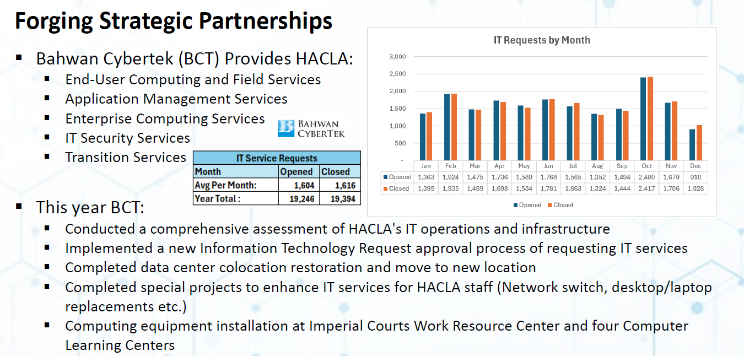

Additional details available in the following link:

<https://hacla.org/sites/default/files/2025-01/2025.01.09%20BOC%20Item%20A3%20-%20IT%20Initiatives%20Annual%20Update%202024%20-%20Memo.pdf>

Additionally, we have also worked with Global housing authorities including **Ministry of Housing**, where we have **developed applications** to support core functions and continue to provide ongoing maintenance and support services.

Through these collaborations, we have gained a strong understanding of the IT ecosystems, compliance standards and support requirements specific to housing authorities. This enables us to deliver reliable, scalable and mission-critical IT services that align with public sector goals.