HanuAi ML Assessment — Task 2
Infotainment Failure Analysis: EDA, Text Mining & Root-Cause Clustering
Stakeholder report • Dataset: 1,000 warranty events, MY2020 vehicles • Companion files: Task2_EDA_TextMining.ipynb, Task2_tagged_dataset.csv/.xlsx

1. Executive summary
Bottom line: the problem is a *head-unit (infotainment module) quality and software-robustness problem that is spread across every plant and model* — not a plant-specific or model-specific defect. 89% of claims end with a part replacement, and 60% of claims are internal module failures or module-communication faults.
Where to act first: (1) head-unit supplier quality & containment, (2) a better remote/diagnostic triage before swapping units, (3) software fix effectiveness, (4) data quality of the claim records.

Key number | Value | Why it matters
Events analysed | 1,000 (4 makes, 23 models, 8 plants) | One production cohort: built 1 Aug – 7 Sep 2019
Claims ending in a part replacement | 89% (887) | Dominant cost driver; 52% also had a reprogramming attempt, i.e. two repair steps
Internal hardware failure + module comm. fault | 35% + 26% = 60% | Points to electronics / supplier quality rather than assembly (4%)
Median time-in-service at claim | 228 days (21% < 90 days, 75% < 1 year) | Early-life failure pattern → design/manufacturing/software, not wear-out
Radio / head-unit or screen is the primary complaint | 49% (251 + 239) | Head unit and display are the failing assets
Technician needed Techline/TAC support | 32% of events | Diagnosis is hard; knowledge not yet at the dealer
Claims opened before the in-service date | 7.6% (76) | Pre-delivery (PDI) defects or date-entry errors

2. Understanding the data
Each row is one warranty event with three free-text narratives (customer complaint, technician diagnosis, repair performed), a technician “causal code” and a customer “complaint code”, vehicle identifiers (make, model, plant), and three dates (build, in-service, claim opened). Six pre-defined structured columns (Trigger, Failure Component, Failure Condition, Additional Context, Fix Component, Fix Condition) were filled for only 5 rows — they define the target schema that text mining had to populate for all 1,000 events.

Data-quality findings and how they were handled
Finding | Treatment
Six structured columns 99.5% empty | Kept the 5 labelled rows as a validation set; filled all six fields for 1,000 rows by text mining
Missing: 1 in-service date, 3 causal codes, 1 causal narrative | In-service date = build date + median lag; causal code = mode within the same complaint code; text left blank; all flagged in the dataset
Constant column (model year = 2020), duplicate column (plant code = plant name) | Dropped from the analysis frame
Non-breaking spaces created a phantom complaint category | Whitespace normalised (10 → 9 categories)
Two date formats (m/d/Y and ISO timestamps) | Parsed to one datetime type
76 claims opened before the in-service date | Flagged; excluded from time-in-service statistics only (kept for everything else)
8 customer narratives merely repeat the complaint code | Flagged and excluded from symptom mining
16 records in French (12) or Spanish (4); IDs/DTC numbers scrubbed; run-together words | Language flag added; multilingual terms and stop-words in the extractors
No exact duplicates; no duplicate event IDs | None needed

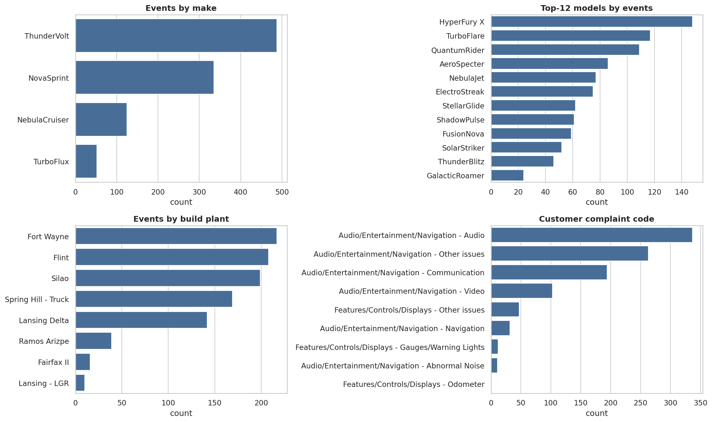
Figure 1 – Events by make, model, plant and complaint code. Counts only: no production volumes were supplied, so these are shares of claims, not failure rates.

3. From free text to structured tags
A transparent dictionary/regex entity extractor (rule-based NER) was built from term-frequency analysis of the corpus and the 5 labelled examples. It is deterministic, explainable to non-technical stakeholders, runs offline, and handles the narrow technical vocabulary well. Handling of negation (e.g. “unable to program”, “no codes set”, “USB programming” ≠ USB fault) prevents false tags. Repair notes are parsed by action clause so that components merely *tested* are not tagged as *fixed*.
Tag family | Examples of values extracted | Coverage
Failure Component | Radio/Head Unit, Display/Touchscreen, Backup Camera, Antenna/Reception, Phone/Bluetooth, Navigation/SD Card, OnStar, Wiring/Connector … | 99% of events
Failure Condition | Internal Fault/Short (37%), Inoperative (25%), Intermittent (20%), Black/Blank Screen (19%), Communication Loss (18%), Reboot (14%), No Sound (13%) … | 86%
Trigger | In Reverse/Camera Use (11%), On Start-up (8%), Phone Connected (8%), While Driving (4%) … | 39% specific (rest = “No Additional Functionality”)
Additional Context | TAC/Techline referenced (35%), Customer-reported intermittent (21%), Repeat repair (17%), Multiple symptoms (13%) | 58% specific
Fix Component / Fix Condition | Replaced (89%), Programmed/Reflashed (59%), Repaired (8%), Reset/Relearn (5%) | 94% / 96%
Process flags | DTC mentioned (14%), bulletin/campaign (10%), TAC case (32%), part on order (4%), not duplicated (2%) | all events

Validation (honest view): against the 5 hand-labelled rows the extractor recovered 9/9 component tags, 4/8 condition tags, 4/8 fix-component tags and 5/8 fix-action tags. Five rows is a smoke test, not a robust accuracy estimate; the recommended next step is a 150–200 row labelled sample to measure precision/recall properly.

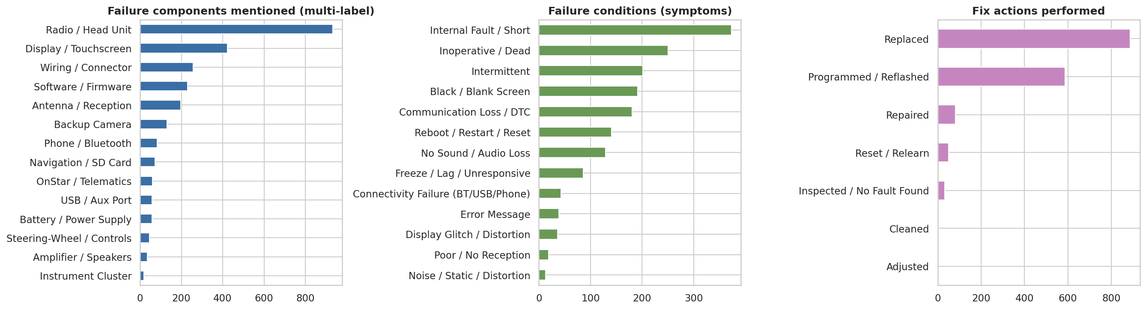
Figure 2 – Mined failure components, conditions (symptoms) and fix actions.

4. Issue classification — “type of issue”
Mined entities were rolled up into seven issue categories, using the technician’s causal code as the backbone and the mined entities to refine it (full rules are in the notebook). The category answers “what kind of failure is it”; the primary component answers “where did the customer see it”.
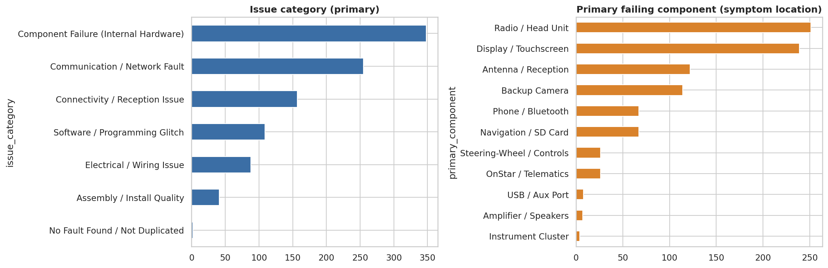
Figure 3 – Issue category (left) and primary failing component (right).
Issue category | Events | Share | Reading
Component Failure (Internal Hardware) | 348 | 35% | Module shorted / broken / mis-registering; replaced
Communication / Network Fault | 255 | 26% | Head unit not communicating on Ethernet/bus
Connectivity / Reception Issue | 157 | 16% | XM/antenna, Bluetooth/phone, USB, SD-card/nav, telematics
Software / Programming Glitch | 109 | 11% | Campaign/bulletin, wrong version, fixed by reprogramming
Electrical / Wiring Issue | 88 | 9% | Technician coded wiring/sensors
Assembly / Install Quality | 41 | 4% | Loose, missing, wrong part, poor contact, routing
No Fault Found / Not Duplicated | 2 | 0.2% | Not reproduced and no part replaced (2% of notes say “unable to duplicate”, but almost all of those ended in a replacement)

5. Patterns and trends
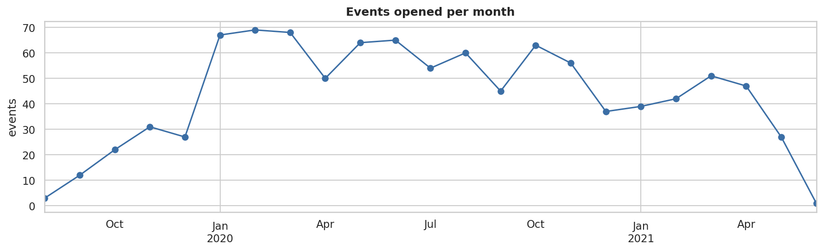
Figure 4 – Claims opened per month.
- Volume ramp-up and plateau. Claims rise from 3 in Aug 2019 to a peak of 67–69 per month in Jan–Mar 2020, stay at 45–65 per month until Nov 2020 and decline in 2021. The late decline is partly an artefact of right-censoring (vehicles in service for less time), so it should not be read as improvement.
- The failure mix is stable. First half vs second half of the period: no statistically significant change in the category mix (χ² p = 0.93). Software/programming (+0.3 pp) and assembly (+1.0 pp) shifted slightly; nothing “emerged” — the problem is chronic, not a new spike.
- No plant or model is a statistically significant outlier. Plant × category (p = 0.71) and plant × cluster (p = 0.34) show no significant concentration. The top-5 models carry 54% of claims (HyperFury X 15%, TurboFlare 12%, QuantumRider 11%, AeroSpecter 9%, NebulaJet 8%) but that reflects sales volume — without production volumes a per-model *rate* cannot be computed. One weak lead: 13 of 39 SD-card/navigation events came from Silao (33% vs 20% of all claims; p ≈ 0.04, not corrected for multiple tests) — worth a targeted check, not a conclusion.
- Single build cohort. Every vehicle was built 1 Aug – 7 Sep 2019. A common component lot, software release or supplier batch is therefore a plausible shared cause — this should be checked against supplier lot / software-version data.
- Early-life failures. Median 228 days to claim; 21% within 90 days, 43% within 180 days, 75% within a year. Time-in-service differs by failure mode (see clusters): XM/antenna (median 163 d) and Bluetooth (184 d) fail soonest.
- Repair behaviour. 89% replaced; 52% had both reprogramming and replacement (a second repair step after software failed to cure); 17% mention a repeat/previous visit; 32% needed Techline/TAC help; only 2% of notes say “could not duplicate”, and nearly all of those ended in a replacement anyway.

6. Clustering and root-cause hypotheses
K-Means on TF-IDF vectors of the cleaned customer + technician narratives (unigrams + bigrams, domain boiler-plate and French/Spanish stop-words removed) with k = 10 chosen for interpretability (silhouette rises only slowly with k and has no sharp optimum). LDA topic modelling was run as an independent second view and recovers the same themes (camera, XM/signal, phone/SD-card, update/software, communication/ground).
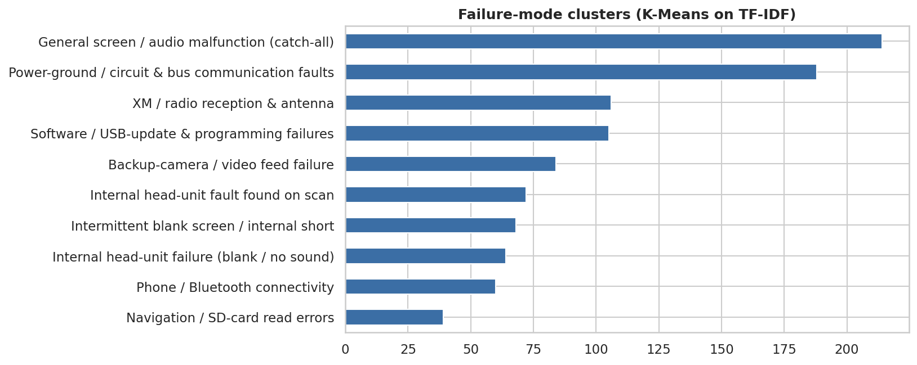
Figure 5 – Failure-mode clusters.
Cluster (share) | Top terms | Median days / replaced | Root-cause hypothesis
Power-ground / circuit & bus communication (19%) | ground, power, circuits, ethernet, module, voltage | 241 d / 92% | Head-unit power/ground or Ethernet-bus interface fault — verify at connector/harness level before replacing; supplier + vehicle-wiring joint review
XM / radio reception & antenna (11%) | xm, signal, antenna, sirius, stations | 163 d / 91% | Earliest failures: tuner/antenna-input hardware or coax connection; check antenna module & receiver lot
Software / USB-update & programming (11%) | update, usb, software, failed, programming | 274 d / 74% | Update/programming failures; only cluster where replacement is not near-universal → software fix works for ~1 in 4; improve flashing procedure and software release quality
Backup-camera / video feed (8%) | camera, rear, reverse, coax, video | 253 d / 89% | Video path (camera, coax cable, connector, head-unit input) — 11% of events trigger “in reverse”; add camera-circuit test step
Internal head-unit fault found on scan (7%) | internal fault, scan, inop | 214 d / 97% | Clear module hardware failure; swap is justified — supplier containment
Intermittent blank screen / internal short (7%) | blank, intermittently, shorted, module | 261 d / 85% | Display/backlight or internal short; intermittent so hard to reproduce
Internal head-unit failure — blank / no sound (6%) | internal failure, blank, sound, inop | 208 d / 95% | Hard failure of the unit; same supplier action
Phone / Bluetooth connectivity (6%) | phone, bluetooth, pair, calls | 184 d / 90% | Early failures; pairing/telephony firmware or module hardware; software first, replace only after reset/update
Navigation / SD-card read errors (4%) | sd card, error, navigation, reader | 265 d / 90% | SD-card reader/card issue; some cards missing at delivery (PDI); weak Silao skew
General screen / audio malfunction (21%) | display, screen, shut, stays, audio | 230 d / 87% | Catch-all with mixed causes; needs better narrative quality at intake

Quality caveat: the clusters are overlapping (silhouette 0.05) and moderately stable across random seeds (adjusted Rand index 0.36–0.50). The themed clusters (camera, XM, Bluetooth, SD card, software) are robust; the generic screen/audio clusters are fuzzy. The cluster names are hypotheses to be confirmed with engineering teardown data — not proven root causes.

7. Recommendations and business impact
# | Action | Evidence | Expected business impact
1 | Open a supplier quality investigation (8D) on the head unit for the Aug–Sep 2019 build cohort: lot/date-code, power/ground and Ethernet interface tests, containment of suspect lots | 60% of claims are internal failure or communication fault; 89% replaced; early-life pattern | Largest lever: each 10-point cut in replacement rate avoids ~100 unit swaps per 1,000 claims (scenario arithmetic, not a forecast); supplier cost recovery
2 | Introduce a guided triage before swapping units: power/ground/connector check, reset, software re-flash, camera/antenna circuit tests, with decision tree in the diagnostic tool | 32% need Techline; 52% programmed *and* replaced; Power-ground cluster 19% | Fewer unnecessary replacements and repeat visits (17% repeat), lower labour hours and customer downtime
3 | Fix software release and flashing reliability: investigate failed updates, USB-update path, bulletin effectiveness (only 10% of claims reference a bulletin) | Software cluster has the lowest replacement rate (74%) – fixes can work | Over-the-air/dealer fixes replace costly hardware swaps for the ~11% software-related claims
4 | Targeted checks: XM/antenna and Bluetooth modules (earliest failures), camera video path, SD-card presence at PDI (Silao) | Clusters 4–11% each; time-to-failure 163–265 d | Pinpoints cheap fixes (cable/connector/card) that avoid head-unit replacement
5 | Improve claim data quality: structured symptom/component picklists at intake, mandatory date validation (76 inconsistent dates), keep DTC numbers, multilingual capture, supplier lot and software version per VIN | Six structured fields 99.5% empty; 7.6% date errors; 1.6% non-English text | Enables failure *rates* by lot/plant/model and early-warning detection
6 | Productionise the text-mining pipeline as a monthly dashboard (top failure modes, trend alerts, repeat-repair watch-list) | Pipeline already runs end-to-end on 1,000 events in seconds | Earlier detection of emerging issues; consistent, searchable tags for engineering

8. Value generation for the customer
- Quantified failure anatomy — from 1,000 unstructured narratives to six structured fields and seven issue categories, ready for dashboards and joins with supplier/vehicle data.
- Targeted engineering effort — instead of “radio doesn’t work”, teams get ten named failure modes with symptoms, repair behaviour, and time-to-failure.
- Cost avoidance — the replacement rate (89%) and double-repair rate (52%) are the numbers to move; triage and software quality are the levers.
- Early warning — a repeatable pipeline can flag a change in category/cluster mix month by month; today the mix is stable, which is itself a finding (a chronic design/supplier problem).

9. Key technical learnings and further improvements

Learnings
- Domain-specific lexicons with negation handling and clause-level parsing of repair notes gave much cleaner tags than naïve keyword matching (e.g. “USB programming” is not a USB-port failure).
- The technician causal code is a relatively clean, consistent backbone for categorisation; free text adds the symptom location and fix behaviour that the code lacks.
- Clustering text full of repair boiler-plate gives low silhouette; removing the repair narrative and boiler-plate terms and choosing k for interpretability made clusters usable. Always pair a quality metric with a stability check.
- Statistical tests (χ², Kruskal-Wallis) were important to avoid over-reading differences: most plant/model/time differences were not significant.

Limitations
- No production/sales volumes → shares not rates; single build cohort; 5 gold labels; rule-based extractor misses unseen phrasings; clusters are hypotheses.

Next improvements
- Label 150–200 events and measure precision/recall; use them to tune the lexicon or fine-tune a small model.
- Add an open-source LLM (e.g. Llama/Mistral instruct) for schema-constrained JSON extraction on the long, messy narratives, validated against the rule-based tags — keep the rules as a fast baseline and consistency check.
- Use multilingual embeddings + BERTopic to cluster French/Spanish records together with English ones and to produce more coherent clusters than TF-IDF.
- Join supplier lot, software version, VIN-level production data and mileage to compute failure rates, run survival (time-to-failure) analysis and build an early-warning model.
- Deploy as a monthly dashboard with alerting on cluster-share changes and repeat-repair watch-lists.

