|  |  |
| --- | --- |
|  | Prepared by:  Emma Bostian  Kevin Conner  Justin Rose  David Hall  Sara Pinti |

Acceptance

Test

**Client: Dr. Erik Eddy**

**Teammate Evaluation Software**

Dr. Meg Fryling

Dr. Darren Lim

Siena College

Department of Computer Science

April 20, 2015

Table of contents

|  |  |
| --- | --- |
| 1. Introduction |  |
| 1.1 Product Overview |  |
| 2. Requirements Inventory |  |
| 2.1 User Case Narratives |  |
| 2.1.1 Student Create Account |  |
| 2.1.2 Student Complete Evaluation |  |
| 2.1.3 Student View Evaluation Results |  |
| 2.1.4 Faculty Establish Class  Roster/Team Profile |  |
| 2.1.5 Faculty Manage Evaluations |  |
| 2.1.6 Faculty View Team Evaluations |  |
| 2.1.7 Administrator Manage User  Permission |  |
| 2.2 Functional Requirements Inventory |  |
| 2.2.1 Student User Level |  |
| 2.2.2 Faculty User Level |  |
| 2.2.3 Administrator User Level |  |
| 2.3 Non Functional Requirements Inventory |  |
| 2.4 Future Enhancements |  |
| 3. External Design Specification |  |
| 3.1 User Displays and Report Formats |  |
| 3.1.1 Login |  |
| 3.1.2 Create Account |  |
| 3.1.3 Student Homepage |  |
| 3.1.4 Student Select Course |  |
| 3.1.5 Student Take Evaluation |  |
| 3.1.6 Faculty Homepage |  |
| 3.2 Logical Data Dictionary |  |
| 3.3 Logical Format of Data Files/Databases | * |
| 4. Architectural Design Specification |  |
| 4.1 Development & Production Environments |  |
| 4.2 Deliverables |  |
| 4.3 Data Flow Diagrams (appendix) |  |
| 4.4 Source Code (appendix) |  |
| 5. Test Requirements & Results |  |
| 5.1 Explanation of Test Plan/Strategy |  |
| 5.2 Test Results (appendix) | Need Input in Appendix |
| 6. Appendix |  |
| 6.1 Timeline | * |
| 6.2 Glossary of Terms |  |
| 6.3 Sources of Information |  |
| 6.4 Data Flow Diagrams |  |
| 6.4.1 Data Flow Diagram Legend |  |
| 6.4.2 Context Diagram |  |
| 6.4.3 Level 0 Diagram |  |
| 6.4.4 Level 1 Diagrams |  |
| 6.4.4.1 Create Account |  |
| 6.4.4.2 Login |  |
| 6.4.4.3 Evaluate Teammate |  |
| 6.4.4.4 View Individual Report |  |
| 6.4.4.5 View Team Report |  |
| 6.4.4.6 Establish Class Roster/Team  Profile |  |
| 6.4.4.7 Manage Team Evaluations |  |
| 6.4.4.8 Manage User Permissions |  |
| 6.5 Source Code |  |
| 6.5.1 TEAMS101 Application Platform  Home |  |
| 6.5.2 About TEAMS 101 |  |
| 6.5.3 Team Evaluation Log In |  |
| 6.5.4 Team Evaluation Create An  Account |  |
| 6.5.5 Team Evaluation Home Page |  |
| 6.6 Test Result |  |
| 6.6.1 Test Directory | * |
| 6.6.2 Unit Test 1 | * |
| 6.6.3 Unit Test 2 | * |

Introduction

**1.1 Product Overview:**

Teammate Evaluation will be a core web application on the TEAMS 101 (Team Evaluation and Management System) dashboard, and it will give students an easily-accessible interface to provide teammate evaluations periodically during group projects. Dr. Erik Eddy realizes the importance that team evaluations hold within a group dynamic, not only in regards to the final grade for the assignment, but for the overall cohesiveness and harmony of the group. Team Evaluation will not only provide Siena College students with the ability to communicate more productively, it will provide professors and administrators the ability to be better acquainted with the team member’s participation and performance.

Requirements Inventory

**1.1 User Case Narratives:**

2.1.1 Student Perspective: Create Account

The student signs into the Siena College computer with his username and password. The student clicks the email from his professor containing the link to the TEAMS101 portal. The student navigates to the Teammate Evaluation application by clicking the icon on the portal, and clicks “Create Account”. The web page prompts the student to enter his first name, last name, Siena email address and asks them to create a new password. After inputting the information on the form, the student clicks “Create Account” and the web page redirects the user to a login screen which will then allow the student to login and take evaluations.

2.1.2 Student Perspective: Complete Evaluation

The student signs into the Siena College computer with his username and password. Next, the student opens a web browser and logs in to his Siena email account. The student clicks the email from his professor containing the link to the TEAMS101 portal. The student navigates to the Teammate Evaluation application by clicking the icon on the portal. The student enters his username and password and clicks “Login”. Once logged in, the student clicks “Complete Evaluation” from the navigation bar. The student rates each team member based on performance. Once completed, the student clicks “Submit” which locks in their evaluation responses and notifies the faculty member that an evaluation has been completed. The student then proceeds to log off of Teammate Evaluation, and the application returns to the home screen.

2.1.3 Student Perspective: View Evaluation Results

The student signs into the Siena College computer with his username and password. Next, the student opens a web browser and logs in to his Siena email account. The student clicks the email from his professor containing the link to the TEAMS101 portal. The student navigates to the Teammate Evaluation application by clicking the icon on the portal. The student enters his username and password and clicks “Login”. The student clicks on the “View My Evaluations” tab from the navigation bar. From this page, the student can view a list of classes that they are currently enrolled in, and he chooses one to view his individual report. Once the specific course has been chosen, the student is shown a list of reports, organized by date. The student selects one individual report to view by clicking a specific date. Once the student has finished examining their individual report, he logs off of Teammate Evaluation by clicking “Log out”, and the application returns to the home screen.

2.1.4 Faculty Member Perspective: Establish Class Roster/Team Profile

The faculty member signs into the Siena College computer with his username and password. Next, the faculty member opens a web browser and navigates to the TEAMS101 portal. The faculty member navigates to the Teammate Evaluation application by clicking the icon on the portal. The faculty member enters his username and password and clicks “Login”.

The faculty member clicks “Create New Class” from the navigation bar and the web page changes to the “Class Roster” form. The faculty member enters each student’s Siena email address and clicks “Save Class Changes”. The web page returns to the “Class Roster” default page with the newly established class listed as a hyperlink to the class profile page. The faculty member clicks the hyperlink to the class page they just created and the web page changes to the class profile.

The faculty member clicks “Add New Team” on the class profile page. The faculty member selects students from the class roster by clicking the plus sign next to their name. The web page automatically updates with the selected team members. Once all team members have been added to the team, the faculty member clicks “Submit”. The web page returns to the class profile home page and the faculty member continues the “Add New Team” process until all students are assigned to a team. After this process is completed, the faculty member logs off of Teammate Evaluation by clicking “Log out”, and the application returns to the home screen.

2.1.5 Faculty Member Perspective: Manage Evaluations

The faculty member signs into the Siena College computer with his username and password. Next, the faculty member opens a web browser and navigates to the TEAMS101 portal. The faculty member navigates to the Teammate Evaluation application by clicking the icon on the portal. The faculty member enters his username and password and clicks “Login”.

The faculty member selects “Manage Evaluations” from the navigation bar and the web page changes to the “Manage Team Evaluations” web page. From this web page, the faculty member can view a list of pre-existing team evaluations that they have previously created. The faculty member is able to Edit and Delete existing evaluations, as well as create new evaluations. The faculty member is also able to send an invitation to complete the evaluations to specific teams.

The faculty member selects “Create New Evaluation” from the “Manage Evaluations” web page, and the page changes to the “Create New Evaluation” form. The faculty member enters evaluation questions into the text boxes in the evaluation form, and once all questions have been entered, he clicks the “Submit Evaluation” button at the bottom of the page. The browser returns to the “Manage Evaluations” web page and the newly created evaluation is listed under the existing evaluations.

The faculty member now clicks “Edit” next to a pre-existing evaluation and the browser changes to the “Edit Existing Evaluation” form. The faculty member clicks the “Delete” button next to existing questions to delete them, and enters new questions into the text box at the bottom of the form. Once the faculty member is done editing an evaluation, he clicks “Submit Evaluation” button at the bottom of the page. The browser returns to the “Manage Evaluations” web page.

The faculty member is also able to click “Delete” next to a pre-existing evaluation in order to delete an entire Team Evaluation from the Database.

Finally, the faculty member clicks “Send Evaluation to Teams” and the browser changes to the “Sent Evaluations to Teams” web page. The faculty member selects the pre-existing Team Evaluation that they want to invite teams to take, and selects the teams from the list of classes that they want to send the evaluation to. Once all teams are selected, the faculty member selects “Send to Teams” button from the bottom of the web page. The web browser confirms that the evaluations have been sent with a confirmation text box, and returns to the home page. The faculty member logs off of Teammate Evaluation by clicking “Log out”, and the application returns to the home screen.

2.1.6 Faculty Member Perspective: View Team Evaluations

The faculty member signs into the Siena College computer with his username and password. Next, the faculty member opens a web browser and navigates to the TEAMS101 portal. The faculty member navigates to the Teammate Evaluation application by clicking the icon on the portal. The faculty member enters his username and password and clicks “Login”.

The faculty member selects “View Team Evaluations” from the navigation bar and the web browser changes to the “View Team Evaluations” web page. The faculty member then selects a class from the list of classes on the web page, and the browser changes to the selected class’s individualized report. From this page, the faculty member can view a summarized report of the ranking of teams in the class, as well as view which teams have completed the evaluations and which have not. The faculty member clicks a team from the list of teams for the class, and the web browser changes to the “Team Profile” page. From this page, faculty members can click team members to view their individualized reports, and view which team members have completed evaluations for their peers.

After the faculty member has viewed all team evaluations, he logs off of Teammate Evaluation by clicking “Log out”, and the application returns to the home screen.

2.1.7 Administrator Perspective: Manage User Permissions

The administrator signs into the Siena College computer with his username and password. Next, the administrator opens a web browser and navigates to the TEAMS101 portal. The administrator navigates to the Teammate Evaluation application by clicking the icon on the portal. The administrator enters his username and password and clicks “Login”.

The administrator clicks “Edit User Permissions” from the navigation bar, and the web browser changes to the “Edit User Permissions” web page. The administrator can view every user account in the database, and is able to search for existing users. The administrator enters a username into the search box, and selects the user account from the results. The web browser changes to the “User Profile” web page. Here, the administrator clicks the “Faculty Member” check box next to the username, and clicks “Save Changes”. The web page changes to show a confirmation of the changes, and automatically notifies the user that they have been given faculty member permissions. The administrator is also able to uncheck the “Faculty Member” box to remove a user as a faculty member.

After the administrator has finished managing permissions, he logs off of Teammate Evaluation by clicking “Log out”, and the application returns to the home screen.

**2.2 Functional Requirements Inventory:**

An outline list below discusses the required functionality of Teammate Evaluation as organized by the user type. Teammate Evaluation will be web-based software and the application will be accessible on all Internet browsers and mobile platforms.

2.2.1 Student User Level

* Capable of logging onto the system
  + A failed login will result in an error message
* Can fill out teammate evaluation form for each teammate
* Can access own evaluation report and view other’s anonymous reports
  + Cannot access own evaluation report unless three teammates have submitted reports for this user
* Can log out of system

2.2.2 Faculty User Level

* Capable of logging onto the system
  + A failed login will result in an error message
* Can fill out teammate evaluation reports for any student in class
* Can assign teams/replace team members
* Can view all student evaluations for any team and who submitted them
* Can log out of system

2.2.3 Administrator User Level

* Capable of logging onto the system
  + A failed login will result in an error message
* Can fill out teammate evaluation reports for any student in class
* Can assign teams/replace team members
* Can view all student evaluations for any team and who submitted them
* Can grant administrator privileges to other users
* Can log out of system

**2.3 Non-Functional Requirements:**

The non-functional requirements will explain the specific properties of TEAMS-101. These following specifications are not definable features, but rather traits that will help with ease of use for the system. As such, these specifications cannot be measured objectively. Below is a list of TEAMS-101’s non-functional requirements:

* Teammate Evaluation will be efficient
* Teammate Evaluation will be user-friendly
* Teammate Evaluation will be compatible on multiple browsers, as well as on mobile platforms
* Teammate Evaluation will require little maintenance and will be stable
* Teammate Evaluation will be easily accessible by all users

**2.4 Future Enhancements:**

As a future enhancement, Dr. Erik Eddy would like Teammate Evaluation to be accessible for students at other colleges and universities to use. One problem with this possible modification is the integration of our software with other schools software, as some universities may opt to use alternative Software which NOVA Tech would not have permissions to access. Other possible enhancements may include updates to front end specifications of the TEAMS101 website as well as the functionality that accompanies the updates.

External Design Specification

**3.1 User Displays and Report Formats:**

To show the design and display ideas for the Teammate Evaluation Software and TEAMS101 web application consider the following pictures of various functions of NOVA Tech’s system.

3.1.1 Login

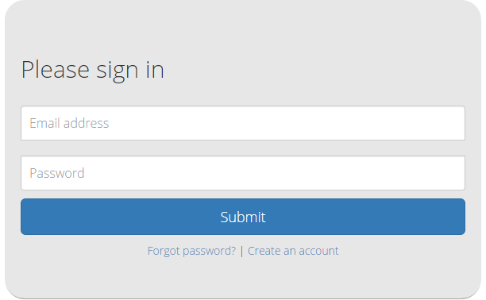

3.1.2 Create Account

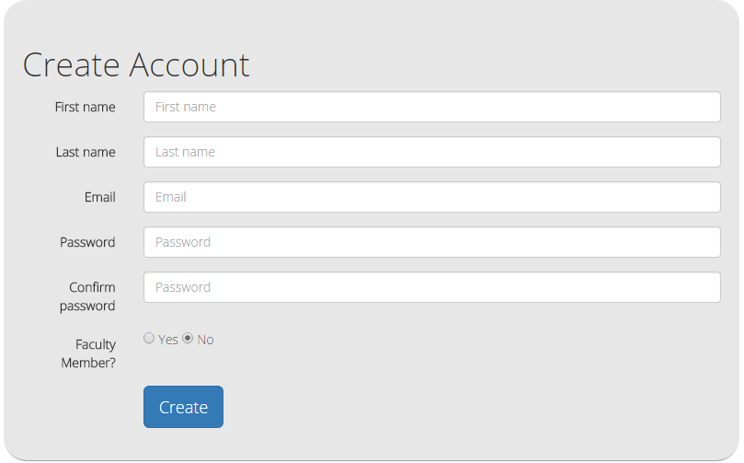

3.1.3 Student Homepage

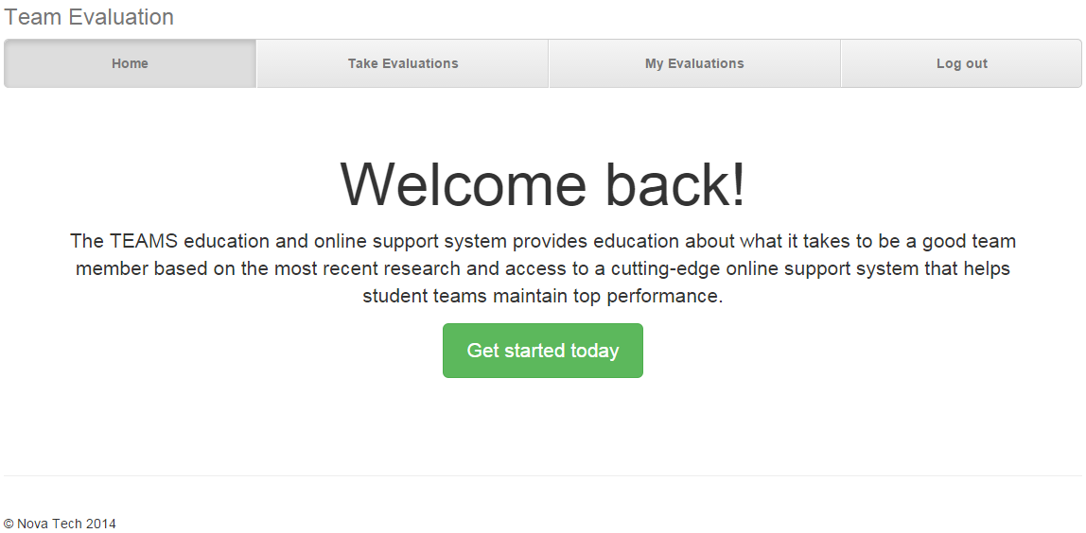

3.1.4 Student Select Course

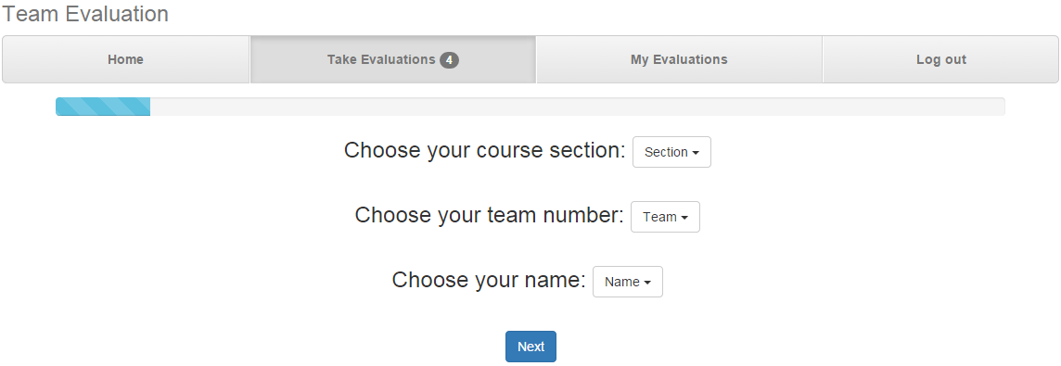

3.1.5 Student Take Evaluation

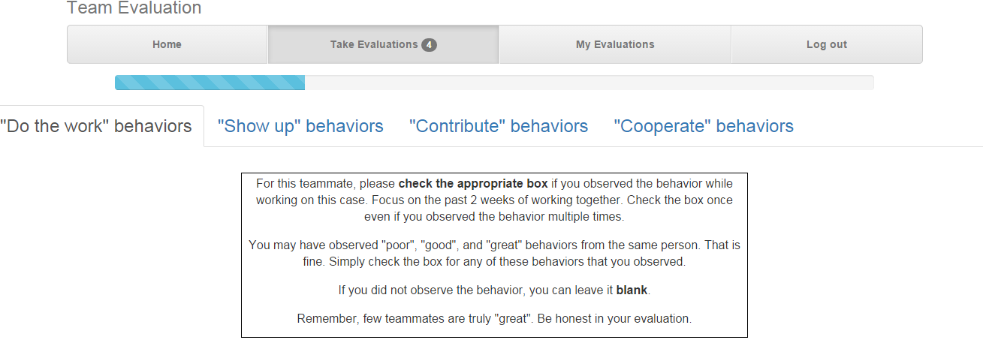

3.1.6 Faculty Homepage/Create Course-Section

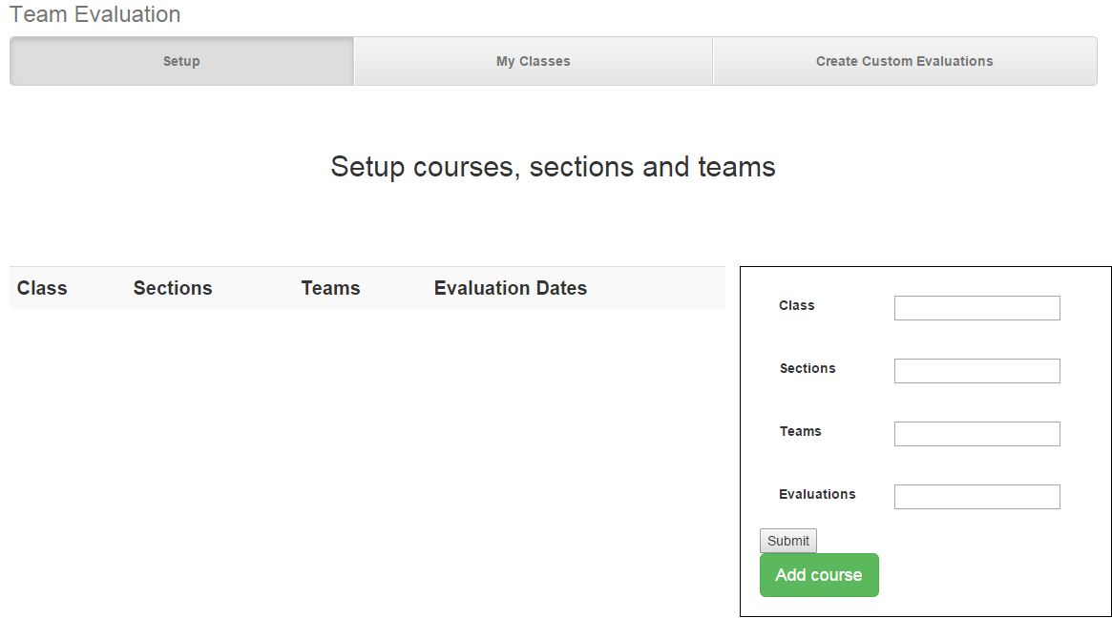

**3.2 Logical Data Dictionary:**

|  |  |  |  |  |  |  |
| --- | --- | --- | --- | --- | --- | --- |
| **Data Name** | **Data Type** | **Data Size** | **Description** | **Acceptable Input** | **Good Example of Input** | **Notes** |
| Username | String | 6-15 Chars | Username | A-Z, a-z, 0-9 | Dj04ferr |  |
| User_pass | String | 6-15 Chars | Password | A-Z, a-z, 0-9, ASCII 33-47 | Pdj901584480 |  |
| UserID | String | 6-15 Chars | Student ID | A-Z, a-z, 0-9 | 901445531 | Unique |
| User_Fname | String | 1-30  Chars | Username | A-Z, a-z | Jonny |  |
| User_Lname | String | 1-30  Chars | Username | A-Z, a-z | Doe |  |
| User_email | String | 6-50  Chars | Email | A-Z, a-z, 0-9 | Dj04ferr@siena.edu |  |
| PW_reset | Boolean | 4-5 Chars | Password Reset Button | TRUE, FALSE | true |  |
| User_Level | Integer | 1 Integer | User Permission Ranking | 0,1,2 | 2 | 0 = Student  1 = Faculty  2 = Admin |
| TeamID | String | 6-15 Chars | Team Id | A-Z, a-z, 0-9 | 113 | Unique |
| Number_on_team | Integer | 1-2 Integers | Number of team members | 1-10 | 4 |  |
| ClassID | Integer | 6-15 Chars | Class Id | A-Z, a-z, 0-9 | 17A | Unique |
| Member_ID | String | 6-15 Chars | ID for a team member | A-Z, a-z, 0-9 | 901445531 | Unique |
| Member_FN | String | 1-30 Chars | User First Name | A-Z, a-z, ‘, - | Hannah |  |
| Member_LN | String | 1-30 Chars | User Last Name | A-Z, a-z, ‘, - | Cooper |  |
| Team_Number | Integer | 1-2 Integers | Team Number | 0-20 | 9 |  |
| Faculty_Member | String | 1-15 Chars | Faculty member name | A-Z, a-z, ‘, - | Lim |  |
| Faculty_ID | String | 6-15 Chars | Faculty member ID number | A-Z, a-z, 0-9 | 901584480 | Unique |

**3.3 Logical Format of Data Files/Databases:**

Architectural Design Specification

**4.1 Development and Production Environments:**

4.1.1 Development Environment

Window’s Computer (Software Lab):

Model: Dell OptiPlex 760

Operating System: Windows Vista

Proc: Intel Core 2 Duo E7500 @2.93GHz

RAM: 4GB

HDD: 500GB

Software:

Adobe Dreamweaver, Google Chrome, Internet Explorer, Mozilla Firefox, MySQL, Notepad ++

NOVA Tech will also be using personal laptops throughout the development process.

4.1.2 Production Environment

Server Hostname: oraserv.cs.siena.edu

CentOS 5.2 (final)

Kernel: 2.6.18-92.el5

Intel Xeon 2.66 GHz CPU

8 GB of Memory

Java SE Runtime Environment (build 1.6.0 10-rc-b28)

GCC Version 4.1.2 20071124 (Red Hat 4.1.2-42)

NOVA Tech will be using a web based application located on a server provided by Dr. Eddy. Team Evaluations will utilize an Oracle database with an Apache Web server.

**4.2 Deliverables:**

Nova Tech will create the software Teammate Evaluation as well as the TEAMS101 Web Application with the following functionality which will be considered our deliverables for the project.

* A login screen for users
* Provide proper landing pages based on user permissions
* Allow for the evaluation of team members maintaining anonymity
* Create a customized report based on team member evaluations and send to user
* Allow administrators to see which students have completed the evaluations
* Allow administrators to see what each students said regarding other group members

**4.3 Data Flow Diagrams:**

Note - See Appendix

**4.4 Source Code:**

Note - See Appendix

Test Requirements & Results

**5.1 Explanation of Test Plan/Strategy:**

The Teammate Evaluation Software will be tested on all four major browsers. Nova Tech will test all the functional requirements of the Teammate Evaluation Software. Testing will be broken into modules and each module will be tested separately. Once a module is completely functional and passes all tests, the module will be tested via interactions with other modules. When this testing is complete, all the modules will be tested as an entire interactive system.

Nova Tech will also test the non-functional requirements of the Teammate Evaluation Software. This includes testing the system for user-friendliness by reviewing new user interactions in the system.

**5.2 Test Results:**

Note - See Appendix

Appendix

**6.1 Timeline:**

**6.2 Glossary of Terms:**

**Actor**: Actors that interact with the system through sues/actors can be human or non human

**Agile method:** Agile software development is a group of software development methods in which requirements and solutions evolve through collaboration between self-organizing, cross-functional teams

**Apache HTTP Server**: Apache Hypertext Transfer Protocol Server, Web server application

**Apple Safari**: Web browser designed by Apple

**Data Stores**: A component of a Data Flow Diagram that represents a location in which information or data is stored

**Database**: Organizes data, typically through a computer, so that the data is easily accessible

**Data Flow**: Data/information flowing to or from a process in a Data Flow Diagram

**Data Flow Diagram**: A graphical representation of the "flow" of data through an information system

**Data Store**: Location where data is held temporarily or permanently in a Data Flow Diagram

**External Entities**: A component of a Data Flow Diagram that represents any human or non-human user of a Software System

**Functional Requirements Inventory**: Defines what the system will be able to do and what is testable about the system

**Gantt Chart**: Bar chart typically used to project scheduling

**GIMP (GNU Image Manipulation Program):** Image retouching and editing tool released as free and open-source software by creators Spencer Kimball and Peter Mattis

**Google Chrome**: Web browser designed by Google

**Inclusion Arrow**: An arrow that points from a scenario to another scenario to show that something must be included for the scenario

**Inheritance Arrow**: An arrow that points from one use to another; the use of being pointed at is the parent and the other is the sub

**Internet Explorer**: Web browser designed by Microsoft

**Level-0 Diagram**: A data flow diagram that represents a system's major processes, data flows, and data stores at a high level of detail

**Level-1 Diagram**: Provides an overview of the major functional areas of the undertaking

**Mozilla Firefox**: Web browser designed by Mozilla Foundation and the Mozilla Corporation

**mySQL (Structured Query Language):** Programming language designed to manage data and develop databases

**Non-Functional Requirements Inventory**: Requirements that are not necessarily specific features that exist in a system, but what the system is intended to do

**Nova Tech:** Team name

**Notepad++:** Text editor specializing in syntactic highlighting of various programming languages

**Oracle Database**: An object-relational database management system produced and marketed

by Oracle Corporation

**Oraserv Database**: Siena College’s database server

**Participation Line**: Shows what scenarios an actor can interact with in a UML Use Case Diagram

**Process**: Transforms or manipulates data in a Data Flow Diagram

**Prototype**: An early sample, model or release of a product built to test a concept

**Scenarios**: The actions that occur within a system and how the user interacts with the system

**SQL**: Structured Query Language, language used to query databases

**SQL Developer:** Program used to create and modify database

**System Boundary**: The boundary between the system and the external entities in a Data Flow

Diagram

**TEAMS 101 - Team Evaluation:** Project name

**UML Use Case Diagram**: A type of behavioral diagram to present a graphical overview of the

functionality provided by a system

**UML (Unified Modeling Language):** A specification language used in software engineering

**Unit Te**

**sting:** A testing method where the system is broken down into units and each unit is tested

**UPC (User Permission Chart):** Chart that demonstrates the permissions of the different users in Team Evaluation

**Visual Paradigm:** a UML CASE Tool supporting UML 2, SysML and Business Process Modeling Notation (BPMN) from the Object Management Group (OMG). In addition to modeling support, it provides report generation and code engineering capabilities including code generation. It can reverse engineer diagrams from code, and provide round-trip engineering for various programming languages.

**Website Map:** A list of pages of a website accessible to users

**6.3 Sources of Information:**

The information that Nova Tech will utilize in creating this software will primarily come from the client, Dr. Erik Eddy, Dr. Fryling via our class lectures, and Dr. Lim in our lab activities. Auxiliary information may come from various other technical classes that our team members have taken, including Database Management and Web Application Development.

**6.4 Data Flow Diagrams:**

The data flow diagrams will contain the context diagram, a level 0 diagram, and multiple level 1 diagrams. These diagrams visually depict the movement of data between both internal processes and external entities. From these diagrams, the structure of the system can be analyzed as well as the ways in which data moves throughout the system, outside of the system, and is stored and retrieved. The following symbols will be used in the data flow diagrams:

**6.4.1 Data Flow Diagram Legend**

|  |  |
| --- | --- |
|  | **Process:** System components that can receive, modify, and output data. |
|  | **Entity:** Contributes data and information to system. Entities can also receive information from the system. |
|  | **Data Flow:** Indicates the movement of data to or from a process. |
|  | **Data Store:** The location where data is held either temporarily or permanently. |
|  | **System Boundary:** The definition between internal processes and external entities. |

**6.4.2 Context Diagram**

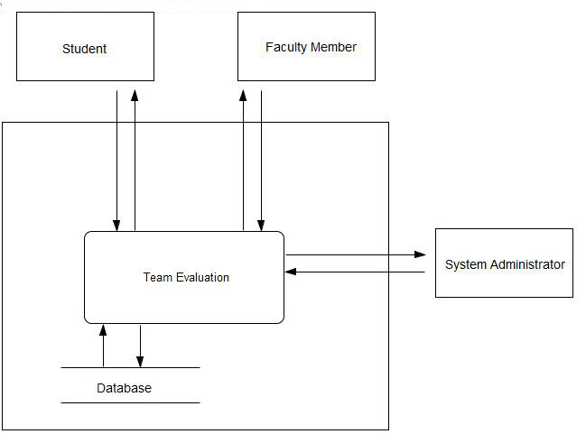

**6.4.3 Level 0 Diagram**

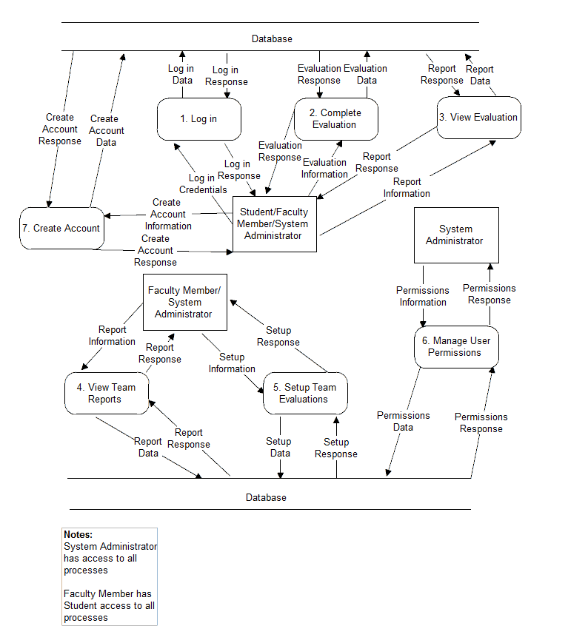

**6.4.4 Level 1 Diagrams**

**6.4.4.1 Create Account**

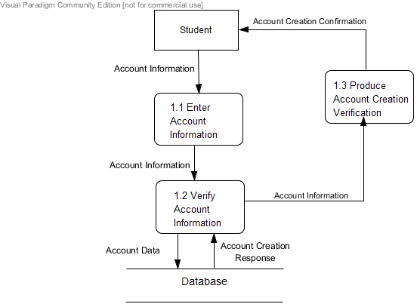

**6.4.4.2 Login**

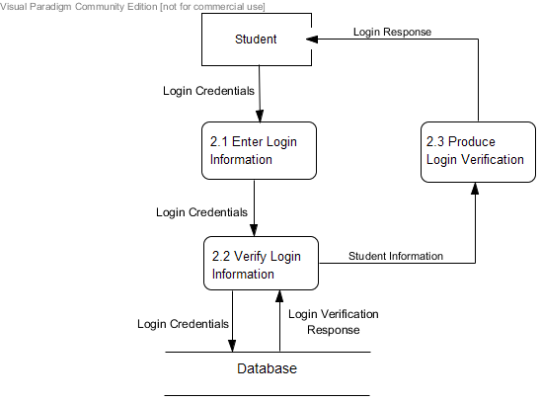

**6.4.4.3 Evaluate Teammate**

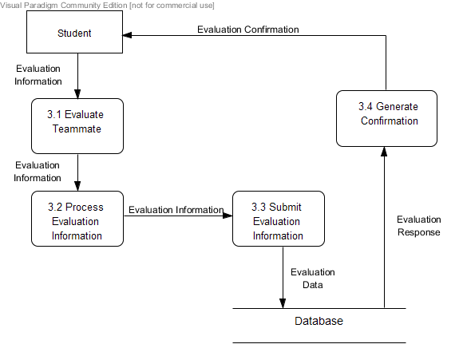

**6.4.4.4 View Individual Report**

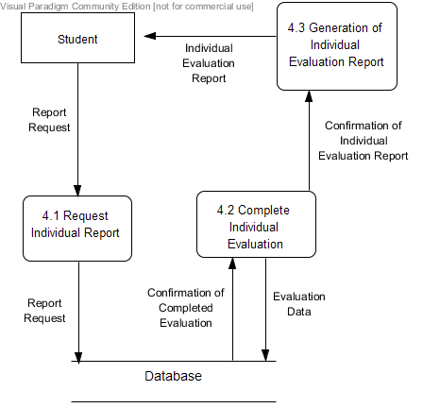

**6.4.4.5 View Team Report**

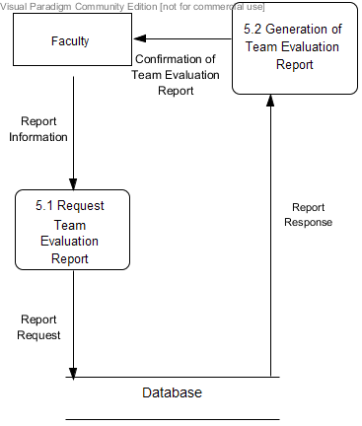

**6.4.4.6 Establish Class Roster/Team Profile**

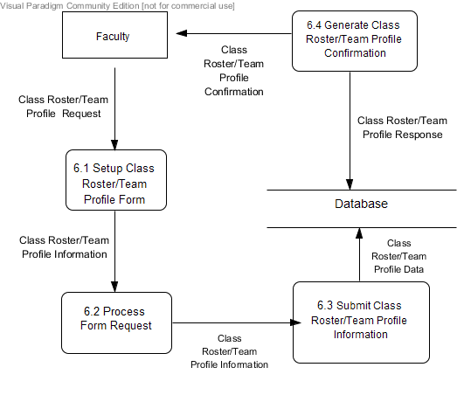

**6.4.4.7 Manage Team Evaluations**

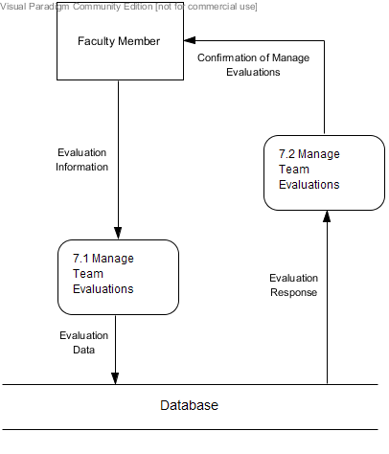

**6.4.4.8 Manage User Permissions**

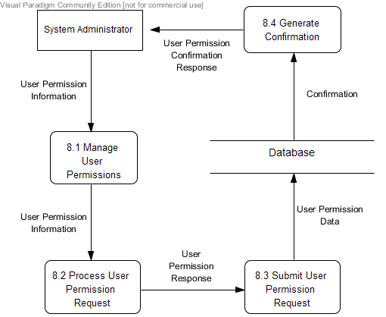

**6.5 Source Code:**

6.5.1 TEAMS 101 Application Platform Home

Visit [*https://github.com/novatechnology/teams101/blob/master/index.php*](https://github.com/novatechnology/teams101/blob/master/index.php) to view the code.

6.5.2 About TEAMS 101

Visit [*https://github.com/novatechnology/teams101/blob/master/about.php*](https://github.com/novatechnology/teams101/blob/master/about.php)to view the code.

6.5.3 Team Evaluation Log In

Visit [*https://github.com/novatechnology/teams101/blob/master/team_evaluation/login/login.php*](https://github.com/novatechnology/teams101/blob/master/team_evaluation/login/login.php)to view the code.

6.5.4 Team Evaluation Create An Account

Visit [*https://github.com/novatechnology/teams101/blob/master/team_evaluation/login/create-account.html*](https://github.com/novatechnology/teams101/blob/master/team_evaluation/login/create-account.html)to view the code.

6.5.5 Team Evaluation Home Page

Visit [*https://github.com/novatechnology/teams101/blob/master/team_evaluation/home.php*](https://github.com/novatechnology/teams101/blob/master/team_evaluation/home.php)to view the code.

**6.6 Test Results:**

6.6.1 Test Directory

***

6.6.2 Unit Test 1

***

6.6.3 Unit Test 2

***