|  |  |
| --- | --- |
|  | Prepared by:  Emma Bostian  Kevin Conner  Justin Rose  David Hall  Sara Pinti |

Requirements Specification

**Client: Dr. Erik Eddy**

**Teammate Evaluation Software**

Dr. Meg Fryling

Dr. Darren Lim

Siena College

Department of Computer Science

october 28, 2014

Table of contents

|  |  |
| --- | --- |
| 1. Product Overview and Summary | 3 |
| 2. Development and Operating Environment | 4 |
| 2.1 Development Environment | 4 |
| 2.2 Operating Environment | 4 |
| 3. User Case Narratives and Permission Charts | 5 |
| 3.1 Student | 5 |
| 3.1.1 Create Account | 5 |
| 3.1.2 Complete Evaluation | 5 |
| 3.1.3 View Evaluation Results | 5 |
| 3.2 Faculty Member | 6 |
| 3.2.1 Establish Class Roster/Team Profile | 6 |
| 3.2.2 Manage Evaluations | 7 |
| 3.2.3 View Team Evaluations | 8 |
| 3.3 System Administrator | 8 |
| 3.3.1 Manage User Permissions | 8 |
| 3.4 User Permission Charts | 9 |
| 4. Use Case Diagram | 10 |
| 4.1 Use Case Diagram Legend | 10 |
| 4.2 UML Use Case Diagram | 11 |
| 5. Data Flow Diagrams | 12 |
| 5.1 Data Flow Diagram Legend | 12 |
| 5.2 Context Diagram | 13 |
| 5.3 Level 0 Diagram | 14 |
| 5.4 Level 1 Diagrams | 15 |
| 5.4.1 Create Account | 15 |
| 5.4.2 Login | 16 |
| 5.4.3 Evaluate Teammate | 17 |
| 5.4.4 View Individual Report | 18 |
| 5.4.5 View Team Report | 19 |
| 5.4.6 Establish Class Roster/Team Profile | 20 |
| 5.4.7 Manage Team Evaluations | 21 |
| 5.4.8 Manage User Permissions | 22 |
| 6. Functional Requirements Inventory | 23 |
| 6.1 Student User Level | 23 |
| 6.2 Staff/Teacher User Level | 23 |
| 6.3 Administrator User Level | 23 |
| 7. Non-Functional Requirements | 24 |
| 8. Exception Handling | 24 |
| 9. Implementation Priorities | 24 |
| 10. Foreseeable Modifications and Enhancements | 24 |
| 11. Testing Requirements | 25 |

product overview and summary

Teammate Evaluation will be a core web application on the TEAMS 101 (Team Evaluation and Management System) dashboard, and it will give students an easily-accessible interface to provide teammate evaluations periodically during group projects. Dr. Erik Eddy realizes the importance that team evaluations hold within a group dynamic, not only in regards to the final grade for the assignment, but for the overall cohesiveness and harmony of the group. Team Evaluation will not only provide Siena College students with the ability to communicate more productively, it will provide professors and administrators the ability to be better acquainted with the team member’s participation and performance.

Development and Operating Environments

2.1 Development Environment

Software Engineering Windows Computer

* Model: Dell Optiplex 760
* Operating System: 64-bit Windows 7 Enterprise
* Processor: Intel(R) Core(™)2 Quad CPU Q9650 @ 3.00GHz 2.99 GHz
* RAM: 4.00 GB
* HDD: 232 GB

Software Engineering Macintosh Computer

* Model: iMac 5.1
* Operating System:
* Processor: Intel Core i5 2.5 GHz
* RAM: 4.00 GB
* HDD: 500 GB

Server

* Hostname: oraserv.cs.siena.edu
* Memory: 8.0 GB
* RAM: 8GB

Software

* Google Chrome, Internet Explorer, Mozilla Firefox, Safari, MySQL, Notepad++, Eclipse, Smartdraw, GIMP

2.2 Operating Environment

NOVA Tech will be using a web based application which will be hosted on a Siena College Oraserv database server. Team Evaluation will work in tandem with an Oracle database and will be hosted on an Apache web server. Team Evaluation will also communicate with Blackboard to update each student's grades.

User Case Narratives & Permission Charts

3.1.1 Student Perspective: Create Account

The student signs into the Siena College computer with his username and password. Next, the student opens a web browser and logs in to his Siena email account. The student clicks the email from his professor containing the link to the TEAMS101 portal. The student navigates to the Teammate Evaluation application by clicking the icon on the portal, and clicks “Create Account”. The web page prompts the student to enter his first name, last name, Siena email address and asks his to create a new password. After inputting the information on the form, the student clicks “Finalize Account” and the web page changes to a confirmation screen which informs the student that his new account has been created.

3.1.2 Student Perspective: Complete Evaluation

The student signs into the Siena College computer with his username and password. Next, the student opens a web browser and logs in to his Siena email account. The student clicks the email from his professor containing the link to the TEAMS101 portal. The student navigates to the Teammate Evaluation application by clicking the icon on the portal. The student enters his username and password and clicks “Login”. Once logged in, the student clicks “Complete Evaluation” from the navigation bar. The student rates each team member on a scale of one to five for each of the group behaviors. Once completed, the student clicks “Submit” which locks in their evaluation responses and notifies the faculty member that an evaluation has been completed. The student then proceeds to log off of Teammate Evaluation, and the application returns to the home screen.

3.1.3 Student Perspective: View Evaluation Results

The student signs into the Siena College computer with his username and password. Next, the student opens a web browser and logs in to his Siena email account. The student clicks the email from his professor containing the link to the TEAMS101 portal. The student navigates to the Teammate Evaluation application by clicking the icon on the portal. The student enters his username and password and clicks “Login”. The student clicks on the “View My Evaluations” tab from the navigation bar. From this page, the student can view a list of classes that they are currently enrolled in, and he chooses one to view his individual report. Once the specific course has been chosen, the student is shown a list of reports, organized by date. The student selects one individual report to view by clicking a specific date. Once the student has finished examining their individual report, he logs off of Teammate Evaluation by clicking “Log out”, and the application returns to the home screen..

3.2.1 Faculty Member Perspective: Establish Class Roster/Team Profile

The faculty member signs into the Siena College computer with his username and password. Next, the faculty member opens a web browser and navigates to the TEAMS101 portal. The faculty member navigates to the Teammate Evaluation application by clicking the icon on the portal. The faculty member enters his username and password and clicks “Login”.

The faculty member clicks “Create New Class” from the navigation bar and the web page changes to the “Class Roster” form. The faculty member enters each student’s Siena email address and clicks “Save Class Changes”. The web page returns to the “Class Roster” default page with the newly established class listed as a hyperlink to the class profile page. The faculty member clicks the hyperlink to the class page they just created and the web page changes to the class profile.

The faculty member clicks “Add New Team” on the class profile page. The faculty member selects students from the class roster by clicking the plus sign next to their name. The web page automatically updates with the selected team members. Once all team members have been added to the team, the faculty member clicks “Submit”. The web page returns to the class profile home page and the faculty member continues the “Add New Team” process until all students are assigned to a team. After this process is completed, the faculty member logs off of Teammate Evaluation by clicking “Log out”, and the application returns to the home screen.

3.2.2 Faculty Member Perspective: Manage Evaluations

The faculty member signs into the Siena College computer with his username and password. Next, the faculty member opens a web browser and navigates to the TEAMS101 portal. The faculty member navigates to the Teammate Evaluation application by clicking the icon on the portal. The faculty member enters his username and password and clicks “Login”.

The faculty member selects “Manage Evaluations” from the navigation bar and the web page changes to the “Manage Team Evaluations” web page. From this web page, the faculty member can view a list of pre-existing team evaluations that they have previously created. The faculty member is able to Edit and Delete existing evaluations, as well as create new evaluations. The faculty member is also able to send an invitation to complete the evaluations to specific teams.

The faculty member selects “Create New Evaluation” from the “Manage Evaluations” web page, and the page changes to the “Create New Evaluation” form. The faculty member enters evaluation questions into the text boxes in the evaluation form, and once all questions have been entered, he clicks the “Submit Evaluation” button at the bottom of the page. The browser returns to the “Manage Evaluations” web page and the newly created evaluation is listed under the existing evaluations.

The faculty member now clicks “Edit” next to a pre-existing evaluation and the browser changes to the “Edit Existing Evaluation” form. The faculty member clicks the “Delete” button next to existing questions to delete them, and enters new questions into the text box at the bottom of the form. Once the faculty member is done editing an evaluation, he clicks “Submit Evaluation” button at the bottom of the page. The browser returns to the “Manage Evaluations” web page.

The faculty member is also able to click “Delete” next to a pre-existing evaluation in order to delete an entire Team Evaluation from the Database.

Finally, the faculty member clicks “Send Evaluation to Teams” and the browser changes to the “Sent Evaluations to Teams” web page. The faculty member selects the pre-existing Team Evaluation that they want to invite teams to take, and selects the teams from the list of classes that they want to send the evaluation to. Once all teams are selected, the faculty member selects “Send to Teams” button from the bottom of the web page. The web browser confirms that the evaluations have been sent with a confirmation text box, and returns to the home page. The faculty member logs off of Teammate Evaluation by clicking “Log out”, and the application returns to the home screen.

3.2.3 Faculty Member Perspective: View Team Evaluations

The faculty member signs into the Siena College computer with his username and password. Next, the faculty member opens a web browser and navigates to the TEAMS101 portal. The faculty member navigates to the Teammate Evaluation application by clicking the icon on the portal. The faculty member enters his username and password and clicks “Login”.

The faculty member selects “View Team Evaluations” from the navigation bar and the web browser changes to the “View Team Evaluations” web page. The faculty member then selects a class from the list of classes on the web page, and the browser changes to the selected class’s individualized report. From this page, the faculty member can view a summarized report of the ranking of teams in the class, as well as view which teams have completed the evaluations and which have not. The faculty member clicks a team from the list of teams for the class, and the web browser changes to the “Team Profile” page. From this page, faculty members can click team members to view their individualized reports, and view which team members have completed evaluations for their peers.

After the faculty member has viewed all team evaluations, he logs off of Teammate Evaluation by clicking “Log out”, and the application returns to the home screen.

3.3.1 Administrator Perspective: Manage User Permissions

The administrator signs into the Siena College computer with his username and password. Next, the administrator opens a web browser and navigates to the TEAMS101 portal. The administrator navigates to the Teammate Evaluation application by clicking the icon on the portal. The administrator enters his username and password and clicks “Login”.

The administrator clicks “Edit User Permissions” from the navigation bar, and the web browser changes to the “Edit User Permissions” web page. The administrator can view every user account in the database, and is able to search for existing users. The administrator enters a username into the search box, and selects the user account from the results. The web browser changes to the “User Profile” web page. Here, the administrator clicks the “Faculty Member” check box next to the username, and clicks “Save Changes”. The web page changes to show a confirmation of the changes, and automatically notifies the user that they have been given faculty member permissions. The administrator is also able to uncheck the “Faculty Member” box to remove a user as a faculty member.

After the administrator has finished managing permissions, he logs off of Teammate Evaluation by clicking “Log out”, and the application returns to the home screen.

3.4 User Permission Charts

X = Granted Permission

System Use

|  |  |  |  |
| --- | --- | --- | --- |
| **System Management Permissions** | System Administrator | Faculty | Student |
| Submit Team Member Evaluations | X | X | X |
| View Individual Report Results | X | X | X |
| View Team Report Results | X | X |  |

System Management

|  |  |  |  |
| --- | --- | --- | --- |
| **System Management Permissions** | System Administrator | Faculty | Student |
| Log In | X | X | X |
| Set Up Team Evaluations | X | X |  |
| Setup Username and Password for Each User | X | X |  |
| Add Faculty Users to System | X |  |  |
| Delete Faculty Users from System | X |  |  |
| Manage User Permissions | X |  |  |
| Add Student Users to System | X | X |  |
| Delete Student Users from System | X | X |  |



Use Case Diagrams

4.1 Use Case Diagram Legend

|  |  |
| --- | --- |
|  | **System Boundary**: Delineates between internal and external components. All system interaction is contained within the system boundary. Actors are located outside of the system boundary. Scenarios are located inside the system boundary. |
|  | **Actor**: An external entity that acts upon the system. Actors can be both human and non-human users. Human actors are placed on the left side of the diagram. Non-human actors are placed on the right side of the diagram. The actor name is displayed underneath the actor. |
|  | **Participation Line**: Indicates the scenarios the actors interact with. |
|  | **Scenario**: A component within the system that the users may interact with. |
|  | Actor A interacts with all scenarios within the system boundary. |
|  | Actor A interacts with scenario B. |
|  | Scenario A includes scenario B |
| A to B extends.JPG | Scenario A extends scenario B. A is the parent scenario and B is the child scenario. |

4.2 UML Use Case Diagram

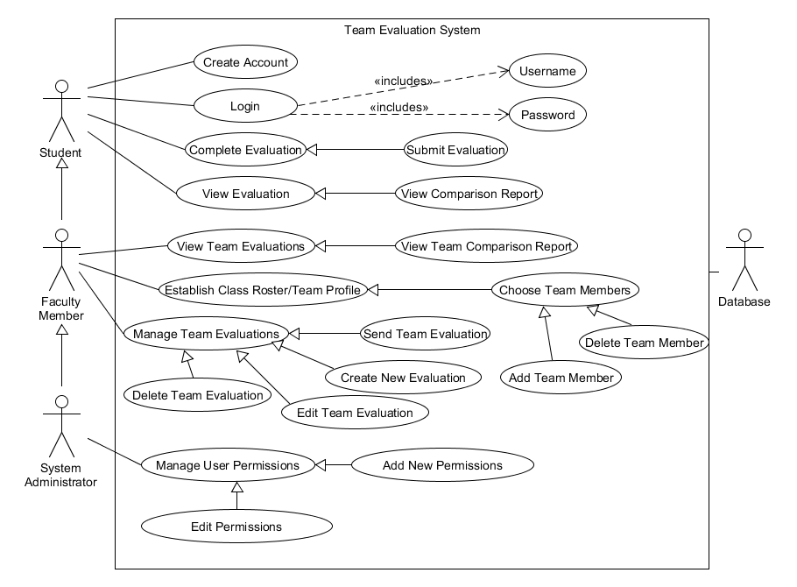

Data Flow Diagrams

The data flow diagrams will contain the context diagram, a level 0 diagram, and multiple level 1 diagrams. These diagrams visually depict the movement of data between both internal processes and external entities. From these diagrams, the structure of the system can be analyzed as well as the ways in which data moves throughout the system, outside of the system, and is stored and retrieved. The following symbols will be used in the data flow diagrams:

5.1 Data Flow Diagram Legend

|  |  |
| --- | --- |
|  | **Process:** System components that can receive, modify, and output data. |
|  | **Entity:** Contributes data and information to system. Entities can also receive information from the system. |
|  | **Data Flow:** Indicates the movement of data to or from a process. |
|  | **Data Store:** The location where data is held either temporarily or permanently. |
|  | **System Boundary:** The definition between internal processes and external entities. |

5.2 Context Diagram

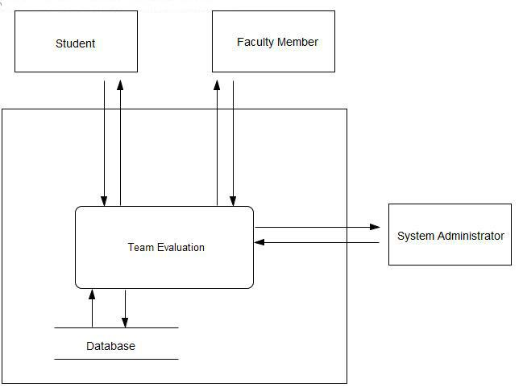

5.3 Level 0 Diagram

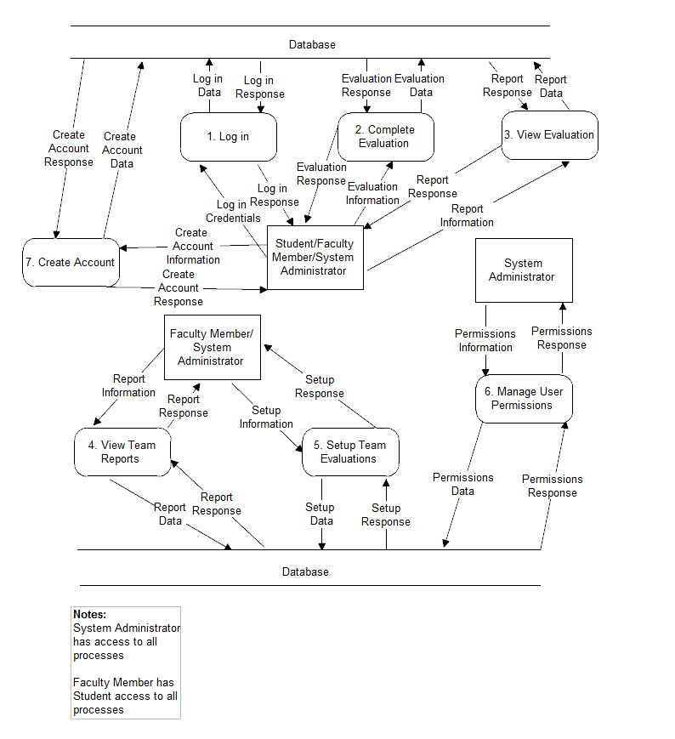

5.4 Level 1 Diagrams

5.4.1 Create Account

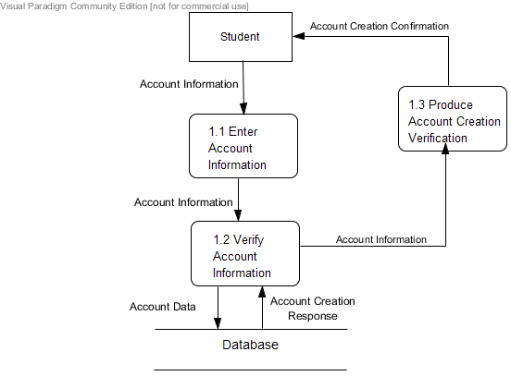

5.4.2 Login

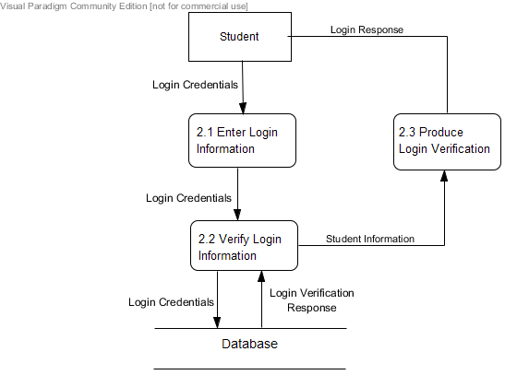

5.4.3 Evaluate Teammate

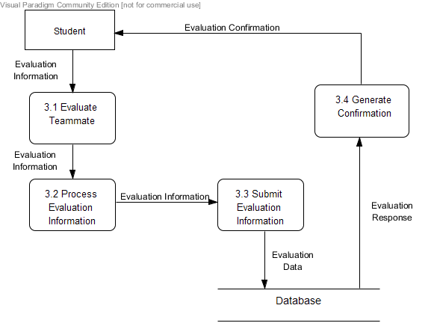

5.4.4 View Individual Report

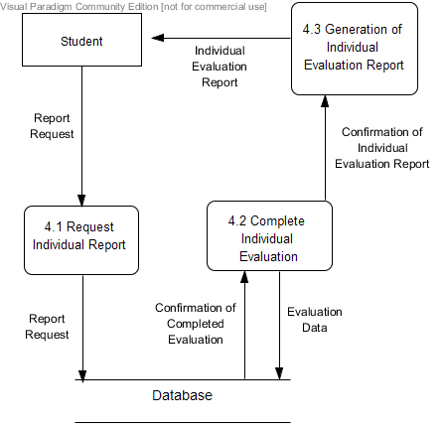

5.4.5 View Team Report

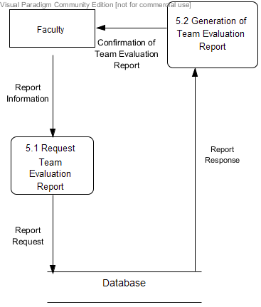

5.4.6 Establish Class Roster/Team Profile

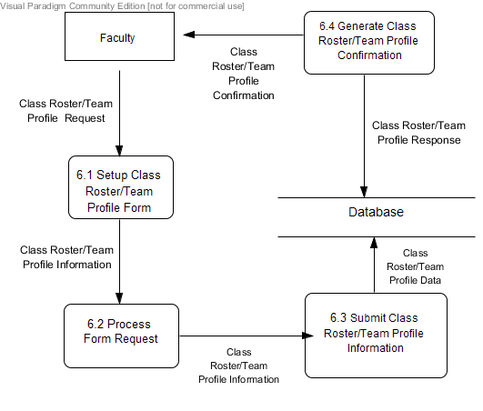

5.4.7 Manage Team Evaluations

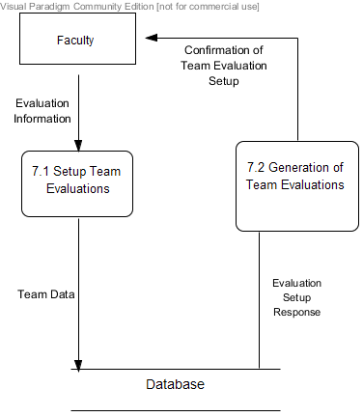

5.4.8 Manage User Permissions

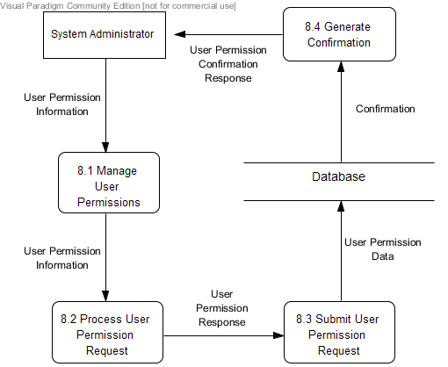

Functional Requirements Inventory

An outline list below discusses the required functionality of Teammate Evaluation as organized by the user type. Teammate Evaluation will be web-based software and the application will be accessible on all Internet browsers and mobile platforms.

6.1 Student User Level

* Capable of logging onto the system
  + A failed login will result in an error message
* Can fill out teammate evaluation form for each teammate
* Can access own evaluation report and view other’s anonymous reports
  + Cannot access own evaluation report unless three teammates have submitted reports for this user
* Can log out of system

6.2 Staff/Teacher User Level

* Capable of logging onto the system
  + A failed login will result in an error message
* Can fill out teammate evaluation reports for any student in class
* Can assign teams/replace team members
* Can view all student evaluations for any team and who submitted them
* Can log out of system

6.3 Administrator User Level

* Capable of logging onto the system
  + A failed login will result in an error message
* Can fill out teammate evaluation reports for any student in class
* Can assign teams/replace team members
* Can view all student evaluations for any team and who submitted them
* Can grant administrator privileges to other users
* Can log out of system

NONFunctional Requirements

The non-functional requirements will explain the specific properties of TEAMS-101. These following specifications are not definable features, but rather traits that will help with ease of use for the system. As such, these specifications cannot be measured objectively. Below is a list of TEAMS-101’s non-functional requirements:

* Teammate Evaluation will be efficient
* Teammate Evaluation will be user-friendly
* Teammate Evaluation will be compatible on multiple browsers, as well as on mobile platforms
* Teammate Evaluation will require little maintenance and will be stable
* Teammate Evaluation will be easily accessible by all users

Exception Handling

Nova Tech will design a system that will be accessed by both students and administrators or professors, therefore an exception will arise when creating the system for a differing account.

The design of the software dictates that a login is required and an exception again arises when outside users try accessing the evaluation link. Nova Tech will handle with new exceptions in the appropriate manner next semester once there is a better understanding of the system.

Implementation Priorities

Nova Tech plans on implementing all facets of Teammate Evaluation and has created a list to determine the essential implementations of the software.

* Administrators ability to access and send out proper evaluation
* Students ability to receive and complete evaluations
* The ability for the software to calculate score based on evaluation responses
* Type of evaluation information and representation for administrative accounts
* Information sent to student in order to give advice on how to improve

Foreseeable Modification and Enhancement

As a future enhancement, Dr. Erik Eddy would like Teammate Evaluation to be accessible for students at other colleges and universities to use. One problem with this possible modification is the access to Blackboard, as some universities may opt to use alternative Software which NOVA Tech would not have permissions to access.

Testing Requirements

The Teams-101 system will be thoroughly tested throughout many phases of development. Nova-Tech will create these testing requirements using the criteria outlined in section 6, and will frequently share these test results with the client to ensure full transparency. It will be tested on both Windows Vista and Mac OS X. It will also be tested using the following web browsers:Mozilla Firefox, Apple Safari, Internet Explorer, and Google Chrome.

Acceptance Criteria

The acceptance criteria for the Teammate Evaluation software will be the functional and nonfunctional requirements outlined in section 6 and 7 of this document. The ability of the Teams-101 system to meet all of the criteria will be thoroughly tested as defined above.

APPENDICES

Glossary of Terms

**Actor**: Actors that interact with the system through sues/actors can be human or non human

**Agile method:** Agile software development is a group of software development methods in which requirements and solutions evolve through collaboration between self-organizing, cross-functional teams

**Apache HTTP Server**: Apache Hypertext Transfer Protocol Server, Web server application

**Apple Safari**: Web browser designed by Apple

**Data Stores**: A component of a Data Flow Diagram that represents a location in which information or data is stored

**Database**: Organizes data, typically through a computer, so that the data is easily accessible

**Data Flow**: Data/information flowing to or from a process in a Data Flow Diagram

**Data Flow Diagram**: A graphical representation of the "flow" of data through an information system

**Data Store**: Location where data is held temporarily or permanently in a Data Flow Diagram

**External Entities**: A component of a Data Flow Diagram that represents any human or non-human user of a Software System

**Functional Requirements Inventory**: Defines what the system will be able to do and what is testable about the system

**Gantt Chart**: Bar chart typically used to project scheduling

**GIMP (GNU Image Manipulation Program):** Image retouching and editing tool released as free and open-source software by creators Spencer Kimball and Peter Mattis

**Google Chrome**: Web browser designed by Google

**Inclusion Arrow**: An arrow that points from a scenario to another scenario to show that something must be included for the scenario

**Inheritance Arrow**: An arrow that points from one use to another; the use of being pointed at is the parent and the other is the sub

**Internet Explorer**: Web browser designed by Microsoft

**Level-0 Diagram**: A data flow diagram that represents a system's major processes, data flows, and data stores at a high level of detail

**Level-1 Diagram**: Provides an overview of the major functional areas of the undertaking

**Mozilla Firefox**: Web browser designed by Mozilla Foundation and the Mozilla Corporation

**mySQL (Structured Query Language):** Programming language designed to manage data and develop databases

**Non-Functional Requirements Inventory**: Requirements that are not necessarily specific features that exist in a system, but what the system is intended to do

**Nova Tech:** Team name

**Notepad++:** Text editor specializing in syntactic highlighting of various programming languages

**Oracle Database**: An object-relational database management system produced and marketed

by Oracle Corporation

**Oraserv Database**: Siena College’s database server

**Participation Line**: Shows what scenarios an actor can interact with in a UML Use Case Diagram

**Process**: Transforms or manipulates data in a Data Flow Diagram

**Prototype**: An early sample, model or release of a product built to test a concept

**Requirements Specification**: Further defining the client’s problem to meet the specifications and requirements

**Scenarios**: The actions that occur within a system and how the user interacts with the system

**SQL**: Structured Query Language, language used to query databases

**SQL Developer:** Program used to create and modify database

**System Boundary**: The boundary between the system and the external entities in a Data Flow

Diagram

**TEAMS 101 - Team Evaluation:** Project name

**UML Use Case Diagram**: A type of behavioral diagram to present a graphical overview of the

functionality provided by a system

**UML (Unified Modeling Language):** A specification language used in software engineering

**UPC (User Permission Chart):** Chart that demonstrates the permissions of the different users in Team Evaluation

**Visual Paradigm:** a UML CASE Tool supporting UML 2, SysML and Business Process Modeling Notation (BPMN) from the Object Management Group (OMG). In addition to modeling support, it provides report generation and code engineering capabilities including code generation. It can reverse engineer diagrams from code, and provide round-trip engineering for various programming languages.

**Timeline:**

