IB PHYSICS SL · THEME A: SPACE, TIME AND MOTION
A.1 Kinematics
A.2 Forces and Momentum
The important stuff. Every idea explained from the ground up.
WHAT THIS TOPIC IS ABOUT Kinematics is just the description of motion: where is something, how fast is it going, and how quickly is that speed changing? It does not ask why it moves like that (that is forces, the next topic). Everything in this guide grows out of one chain of ideas: position → velocity → acceleration.

How this guide is organised
Chapter | What is in it | How to use it
1. Kinematics (A.1) | Motion described without asking why: displacement, velocity, acceleration, motion graphs, SUVAT, free fall, projectiles and fluid resistance. | Read in order the first time. Come back to single sections when you are stuck.
2. Forces and Momentum (A.2) | Why things move: Newton’s three laws, free-body diagrams, the forces you need to know, momentum and impulse, collisions and circular motion. | Read after Chapter 1: it uses the kinematics equations throughout.

The six-step method for any problem
Step | What you do | Why
1. Draw | Sketch the situation. Choose the origin and which direction is positive. | Signs are the biggest source of lost marks. Decide them once, at the start.
2. List | Write what you know and what you want, with units. | Shows you which quantities are missing.
3. Choose | Pick the equation (or graph rule) that contains what you want and leaves out the quantity you do not have. | Avoids needless extra calculations.
4. Rearrange | Solve for the unknown in symbols first. | Fewer rounding errors; easier to check.
5. Substitute | Put in numbers with units and calculate. | Wrong units show up as wrong answers.
6. Check | Is the sign right? Is the size sensible? Does it match a graph or a limiting case? | Catches slips before the examiner does.
Unless a question says otherwise: take g = 9.81 m s⁻² (the value in the IB data booklet) and ignore air resistance.

Contents
Section | Title | Section | Title
Chapter 1 | Kinematics | Chapter 2 | Forces and Momentum
1.1 | The big picture: how everything connects | 2.1 | Forces and Newton’s first law
1.2 | Distance, displacement and signs | 2.2 | Free-body diagrams
1.3 | Speed and velocity | 2.3 | The forces you need to know
1.4 | Acceleration | 2.4 | Newton’s second law
1.5 | Motion graphs: gradients and areas | 2.5 | Forces at an angle and on slopes
1.6 | Equations of motion (SUVAT) | 2.6 | Newton’s third law
1.7 | Free fall | 2.7 | Momentum
1.8 | Vectors: splitting into components | 2.8 | Impulse and force–time graphs
1.9 | Projectile motion | 2.9 | Conservation of momentum: collisions and explosions
1.10 | Fluid resistance and terminal speed | 2.10 | Circular motion
1.11 | Experiments: measuring g and uncertainty
1.12 | Relative velocity in a straight line (enrichment)

Chapter 1
Kinematics

1.1 The big picture: how everything connects
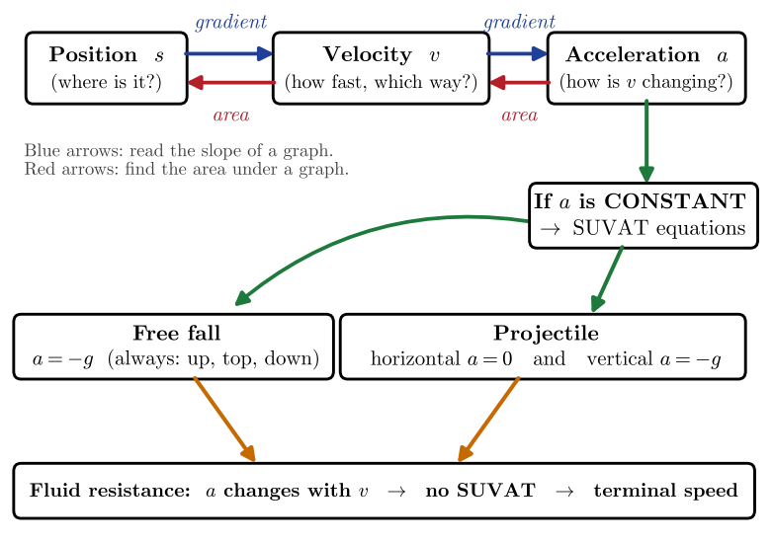  Figure 1.1: How the ideas in kinematics connect. Gradients take you along the chain from position to velocity to acceleration; areas take you back. Constant acceleration gives SUVAT; free fall and projectiles are special cases; fluid resistance breaks the “constant acceleration” assumption. | Kinematics looks like a long list of topics: graphs, equations, free fall, projectiles. They are all one idea seen from different angles. Three quantities describe motion, and each one is how quickly the previous one changes:  - Position (s) tells you where an object is.  - Velocity (v) tells you how quickly position is changing, and in which direction.  - Acceleration (a) tells you how quickly velocity is changing.  On a graph, “how quickly something changes” is a gradient (slope), and going the other way (adding up all the little changes) is an area. That is why graphs are so central: they are the picture of this chain.
  IN PLAIN ENGLISH Velocity answers “how fast is my position changing?” Acceleration answers “how fast is my velocity changing?” If you can say those two sentences without looking, you already understand most of this topic. Everything else is learning to read that idea from a graph, an equation or a diagram.

1.2 Distance, displacement and signs
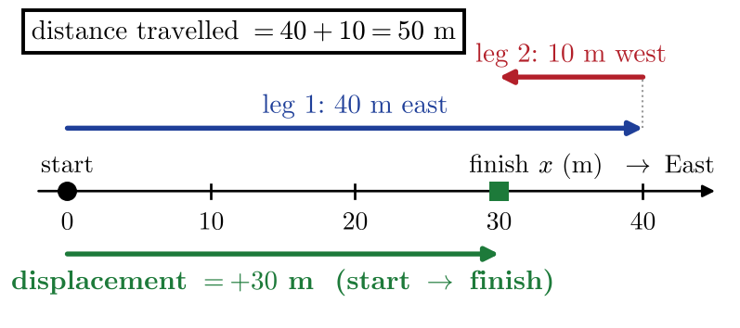  Figure 1.2: A walk of 40 m east followed by 10 m west. The distance travelled is 50 m, but the displacement is only +30 m (30 m east of the start). | Position is always measured relative to a chosen origin. You choose the origin and which direction counts as positive; the physics does not care, but you must stay consistent.  Distance is the total length of the path travelled. It only ever adds up, so it is never negative. Displacement is the straight-line change in position from start to finish, with direction:  Quantities that have only a size are scalars. Quantities that also have a direction are vectors. In one dimension, direction is shown by a sign: after you choose “east is positive”, a displacement of −5 m simply means 5 m to the west.
   | $$Δs=s_{\text{final}}−s_{\text{initial}}$$ | (1.1)

Scalar (size only) | Vector (size and direction) | Link
distance (m) | displacement (m) | displacement is distance with direction, measured start → finish
speed (m s⁻¹) | velocity (m s⁻¹) | velocity is displacement per unit time
time (s) | acceleration (m s⁻²) | acceleration is change of velocity per unit time

WATCH OUT A negative sign means “opposite to the positive direction”. It does not mean “smaller” or “wrong”. A velocity of −8 m s⁻¹ is faster than +3 m s⁻¹. Also: the distance travelled is always at least as big as the size of the displacement. They are equal only for straight-line motion that never turns back.

1.3 Speed and velocity
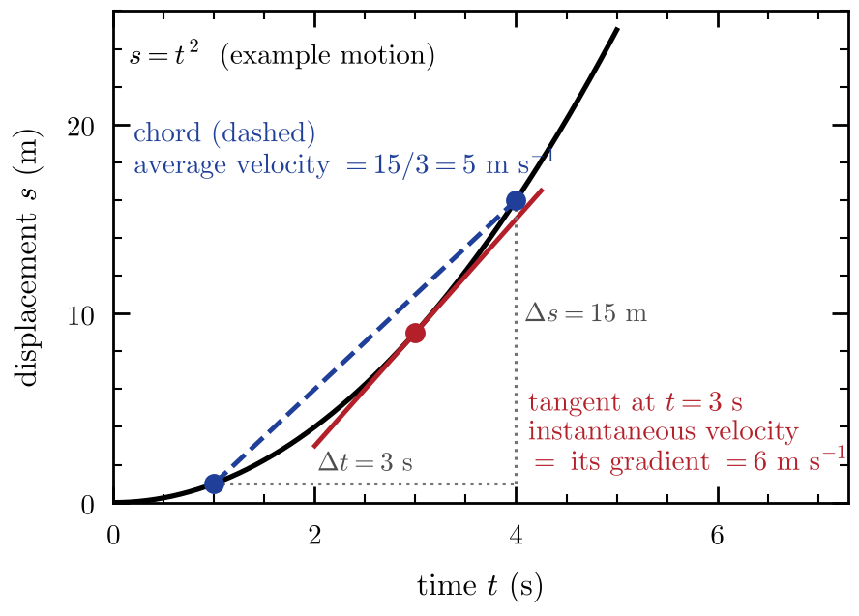  Figure 1.3: On a displacement–time graph, the chord between two points (dashed) gives the average velocity over that interval. The tangent at a single point (red) gives the instantaneous velocity at that moment. | Speed is how much distance is covered per second. Velocity is how much displacement is covered per second, so velocity has a direction. For a whole journey we use averages:  An average hides what happens in between. The instantaneous velocity is the velocity at one moment. It is what you get from the average when you make the time interval Δt shrink towards zero:
   | $$\text{average speed}=\frac{\text{total distance}}{\text{total time}}$$ | (1.2)
   | $$\text{average velocity} \overline{v}=\frac{Δs}{Δt}=\frac{s_{2}−s_{1}}{t_{2}−t_{1}}$$ | (1.3)
   | $$v=\frac{ds}{dt} \left(\text{the gradient of the tangent to the }s\text{–}t\text{ graph}\right)$$ | (1.4)

 | Average velocity | Instantaneous velocity
Over what? | a time interval (from t₁ to t₂) | a single instant
From an s–t graph | gradient of the chord joining two points | gradient of the tangent at that point
Calculation | $\frac{Δs}{Δt}$ | draw tangent, then $\frac{\text{rise}}{\text{run}}$
Speedometer shows… | — | (the size of) the instantaneous velocity

WATCH OUT Average speed is not the average of two speeds. If you drive 20 km h⁻¹ uphill and 30 km h⁻¹ downhill over the same distance d, you spend more time at the slow speed. Total time = $\frac{d}{20}+\frac{d}{30}=\frac{d}{12}$, so the average speed is $2d÷\frac{d}{12}$ = 24 km h⁻¹, not 25. Always use $\frac{\text{total distance}}{\text{total time}}$.
Handy conversion: to go from m s⁻¹ to km h⁻¹ multiply by 3.6; to go back, divide by 3.6.

1.4 Acceleration
Acceleration is the rate at which velocity changes. If a car’s velocity rises from 4 m s⁻¹ to 10 m s⁻¹ in 3 seconds, it gains 2 m s⁻¹ every second, so its acceleration is 2 m s⁻² (read “2 metres per second, per second”).
 | $$a=\frac{Δv}{Δt}=\frac{v−u}{t}$$ | (1.5)
Here u is the initial velocity and v the final velocity. Acceleration is a vector, so it also has a sign. The key question is not “is a positive or negative?” but “do v and a point the same way?”
Velocity v | Acceleration a | What happens to the speed? | Example
+ | + | speeds up (same direction) | car pulling away to the right
+ | − | slows down (opposite directions) | car braking while moving right
− | − | speeds up (same direction) | ball falling when “up” is positive
− | + | slows down (opposite directions) | ball rising when “up” is negative

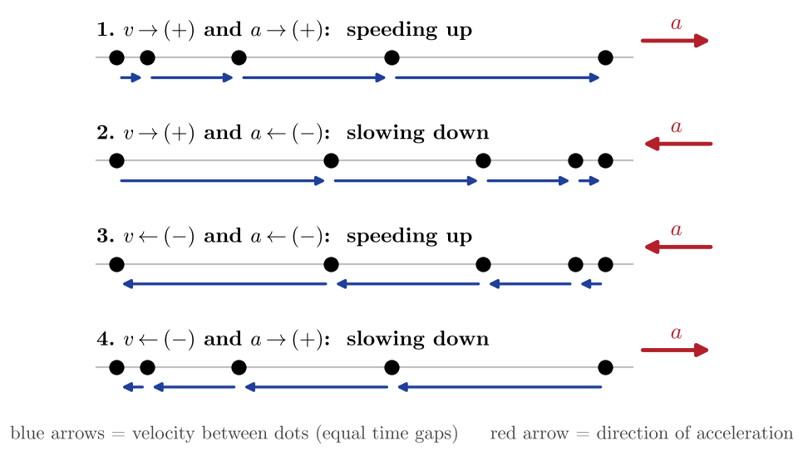  Figure 1.4: Motion diagrams. Each dot is the object’s position at equal time intervals; the blue arrows show how far it moved in each interval (its velocity). When the gaps grow the object speeds up; when they shrink it slows down. The red arrow shows the direction of the acceleration.
  KEY IDEA Same direction → speeding up. Opposite directions → slowing down. The word “deceleration” just means the acceleration points opposite to the velocity. Acceleration can also be non-zero while velocity is momentarily zero (for example, at the top of a throw): what matters is that the velocity is changing.

1.5 Motion graphs: gradients and areas
There are three graphs for the same motion. Each one is read in two ways: by its gradient and by the area under it.
Graph | Gradient (slope) gives… | Area under the graph gives…
Displacement–time (s–t) | velocity | (nothing useful)
Velocity–time (v–t) | acceleration | displacement
Acceleration–time (a–t) | (not needed at SL) | change in velocity Δv

The three graphs for one journey are shown in Figure 1.5. The object speeds up (A), cruises (B), then slows, stops and reverses (C). Notice how each graph is the slope of the one above it.
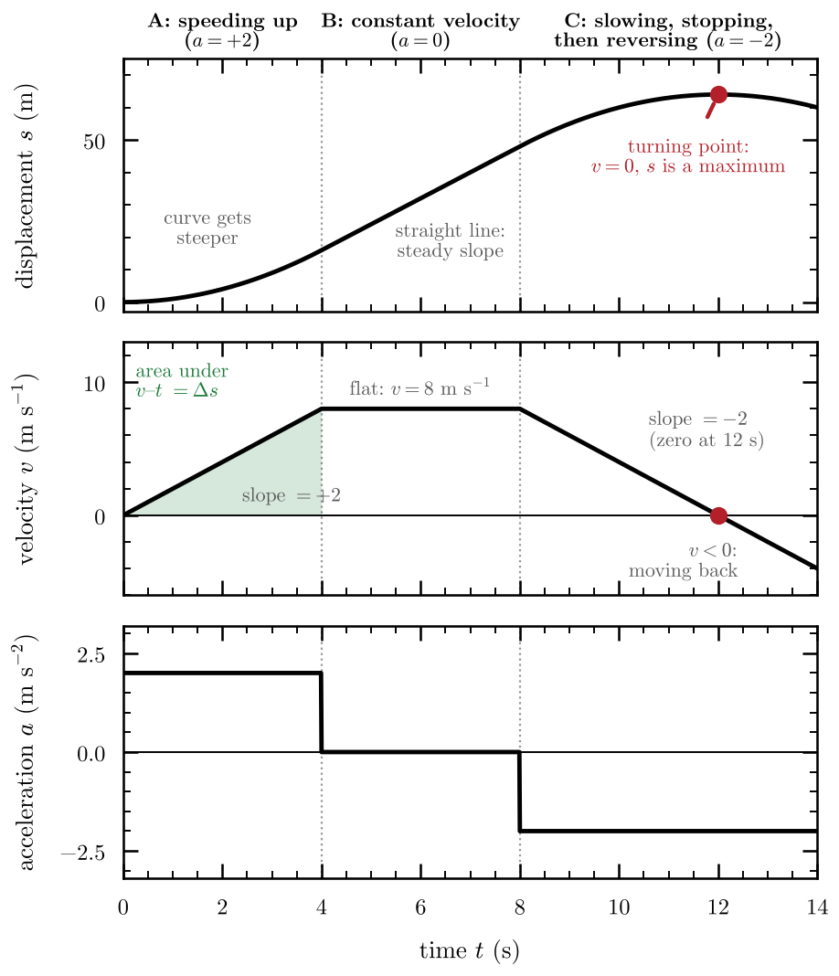 | Figure 1.5: The same journey on all three graphs, sharing one time axis. The slope of the s–t graph is the height of the v–t graph; the slope of the v–t graph is the height of the a–t graph. At t = 12 s the velocity is zero, so the displacement is at its maximum: that is the turning point.

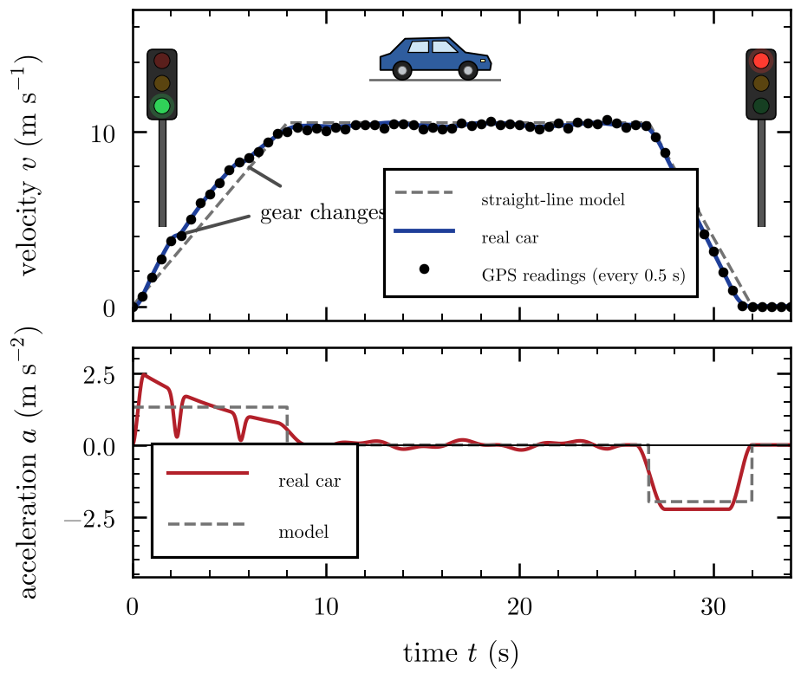 | Figure 1.6: A real car pulling away from one set of traffic lights, cruising and braking at the next (computer model, with simulated GPS readings every 0.5 s). A real acceleration cannot jump from one value to another, so the real v–t graph has no sharp corners, and each gear change shows up as a brief dip in a. The straight-line model used in exam questions has the same top speed and the same area under it (about 267 m).

What each shape means
Graph | Shape | Meaning
s–t | horizontal line | at rest (gradient = 0)
s–t | straight sloped line | constant velocity
s–t | curve getting steeper / flatter | speeding up / slowing down
v–t | horizontal line | constant velocity, a = 0
v–t | straight sloped line | constant acceleration
v–t | line crossing the time axis | velocity changes sign: the object turns round
a–t | horizontal line (not on the axis) | constant acceleration, so SUVAT works

Using areas on a v–t graph
Areas above the time axis are positive displacement; areas below it are negative displacement. This gives a two-line rule that comes up in nearly every graph question:
- Displacement = the signed sum of the areas (add the areas above, subtract the areas below).
- Distance travelled = the sum of the sizes of all the areas (treat every area as positive).
WATCH OUT (the “hill illusion”) Do not read a graph like a picture of the path. A v–t graph that slopes downwards does not mean the object is going down a hill; it means its velocity is decreasing. Always say what the axes are, then describe what the line does. Also: a v–t graph with a negative gradient does not always mean “slowing down”: if the velocity is already negative, a negative acceleration makes it speed up in the negative direction (see the table in 1.4).

1.6 Equations of motion (SUVAT)
When the acceleration is constant, motion in a straight line can be described exactly by four equations. They are called the SUVAT equations after the five quantities in them:
Symbol | Quantity | Unit
s | displacement (change in position) | m
u | initial velocity (at the start of the interval) | m s⁻¹
v | final velocity (at the end of the interval) | m s⁻¹
a | acceleration (constant) | m s⁻²
t | time taken | s

Where they come from (no calculus needed)
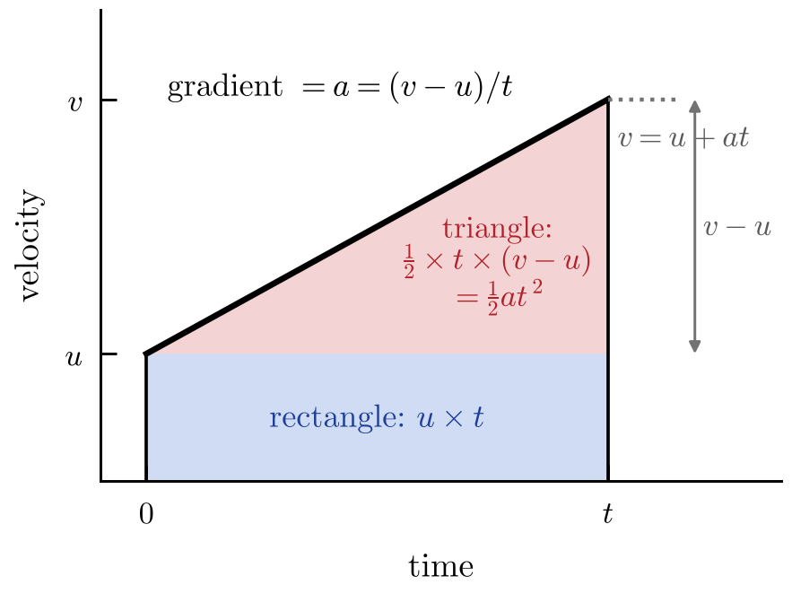  Figure 1.7: A straight-line v–t graph for constant acceleration. The area under it (a rectangle plus a triangle) is the displacement. | Take the v–t graph of constant acceleration: a straight line from u at time 0 to v at time t (Figure 1.7). We only need the two graph rules: gradient = acceleration and area = displacement.  - Gradient. The gradient is $a=\frac{v−u}{t}$. Rearranging gives $v=u+at$.  - Trapezium. The area is $\frac{1}{2}×\left(\text{sum of parallel sides}\right)×\text{width}=\frac{1}{2}\left(u+v\right)t$, so $s=\frac{1}{2}\left(u+v\right)t$.  - Rectangle + triangle. Rectangle: $u×t$. Triangle: $\frac{1}{2}×t×\left(v−u\right)=\frac{1}{2}×t×at=\frac{1}{2}at^{2}$. So $s=ut+\frac{1}{2}at^{2}$.  - Eliminate t. Put $t=\frac{v−u}{a}$ into $s=\frac{1}{2}\left(u+v\right)t$ to get $s=\frac{v^{2}−u^{2}}{2a}$. So $v^{2}=u^{2}+2as$.
  $$v=u+at$$ | (1.6) | $$s=\frac{1}{2}\left(u+v\right)t$$ | (1.7)
  $$s=ut+\frac{1}{2}at^{2}$$ | (1.8) | $$v^{2}=u^{2}+2as$$ | (1.9)

WHY IT WORKS The middle equation says displacement = average velocity × time. For constantly changing velocity the average is exactly halfway between u and v, which is why the $\frac{1}{2}\left(u+v\right)$ appears. Every equation here is the same graph, read a different way.

Choosing the right equation
Do not pick the equation that “looks right”. Write the five SUVAT quantities as a list, mark the three you know and the one you want. The fifth quantity is the one you neither know nor want: choose the equation that leaves it out.
Equation | Missing variable | Use it when you have no…
$v=u+at$ | s | displacement
$s=\frac{1}{2}\left(u+v\right)t$ | a | acceleration
$s=ut+\frac{1}{2}at^{2}$ | v | final velocity
$v^{2}=u^{2}+2as$ | t | time

WATCH OUT SUVAT works only for constant acceleration in a straight line. If the acceleration changes (for example, a skydiver with air resistance), split the motion into stages or use graphs. For a motion in two stages, the final velocity of stage 1 is the initial velocity of stage 2. Quadratic equations in t (from $s=ut+\frac{1}{2}at^{2}$) give two answers: reject any that are physically impossible, such as a negative time.

EXAM TIP For “derive” questions, start by stating the assumption: constant acceleration. Then use the trapezium: $v=u+at$ and $s=\frac{1}{2}\left(u+v\right)t$ are the two shortest steps to any of the others.

1.7 Free fall
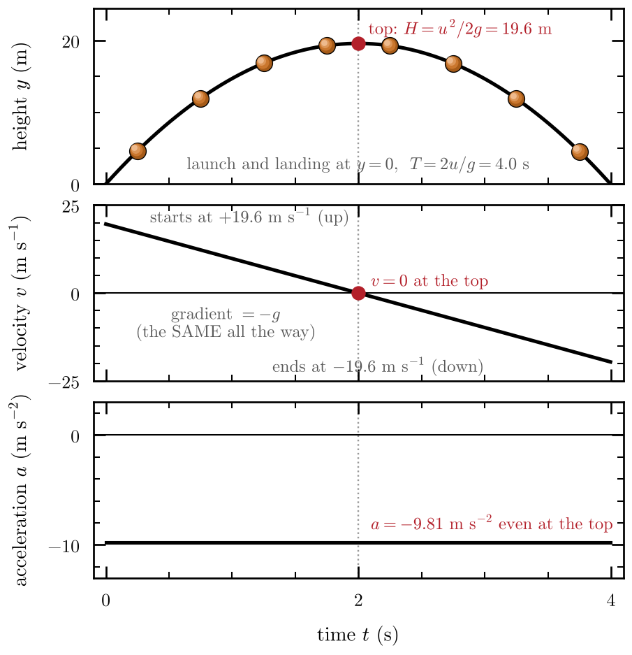  Figure 1.8: A ball thrown upward at 19.6 m s⁻¹ (up is positive). The velocity decreases by 9.81 m s⁻¹ every second, passes through zero at the top, and keeps going into negative values. The acceleration never changes. | An object is in free fall when gravity is the only force acting on it. Near the Earth’s surface, every object in free fall has the same acceleration, whatever its mass:  “Free fall” does not mean “falling”. A ball thrown upward is in free fall from the moment it leaves your hand: on the way up, at the top, and on the way down. The acceleration is always 9.81 m s⁻² downward. If you choose up as positive, then a = −9.81 m s⁻² throughout, and the SUVAT equations apply.
   | $$a=g=9.81 {\text{m s}}^{−2}\text{ directed downwards}$$ | (1.10)

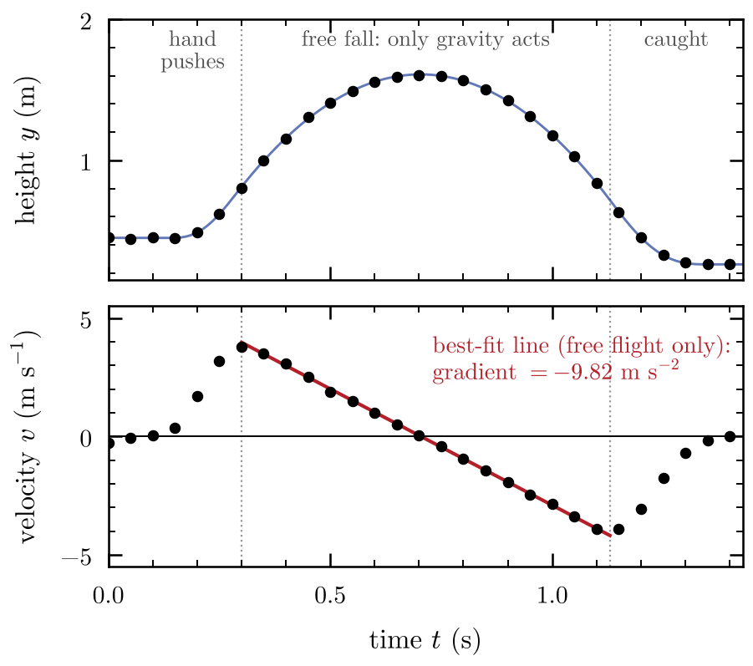 | Figure 1.9: Simulated motion-sensor readings (every 0.05 s) for a ball tossed upward and caught. The ball is in free fall only between release and catch: that part of the v–t graph is a straight line with gradient -9.82 m s⁻², very close to −g. While the hand is pushing or catching, it is not free fall.

Useful results (launch and landing at the same height, no air resistance)
Quantity | Result | How it comes from SUVAT
time to the top | $t_{\text{up}}=\frac{u}{g}$ | $v=u+at$ with v = 0
maximum height | $H=\frac{u^{2}}{2g}$ | $v^{2}=u^{2}+2as$ with v = 0
total time in the air | $T=\frac{2u}{g}$ | going up and coming down take equal times
speed on returning to the launch height | = u (but downward) | the motion is symmetric
dropped from rest through height h | $t=\sqrt{\frac{2h}{g}}, v=\sqrt{2gh}$ | $s=\frac{1}{2}at^{2}$ and $v^{2}=2as$ with u = 0

WHY a ≠ 0 AT THE TOP At the very top the velocity is zero for an instant, but the acceleration is not zero. If it were, the ball would stay at rest there forever, like a ball with no forces on it. Gravity is still pulling, which is why the velocity goes from positive (rising) to negative (falling) rather than staying at zero.

WATCH OUT The number g is positive (9.81). The minus sign belongs to your sign convention (up positive means a = −g). If you choose down as positive instead, then a = +g. Pick one convention for a problem and use it for every quantity: s, u, v and a.

1.8 Vectors: splitting into components
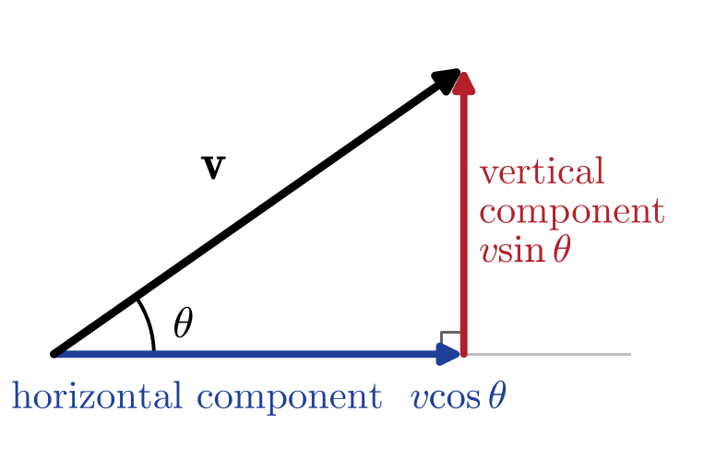  Figure 1.10: Resolving a vector of magnitude v at angle θ above the horizontal into a horizontal component v cos θ and a vertical component v sin θ. | A velocity at an angle can be split into two perpendicular parts that act independently: one horizontal, one vertical. This is the tool that turns a curved, two-dimensional motion into two simple one-dimensional motions.  To go back from components to a single vector, use Pythagoras for the size and the tangent for the angle:
  $$v_{x}=vcosθ$$ | (1.11) | $$v_{y}=vsinθ$$ | (1.12)
  $$v=\sqrt{v_{x}^{2}+v_{y}^{2}}$$ | (1.13) | $$tanθ=\frac{\left|v_{y}\right|}{\left|v_{x}\right|}$$ | (1.14)

WATCH OUT Check which angle you are given. If θ is measured from the horizontal: horizontal part = cos θ, vertical part = sin θ. If θ is measured from the vertical, they swap. A quick check: when θ is small (almost horizontal), the horizontal component should be nearly the whole vector.
Direction of a final answer: use the sizes of the components in $tanθ=\frac{\left|v_{y}\right|}{\left|v_{x}\right|}$ and then describe it in words, for example “58° below the horizontal”. This avoids the calculator giving an angle in the wrong quadrant.

1.9 Projectile motion
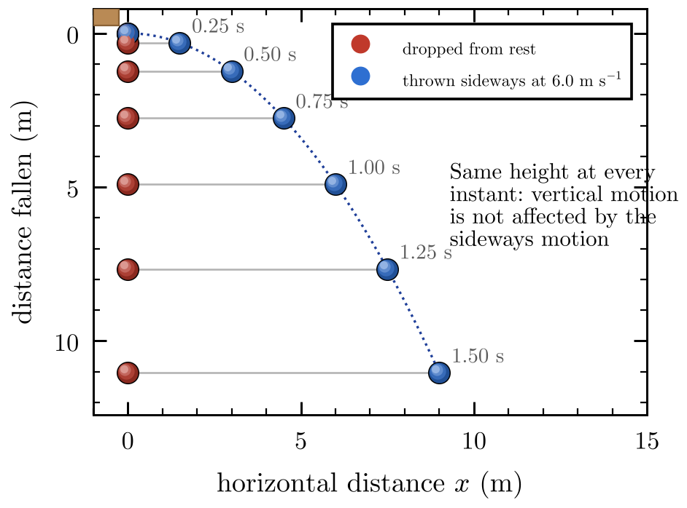  Figure 1.11: One ball is dropped; another is thrown sideways at the same moment. Positions are shown every 0.25 s. At every instant both are at the same height: the sideways motion has no effect on the fall. | A projectile is an object that, once launched, moves under gravity alone (ignoring air resistance). Its path is a curve called a parabola. Two ideas unlock every projectile problem:
  KEY IDEA 1. Horizontal and vertical motion are independent. Nothing pushes sideways (a_{x} = 0), so the horizontal velocity never changes. Gravity acts only vertically (a_{y} = −g).
  2. They share the same clock. The time of flight is the link between the two directions.

 | Horizontal (x) | Vertical (y, up positive)
Acceleration | 0 | −g = −9.81 m s⁻²
Initial velocity | u_{x} = u cos θ | u_{y} = u sin θ
Velocity at time t | v_{x} = u_{x} (constant) | v_{y} = u_{y} − gt
Displacement at time t | s_{x} = u_{x} t | $s_{y}=u_{y}t−\frac{1}{2}gt^{2}$
No-time equation | — | $v_{y}^{2}=u_{y}^{2}−2gs_{y}$

$$s_{x}=u_{x}t$$ | (1.15) | $$v_{y}=u_{y}−gt$$ | (1.16)
$$s_{y}=u_{y}t−\frac{1}{2}gt^{2}$$ | (1.17) | $$v_{y}^{2}=u_{y}^{2}−2gs_{y}$$ | (1.18)

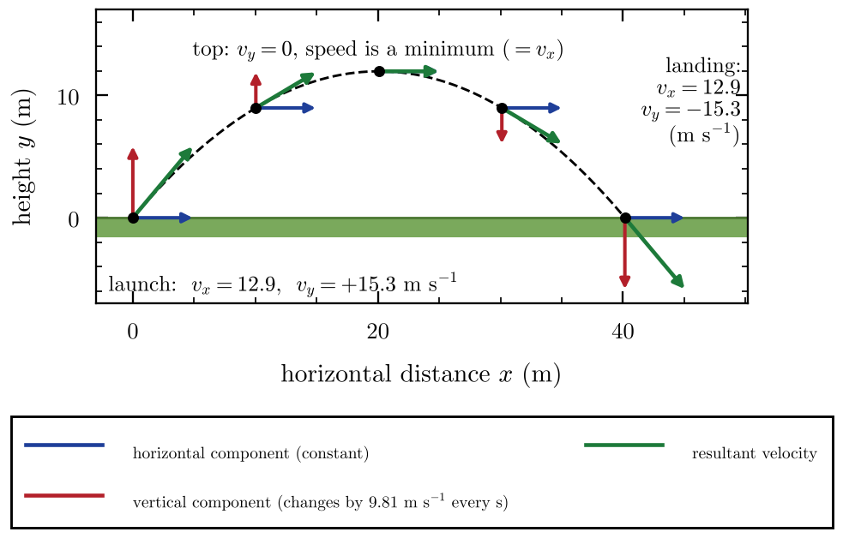 | Figure 1.12: Velocity of a projectile launched at 20 m s⁻¹, 50° above the horizontal, shown at equal time steps. The blue horizontal component never changes; the red vertical component shrinks to zero at the top, then grows downward.

What is special about the top of the path?
- The vertical velocity is zero (v_{y} = 0), but the object is not at rest.
- The speed is at its smallest, equal to the horizontal velocity u_{x}.
- The acceleration is still g downward.
- If the object is launched horizontally (θ = 0), u_{y} = 0: the starting point is the top.

The method for any projectile problem
- Resolve the launch velocity into u_{x} and u_{y}.
- Use the vertical equations to find the time (from a height, a landing level, or v_{y} = 0).
- Put that time into the horizontal equation to find the distance.
- Combine v_{x} and v_{y} with Pythagoras and tan θ for the final speed and direction.

Shortcuts when the landing height equals the launch height
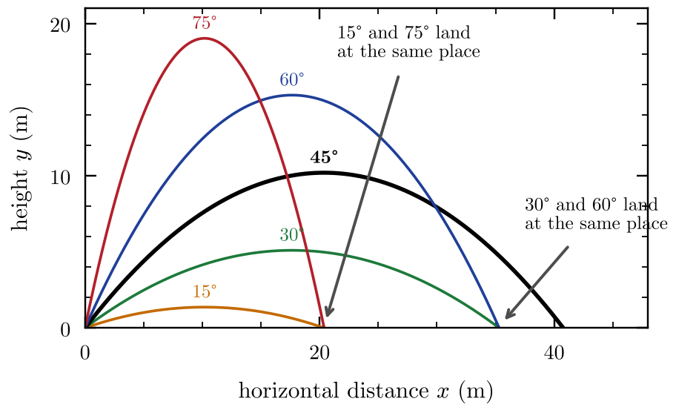  Figure 1.13: Paths for the same launch speed (20 m s⁻¹) at five angles. The range is greatest at 45°. Angles that add to 90° (30° and 60°; 15° and 75°) give the same range but different heights and times. | If the projectile lands at the same height it started from, and there is no air resistance, the flight is symmetric. Setting s_{y} = 0 in Eq. 1.17 and v_{y} = 0 in Eq. 1.16 gives:  Here T is the time of flight, H the maximum height above the launch point and R the horizontal range (R = u_{x} T, and 2 sin θ cos θ = sin 2θ). Figure 1.13 shows what these mean.
  $$T=\frac{2usinθ}{g}$$ | (1.19) | $$H=\frac{{\left(usinθ\right)}^{2}}{2g}$$ | (1.20)
  $$R=\frac{u^{2}sin2θ}{g}$$ | (1.21)

Landing at a different height
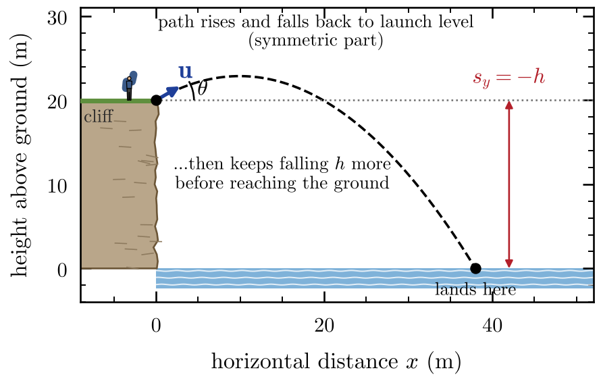  Figure 1.14: A launch from the top of a cliff. The path first rises, then falls back to the launch level, then keeps falling a further height h. Here s_{y} = −h at the moment of landing. | If the object lands higher or lower than the launch point, Eqs. 1.19–1.21 do not apply. Solve $s_{y}=u_{y}t−\frac{1}{2}gt^{2}$ with the correct s_{y} (negative if it lands lower). This is a quadratic equation in t: there will be two roots, and you keep the positive, physically sensible one.
  WATCH OUT The formulas T, H and R are shortcuts with conditions: (i) same launch and landing height, (ii) no air resistance. Using them for a cliff launch, or a ball hit from above the ground, is one of the most common ways to lose marks. When in doubt, go back to Eqs. 1.15–1.18.

EXAM TIP State your assumptions: “neglect air resistance, so a_{x} = 0 and a_{y} = −g.” Then show the vertical equation that gives the time before you move to the horizontal.

1.10 Fluid resistance and terminal speed
Everything so far ignored air. In reality, anything moving through a fluid (air or a liquid) feels a force, called fluid resistance or drag, that opposes its motion. Drag has four features worth knowing:
- It acts opposite to the velocity.
- It increases with speed: the faster you go, the harder the fluid pushes back.
- It is larger for a larger cross-sectional area and for a less streamlined shape.
- It is larger in a denser fluid (water pushes back far more than air).
For an object falling straight down, two forces act: the weight mg downward and the drag D upward. The resultant force (Newton’s second law, which you meet in the next topic) gives the acceleration:
 | $$a=\frac{mg−D}{m}$$ | (1.22)

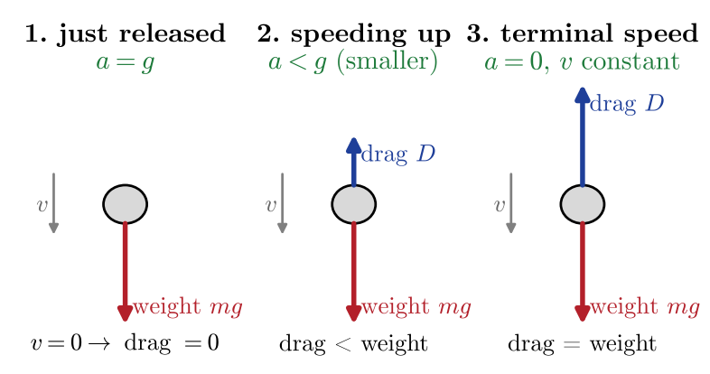
Figure 1.15: Forces on a falling object at three stages. As it speeds up, the upward drag grows until it equals the weight.
Follow the story in Figure 1.15 step by step. This chain of reasoning is exactly what exam questions want to see:
- Released from rest: speed is zero, so drag is zero. The only force is weight, so a = g.
- As the speed increases, drag increases. The resultant downward force decreases, so the acceleration decreases (but the object is still speeding up).
- Eventually drag equals the weight. The resultant force is zero, so a = 0 and the velocity is constant. This is the terminal speed.
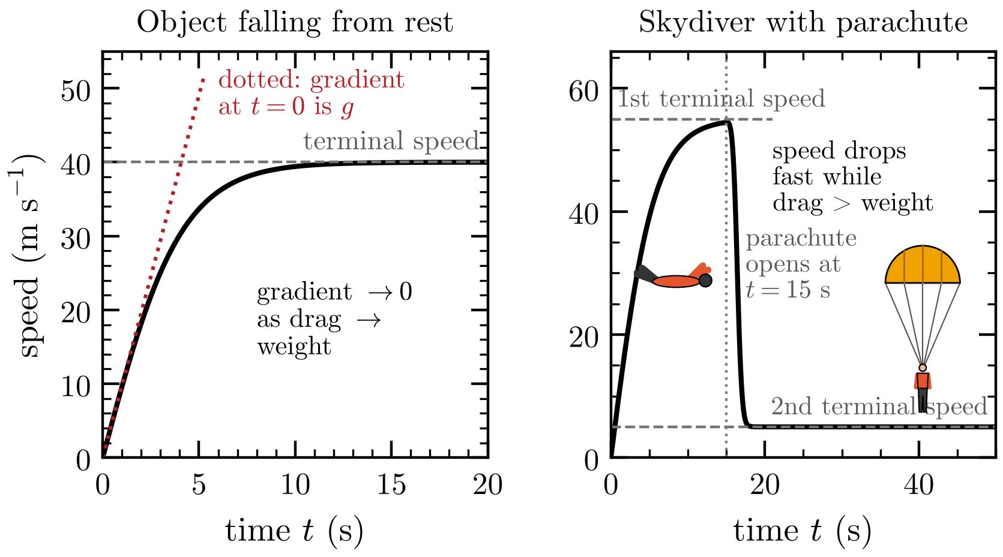
Figure 1.16: Left: speed against time for an object falling from rest; the gradient starts at g and falls to zero as the speed approaches its terminal value. Right: a skydiver. Opening the parachute suddenly makes drag larger than weight, so the skydiver slows down to a new, much lower, terminal speed.
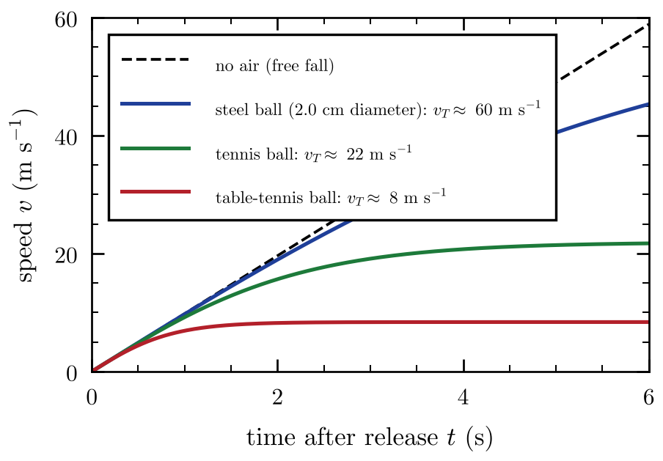 | Figure 1.17: Computed speed–time graphs for three balls dropped from rest in air, compared with free fall (no air). The light table-tennis ball reaches its low terminal speed in about a second; the small, dense steel ball is still close to free fall after several seconds.

KEY IDEA Terminal speed is the constant speed an object reaches when the drag force equals its weight (resultant force zero, acceleration zero). A parachute has a huge area, so it needs a much lower speed before drag can balance the weight.

WATCH OUT Terminal speed does not mean the object has stopped accelerating because gravity switched off. Gravity is still acting; it is simply balanced by the drag. Also note that the speed-time graph has a gradient which is decreasing, not that the speed is decreasing.

Drag on a thrown object
When an object is thrown upward through the air, both weight and drag point down, so on the way up the acceleration is greater than g. At the top the speed is momentarily zero, so drag is zero and the acceleration is exactly g. On the way down drag points up, so the acceleration is less than g.

Projectiles with fluid resistance (qualitative)
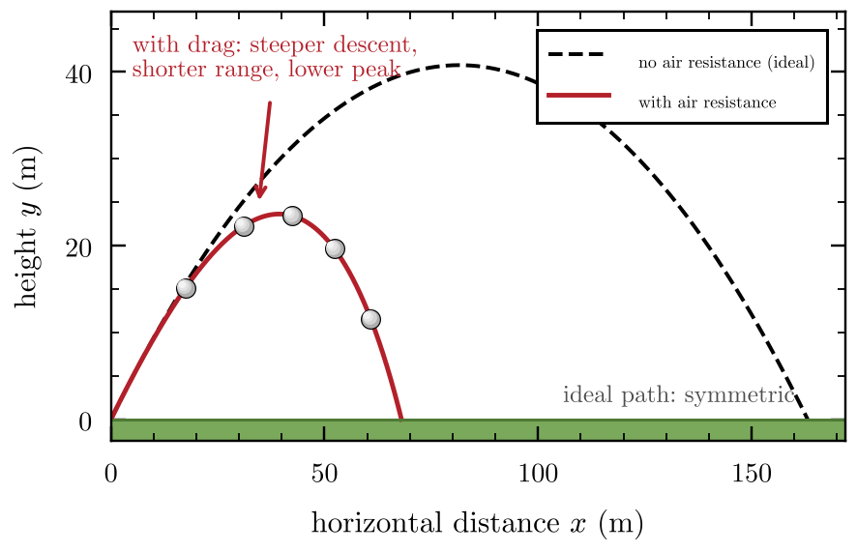 | Figure 1.18: A projectile launched at 40 m s⁻¹ at 45° with and without air resistance (computer model). Drag makes the path lopsided: lower, shorter, and steeper on the way down.

Quantity | No air resistance | With air resistance
Horizontal velocity | constant | decreases all the way (drag acts backwards)
Vertical acceleration | always −g | larger than g on the way up; exactly g at the top; smaller than g on the way down
Maximum height | H | lower
Range | R | shorter
Time of flight | $\frac{2usinθ}{g}$ | usually shorter; the descent takes longer than the ascent
Shape of path | symmetric parabola | asymmetric, steeper on the way down
Landing angle | same as launch angle | steeper than the launch angle
Landing speed | equal to launch speed | smaller than launch speed

1.11 Experiments: measuring g and uncertainty
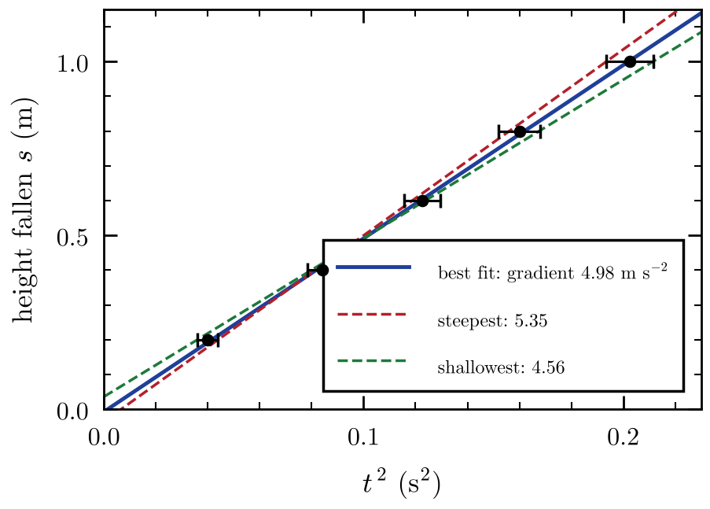  Figure 1.19: Height fallen against t² for a dropped ball, with error bars in t². The best-fit line (blue) and the steepest and shallowest lines (dashed) that still pass through all the error bars give the uncertainty in the gradient. | A classic experiment measures g by dropping a small, dense object from different heights and timing the fall. Starting from rest, $s=\frac{1}{2}gt^{2}$ (Eq. 1.8 with u = 0 and a = g). This is not a straight line in s against t, but it becomes one if you plot s against t²:  Every measurement has an uncertainty. Use these rules to combine them:
   | $$s=\frac{g}{2} t^{2} \text{so} g=2×\left(\text{gradient of the }s\text{–}t^{2}\text{ graph}\right)$$ | (1.23)

Operation | Rule for the uncertainty | Example
a ± b | add the absolute uncertainties | (5.0 ± 0.1) + (3.0 ± 0.1) = 8.0 ± 0.2
a × b or a ÷ b | add the percentage (fractional) uncertainties | 10 ± 2% and 5 ± 3% → product ± 5%
a^{n} | multiply the percentage uncertainty by n | t = 0.50 ± 2% → t² has ± 4%
Gradient of a best-fit line | $\frac{\text{steepest}−\text{shallowest}}{2}$ | $\frac{5.35−4.56}{2}≈0.4$

Type of error | Cause (example) | Effect and fix
Random | reaction time when using a stopwatch; scatter in repeat readings | scatter of points; repeat and average
Systematic | zero error on the ruler; air resistance on the falling ball; a timer that starts late | all values shifted the same way; cannot be averaged away; improve the method

EXAM TIP Report the final answer with a sensible number of significant figures and its uncertainty, e.g. g = 9.6 ± 0.5 m s⁻². The uncertainty is normally given to one significant figure, and the answer to the same decimal place.

1.12 Relative velocity in a straight line (enrichment)
Velocity always depends on who is measuring. A passenger walking at 1 m s⁻¹ along a train moving at 20 m s⁻¹ has a velocity of 21 m s⁻¹ relative to the ground but 1 m s⁻¹ relative to the train. For motion along a line (adding signed velocities):
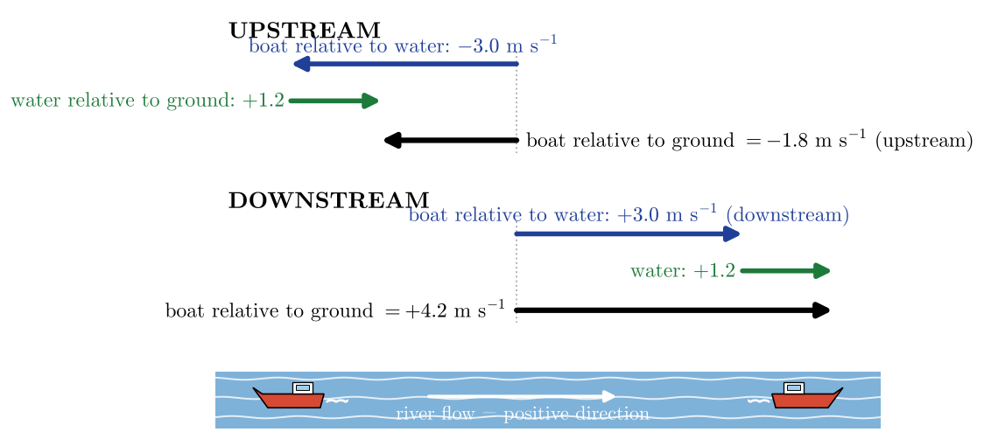  Figure 1.20: A boat that can move at 3.0 m s⁻¹ relative to the water, in a river flowing at 1.2 m s⁻¹. Upstream the velocities partly cancel; downstream they add. | A common case is a boat in a river. The boat’s speed relative to the water is fixed by its engine; the water moves relative to the ground; the ground-based observer sees the sum.
   | $$v_{\text{A relative to C}}=v_{\text{A relative to B}}+v_{\text{B relative to C}}$$ | (1.24)
  EXAM TIP For relative-velocity questions, choose a positive direction first, label each velocity with “of what, relative to what” (for example v_{boat/water}, v_{water/ground}) and then simply add. Check that the “inner” labels cancel: boat/water + water/ground = boat/ground.

Chapter 2
Forces and Momentum
WHAT THIS TOPIC IS ABOUT Kinematics described motion without asking why it happens. This topic gives the reason: forces. A force changes the velocity of an object, and the rule that links the two is Newton’s second law. The same idea, written in terms of momentum, explains collisions, explosions, impacts and even why things move in circles.

2.1 Forces and Newton’s first law
A force is a push or a pull that one object exerts on another. Every force is an interaction between two objects: something pushes or pulls on something else. Force is a vector, so it has a size and a direction, and its SI unit is the newton (N). One newton is the force that gives a 1 kg mass an acceleration of 1 m s⁻².
Usually several forces act on an object at once. What matters is their vector sum, called the resultant force (or net force). If the forces cancel out, the resultant force is zero.
Newton’s first law says what happens when the resultant force is zero:
KEY IDEA Newton’s first law. An object stays at rest, or keeps moving at a constant velocity (constant speed in a straight line), unless a resultant force acts on it.
This was a revolutionary idea. Everyday experience suggests that things stop unless you keep pushing them, but that is only because friction and drag are always acting. In space, a moving probe keeps going for ever with its engines switched off.
The tendency of an object to keep doing what it is already doing is called inertia. The more mass an object has, the more inertia it has: it is harder to start it moving, stop it or turn it.
An object with zero resultant force is in equilibrium. There are two kinds:
- Static equilibrium: at rest, for example a book on a table.
- Dynamic equilibrium: moving at constant velocity, for example a car cruising at a steady 25 m s⁻¹ on a straight road, or a skydiver at terminal speed.
WATCH OUT “Constant velocity” needs no resultant force. A car cruising at a steady speed still needs its engine, but only to balance drag and friction: the driving force equals the resistive forces, so the resultant is zero. A resultant force is needed only to change the velocity.

2.2 Free-body diagrams
A free-body diagram shows one object on its own, with an arrow for every force that acts on it. It is the most important tool in this topic: almost every force problem starts with one.

The method for any free-body diagram
- Draw the object on its own, as a box or a dot. Do not draw the things around it.
- Add the weight, acting downwards from the centre of mass.
- Go round the object: wherever it touches something (a surface, a rope, a fluid), add the force that thing exerts on it.
- Label every arrow with its name or symbol, and make the lengths roughly match the sizes of the forces.
- Check: only forces on this object, and every force has a cause you can name.
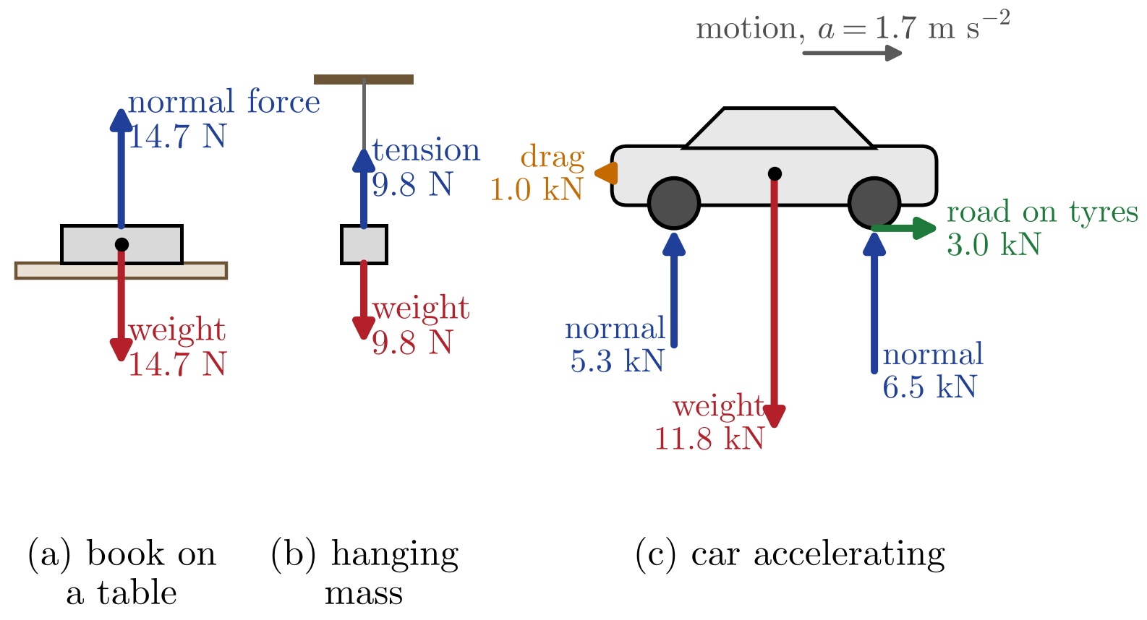
Figure 2.1: Free-body diagrams drawn to scale. (a) A 1.5 kg book resting on a table: the normal force balances the weight. (b) A 1.0 kg mass hanging from a string: the tension balances the weight. (c) A 1200 kg car accelerating: the road pushes the drive wheels forwards with 3.0 kN, drag is 1.0 kN, so the resultant is 2.0 kN forwards.
EXAM TIP Never draw “the force of motion” or “the acceleration” on a free-body diagram. A moving object does not carry a force with it. Only draw forces that something else exerts on the object: weight, normal force, tension, friction, drag, buoyancy, thrust.

2.3 The forces you need to know

Weight
The weight of an object is the gravitational force that the Earth exerts on it. Near the Earth’s surface it is
 | $$F_{g}=mg$$ | (2.1)
where $m$ is the mass and $g=9.81 {\text{N kg}}^{−1}$ is the gravitational field strength. This is the same number as the free-fall acceleration in Chapter 1 (1 N kg⁻¹ = 1 m s⁻²).
WATCH OUT Mass and weight are different. Mass (kg) is the amount of matter and does not change from place to place. Weight (N) is a force and depends on where you are: a 60 kg astronaut weighs 589 N on Earth but only 97 N on the Moon, where $g=1.62 {\text{N kg}}^{−1}$.

Normal force and tension
When an object presses on a surface, the surface pushes back, at right angles to itself. This is the normal force $F_{N}$ (“normal” means perpendicular). The surface deforms very slightly, like a stiff spring, and pushes back just hard enough to stop the object sinking in. The normal force is not always equal to the weight: it is smaller on a slope, and it changes in an accelerating lift (Section 2.4).
A taut string, rope or cable pulls on the objects at each end. This pull is the tension $T$. It always acts along the string, away from the object. For a light string over a smooth pulley, the tension is the same all the way along.

Friction
Friction acts where two surfaces touch, parallel to the surfaces, and opposes their sliding over each other. There are two kinds:
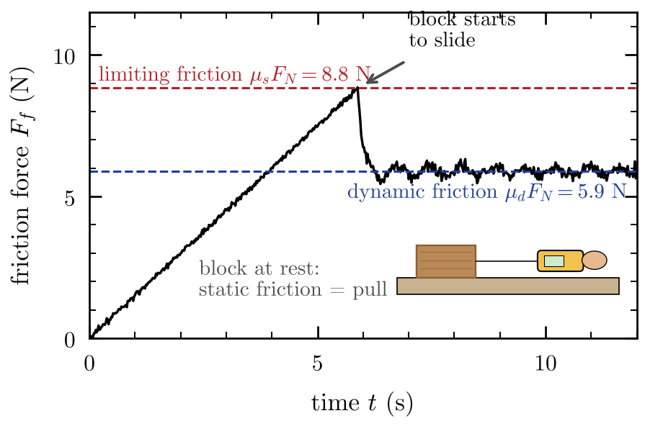  Figure 2.2: Force-sensor reading for a 2.0 kg block pulled with a slowly increasing force (simulated data). While the block is still, static friction exactly matches the pull and rises with it. At the limit, $μ_{s}F_{N}=8.8$ N, the block starts to slide and the friction drops to the dynamic value, $μ_{d}F_{N}≈5.9$ N, with small stick–slip fluctuations. | - Static friction acts when the surfaces are not sliding. It is only as large as it needs to be to stop sliding, up to a maximum value.  - Dynamic (kinetic) friction acts when the surfaces are sliding. It is roughly constant and usually a little smaller than the maximum static friction.  Here $μ_{s}$ and $μ_{d}$ are the coefficients of static and dynamic friction. They have no units and depend on the two surfaces (rubber on dry tarmac is about 0.8; steel on ice is about 0.03). Notice that friction depends on how hard the surfaces are pressed together ($F_{N}$), not on the area of contact.
  $$F_{f}≤μ_{s}F_{N}$$ | (2.2) | $$F_{f}=μ_{d}F_{N}$$ | (2.3)
  WATCH OUT $F_{f}=μ_{s}F_{N}$ is the maximum static friction, not the actual friction. A box resting on a level floor with nobody pushing it has zero friction on it. If you push it gently with 20 N and it does not move, the static friction is exactly 20 N.

Elastic restoring force (Hooke’s law)
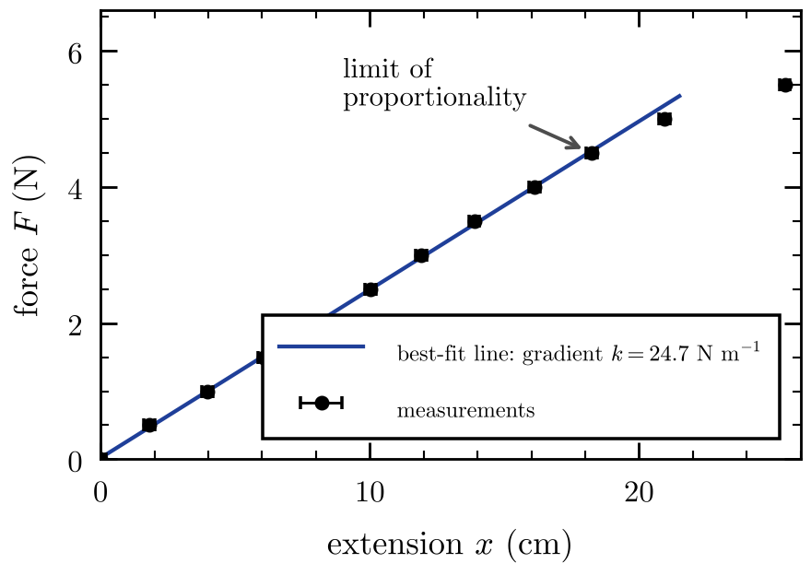  Figure 2.3: Force against extension for a spring (simulated measurements with small random errors). The straight part obeys Hooke’s law; its gradient is the spring constant, here about 25 N m⁻¹. Above about 4.5 N the spring passes its limit of proportionality and stretches more than Hooke’s law predicts. | A stretched or compressed spring pulls or pushes back towards its natural length. For many springs, the force is proportional to the extension $x$ (the change in length):  The spring constant $k$ (N m⁻¹) measures stiffness: a stiff spring has a large $k$. The minus sign shows that the force is opposite to the displacement: stretch the spring and it pulls back. Hooke’s law only works up to the limit of proportionality; beyond it the graph curves.
   | $$F_{H}=−kx$$ | (2.4)

Drag and buoyancy in a fluid
An object moving through a fluid feels a drag force opposite to its velocity (Section 1.10). For a small sphere moving slowly through a viscous fluid, the drag is given by Stokes’ law:
 | $$F_{d}=6πηrv$$ | (2.5)
where $η$ is the viscosity of the fluid (Pa s), $r$ is the radius of the sphere and $v$ is its speed. Stokes’ law applies only to smooth spheres moving slowly, with a smooth (non-turbulent) flow of fluid around them.
Any object in a fluid also feels an upward buoyancy force (upthrust), equal to the weight of the fluid it pushes aside (Archimedes’ principle):
 | $$F_{b}=ρVg$$ | (2.6)
where $ρ$ is the density of the fluid and $V$ is the volume of fluid displaced. An object floats when the buoyancy can balance its weight before it is completely submerged.
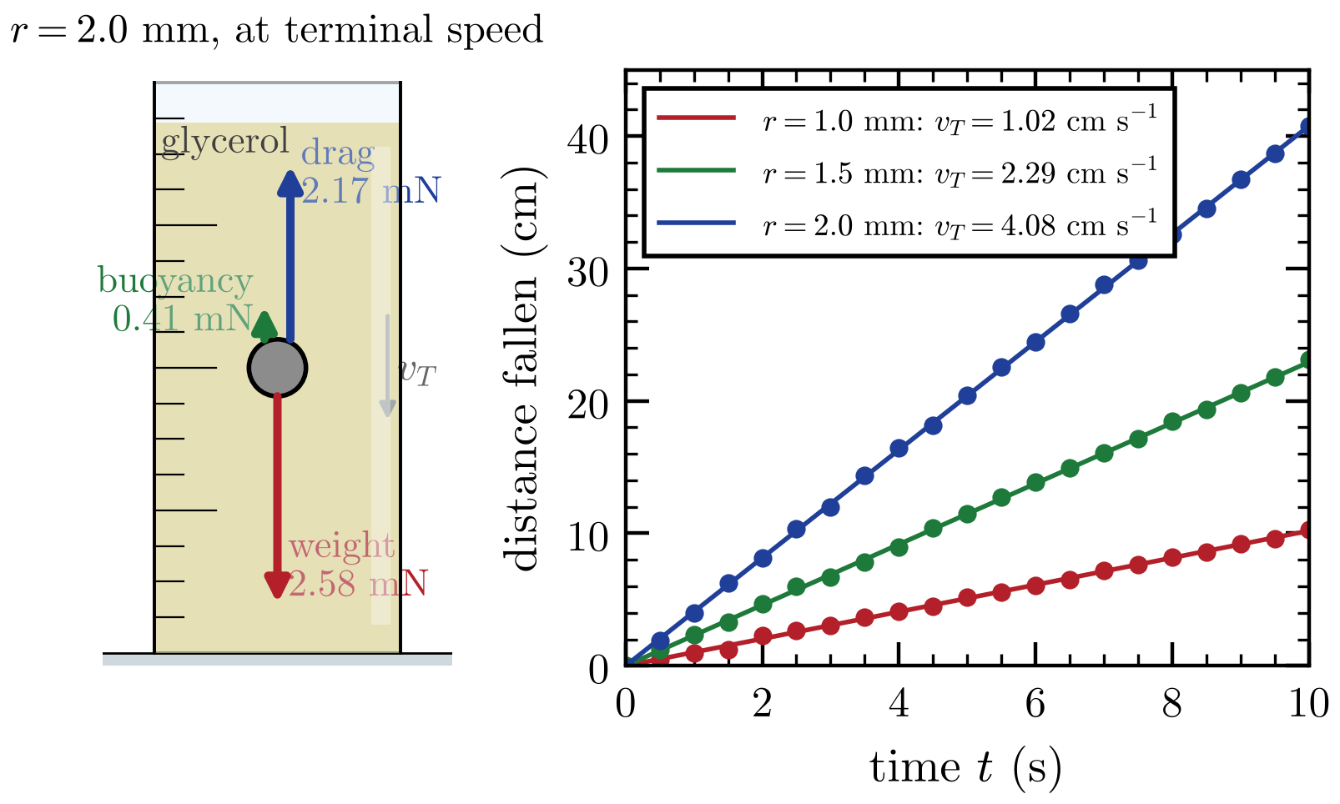
Figure 2.4: Left: forces on a steel ball bearing falling at its terminal speed in glycerol, drawn to scale. Right: position–time data for ball bearings of three sizes (simulated video measurements). Each graph is a straight line, so each ball falls at a constant terminal speed; doubling the radius makes the terminal speed four times larger, as Stokes’ law predicts.
At terminal speed the forces balance: $mg=F_{b}+F_{d}$. Putting in Stokes’ law gives a terminal speed that grows with $r^{2}$, which is why fine sand and mud take so long to settle in water.
Force | Equation | Direction
Weight | $F_{g}=mg$ | towards the centre of the Earth (down)
Normal force | (found from the other forces) | perpendicular to the surface, away from it
Tension | (found from the other forces) | along the string, away from the object
Static friction | $F_{f}≤μ_{s}F_{N}$ | along the surface, opposing the sliding that would happen
Dynamic friction | $F_{f}=μ_{d}F_{N}$ | along the surface, opposing the sliding
Elastic (spring) | $F_{H}=−kx$ | towards the natural length
Viscous drag | $F_{d}=6πηrv$ | opposite to the velocity
Buoyancy | $F_{b}=ρVg$ | upwards

2.4 Newton’s second law
When the resultant force on an object is not zero, the object accelerates in the direction of the resultant force. The acceleration is proportional to the resultant force and inversely proportional to the mass:
 | $$F=ma$$ | (2.7)
Here $F$ is the resultant force (the vector sum of all the forces), not any single force. Double the resultant force and the acceleration doubles; double the mass and the acceleration halves.

The method for any $F=ma$ problem
- Draw a free-body diagram of one object.
- Choose a positive direction, usually the direction of the acceleration.
- Write the resultant force as (forces in the positive direction) minus (forces in the negative direction).
- Set the resultant equal to $ma$ and solve. If you then need a velocity, distance or time, use the SUVAT equations from Chapter 1.
For the car in Figure 2.1(c): resultant force $F=3.0 \text{kN}−1.0 \text{kN}=2.0 \text{kN}$, so $a=\frac{F}{m}=\frac{2000}{1200}=1.7 {\text{m s}}^{−2}$.

Apparent weight in a lift
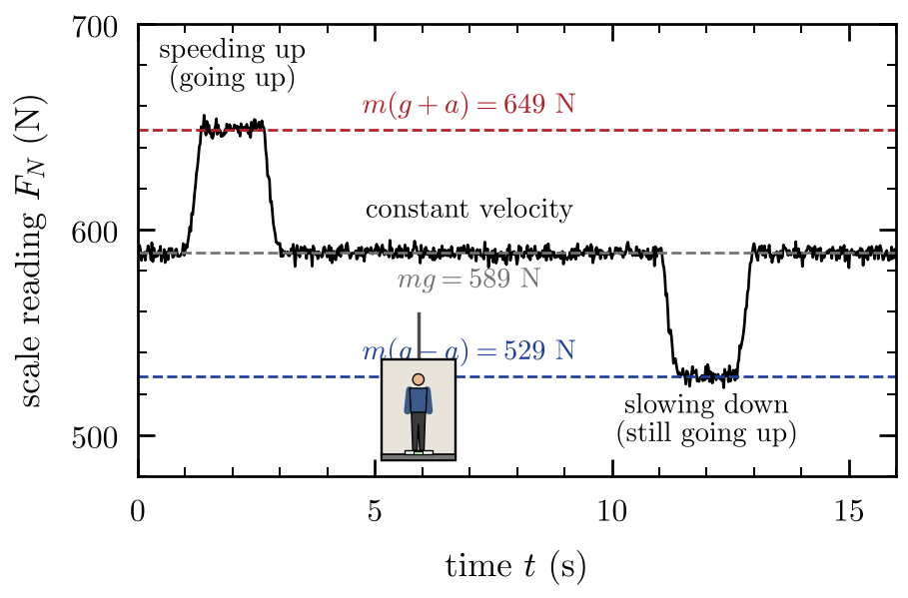  Figure 2.5: Scale reading for a 60 kg person in a lift that starts from rest, rises at constant speed and stops (simulated data, including small vibrations). The reading is 649 N while the lift speeds up at 1.0 m s⁻², 589 N (the true weight) at constant velocity, and 529 N while it slows down. | Bathroom scales measure the normal force, not your weight. In a lift that accelerates upwards, the floor must push up harder than your weight to give you the upward acceleration. Taking up as positive, $F_{N}−mg=ma$, so  The scale reads more than your weight when the acceleration is upwards (speeding up on the way up, or slowing down on the way down), less when it is downwards, and exactly your weight when the lift moves at constant velocity. In free fall $a=−g$ and the scale reads zero: this is “weightlessness”.
   | $$F_{N}=m\left(g+a\right)$$ | (2.8)

Connected objects
When objects are joined by a string, or one pushes another, they share the same acceleration. You can find it by treating them as one object (total mass, external forces only), then draw a separate free-body diagram for one part to find the force between them.
WATCH OUT $F=ma$ uses the resultant force. A common mistake is to put the driving force or the tension in place of $F$ and forget the friction or the weight acting the other way. Draw the free-body diagram first, every time.

2.5 Forces at an angle and on slopes
A force at an angle can be replaced by two perpendicular components, exactly as for velocities in Section 1.8. Choose directions that make the problem easy: usually along and perpendicular to the motion.
On a slope at angle $θ$ to the horizontal, resolve the weight along and perpendicular to the slope:
$$F_{∥}=mgsinθ$$ | (2.9) | $$F_{⊥}=mgcosθ$$ | (2.10)

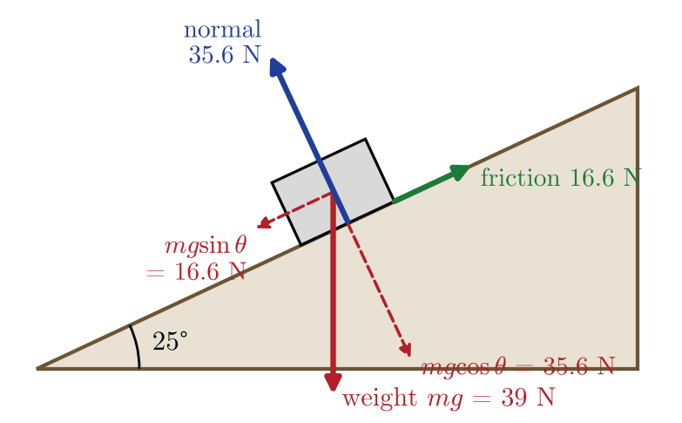  Figure 2.6: A 4.0 kg block at rest on a slope of 25°, drawn to scale. The weight (39 N) is resolved into 16.6 N down the slope and 35.6 N into the slope. The normal force balances the perpendicular part; static friction (16.6 N up the slope) balances the parallel part. | The block does not move into the slope, so the normal force balances the perpendicular component: $F_{N}=mgcosθ$. The component $mgsinθ$ pulls the block down the slope; if the block stays still, static friction balances it.  The block is just about to slip when the friction needed equals its maximum value, $mgsinθ=μ_{s}mgcosθ$. The mass cancels, leaving  So you can measure $μ_{s}$ by slowly tilting a slope and recording the angle at which the block starts to slide. For the block in Figure 2.6 to stay at rest, $μ_{s}$ must be at least $tan{25}^{∘}=0.47$.
   | $$tanθ=μ_{s}$$ | (2.11)
  EXAM TIP On a slope, the angle between the weight and the perpendicular to the slope is the same as the slope angle $θ$. A quick check: when $θ=0$ (flat ground) the component along the slope, $mgsinθ$, must be zero, and the component into the slope, $mgcosθ$, must be the whole weight.

2.6 Newton’s third law
KEY IDEA Newton’s third law. When object A exerts a force on object B, object B exerts a force on object A that is equal in size and opposite in direction.
The two forces in a third-law pair always:
- act on different objects (one on A, one on B);
- are the same type of force (both gravitational, both contact, both friction, and so on);
- have equal size and opposite direction, and act along the same line;
- exist at the same time: you cannot have one without the other.
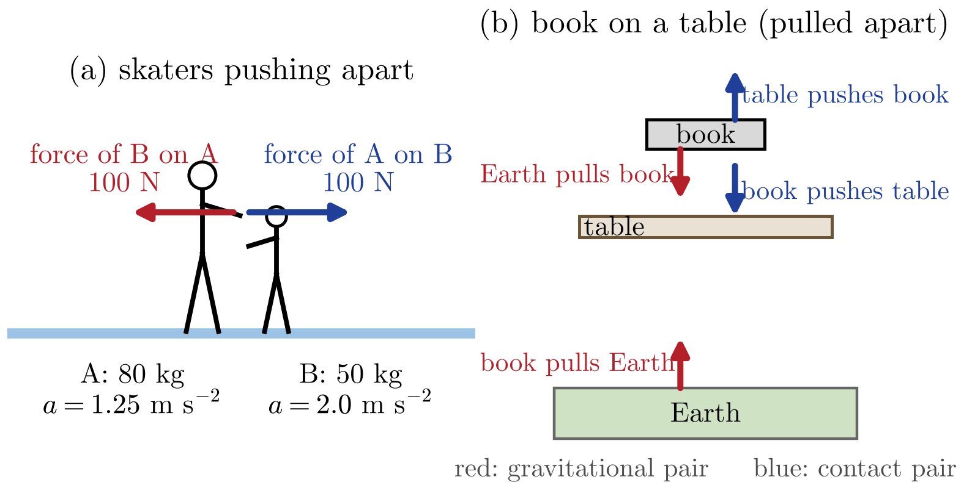
Figure 2.7: Newton’s third-law pairs. (a) Two skaters push apart: each feels an equal and opposite force, but the lighter one accelerates more. (b) A book on a table, shown pulled apart for clarity. The weight of the book and the normal force on it act on the same object, so they are not a third-law pair. Each has its own partner: the book pulls the Earth up, and the book pushes down on the table.
WATCH OUT The weight of a book and the normal force on it are equal and opposite, but this is because of Newton’s first law (the book is in equilibrium), not the third. They act on the same object and are different types of force. If the table were in an accelerating lift they would not even be equal.
If the forces are equal and opposite, why does anything move? Because the two forces act on different objects, so they never cancel each other. When you walk, you push backwards on the ground with friction, and the ground pushes you forwards with an equal force. The Earth’s huge mass means its acceleration is far too small to notice.

2.7 Momentum
The linear momentum of an object is its mass multiplied by its velocity:
 | $$p=mv$$ | (2.12)
Momentum is a vector, in the same direction as the velocity, with units kg m s⁻¹ (which are the same as N s). It measures how hard it is to stop a moving object: a slow lorry and a fast bullet can both have a lot of momentum.
Newton’s second law can be written in terms of momentum. The resultant force equals the rate of change of momentum:
 | $$F=\frac{Δp}{Δt}$$ | (2.13)
If the mass is constant, $Δp=mΔv$, and this becomes $F=m\frac{Δv}{Δt}=ma$: the same law as before. The momentum form is more general, because it also works when the mass changes, for example a rocket burning fuel or sand falling onto a conveyor belt.
The kinetic energy of an object can also be written in terms of its momentum. Since $E_{k}=\frac{1}{2}mv^{2}$ and $v=\frac{p}{m}$,
 | $$E_{k}=\frac{p^{2}}{2m}$$ | (2.14)

IN PLAIN ENGLISH Force is how quickly momentum changes. A large force changes momentum quickly; a small force needs a long time to make the same change.

2.8 Impulse and force–time graphs
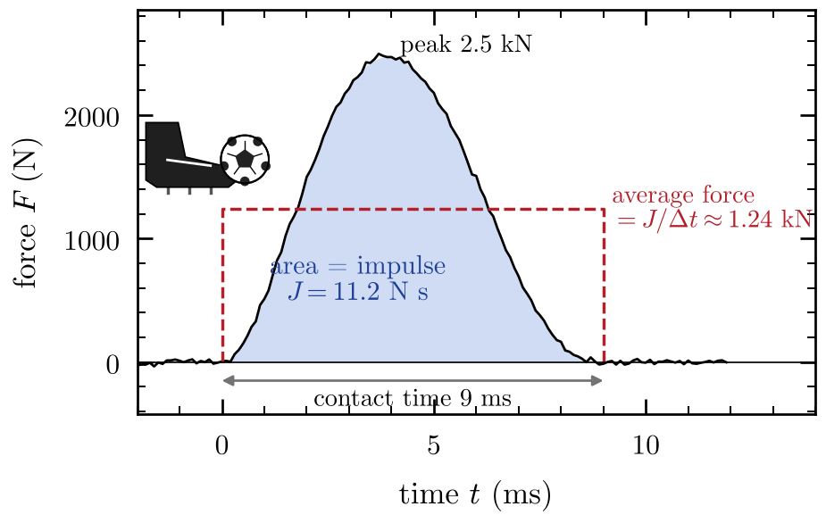  Figure 2.8: Force on a football during a kick, as a force sensor would record it (simulated data, sampled 10 000 times a second). The contact lasts about 9 ms and the force peaks at about 2.5 kN. The shaded area is the impulse, 11.2 N s, which sends the 0.43 kg ball off at 26 m s⁻¹. The dashed rectangle shows the average force: same area, same impulse. | Rearranging Eq. 2.13 gives the impulse $J$, the product of the force and the time for which it acts. The impulse equals the change in momentum it produces:  Impulse has the units N s. In real impacts the force is not constant: it rises from zero to a peak and falls again. The impulse is then the area under the force–time graph, and $F$ in Eq. 2.15 is the average force.  For a given change in momentum, the impulse is fixed. Making the collision last longer therefore makes the average force smaller. This is how many safety features work:  - Airbags, seatbelts and crumple zones stretch out the time a passenger takes to stop.  - Bending your knees when you land from a jump makes the stopping time longer.  - Helmets and gym mats contain soft material that squashes slowly.
   | $$J=FΔt=Δp$$ | (2.15)

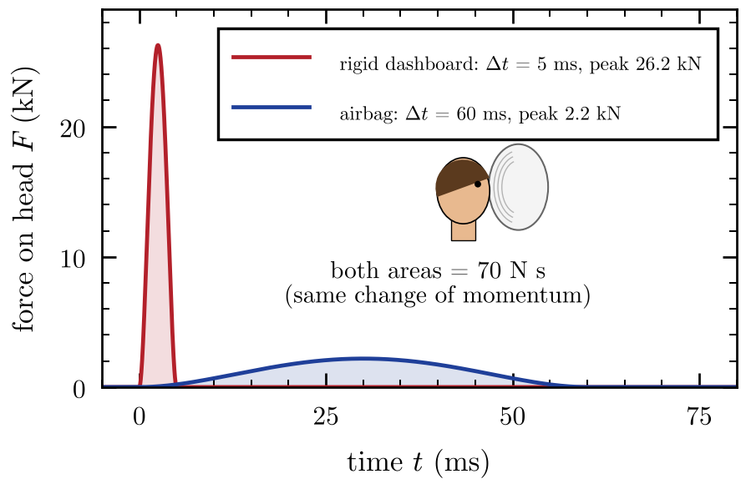 | Figure 2.9: The same impulse delivered in two ways (computer model). A 5.0 kg head moving at 14 m s⁻¹ (50 km h⁻¹) is brought to rest, so the impulse is 70 N s in both cases. Hitting a rigid dashboard takes about 5 ms and the force peaks at about 26 kN. An airbag stretches the stop to about 60 ms, and the peak force falls to about 2 kN.

WATCH OUT Safety features do not reduce the change in momentum or the impulse: the person still stops from the same speed. They reduce the force by making the time longer.

2.9 Conservation of momentum: collisions and explosions
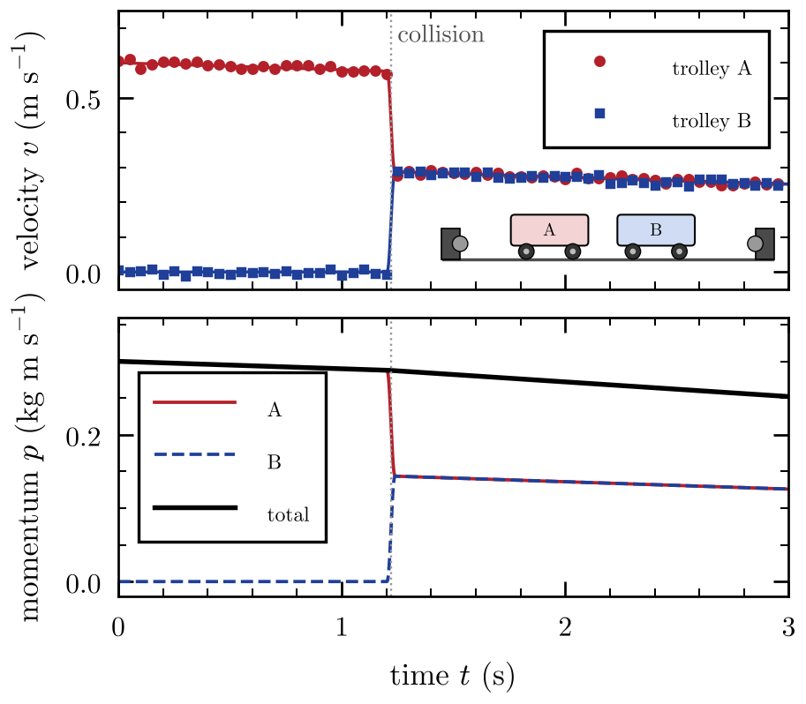  Figure 2.10: Motion-sensor data for two 0.50 kg trolleys (simulated). Trolley A rolls at 0.60 m s⁻¹ into trolley B, which is at rest; they stick together and move off at 0.30 m s⁻¹. Bottom: A loses exactly the momentum that B gains, so the total momentum (0.30 kg m s⁻¹) stays the same through the collision. It falls slowly afterwards only because friction, an external force, acts on the trolleys. | When two objects collide, Newton’s third law says they exert equal and opposite forces on each other, for exactly the same time. So they receive equal and opposite impulses: whatever momentum one gains, the other loses. This gives one of the most important laws in physics:  For two objects that collide,  where $u$ means a velocity before the collision and $v$ a velocity after it. Velocities are vectors, so choose a positive direction and give velocities in the other direction a minus sign.
  KEY IDEA Conservation of momentum. In a system on which no external resultant force acts, the total momentum stays constant.
   | $$m_{1}u_{1}+m_{2}u_{2}=m_{1}v_{1}+m_{2}v_{2}$$ | (2.16)

Elastic and inelastic collisions
Momentum is always conserved in a collision (if there is no external force). Kinetic energy usually is not: some of it is changed into thermal energy, sound and the work done in permanently bending things.
Type of collision | Momentum | Kinetic energy
Elastic | conserved | conserved (no kinetic energy is lost)
Inelastic | conserved | not conserved (some is changed into other forms)
Totally inelastic | conserved | the objects stick together: the largest possible loss
Explosion | conserved (often zero before) | increases (comes from stored chemical or elastic energy)
In the trolley collision of Figure 2.10, the kinetic energy before is $\frac{1}{2}×0.50×{0.60}^{2}=0.090$ J and after it is $\frac{1}{2}×1.0×{0.30}^{2}=0.045$ J. Half of the kinetic energy has been changed into other forms, so the collision is totally inelastic, even though momentum is perfectly conserved.

Explosions
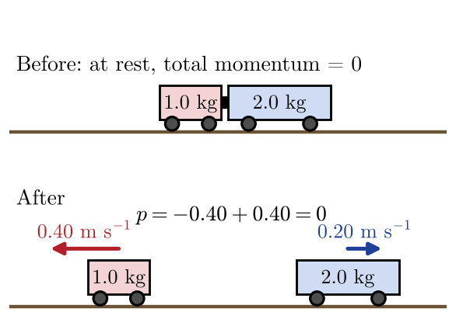  Figure 2.11: Two trolleys at rest are pushed apart by a compressed spring. Afterwards the 1.0 kg trolley moves left at 0.40 m s⁻¹ and the 2.0 kg trolley moves right at 0.20 m s⁻¹. Their momenta are equal and opposite ($∓0.40$ kg m s⁻¹), so the total stays zero. | In an explosion the objects start together, often at rest, so the total momentum is zero before. It must still be zero after: the pieces fly apart with equal and opposite momenta. The kinetic energy comes from a store of energy such as a compressed spring or a chemical reaction. The recoil of a gun and the thrust of a rocket work the same way.
  EXAM TIP In any collision question, write “total momentum before = total momentum after”, put in the numbers with signs, and solve. Only then think about kinetic energy, which you need if the question asks whether the collision is elastic. Remember that $E_{k}=\frac{p^{2}}{2m}$ means that, for the same momentum, the lighter object always has more kinetic energy.

2.10 Circular motion
An object moving in a circle at constant speed is accelerating, because the direction of its velocity keeps changing. To describe this motion we use:
- the period $T$: the time for one complete circle;
- the frequency $f$: the number of circles per second, $f=\frac{1}{T}$;
- the angular velocity $ω$: the angle swept out per second, in radians per second (rad s⁻¹).
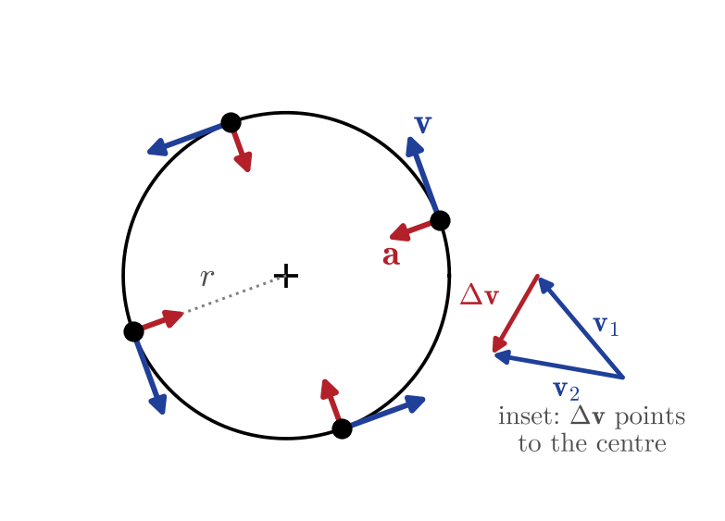  Figure 2.12: An object moving anticlockwise round a circle at constant speed. The velocity (blue) is always tangent to the circle; the acceleration (red) always points to the centre. Inset: in a short time the velocity changes by $Δv$, which also points towards the centre. | In one period the object travels a distance $2πr$ and sweeps out an angle of $2π$ radians, so  The velocity is always along the tangent to the circle. The acceleration points towards the centre of the circle and is called the centripetal acceleration:  By Newton’s second law, a centripetal acceleration needs a resultant force towards the centre, the centripetal force:  The centripetal force is not a new kind of force. It is the name for the resultant force towards the centre, and it is always provided by one or more of the real forces from Section 2.3.
  $$v=\frac{2πr}{T}=ωr$$ | (2.17) | $$ω=\frac{2π}{T}=2πf$$ | (2.18)
   | $$a=\frac{v^{2}}{r}=ω^{2}r=\frac{4π^{2}r}{T^{2}}$$ | (2.19)
   | $$F=\frac{mv^{2}}{r}=mω^{2}r$$ | (2.20)

Situation | What provides the centripetal force
Ball whirled on a string | tension in the string
Car going round a level bend | friction between the tyres and the road
Moon orbiting the Earth | gravitational force of the Earth on the Moon
Conical pendulum | horizontal component of the tension
Passenger at the top of a loop-the-loop | weight plus the normal force from the seat (both downwards)

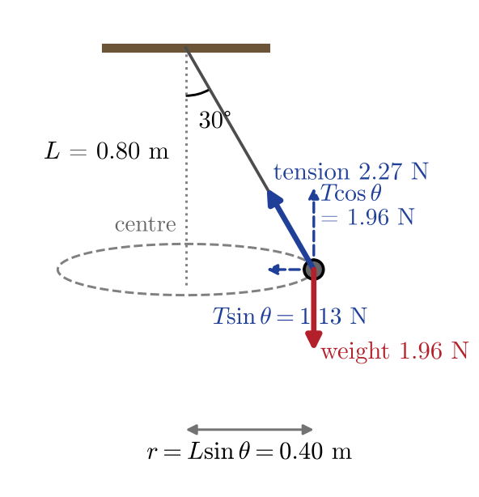  Figure 2.13: A conical pendulum drawn to scale: a 0.20 kg bob on a 0.80 m string moving in a horizontal circle with the string at 30° to the vertical. The vertical component of the tension balances the weight; the horizontal component (1.13 N) is the centripetal force, which gives a speed of 1.50 m s⁻¹ and a period of 1.67 s. | For the conical pendulum, $Tcosθ=mg$ vertically and $Tsinθ=\frac{mv^{2}}{r}$ horizontally. Dividing one by the other gives $tanθ=\frac{v^{2}}{rg}$: the faster the bob goes, the further out the string swings.
  WATCH OUT There is no outward “centrifugal force” acting on an object moving in a circle. If you feel pushed outwards in a turning car, it is your body trying to keep going in a straight line (Newton’s first law) while the car turns underneath you. On a free-body diagram, the resultant force points inwards, towards the centre.

EXAM TIP Circular motion questions: (1) draw the free-body diagram; (2) find the resultant force towards the centre; (3) set it equal to $\frac{mv^{2}}{r}$. Convert any period or frequency into $v$ or $ω$ first, and remember that $r$ is the radius of the circle, which for a conical pendulum is $Lsinθ$, not the string length $L$.

