**Sending messages between two users**

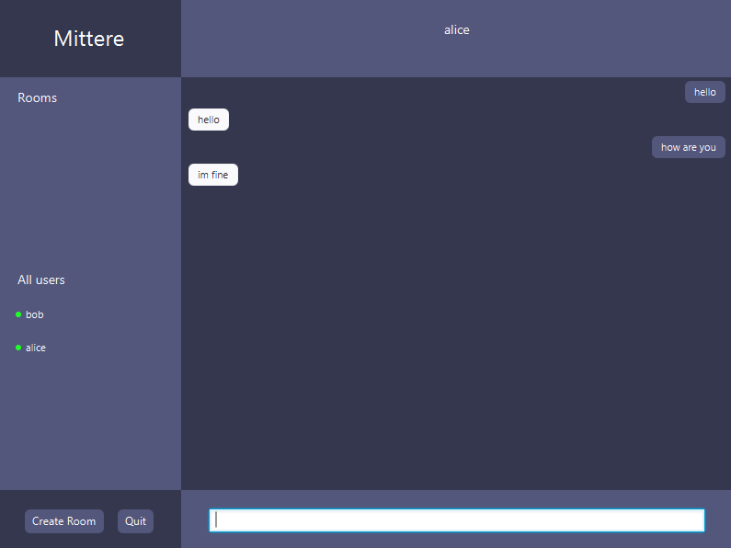

Figure 1 Bob sending message to Alice

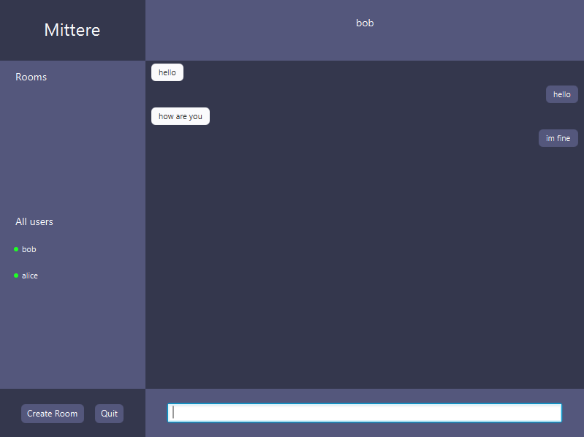

Figure 2 Alice replying to Bob

**Able to view another user is typing**

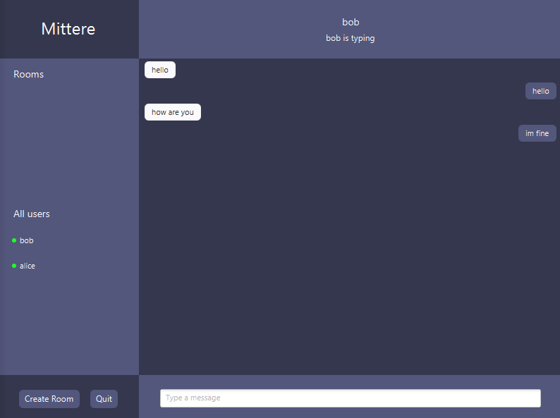

Figure 3 Alice can see that Bob is currently typing his message

**Able to view another user is online (Sidebar)**

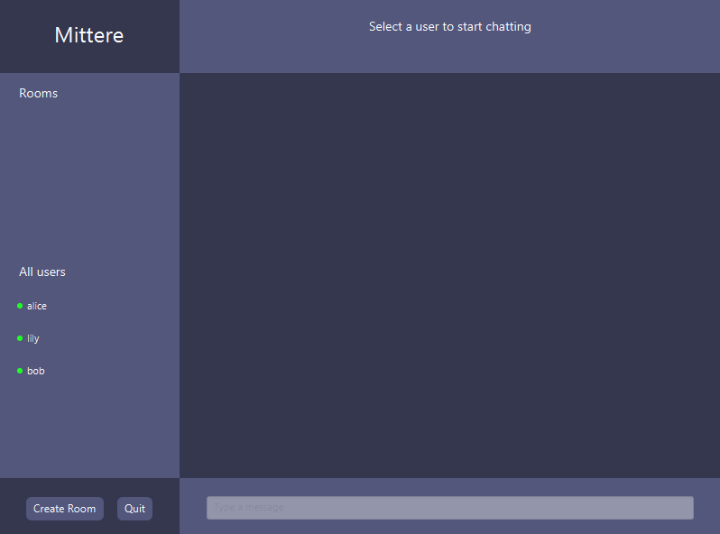

Figure 4 Lily can view on the sidebar who is currently online

**Able to view another user is online (Chatroom)**

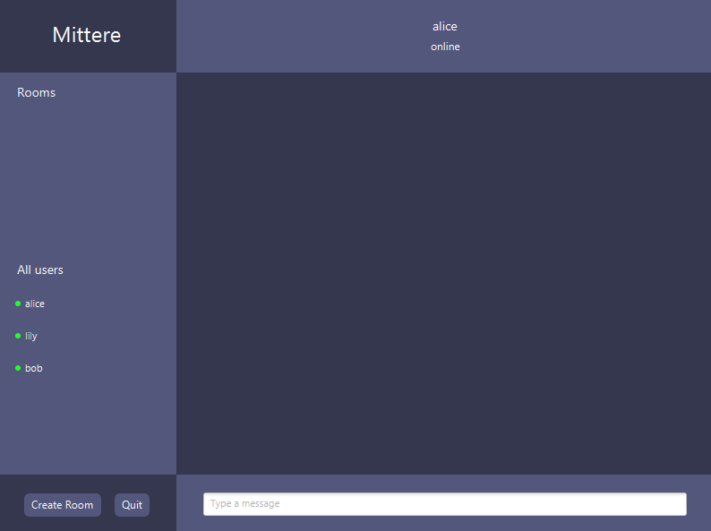

Figure 5 Lily can view on the chatroom that Alice is online

**Able to create a group chat**

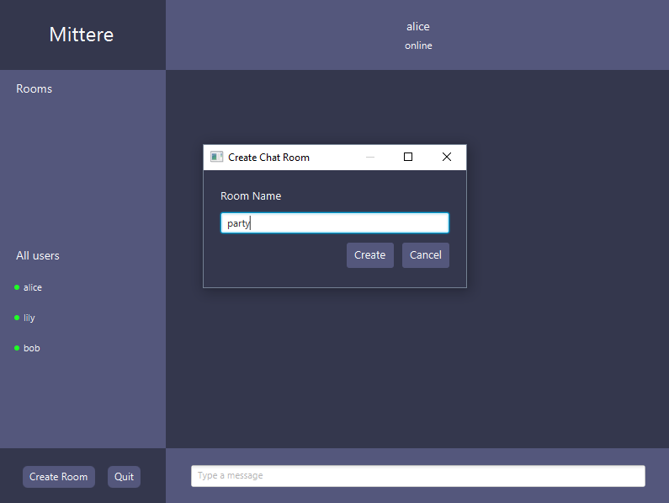

Figure 6 Lily can create a group chat

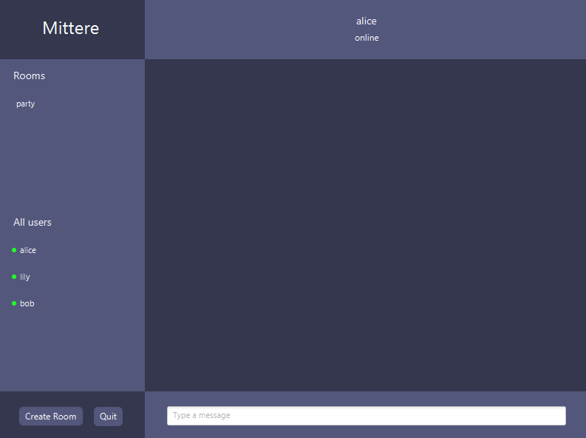

Figure 7 Lily can view the newly created group chat on the side bar

**Able to send and receive messages in the group chat**

**Able to receive notification when the user receives a message**

**Able to notify when invalid port and localhost**

**Check if username is unique before joining**

**Check if group name is unique before joining**

**User is removed from the online list when the user is disconnected**