Edge-AI Predictive Monitoring for Vaccine Refrigeration
in Rural Ghanaian Health Clinics

A Combined Edge AI, Embedded Systems, and IoT Approach to Cold-Chain Integrity and Predictive Fault Detection

Adu-Gyamfi Kwadwo
B.Sc. Electrical/Electronic Engineering, Kwame Nkrumah University of Science and Technology

Table of Contents
Abstract 3
1. Introduction 4
2. Related Work 5
3. Proposed System 6
4. Methodology 7
5. System Implementation 9
6. Results 12
7. Discussion 13
8. Future Work 14
9. Conclusion 15
References 16

Abstract
Vaccine cold-chain failures remain a major and preventable cause of vaccine wastage worldwide, and the problem is especially acute in rural, resource-constrained health facilities where unreliable electricity, limited technical support, and unreliable internet connectivity compound the risk. This work presents the design, validation, and prototype implementation of an edge-AI-informed monitoring system for vaccine refrigeration units, motivated specifically by the documented cold-chain challenges faced by rural health clinics in Ghana. Unlike existing systems, which are largely reactive (alerting only after a temperature threshold has already been breached) and cloud-dependent, the proposed system combines three complementary detection layers running locally on a low-cost ESP32-S3 microcontroller: (1) predictive compressor-fault detection derived from a machine-learning analysis of cycling behaviour, (2) gas-based detection of likely non-vaccine items placed in the unit, and (3) cumulative vaccine-exposure-risk tracking using a real-time clock. The predictive detection approach was first validated against a genuine, publicly available industrial dataset of a failing air compressor, achieving 95.3% recall in identifying documented failure periods, before being applied to a purpose-built simulation of vaccine-fridge degradation. The resulting detection logic was distilled into lightweight, real-time embedded logic and implemented and verified in a simulated hardware environment (Wokwi), including a live IoT reporting layer built on MQTT and a web-based dashboard. This document describes the related work that motivated the system, the validation methodology, the complete system design, results, and an honest discussion of the system's current limitations and next steps.

Note on terminology. This work uses the term "edge AI" to describe a system whose decision-making runs locally on the embedded device rather than in the cloud, and whose logic is derived from machine-learning analysis of data. It does not claim that a trained machine-learning model runs its inference directly on the microcontroller. As explained in Section 4.3, the Isolation Forest model used in this work runs offline, on a workstation, to discover a predictive signal in the data; that signal is then distilled into lightweight, explainable threshold logic that executes on the ESP32-S3 in real time. This is a deliberate and common engineering pattern for constrained edge hardware, and it is stated explicitly here so the scope of the term "edge AI" is unambiguous throughout the rest of this document.

1. Introduction

1.1 Background and Problem Statement
The World Health Organization estimates that a substantial proportion of vaccines produced worldwide are wasted every year, in large part due to cold-chain failures — temperature excursions during storage or transport that compromise vaccine potency. Beyond the direct loss of vaccine stock, an undetected refrigeration failure also imposes a secondary cost: unplanned equipment downtime, emergency repair costs, and disruption to a facility's ability to serve patients while the unit is out of service.
The overwhelming majority of existing vaccine cold-chain monitoring solutions are reactive rather than predictive: they measure temperature and raise an alert only once a threshold has already been crossed, by which point the vaccines inside may already be compromised. Very few systems attempt to anticipate an impending equipment failure before it manifests as a temperature excursion, and fewer still are designed to remain fully functional when internet connectivity is unreliable or absent — a common condition in the settings where this problem is most severe.

1.2 Motivation: The Ghana Context
This work is grounded in the documented, real cold-chain challenges faced by health facilities in Ghana. During the national COVID-19 vaccination effort, Ghana's rollout was significantly constrained by frequent power outages and a shortage of temperature-controlled transport, at one point, only fourteen temperature-controlled vehicles existed in the entire country. Reporting from UNICEF describing a rural health centre in the Dokrochiwa community illustrates the human dimension of this problem directly: an unreliable refrigeration unit forced staff to hold only two weeks of vaccine stock at a time rather than a full month, causing mothers to travel long distances only to find that stock had run out, eroding trust in the health system.
Ghana Health Service assessments attribute these failures principally to unreliable electricity supply, aging equipment, and the particular vulnerability of rural CHPS (Community-based Health Planning and Services) compounds. In response, UNICEF and Gavi have supplied thousands of pieces of cold-chain equipment to Ghana, including more than two hundred solar-powered refrigeration units. This equipment, however, still lacks any predictive monitoring layer: a solar-powered unit in a remote clinic can fail quietly, with the failure discovered only when a staff member opens the door and finds the contents already warm.
This local, documented gap — reliable equipment without predictive monitoring, deployed into settings with unreliable power and unreliable connectivity — is the specific problem this work addresses.

1.3 Research Objectives
- To review existing vaccine cold-chain monitoring and industrial predictive-maintenance literature and identify a concrete, addressable gap.
- To validate a machine-learning-based predictive fault-detection approach against genuine, real-world equipment failure data before applying it to the target domain.
- To apply and adapt this validated approach to a vaccine-refrigeration-specific context, given the absence of any public dataset of real vaccine-fridge failures.
- To design and implement a low-cost, edge-AI-capable embedded prototype that performs predictive fault detection, misuse detection, and cumulative exposure tracking without dependence on continuous internet connectivity.
- To add an optional IoT reporting layer for remote visibility, explicitly designed as a convenience layer rather than a dependency of the core safety functions.

2. Related Work
Existing approaches to this problem fall into three broad categories, reviewed below, each of which addresses part of the problem but not the combination this work proposes.

2.1 Basic IoT-Based Cold-Chain Monitoring
The most common category of existing system pairs a microcontroller (typically an ESP32) with a temperature and humidity sensor, streaming readings to a cloud dashboard, most commonly Firebase and triggering an SMS or buzzer alert when a fixed temperature threshold is crossed. Representative examples in the literature include an ESP32/DHT22/HX711-based system for underserved-area vaccine storage with SMS alerting and a chatbot interface; an ESP32/SHT31-based design that stores readings to both Firebase and local SD-card storage for resilience against connectivity loss; an open-source ESP32 and GPS-based system for tracking vaccines in transit; and an Arduino-based supply-chain monitoring system incorporating location and quantity tracking. These systems are valuable and widely deployed, but they share a common limitation: they are reactive by design, only raising an alert once a threshold has already been breached, and most depend on continuous cloud connectivity to function at all.

2.2 AI-Based Anomaly Detection for Vaccine Refrigeration
A smaller body of work applies machine learning directly to vaccine-fridge temperature monitoring. Notably, a semi-supervised convolutional-autoencoder approach has been demonstrated running directly on an ESP32-class microcontroller to detect subtle temperature anomalies in vaccine refrigeration that a simple fixed threshold would miss, reporting approximately 92% detection accuracy in testing. This represents a meaningful advance over threshold-based alerting, since it can catch abnormal patterns before they cross a hard limit. However, this class of system monitors the vaccine's thermal environment; it does not monitor the health of the refrigeration equipment itself, and therefore cannot provide advance warning of an impending compressor failure before the temperature is already affected.

2.3 TinyML Predictive Maintenance in Industrial Refrigeration
A separate and more mature body of work applies TinyML techniques to predictive maintenance of refrigeration and cooling equipment in general industrial settings, unrelated to vaccine storage specifically. Documented examples include vibration-based fault detection running on ESP32 hardware, a lightweight edge-AI system on the ESP32-S3 combining on-device inference with fault-type and time-to-failure estimation, and current-based compressor failure detection using an Isolation Forest model. These approaches demonstrate that predictive, on-device fault detection for compressor-driven cooling equipment is both feasible and effective. However, none of this work has been adapted to, or validated within, the specific context of hospital or clinic vaccine refrigeration.

2.4 Identified Research Gap
No existing system in the reviewed literature combines all three of the following properties in a single, low-cost device: (1) predictive detection of an impending refrigeration-equipment failure, ahead of any temperature excursion; (2) tracking of cumulative vaccine-exposure risk derived from the full temperature history, rather than a single threshold breach; and (3) fully local, on-device operation that continues to function correctly when internet connectivity is unreliable or unavailable — a condition that is the norm, not the exception, in the rural clinic settings where this problem is most severe. This is the gap this work addresses.

3. Proposed System

3.1 System Overview
The proposed system is built around a single ESP32-S3 microcontroller and combines three independent detection layers with a local alerting mechanism and an optional IoT reporting layer. Table 1 summarises the system's functional layers.
Layer | Function | Detection Basis
Predictive fault detection | Warns of likely compressor degradation before a temperature excursion occurs | Machine-learning-derived compressor on/off cycling signature, distilled into on-device threshold logic
Misuse / gas detection | Flags likely non-vaccine items (e.g. alcohol-based drinks) placed in the unit | MQ2 combustible-gas/vapour sensor, rule-based threshold
Cumulative exposure tracking | Tracks total time-above-threshold exposure per day, not just instantaneous breaches | DS1307 real-time clock, cumulative timer logic
Local alerting | Immediate, distinguishable audible and visual alerts per condition, independent of connectivity | Status LEDs (green/yellow/red/compressor) and a multi-tone buzzer
IoT reporting (optional) | Remote live visibility of device status via a web dashboard | Wi-Fi, MQTT publish/subscribe, Streamlit dashboard

3.2 Design Rationale
Two design decisions were made deliberately and are worth stating explicitly. First, the predictive and misuse-detection layers are designed to operate entirely locally: the device's core safety behaviour — sensing, fault detection, and alerting — does not depend on Wi-Fi or MQTT connectivity being available or successful. This directly reflects the connectivity constraints documented in the Ghana context described in Section 1.2. Second, rather than deploying the trained machine-learning model itself onto the microcontroller, the system uses the model to discover a predictive signal from data, which is then distilled into lightweight, explainable threshold logic suitable for real-time execution on constrained hardware. This decision, and the reasoning behind it, is discussed in detail in Section 4.3.

4. Methodology

4.1 Stage 1: Validation on Real-World Industrial Data
Because no public dataset of real vaccine-refrigerator failures exists, the detection methodology was first validated against a genuine, independently collected dataset of a different but physically analogous system: the MetroPT-3 dataset, published by INESC TEC and the University of Porto via the UCI Machine Learning Repository. This dataset contains second-by-second sensor readings — including motor current, multiple pressure channels, and oil temperature — from a real metro train's air compressor over a period of approximately seven months, along with a set of independently documented real failure events.
An Isolation Forest anomaly-detection model was trained exclusively on features extracted from documented normal-operation periods, using seven engineered features computed per hourly window: average compressor on-time, average off-time, signal variability, peak and minimum readings, cycle count, and a three-hour rolling average of cycle count. The trained model was then evaluated against the full dataset, including the documented failure windows.
The model correctly identified 82 of 86 documented failure hours as anomalous, a recall of 95.3%, while false-flagging 201 of 4,327 normal hours (approximately 4.6%). This recall/false-alarm trade-off is appropriate for a safety-oriented application, where a missed detection is substantially more costly than an occasional false alarm.

4.2 Stage 2: Application to a Domain-Specific Simulation
With the detection methodology validated on genuine failure data, the same feature-extraction and modelling approach was applied to the actual target domain. A physics-based simulation of a vaccine refrigerator was constructed in Python, modelling a standard 2–8°C compressor-cycling thermostat with realistic door-open events, and a gradual compressor degradation beginning at day 20 of a 30-day simulated run, implemented as a progressive reduction in cooling efficiency and increase in warming rate, deliberately gradual, reflecting how real compressor wear develops over time rather than failing instantaneously.
Applying the same hourly feature extraction and Isolation Forest approach to this simulated data produced a consistent, interpretable result: the model's anomaly score declined steadily as simulated wear progressed, from an average of approximately 0.10 in the early degradation period to approximately 0.02 by the final day of the simulation — directly demonstrating that the detection confidence tracks the true underlying severity of the fault, rather than behaving as a single blunt trigger. Figure 1 presents this result.

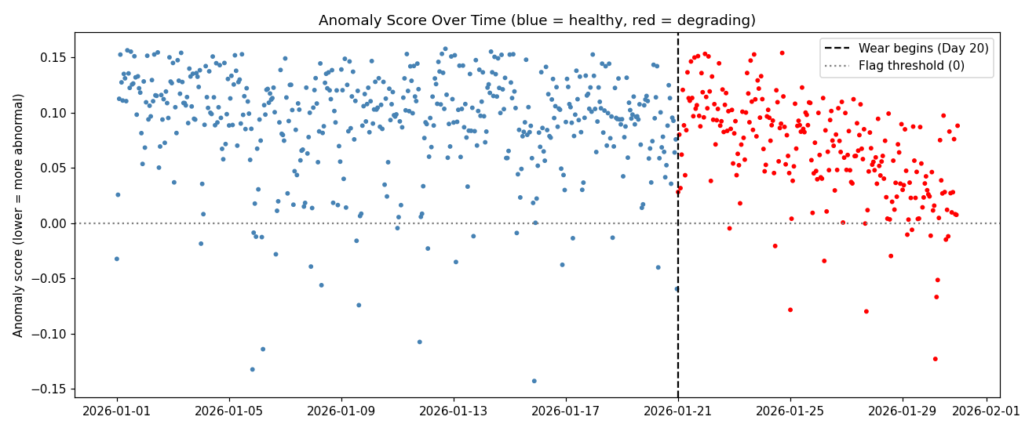
Figure 1. Anomaly score over the full simulated run. Blue points are healthy hours; red points are hours after simulated wear onset (Day 20). The steady downward trend in anomaly score demonstrates that detection confidence increases in proportion to fault severity.

4.3 Model Distillation for Embedded Deployment
The Isolation Forest model itself was deliberately not deployed onto the ESP32-S3. This was a considered engineering decision, not an oversight: Isolation Forest models comprise on the order of a hundred individual decision trees with no standard, low-risk export path to embedded C++, unlike some simpler model classes. Attempting a full, correct export within the available project timeline carried a material risk of introducing subtle numerical errors that would be difficult to detect without extensive on-device testing.
Instead, the validated model was used analytically, offline, to discover the underlying predictive signal in the data, which was then translated into lightweight, explainable logic suitable for real-time execution on the microcontroller — an approach commonly referred to as model distillation. Analysis of the simulation data (Section 4.2) showed that the dominant, physically interpretable predictive signal is the ratio between compressor on-time and off-time: a healthy unit was found to run with a median on/off ratio of approximately 0.46 (roughly 19 seconds on to 41 seconds off), while degrading units showed this ratio rising toward 1.2–2.3 depending on severity. This on-device logic continuously calibrates a per-unit baseline during an initial calibration period, then compares a rolling average of the five most recent on/off cycles against that baseline — smoothing was found to be necessary, since single-cycle comparisons proved too noisy to be reliable, as detailed in Section 4.4.

4.4 Threshold Derivation from Empirical Data
Initial threshold values were selected as reasoned estimates rather than derived directly from the data. On review, this was corrected: the actual per-hour on/off ratio distributions in the saved simulation output were analysed directly using robust (median-based) statistics, since the raw per-hour ratio proved highly skewed and unsuitable for mean/standard-deviation-based thresholding. This analysis confirmed that a warning threshold of 1.8× the calibrated baseline ratio and a critical threshold of 3.5× baseline are both grounded in the actual measured separation between healthy and degrading cycle behaviour (approximately 2.55× and 5× respectively at the aggregate and late-stage-degradation levels), while the five-cycle rolling average was introduced specifically to address the single-cycle noise problem identified during this analysis.

5. System Implementation

5.1 Hardware Architecture
The prototype was implemented and verified using the Wokwi hardware simulator, targeting an ESP32-S3 development board. Table 2 lists the sensing and actuation components and their function.
Component | Interface | Function
DHT22 | Single-wire digital (pull-up resistor) | Temperature and humidity sensing
Push-button | Digital input, internal pull-up | Door-open/close sensing
MQ2 gas sensor | Analogue input | Combustible-vapour / misuse detection
DS1307 real-time clock | I2C | Persistent real-time clock for cumulative exposure tracking
Status LEDs (green / yellow / red) | Digital output | Fridge-health status indication
Status LED (blue) | Digital output | Compressor-running indication
Piezo buzzer | PWM (LEDC hardware tone generation) | Distinguishable audible alerts per condition

5.2 Predictive Fault Detection Module
During an initial calibration period, the device establishes a per-unit baseline compressor on-time and off-time from the first several completed cycles. Once calibrated, each subsequent completed cycle is added to a rolling window of the five most recent cycles; once the window contains sufficient data, a smoothed on/off ratio is computed and compared against the calibrated baseline, as described in Section 4.4. Cycles occurring immediately after a door-open event are deliberately excluded from this evaluation to avoid conflating door-driven temperature disturbance with genuine compressor degradation.

5.3 Gas / Misuse Detection Module
An MQ2 combustible-gas sensor is polled periodically and compared against an empirically determined threshold, calibrated from observed resting and elevated readings within the simulation environment. It is important to state precisely what this module does and does not detect: the MQ2 sensor responds to combustible gases and vapours — for example, alcohol-based beverages — and does not constitute a general food-detection sensor. This scope was chosen deliberately: it addresses a real, documented category of vaccine-fridge misuse (storage of food or drink, which international guidance explicitly discourages) within the constraints of the sensor hardware available, rather than overstating its capability.

5.4 Cumulative Vaccine Exposure Tracking
A DS1307 real-time clock provides a persistent, battery-backed time source. Whenever the sensed temperature is at or above the safe upper limit, elapsed time is accumulated into a daily counter; if this cumulative warm-time exceeds a configured threshold within a calendar day, a distinct exposure-risk alert is raised, independent of whether any single instantaneous reading looked severe. This directly distinguishes the system from simple threshold-alarm designs, which cannot detect the cumulative effect of many short excursions. The daily-reset design is a deliberate first-phase simplification, discussed further in Section 7.2.

5.5 IoT Connectivity Layer
The device connects to Wi-Fi and publishes its status — temperature, compressor state, alert level, gas-sensor reading, cumulative exposure, door state, and device time — as a JSON payload over MQTT at regular intervals. A companion Python/Streamlit application subscribes to the same topic and renders a live web dashboard, shown in Figure 3. Critically, the MQTT connection logic is implemented as non-blocking: if the connection is unavailable or fails, the device retries periodically in the background but continues to execute all core sensing, detection, and alerting functions without interruption. This is a direct, deliberate reflection of the connectivity constraints described in Section 1.2 — the IoT layer is designed as a convenience, not a dependency.

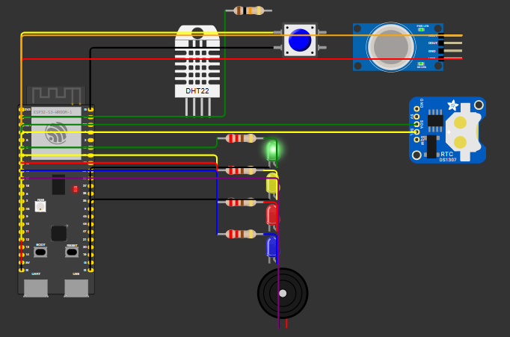
Figure 2. Full prototype circuit (ESP32-S3, DHT22, door button, MQ2 gas sensor, DS1307 RTC, status LEDs, and buzzer)

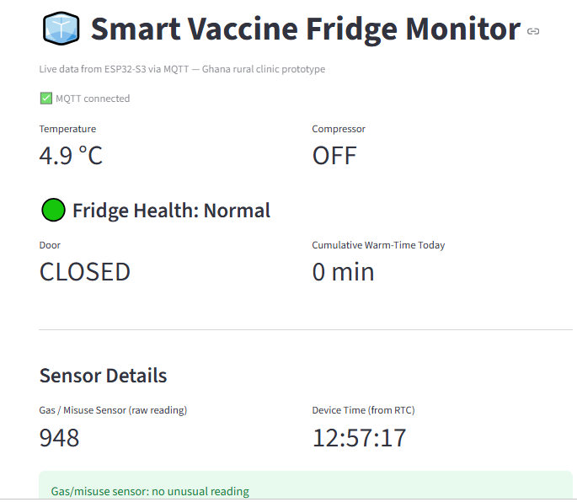

Figure 3. Live IoT dashboard receiving real-time device status over MQTT, confirming successful end-to-end connectivity.

6. Results

6.1 Real-Data Validation Results
Metric | Strict Model (contamination = 0.05) | Sensitive Model (contamination = 0.15)
Documented failure hours correctly flagged | 82 / 86 (95.3%) | —
Normal hours false-flagged | 201 / 4,327 (4.6%) | —
Average anomaly score, normal hours | 0.2519 | —
Average anomaly score, failure hours | −0.0648 | —

6.2 Simulated Fridge Validation Results
Configuration | Degrading Hours Flagged | Healthy Hours False-Flagged | First Correct Detection
Strict (contamination = 0.05) | 15 / 240 | 24 / 480 | Day 22
Sensitive (contamination = 0.15) | 87 / 240 | 72 / 480 | Day 21
As discussed in Section 4.2, the raw flag counts understate the result's significance: the anomaly score trend (Figure 1) shows a consistent, monotonic decline through the degradation period, indicating that detection confidence scales correctly with fault severity even where individual hours fall short of the binary flagging threshold.

6.3 Embedded System Verification
The complete embedded prototype was implemented and verified in the Wokwi hardware simulator. Verified behaviours include: correct DHT22 temperature sensing (following resolution of an initial pull-up and read-interval issue); correct compressor on/off cycling logic; correct calibration-phase behaviour (three cycles); correct rolling-window smoothing and drift-factor calculation using cycle data gathered during testing; correct door-event exclusion logic; correctly distinguishable multi-tone audible alerts for warning, critical, misuse, and exposure-risk conditions, each independently repeating until the underlying condition clears; correct MQ2 gas-sensor threshold behaviour at both resting (false) and elevated (true) readings, following empirical threshold calibration; correct RTC-based cumulative exposure accumulation and daily reset; and correct non-blocking Wi-Fi/MQTT operation, confirmed via successful end-to-end delivery to a live web dashboard (Figure 3).

7. Discussion

7.1 Key Findings
- A predictive fault-detection methodology validated on genuine industrial failure data (95.3% recall) transfers coherently to a domain-specific vaccine-refrigeration simulation, producing a physically interpretable signal — the compressor on/off cycling ratio — rather than an opaque model output.
- Single-cycle comparisons of this signal are statistically unreliable; a rolling average across multiple cycles is necessary for stable, defensible detection, and this smoothing requirement was identified empirically rather than assumed in advance.
- Deliberately excluding the machine-learning model itself from the embedded device, in favour of a distilled, explainable, data-derived rule set, is a defensible and common engineering pattern for resource-constrained deployment targets, and does not diminish the validity of the underlying research.
- Designing the safety-critical detection and alerting functions to be fully independent of network connectivity is not merely a convenience but a direct requirement given the documented power and connectivity constraints of the target deployment context.

7.2 Limitations
The following limitations are stated explicitly and are treated as scope boundaries for the current phase of work, not as concealed weaknesses:
- No public dataset of real vaccine-refrigerator failures currently exists; the threshold values used in the embedded system are derived from a domain-specific simulation rather than from real vaccine-fridge sensor logs. Addressing this gap is itself a contribution of the identified research need (Section 2.4).
- The real-world validation dataset (MetroPT-3) is drawn from a physically analogous but distinct system — a metro train's air compressor — used specifically to validate the detection methodology on genuine failure data, not as direct evidence of vaccine-fridge-specific performance.
- The MQ2 gas sensor detects combustible gases and vapours only, and should not be characterised as a general-purpose food-detection sensor; its scope is intentionally limited to a realistic subset of misuse cases.
- Cumulative vaccine-exposure tracking currently resets on a daily cycle rather than tracking exposure across a vaccine's full storage lifetime, which is a simplification appropriate to this prototype stage.
- The public MQTT broker used for the IoT demonstration is unauthenticated and unsuitable for production deployment; a private, authenticated broker would be required in a real installation.
- The entire system has been implemented and verified in a hardware simulator (Wokwi); physical hardware validation has not yet been performed.

8. Future Work
- Collection of real sensor data from physical vaccine refrigeration units, including documented failure events, to replace simulation-derived thresholds with directly validated ones.
- Physical hardware implementation and field testing, moving beyond the current Wokwi-simulated prototype.
- Extension of cumulative exposure tracking to track exposure across a vaccine's full shelf life rather than resetting daily, incorporating established time-temperature stability guidance for specific vaccine types.
- Investigation of a properly exported, quantised machine-learning model (for example, via a compact one-class model or a quantised autoencoder) for direct on-device inference, as a successor to the current distilled rule-based approach.
- Migration of the IoT reporting layer to a private, authenticated MQTT broker suitable for production deployment, and evaluation of low-power / intermittent-connectivity reporting strategies appropriate to rural deployment conditions.
- Incorporation of a broader-spectrum gas/air-quality sensor to extend misuse detection beyond combustible vapours.

9. Conclusion
This work has presented the design, empirical validation, and prototype implementation of an edge-AI vaccine refrigeration monitoring system, motivated by a documented, real cold-chain challenge in rural Ghanaian health clinics. By first validating a predictive fault-detection methodology against genuine industrial failure data, then deliberately and transparently adapting that methodology to a domain-specific simulation and a resource-constrained embedded target, this work demonstrates a complete, honestly-scoped research pipeline: from problem identification and literature gap analysis, through empirical validation, to a working, verified prototype combining predictive fault detection, misuse detection, cumulative exposure tracking, and optional IoT reporting — all designed to remain functional under the power and connectivity constraints that define the target deployment context. The system's current limitations have been stated explicitly, and a clear set of next steps has been identified to move from validated prototype toward field-deployable system.

References
Direct Relief (2026). The Hidden Systems Behind Global Health.
IQVIA. Tip of the Iceberg: Economic and Environmental Impact of the Vaccine Cold Chain.
World Health Organization (IVB). Monitoring Vaccine Wastage at Country Level.
UNICEF Ghana (2022). In Ghana, a Strong Cold Chain Makes All the Difference. (Dokrochiwa Health Centre; UNICEF/Gavi Cold Chain Equipment Optimisation Platform delivery of 2,343 items including 200+ solar-powered units).
Ghana Health Service. Assessments of national cold chain infrastructure and rural CHPS compound conditions.
Harrabi, M., Hamdi, A., Ouni, B., & Bel Hadj Tahar, J. (2024). Real-time temperature anomaly detection in vaccine refrigeration systems using deep learning on a resource-constrained microcontroller. Frontiers in Artificial Intelligence, 7:1429602. DOI: 10.3389/frai.2024.1429602.
Design of a Lightweight Edge-AI System for Predictive Maintenance on ESP32-S3. MDPI Applied Sciences.
INESC TEC / University of Porto. MetroPT-3 Dataset. UCI Machine Learning Repository, dataset ID 791.
MetroPT-3 Dataset (Kaggle mirror).
ResearchGate. "IoT-Based Multi-Parameter Monitoring for Robust Vaccine Storage in Underserved Areas."
Jurnal Otomasi Kontrol dan Instrumentasi. "Design of a Temperature and Humidity Monitoring System for Cold Chain Vaccine Storage."
GitHub (MananDesai28). "Vaccine-Temperature-Monitoring-System-using-IoT."
"Smart IoT-Based COVID-19 Vaccine Supply Chain, Monitoring, and Control System."
DFRobot. "TinyML-ESP32 Integration" for predictive maintenance.
"Embedded TinyML for Predictive Maintenance: Vibration Analysis on ESP32."

