Design Proposal

Project Proposal

The Project will be named, PyAmnesia, which will implement the python version of the game Amnesia. Amnesia is a 1st person interactive horror game, in which the user must solve tasks to avoid dying to a monster. My version will utilize pygame, and will play music in the background which will heighten the scariness of the game.

Competitive Analysis

For most games utilizing PyGame, most projects for hack112 or other projects seek to emulate 2D games. Furthermore, games that do utilize 3D models usually lack good graphics, and tend to be based around mazes or areas that are already defined. My game will not center around a maze, but it will have 5 different types of rooms, that will be randomly chosen. In order for the player to complete the game, they must get through 3 main stages.

Structural Plan

The game will consist of through main blocks of code. The ones that code for graphics, audio, monsters, and the user.

Graphics

This will consist of a 2D list that is utilized to make the room.

Audio

This will consist of audio files that can be loaded up when the monster reaches the player.

Monster

This will consist of the graphics utilized to represent the monster, and data values storing its location and speed and logic showing how it will move relative to the player.

User

This will be a class that has different methods such as walk, run, and also interactions with different objects within the room.

Algorithmic Plan

The trickiest part of the project will be implemented the state of when the user is being attacked by the monster. The room must start to shake, and the monster must race towards the user while ominous music is being played. To implement the shaking/hallucination version of the room, I will implement a “state” within the game, where the normal objects are modified to oscillate, and when music will be played, and the intensity of the music will vary with how close the monster is to the player.

Timeline Plan

TP2

* Finish user interaction with map, and implement puzzles + user interaction with objects

TP3

* Implement monster + better graphics + death hallucination/state

Version Control Plan

Whenever a new capability is implemented into my video game, I will back up the old version while making a new copy. This new copy will contain any new functionalities, while the old will contain any already functional pieces of code. Furthermore in the name of the code, I will include a short description of what it does.

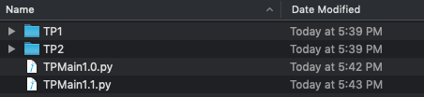

Module List

Pygame

Storyboard

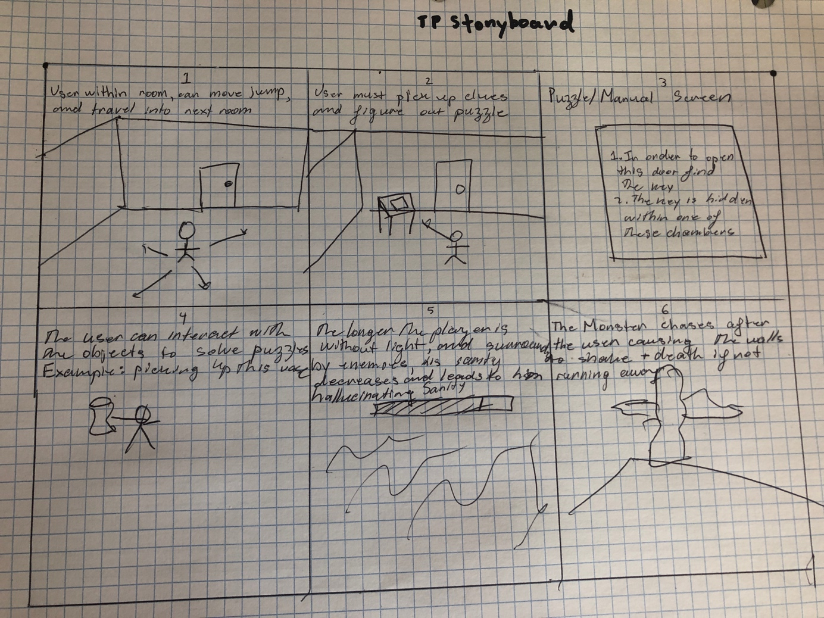

TP2 Update

No Changes Made

TP3

I realized that I would be impractical to implement Amnesia so I switched to a to a shooter game. The game still utilizes raycasting, and utilizes complex trigonometry and accomplish these graphics. Lastly, the name of the program was changed from PyAmnesia to PyShooter.