LA-UR-20-23488
May 2020

Analysis of the Frequency of Extreme Precipitation Events at Los Alamos National Laboratory

Authors: Kenneth Waight and David Bruggeman, EPC-CP
Los Alamos National Laboratory, an affirmative action/equal opportunity employer, is operated by Triad National Security, LLC, for the National Nuclear Security Administration of the U.S. Department of Energy under contract 89233218CNA000001. By acceptance of this article, the publisher recognizes that the U.S. Government retains a nonexclusive, royalty-free license to publish or reproduce the published form of this contribution, or to allow others to do so, for U.S. Government purposes. Los Alamos National Laboratory requests that the publisher identify this article as work performed under the auspices of the U.S. Department of Energy. Los Alamos National Laboratory strongly supports academic freedom and a researcher’s right to publish; as an institution, however, the Laboratory does not endorse the viewpoint of a publication or guarantee its technical correctness.

TABLE OF CONTENTS
Acronyms and Abbreviations iv
1.0 background 5
2.0 DETERMINATION OF methodOLOGY 5
3.0 DATA AND results 6
4.0 SUMMARY AND RECOMMENDATION 11
5.0 REFERENCES 11

List of Figures
3-1 PDS for 15-minute precipitation data, showing the 28 top precipitation events and the dates when they occurred 7
3-2 Beta-P curve for top 28 precipitation events of 15-minute duration 8
3-3 Extreme precipitation curves for recurrence intervals from 1 to 100 years.. 10

List of Tables
3-1 Beta-P empirical constants for each duration 9
3-2 Extreme precipitation rates for 1- to 100-year recurrence intervals and durations from 5 to 120 minutes 10

Acronyms and Abbreviations
AMS Annual Maximum Series
EPC Environmental Protection and Compliance
LANL Los Alamos National Laboratory
MAQ Meteorology & Air Quality
NOAA National Oceanic and Atmospheric Administration
PDS Partial Duration Series
TA Technical Area

1.0 background
The Environmental Protection and Compliance (EPC) Storm Water Permitting and Compliance Program is currently updating its stormwater compliance standards for the Los Alamos National Laboratory (LANL) Engineering Standards Manual (2015) and is addressing the required current meteorological data needed for storm water applications. Information on the frequency of extreme precipitation events at LANL is needed. In response to this request, LANL Meteorology & Air Quality (MAQ) was tasked to estimate the frequency of extreme precipitation events.
An earlier study by Foley (2012) which estimated extreme precipitation rates at LANL for a set of duration periods and average recurrence intervals (return periods) was evaluated. However, it was determined that this study would not be helpful since its technical support documentation was unavailable and the meteorological data and the methodology employed were not well understood. This led to the need to develop a new peer-reviewed methodology.
This report documents the development of the new methodology and the application of a temporally representative precipitation dataset from February 1990 through December 2018, monitored at the official LANL meteorological station, Technical Area (TA)-6, to develop the frequency of extreme precipitation events.

2.0 DETERMINATION OF methodOLOGY
The search for a new methodology began by testing a method based on an approach by Chow et al. (1988), but it was determined that it had two shortcomings. The first weakness is that the Chow calculation of extremes is based on an Annual Maximum Series (AMS), which is a series of the single largest precipitation event in each year of the data record. DeGaetano and Zarrow (2011) recommend the use of a Partial Duration Series (PDS), which is a set of the N highest precipitation events in a data record of N years. Since it allows for the possibility of multiple independent high precipitation events in a single calendar year, a PDS can better represent the full set of the highest precipitation events. The Precipitation Frequency Atlas of the United States, NOAA Atlas 14, (Bonnin et al. 2011) uses both AMS and PDS methods, because the return periods calculated from the two methods are not exactly the same, and both may be useful: “ARI [average recurrence interval] is the average period between exceedances (at a particular location and duration) and is associated with the partial duration series (PDS). Annual exceedance probability (AEP) is the probability that a particular level of rainfall will be exceeded in any particular year (at a particular location and duration) and is derived using the annual maximum series (AMS).” The Storm Water group decided that the PDS approach would be better for their purposes, because of the ability to capture multiple high precipitation events in a single year, which is not uncommon for the LANL dataset.

The second shortcoming of the Chow method is the use of a particular probability distribution function, the Extreme Value Type I or Gumbel distribution, to fit the observations to a function, which is then used to calculate extreme precipitation amounts for a given return period. Wilks (1993) examined a set of extreme value distributions, including a Gumbel distribution, and concluded that a different type of function, the beta-P extreme value distribution, was the best overall statistical technique due to its effectiveness in extrapolating observed data to extreme values for the longest return periods (e.g., 100 years).
Based on these findings, MAQ concluded that the DeGaetano and Zarrow PDS approach, using a beta-P extreme value distribution, is the best and most appropriate extreme precipitation event methodology available. Accordingly, this methodology will be used to develop the frequency of extreme precipitation events at LANL.

3.0 DATA AND results
3.1 Meteorological Data
TA-06 precipitation data every 15 minutes from February 1990 through December 2018 was used for this analysis. The 15-minute period is the minimum duration measured by the TA-06 tipping bucket rain gauge. Precipitation data was obtained from the internal Meteorology Program’s website, the Weather Machine, at https://weather.lanl.gov.
The important 90% data completeness requirement was met for each of the 29 years, with all but three years exceeding 98% data availability. The data availability for the years not meeting 98% availability, ranged from 90%-95%. This 347-month data period was sufficiently long to encompass decadal climatic oscillations and is thus judged to be temporally representative for an extreme precipitation analysis.
3.2 Extreme Precipitation Event Analysis
For each duration from 15 minutes to 120 minutes, a PDS was constructed and a beta-P curve fitted to the LANL 15-minute precipitation data. Extreme precipitation values were determined for average recurrence intervals ranging from 2 to 100 years using the DeGaetano and Zarrow beta-P equation:
(Equation 1)
Where, x = extreme precipitation amount (inches) for an average recurrence interval of R (years)
ω is the frequency of the data in the series (from Equation 8 of DeGaetano and Zarrow)
α, β, and θ are empirical coefficients calculated from the curve-fitting for each duration.
The precipitation amounts (inches) were later converted to precipitation rates (inches/hour), and for this dataset, ω was calculated to be 0.968 yr⁻¹.
3.3 Results
Figure 3-1 shows the PDS for the 15-minute duration dataset. Since there was a little more than 28 years of data, the top 28 15-minute precipitation events during that period were selected, with the requirement that they occurred at least 12 hours apart. This requirement was invoked to establish event independence, defined as not occurring from the same storm system.
Other analysts apply a much longer separation period of 7 days, as recommended by DeGaetano and Zarrow, to ensure that a synoptic scale system lasting multiple days could only be represented once in the series. However, since all of the top 28 15-minute precipitation events were caused by warm season convective storms of much smaller scale (i.e., mesoscale), and which typically last for a short period, a 12-hour separation between events seems reasonable for LANL climatology. These summertime convective storms are almost-entirely driven by the North American Monsoon (Adams and Comrie 1997).

Figure 3-1: PDS for 15-minute precipitation data showing the 28 top precipitation events and the dates when they occurred.¹
1 The second and third largest precipitation events occurred on successive days, showing the possible significance of the minimum separation criteria (12 hours). All extreme 15-minute events occurred in the warm season.
As described in DeGaetano and Zarrow and the NOAA Atlas, a special procedure was necessary to calculate the 1-year recurrence interval values. From the NOAA Atlas: “A 1-year AEP estimate, associated with AMS, has little meaning statistically or physically.
However, the 1-year ARI, associated with PDS does have meaning and is used in several practical applications.” It then demonstrates that an AMS-calculated recurrence interval of 1.58 years is mathematically equivalent to the desired PDS recurrence interval of 1 year. So for each of the eight duration periods, an AMS was constructed, a beta-P curve was fitted to the precipitation data, and a single extreme value was calculated for a recurrence interval of 1.58 years and assigned to the PDS recurrence interval for 1 year.

In order to apply the beta-P curve fitting from Equation 1, a Python script was written to read the raw file of 15-minute precipitation data and perform the calculations. A routine called least-squares from the widely-used scipy package was applied to fit the observed data to beta-P curves. A set of simple software quality assurance tests were performed on the code. Figure 3-2 shows an example of a curve fitted to the 28 top precipitation events of Figure 3-1 for a 15-minute duration.
The average recurrence interval was calculated for each event from the length of the series and the ranking of the event in the series. The red dots in Figure 3-2 represent the observed data in Figure 3-1. The dot farthest to the right represents the highest 15-minute precipitation event of 0.89 inch in the series, and the average recurrence interval was calculated to be 29 years. The blue curve in Figure 3-2 represents the beta-P curve which best fits the 28 top 15-minute precipitation events, which was used to produce the extreme value results for that duration.

Figure 3-2: Beta-P curve for top 28 precipitation events of 15-minute duration.
This beta-P curve fitting technique was applied to produce a set of empirical constants for durations ranging from 15 minutes to 120 minutes, shown in Table 3-1. To subsequently calculate the extreme precipitation values for each desired average recurrence interval, the beta-P curve was constructed from the empirical constants in this table.
Table 3-1: Beta-P empirical constants for each duration.
Duration (minutes) | α | β | θ
15 | 0.15 | 0.46 | 29.30
30 | 0.15 | 0.69 | 28.79
45 | 0.47 | 0.84 | 9.36
60 | 0.38 | 0.89 | 11.46
75 | 0.33 | 0.93 | 12.87
90 | 0.16 | 0.91 | 23.62
105 | 0.20 | 0.94 | 20.42
120 | 0.19 | 0.96 | 20.67

Table 3-2 shows the calculated values using the applicable beta-P curve for each duration, with a linear extrapolation (from 15- and 30-minute durations) to 5-minute and 10-minute durations. The extrapolated values are in italics. Note that the highest observed 15-minute value (in almost 29 years of data) of 3.56 inches/hour (0.89 inches in 15 minutes) is quite close to the 25-year value of 3.69 inches/hour from the fitted beta-P curve. The higher precipitation rates (e.g. 4 and 5 inches/hour) calculated for longer recurrence intervals from the theoretical relationship have not yet been observed, but these estimates can be refined in the future as the dataset continues to lengthen.
Based on the same information as Table 3-2, Figure 3-3 was constructed to show the rainfall rate with respect to duration. To do this, the rainfall amount was normalized to an hourly rainfall rate. The extrapolated 5- and 10-minute durations in Table 3-2 are not shown in this figure since they are estimates derived in a different manner than the method used to develop these curves.
Table 3-2: Extreme precipitation rates for 1- to 100-year recurrence intervals and durations from 5 to 120 minutes.³
Duration (minutes) | 1-yr | 2-yr | 5-yr | 10-yr | 25-yr | 50-yr | 100-yr
5 | 2.03 | 2.43 | 2.95 | 3.42 | 4.17 | 4.83 | 5.60
10 | 1.86 | 2.27 | 2.76 | 3.22 | 3.93 | 4.56 | 5.30
15 | 1.70 | 2.11 | 2.58 | 3.01 | 3.69 | 4.30 | 5.01
30 | 1.21 | 1.62 | 2.02 | 2.39 | 2.97 | 3.50 | 4.13
45 | 0.93 | 1.27 | 1.60 | 1.88 | 2.31 | 2.70 | 3.16
60 | 0.76 | 1.02 | 1.28 | 1.51 | 1.86 | 2.19 | 2.57
75 | 0.64 | 0.86 | 1.08 | 1.27 | 1.58 | 1.86 | 2.19
90 | 0.55 | 0.72 | 0.91 | 1.09 | 1.38 | 1.65 | 1.97
105 | 0.49 | 0.64 | 0.80 | 0.95 | 1.20 | 1.43 | 1.70
120 | 0.44 | 0.57 | 0.72 | 0.85 | 1.08 | 1.28 | 1.53
3 This method cannot be applied to durations shorter than the observed data frequency of 15 minutes. 5- and 10-minute durations (in italics) were estimated by linearly extrapolation of 15- and 30-minute durations.
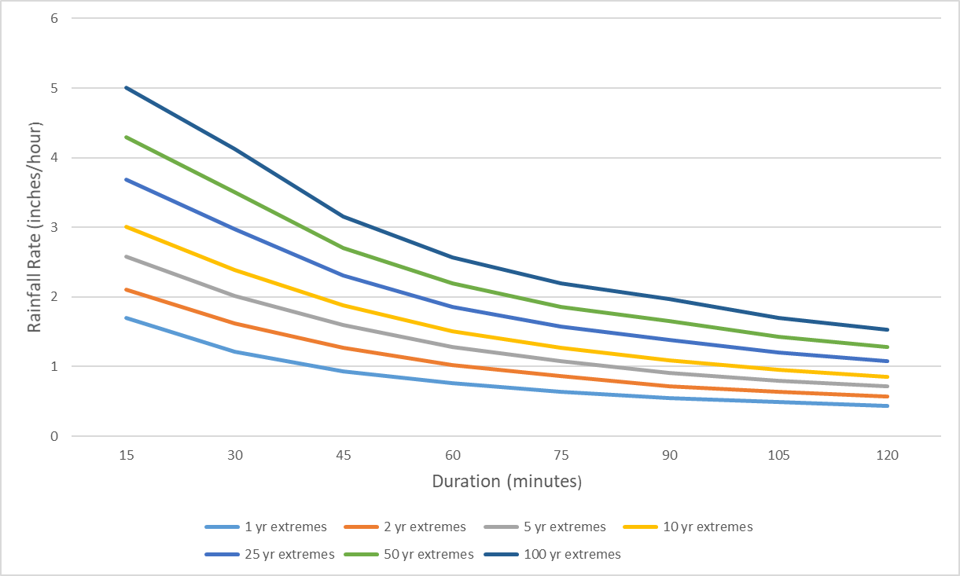
Figure 3-3: Extreme precipitation curves for recurrence intervals from 1 to 100 years.²
2 Based on 15-minute precipitation data from the TA-6 meteorological tower at LANL, collected from 1990-2018. The y-axis is the rainfall rate instead of the rainfall amount.

3.4 Comparison with NOAA Atlas Values
To test the accuracy of the methodology, the extreme precipitation rates in Table 3-2 were compared to the Los Alamos location in the NOAA Atlas 14 online viewer (https://hdsc.nws.noaa.gov/hdsc/pfds/pfds_map_cont.html?bkmrk=nm). The comparison tested the longest interval/shortest duration and shortest interval/longest duration values.
Comparison 1 (100-year average recurrence interval/15-minute duration): The NOAA Atlas estimates a maximum precipitation amount of 1.30 inches for a 100-year average recurrence interval for a 15-minute duration, or 5.20 inches/hour, compared to 5.01 inches/hour in Table 3-2. The difference is less than 4%.
Comparison 2 (1-year average recurrence interval/120-minute duration): The NOAA Atlas estimates a maximum precipitation amount of 0.79 inch for a 1-year average recurrence interval value for a 120-minute duration, or 0.395 inch/hour, compared to 0.44 inch/hour in Table 3-2. The difference is about 10%.
The NOAA Atlas precipitation extremes line up well with this study, with very minor differences depending on the duration and average recurrence interval.

4.0 SUMMARY AND RECOMMENDATION
A high-quality, long-period dataset with more than 28 years of 15-minute precipitation data at the official LANL meteorological tower (TA-06) was used to estimate the frequency of extreme precipitation events, applying a method similar to that described by DeGaetano and Zarrow.
Most, if not all of the more extreme observed events at LANL occur during the warm monsoonal season, frequented by thunderstorms.
For duration periods ranging from 15 to 120 minutes, a PDS of the highest precipitation events was constructed and then used to fit a beta-P curve to estimate the maximum expected precipitation amount for a set of average recurrence intervals, or return periods, ranging from 1 to 100 years. The maximum precipitation amounts were converted to rainfall rates and presented in Figure 3-3.
It is recommended that these values should be used as input to various algorithms needed for storm water management, flooding calculations, and other civil engineering applications.

5.0 REFERENCES
Adams, D.K. and A.C. Comrie, 1997: The North American Monsoon. Bull. Amer. Meteor. Soc., 78, 2197-2213.
Bonnin, G.M., D. Martin, B. Lin, T. Parzybok, M. Yekta and D. Riley, 2011: Precipitation
Frequency Atlas of the United States. NOAA Atlas 14 Volume 1, Version 5.0, National
Weather Service, Silver Spring, Maryland.
Chow, V.T., D.R. Maidment, and L.W. Mays, 1988: Applied Hydrology. McGraw-Hill
International Editions, 572 pp.
DeGaetano, A. and D. Zarrow, 2011: Extreme Precipitation in New York & New England,
Technical Documentation & User Manual.
http://precip.eas.cornell.edu/docs/xprecip_techdoc.pdf
Foley, W.J., 2012. EP-DIV-GUIDE-20087 – Design Storms for Individual Permit (IP)
Corrective Actions and Control Measures – Design Guide. LA-UR-12-25266
LANL Engineering Standards Manual STD-342-100. Chapter 3, Civil Standards, Section G20GEN Hydrological Analyses, Rev. 3, 27 May 2015.
NOAA Atlas 14 online viewer: (https://hdsc.nws.noaa.gov/hdsc/pfds/pfds_map_cont.html?bkmrk=nm).
Wilks, D.S., 1993: Comparison of three-parameter probability distributions for representing
annual extreme and partial duration precipitation series. Water Resour. Res., 29,
3543-3549.

