NAME: BINEY KWAKU EGYIR

CLASS: ELECTRICAL ENGINEERING YEAR 3

**ASSIGNMENT 3**

Conditional output box is located in the ASM chart in the question, it suggests the machine is a Mealy FSM. Here we have 3 states ST1, ST2 and ST3 so as per question, we require 3 flip flops D3 D2, D1

State assignment = > ST1 => 001

ST2 => 010

ST3 => 100



Figure 1(state diagram)

|  |  |  |  |
| --- | --- | --- | --- |
| Present State  Q3Q2Q1 | Inputs  A B C | Next State  Q3*Q2*Q1* | Output(z) |
| 001 | 0 X X | 001 | 0 |
| 001 | 1 X X | 010 | 0 |
| 010 | X 0 X | 100 | 0 |
| 010 | X 1 1 | 100 | 1 |
| 010 | X 1 1 | 001 | 1 |
| 100 | X X X | 001 | 0 |

Using ***Quinn McCluskey***, the following equations were derived:

D3= Q3’Q2Q1’B’ + Q3’Q2Q1’C’

D2= Q3’Q2’Q1A

D1= Q3’Q2’Q1A’ + Q3’Q2Q1’BC + Q3Q2’Q1’

Z = Q3’Q2Q1’B

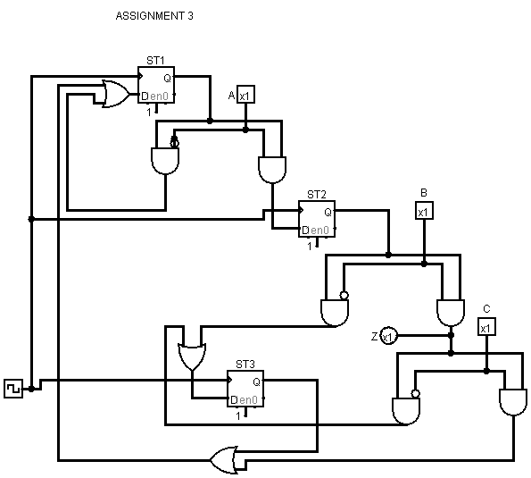

Figure 2 (ASM circuit drawn from chart)