ADVANCED EXCEL BUSINESS INTELLIGENCE REPORT
Superstore Retail
Performance Intelligence
A Refreshable Excel BI Analysis of Sales, Profitability,
Discounts, Customers and Data Quality
Stage 5 - Reporting and Documentation
Prepared by Patrick Adu Osei
Analysis period: January 2014-December 2017 | Report date: 9 August 2026

Document Control
Field | Value
Report title | Superstore Retail Performance Intelligence
Version | 1.0
Prepared by | Patrick Adu Osei
Source workbook | Superstore Advanced Excel Final - Conditional Formatting
Source data | Sample - Superstore_raw_data.csv
Order-date coverage | 3 January 2014 to 30 December 2017
Last validated refresh | 9 August 2026, 15:51 UTC
Unit of analysis | One sales order line; 9,994 lines across 5,009 distinct orders

Contents
Table of contents updates automatically in Microsoft Word.
In Microsoft Word, right-click the table of contents and choose Update Field if page numbers do not refresh automatically.

1. Executive Summary
This report documents the completed Superstore analysis as a professional, reproducible Excel business intelligence solution. The project replaces a static spreadsheet workflow with parameterized Power Query extraction and transformation, relational modeling in Power Pivot, centralized DAX measures, model-based PivotTables, connected slicers and timelines, data-quality controls, and refresh audit evidence.
Headline result: The model reports 2,297,200.86 dollars in sales and 286,397.02 dollars in profit, producing a 12.47% margin across 5,009 orders and 9,994 sales lines.
The business is profitable and grew strongly in 2016 and 2017, but profitability is materially weakened by discounting and a concentrated set of product losses. Discounted lines represent 52.64% of sales yet are unprofitable in aggregate. Discounts above 20% generate a combined loss of $135,376.06 and a margin of -37.32%. Furniture produces 32.30% of sales but only 6.44% of profit, with Tables and Bookcases generating losses. Technology and Office Supplies are the strongest profit engines.
The data pipeline validated all 9,994 input rows with zero rejected records. The overall quality status is REVIEW rather than FAIL because the controls intentionally flag 1,998 business-review instances, comprising 1,871 negative-profit lines and 127 high-sales outlier flags. These flags support investigation; they do not indicate broken ETL.

Priority actions
- Introduce approval and minimum-margin controls for discounts above 20%.
- Review pricing, freight, supplier terms and discount practices for Tables, Bookcases and Machines.
- Protect profitable Technology and Office Supplies availability, especially Copiers, Accessories, Paper and Labels.
- Use customer profitability, not sales alone, when approving account-specific discounts.
- Complete the workbook governance cleanup and retain refresh, quality and version evidence for each reporting cycle.

2. Purpose and Analytical Questions
The objective was to transform raw Superstore transaction data into a controlled analytical product that can be refreshed, audited and used repeatedly for management decisions. The report addresses the following questions:
- What are the current sales, profit, margin, order and customer KPIs?
- How have sales and profit changed over time?
- Which categories, sub-categories and products create or destroy value?
- How does discount intensity affect sales and profitability?
- Which regions and customer segments contribute the most profit?
- Which customers and products require profitability intervention?
- Can the results be refreshed and reproduced with visible quality and audit controls?

3. Data Scope, Grain and Assumptions
The source contains 9,994 sales order-line records from a sample United States retail dataset. The distinction between lines and orders is important: the dataset contains 5,009 distinct orders, so describing all 9,994 records as transactions or orders would overstate order volume. Each line records product, customer, location, order and ship dates, quantity, sales, discount and profit.
Scope item | Definition
Order-date period | 3 January 2014 to 30 December 2017
Source rows | 9994
Valid rows | 9994
Rejected rows | 0
Distinct orders | 5009
Distinct customers | 793
Currency | US dollars, as represented in the source dataset
Refresh dependency | The CSV must retain the expected column names and data types

Interpretation constraint: The supplied Profit field is treated as the model's profitability measure. The dataset does not expose a full managerial cost model, marketing spend, returns, inventory carrying cost or customer acquisition cost; therefore, results should not be interpreted as a complete economic profit statement.

4. Methodology and Reproducible Architecture
Microsoft describes Power Query as a way to connect to external data, shape it and load it into Excel for charts and reports, with subsequent refreshes keeping the analysis current [1]. Power Pivot supports relational Data Models, relationships and calculations inside Excel [2]. Those capabilities were combined with explicit DAX measures, model-based PivotTables, quality controls and an audit snapshot.
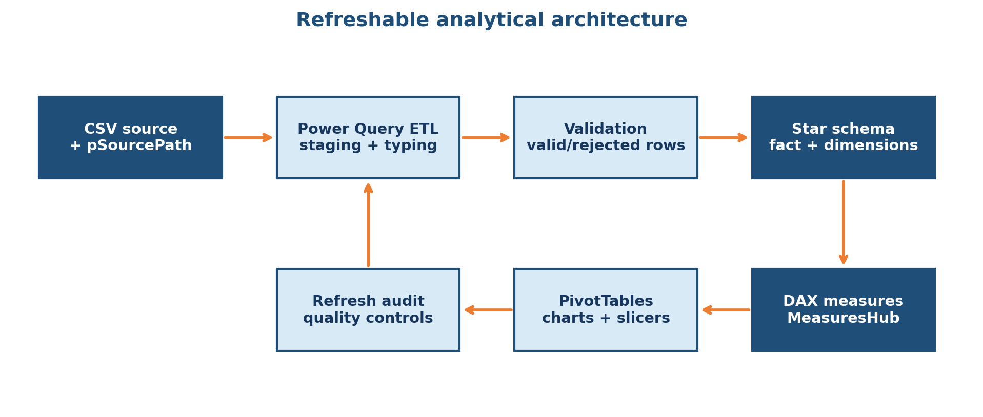
Figure 1. Refreshable analytical architecture
Source: Author's implementation based on the attached Excel workbook.

4.1 Power Query ETL
The pipeline begins with the text parameter pSourcePath, which separates the workbook logic from a hard-coded local file location. The staging query standardizes headers, trims text, converts dates and numeric fields, assigns types and creates validation attributes. Intermediate validation queries isolate valid rows and retain rejected-record capability. Staging and helper queries are kept connection-only, while curated facts, dimensions, quality and audit outputs are loaded as required.

4.2 Data-quality controls
Data_Checks evaluates blank identifiers, invalid dates, duplicate line keys, invalid quantities, discount range, missing or negative sales, and missing profit. Review-level checks identify high-sales outliers and negative-profit lines. DQ_InvalidRows provides a rejected-record register when invalid source rows exist. Refresh_Audit records source path, refresh timestamp, row counts and order-date coverage.

4.3 Relational Data Model
FactSales is modeled at sales-line grain and connects to DimProduct, DimCustomer, DimLocation and DimDate through one-to-many relationships. The active date relationship uses Order Date. A second inactive relationship supports Ship Date calculations through USERELATIONSHIP-based measures. MeasuresHub centralizes business calculations so PivotTables do not rely on inconsistent worksheet formulas or ad hoc aggregations.
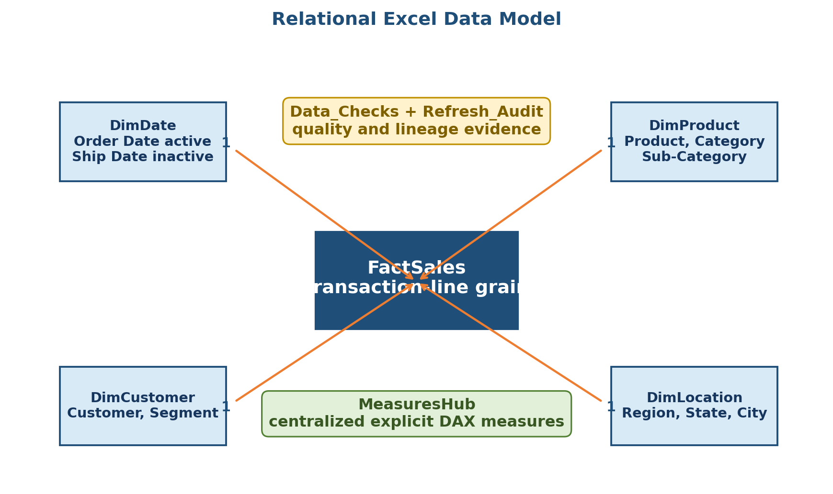
Figure 2. Excel Power Pivot relational model
Source: Attached Excel Data Model.

4.4 Reporting layer
The reporting layer contains an executive dashboard, Data Quality page, Profit Drivers page, Customer page and Region page. Five slicers and one date timeline are connected to the principal business PivotTables. Backend PivotTables on 99_Pivots support the dashboard charts, while 99_Audit displays the latest refresh snapshot.
This architecture follows reproducible-analysis principles: the same source schema and documented steps should generate the same outputs, while auditability and quality assurance improve trust and business continuity [5].

5. Stage 4 Analytical Results

5.1 KPI overview
KPI | Result | Definition
Total Sales | $2,297,200.86 | Revenue represented by all valid sales lines
Total Profit | $286,397.02 | Net profit supplied by the source data
Profit Margin | 12.47% | Total Profit divided by Total Sales
Order Count | 5,009 | Distinct Order IDs
Average Order Value | $458.61 | Total Sales divided by distinct orders
Customer Count | 793 | Distinct Customer IDs
Loss-Making Line % | 18.72% | Negative-profit lines divided by all sales lines
High-Discount Margin | -37.32% | Margin on lines discounted above 20%

5.2 Sales and profit over time
Sales declined by 2.83% in 2015, but profit increased by 24.37%, indicating a stronger margin mix. Growth accelerated in 2016, when sales increased by 29.47% and profit by 32.74%. In 2017, sales reached $733,215.26 and profit $93,439.27; however, profit growth of 14.24% lagged sales growth of 20.36%, and margin eased from 13.43% to 12.74%.
Year | Sales | Profit | Margin | Sales YoY | Profit YoY
2,014 | $484,247.50 | $49,543.97 | 10.23% | - | -
2,015 | $470,532.51 | $61,618.60 | 13.10% | -2.83% | 24.37%
2,016 | $609,205.60 | $81,795.17 | 13.43% | 29.47% | 32.74%
2,017 | $733,215.26 | $93,439.27 | 12.74% | 20.36% | 14.24%

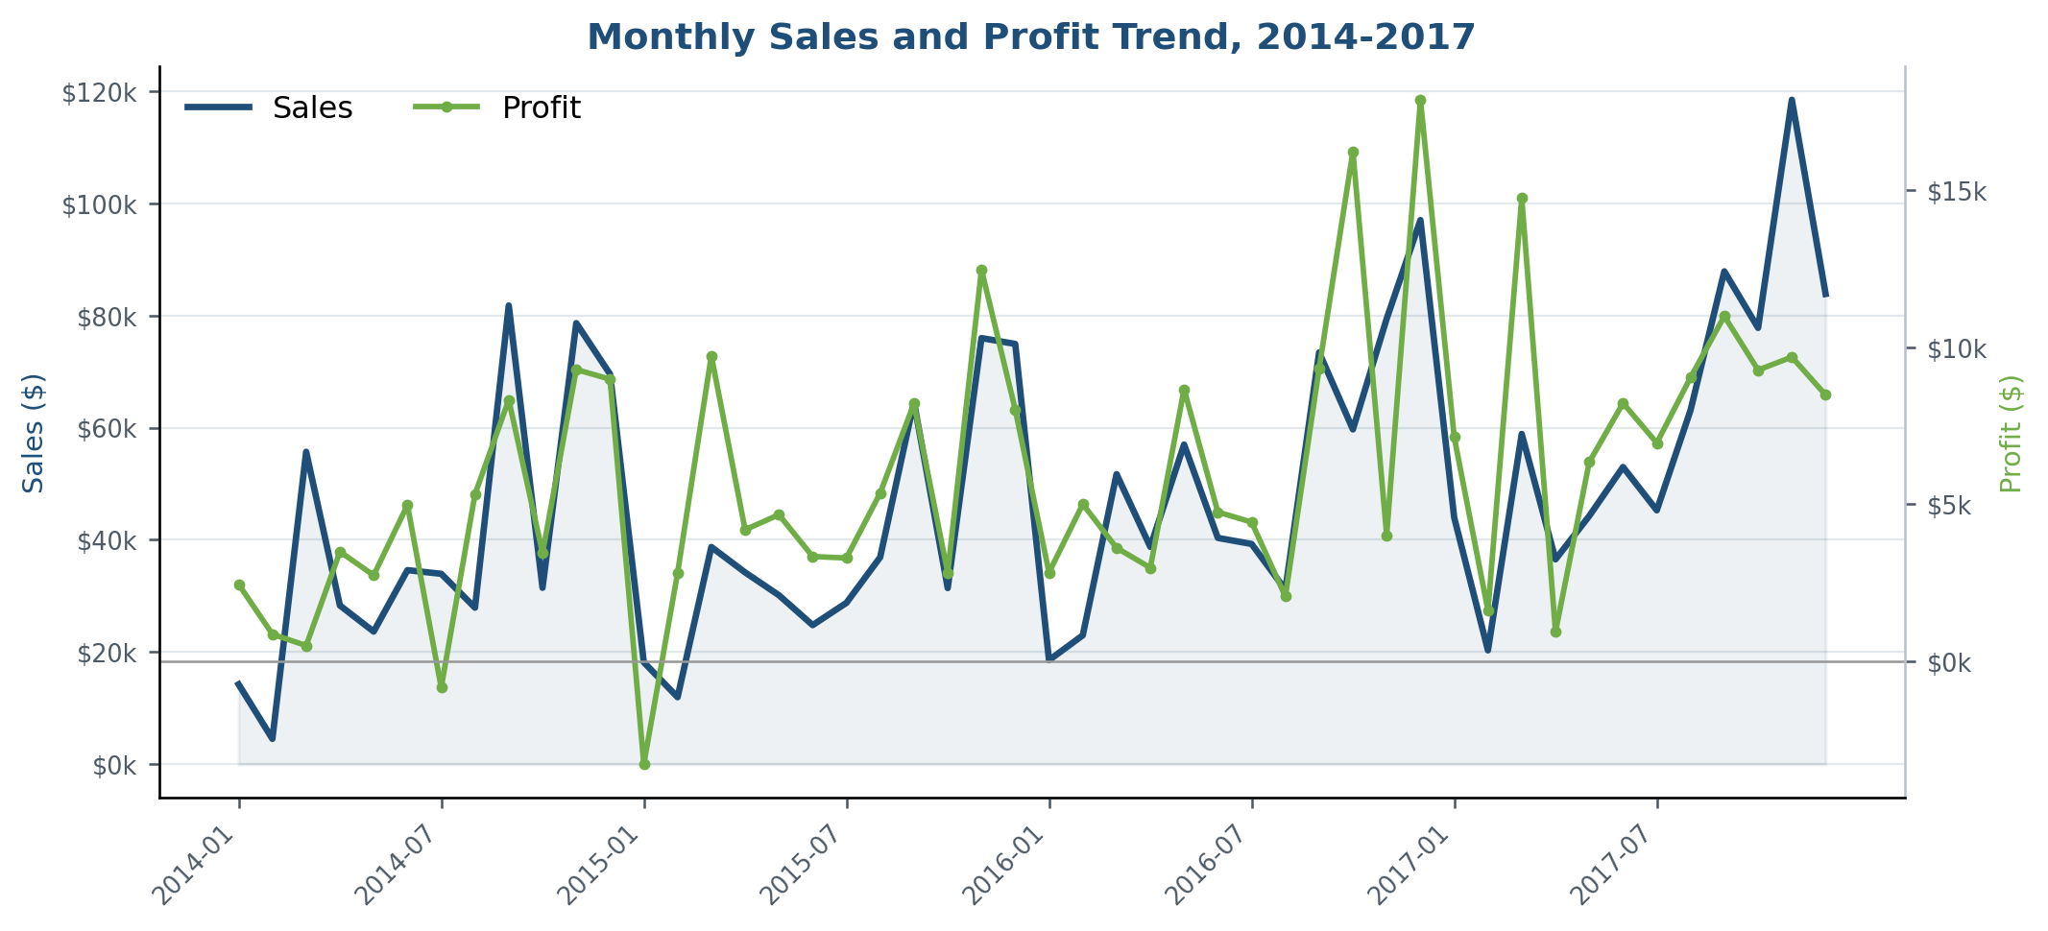
Figure 3. Monthly sales and profit trend
Source: PT_MonthlyTrend, attached Excel Data Model.
Seasonality: November 2017 recorded the highest monthly sales at $118,447.83. December 2016 recorded the highest monthly profit at $17,885.31. July 2014 and January 2015 were the only loss-making months in the period.

5.3 Category and sub-category performance
Technology is the largest and most profitable category, while Office Supplies produces almost the same margin. Furniture is the principal category-level weakness: it contributes 32.30% of sales but only 6.44% of profit and has a margin of 2.49%.
Category | Sales | Profit | Margin | Profit share
Furniture | $741,999.80 | $18,451.27 | 2.49% | 6.44%
Office Supplies | $719,047.03 | $122,490.80 | 17.04% | 42.77%
Technology | $836,154.03 | $145,454.95 | 17.40% | 50.79%

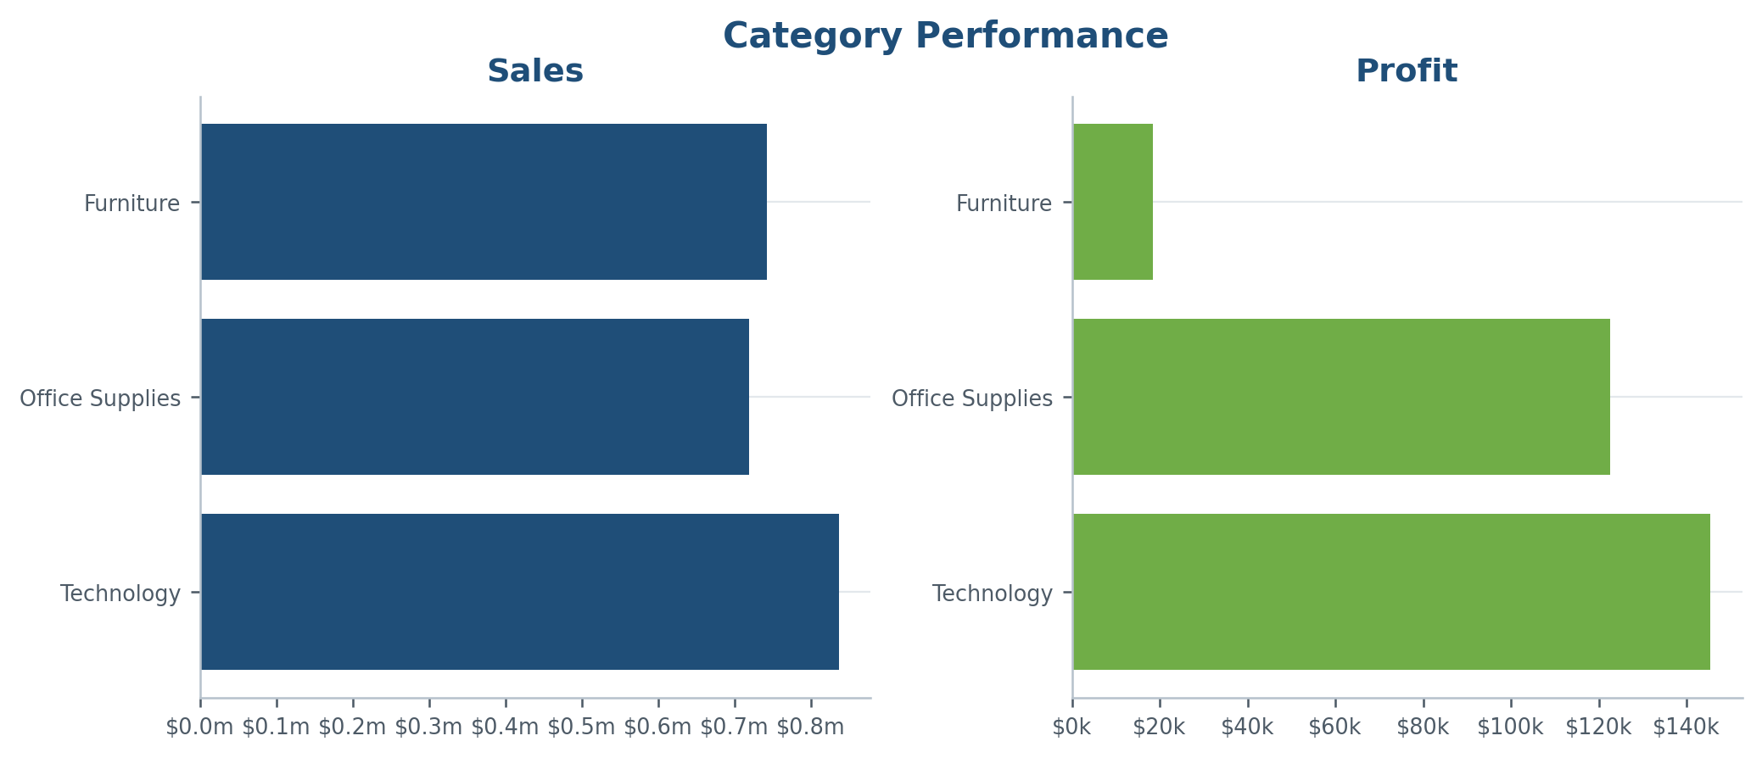
Figure 4. Category sales and profit
Source: PT_Category, attached Excel Data Model.
At sub-category level, Copiers produce the highest profit ($55,617.82) and a 37.20% margin. Phones generate the highest sub-category sales ($330,007.05) and $44,515.73 profit. Machines generate $189,238.63 sales but only $3,384.76 profit, a 1.79% margin. Tables lose $17,725.48, Bookcases lose $3,472.56, and Supplies lose $1,189.10.

5.4 Discount effectiveness and profitability
Discounting is the dominant profitability risk. No-discount lines produce $320,987.60 profit at a 29.51% margin. Medium discounts remain profitable, but margin falls to 11.58%. High discounts generate a -15.30% margin and very-high discounts a -77.40% margin.
Discount band | Sales | Profit | Profit margin
No Discount | $1,087,908.47 | $320,987.60 | 29.51%
Low: 1%-10% | $54,369.35 | $9,029.18 | 16.61%
Medium: 11%-20% | $792,152.89 | $91,756.30 | 11.58%
High: 21%-40% | $234,137.90 | $-35,817.47 | -15.30%
Very High: >40% | $128,632.25 | $-99,558.59 | -77.40%

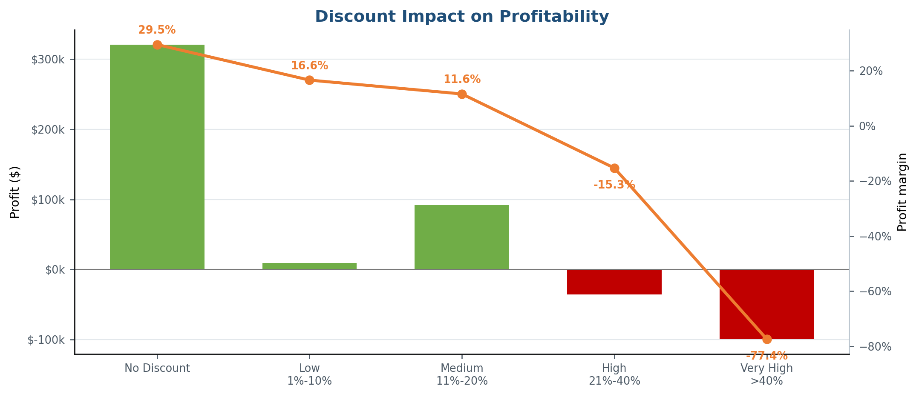
Figure 5. Discount impact on profitability
Source: PT_DiscountImpact, attached Excel Data Model.
Business implication: Discounted lines generate $1,209,292.39, or 52.64% of sales, but lose $34,590.58 in aggregate. High and very-high discounts alone lose $135,376.06, equivalent to 47.27% of current total profit.

5.5 Regional performance
West and East generate 69.81% of total profit. West leads with $108,418.45 profit and a 14.94% margin. Central records $501,239.89 in sales but only $39,706.36 profit, producing the weakest regional margin at 7.92%.
Region | Sales | Profit | Margin | Profit share
West | $725,457.82 | $108,418.45 | 14.94% | 37.86%
East | $678,781.24 | $91,522.78 | 13.48% | 31.96%
South | $391,721.91 | $46,749.43 | 11.93% | 16.32%
Central | $501,239.89 | $39,706.36 | 7.92% | 13.86%

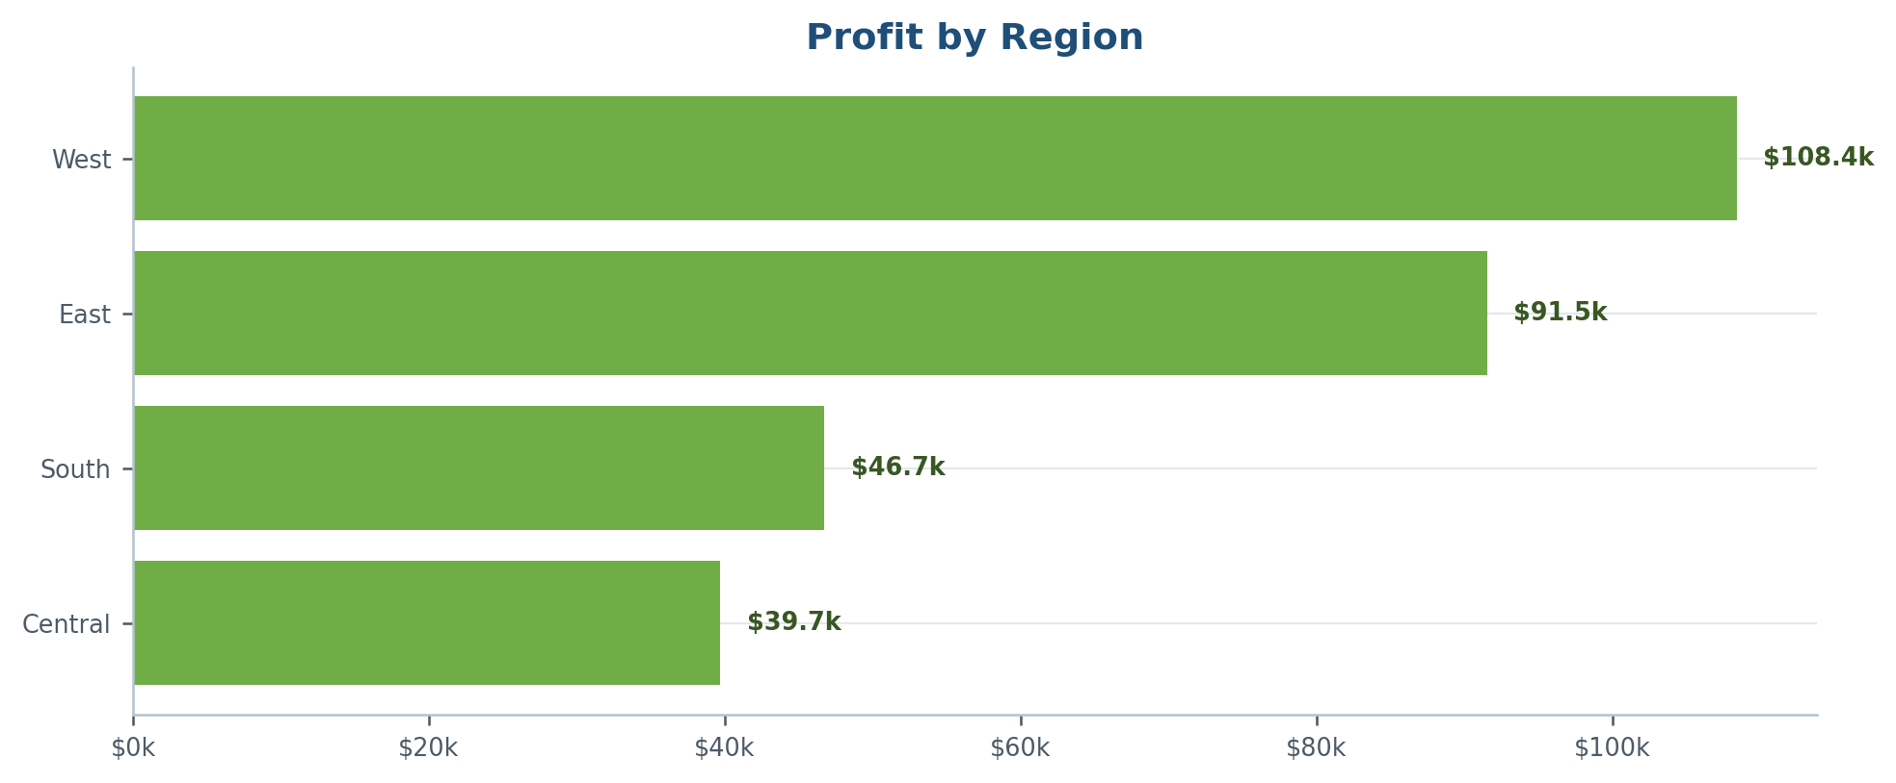
Figure 6. Profit by region
Source: PT_Region, attached Excel Data Model.

5.6 Segment and customer performance
Consumer is the scale segment, producing 50.56% of sales and 46.83% of profit, but its 11.55% margin is below Corporate (13.03%) and Home Office (14.03%). Growth and retention initiatives should therefore be judged on margin and customer value, not sales volume alone.
Segment | Sales | Profit | Margin | Sales share
Consumer | $1,161,401.34 | $134,119.21 | 11.55% | 50.56%
Corporate | $706,146.37 | $91,979.13 | 13.03% | 30.74%
Home Office | $429,653.15 | $60,298.68 | 14.03% | 18.70%

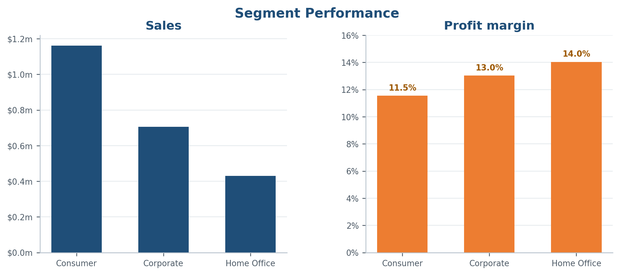
Figure 7. Segment sales and margin
Source: PT_Segment, attached Excel Data Model.
The ten highest-sales customers account for $153,811.17, or 6.70% of sales, and $41,139.70, or 14.36% of profit. Sean Miller is the highest-sales customer at $25,043.05 but generates a $1,980.74 loss. Tamara Chand generates the highest profit within the top-ten group at $8,981.32.

5.7 Loss-making products and fulfilment
The model identifies 1,871 negative-profit lines, representing 18.72% of all sales lines. Their negative profit totals $156,131.29. The largest product-level loss is the Cubify CubeX Double Head 3D Printer at $8,879.97, followed by the Lexmark MX611dhe printer at $4,589.97.
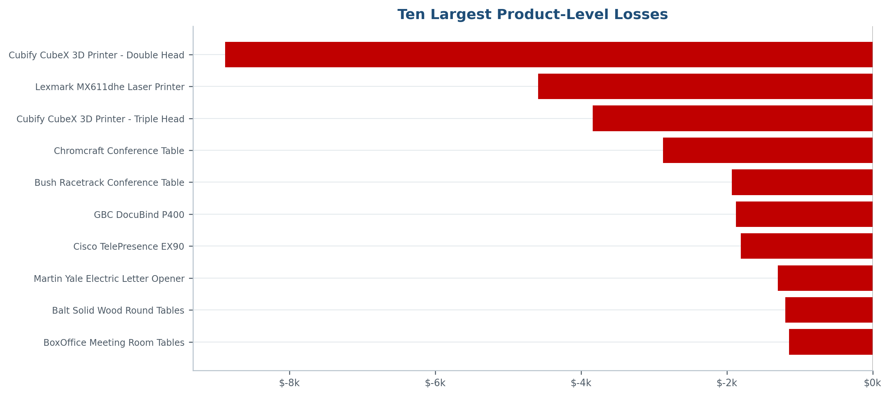
Figure 8. Ten largest product-level losses
Source: PT_LossProducts_Display, attached Excel Data Model.
Standard Class accounts for 59.13% of sales and 57.30% of profit. Ship-mode margins range from 12.08% to 13.94%, suggesting that discount and product mix are stronger profitability drivers than ship mode at the aggregate level. This does not rule out freight or service-level effects because detailed fulfilment cost is unavailable.

6. Data Quality and Model Assurance
The Data Quality page separates structural failures from business-review flags. All eleven error-level checks currently pass. Two checks remain in REVIEW: high-sales outliers and negative-profit rows. The audit reconciles 9,994 source rows to 9,994 valid rows, with zero rejected rows.
Control | Current result | Interpretation
Source rows | 9,994 | Rows read from the CSV
Valid rows | 9,994 | Rows loaded to the analytical pipeline
Rejected rows | 0 | No structural rejection in the current refresh
Error-level checks | 11 PASS | Required structural controls passed
Review-level checks | 2 REVIEW | Business anomalies require investigation
Flag instances | 1,998 | 1,871 loss-line flags plus 127 high-sales outlier flags
DQ pass rate | 84.62% | 11 of 13 checks are PASS; REVIEW is not equivalent to FAIL
Refresh status | 9 August 2026, 15:51 UTC | Latest cached refresh snapshot

Labeling recommendation: Rename 'DQ Failure Instances' to 'DQ Flag Instances' because the measure includes REVIEW-level business anomalies even when the error-level pipeline checks pass.

7. Key Findings and Business Implications
Profitable growth, but weaker margin conversion. 2017 is the strongest sales year, but profit growth trails sales growth and margin falls from 13.43% to 12.74%.
Discounting destroys material value. Discounted lines are unprofitable in aggregate; discounts above 20% generate a -37.32% margin.
Furniture is a structural margin problem. Furniture contributes almost one-third of sales but only 6.44% of profit, driven by losses in Tables and Bookcases.
Technology and Office Supplies fund profitability. Together they generate 93.56% of profit, with Copiers, Accessories, Paper, Labels and Envelopes producing attractive margins.
Revenue concentration is not excessive. The top ten customers represent 6.70% of sales, but individual high-sales accounts can still be loss-making.
Regional efficiency differs. Central has the weakest margin despite more sales than South, indicating a pricing, product-mix or discount issue rather than a pure scale issue.
Data is usable and governed. All input rows reconcile, rejected rows are visible by design, and refresh metadata supports traceability.

8. Recommendations and Action Plan
Pri. | Horizon | Initiative | Action | Owner | Success measure
P1 | 0-30 days | Discount governance | Set approval thresholds above 20%; introduce product/customer minimum-margin checks. | Commercial / Finance | High-discount margin; discounted profit
P1 | 0-30 days | Loss-product review | Review the top loss-making printers, Tables and Bookcases for price, freight, supplier and discount causes. | Category Management | Loss amount; loss-line percentage
P2 | 30-60 days | Furniture recovery | Create sub-category plans for Tables and Bookcases and monitor margin by region and segment. | Merchandising | Furniture margin; sub-category profit
P2 | 30-60 days | Customer profitability | Require account-level profit review before retention or discount campaigns. | Sales / CRM | Profit per customer; customer margin
P2 | 30-90 days | Growth allocation | Protect availability and promotion for profitable Technology and Office Supplies products. | Inventory / Marketing | In-stock rate; profit contribution
P3 | Monthly | Governed refresh | Refresh the model, review DQ/Audit results, archive outputs and record decisions. | Report Owner | Refresh success; DQ status; audit completeness

9. Limitations and Responsible Interpretation
- The dataset is a sample and does not represent a named operating company or current market conditions.
- Observed discount-profit relationships are descriptive associations and do not prove that discounts alone caused every loss.
- The Profit field does not expose its full cost build-up; freight, returns, marketing and acquisition costs are not separately modeled.
- The analysis is historical and descriptive. No demand, sales or profitability forecast has been fitted or validated.
- The date table extends beyond the final Order Date to cover Ship Date. Ordinary order measures can therefore be blank when a ship-only future date is selected.
- Refresh_Audit records the latest snapshot, not a permanent history. Refresh_Log is currently empty and should not be described as an automated audit trail until an append process exists.
- The high-sales outlier threshold should be explicitly documented in the Data_Checks methodology before production use.

10. Refresh and Reproduction Procedure
Microsoft supports Refresh All for updating workbook connections and PivotTables [3,4]. Use the following controlled procedure for each reporting cycle:
- Place the replacement CSV in the approved folder and retain the expected source column names.
- Update pSourcePath only if the source location changes; avoid editing the staging M code for routine refreshes.
- Open the workbook in desktop Excel and run Data > Refresh All, or press Ctrl+Alt+F5.
- Wait for all queries and the Data Model to finish processing before using the slicers or saving the file.
- Validate Refresh_Audit: source path, UTC timestamp, source rows, valid rows and date coverage.
- Review 01_Data_Quality. Any FAIL requires correction before publication; REVIEW requires investigation and documented acceptance.
- Reconcile the executive KPIs and test at least one region, category, segment and date selection.
- Save a versioned workbook and report output, recording the refresh date, owner and exceptions.

Current-refresh acceptance baseline
Acceptance check | Baseline
Source rows = valid rows | 9,994 = 9,994
Rejected rows | 0
Total Sales | $2,297,200.86
Total Profit | $286,397.02
Profit Margin | 12.47%
Order Count | 5,009
Customer Count | 793
Data-quality status | REVIEW, with no error-level failures

11. Conclusion
The project has successfully progressed from static spreadsheet analysis to a refreshable Excel BI solution. Its strongest contribution is not only the dashboard, but the controlled chain from parameterized source ingestion through data quality, relational modeling, DAX measures, interactive analysis and refresh evidence. The analytical result is commercially clear: growth is positive, but discount governance and product-level margin recovery are required to protect profit. With the final cleanup actions in Appendix C, the workbook and this report form a strong advanced-Excel portfolio project and a credible foundation for recurring management reporting.

Appendix A. Metric and Analytical Definitions
Metric | Logic | Use
Total Sales | SUM of FactSales[Sales] | Revenue across current filter context
Total Profit | SUM of FactSales[Profit] | Profit across current filter context
Profit Margin % | Total Profit / Total Sales | Profitability efficiency
Order Count | DISTINCTCOUNT of Order ID | Unique customer orders
Average Order Value | Total Sales / Order Count | Average revenue per order
Loss-Making Line % | Loss-making line count / sales line count | Frequency of negative-profit lines
High-Discount Margin | High-discount profit / high-discount sales | Margin where discount exceeds 20%
Negative Profit | Profit on lines where Profit < 0 | Magnitude of transaction-line losses
Sales by Ship Date | Total Sales with inactive Ship Date relationship activated | Alternative date perspective
DQ Pass Rate % | PASS checks / all checks | Share of quality checks passing

Appendix B. Workbook Inventory
The attached workbook contains 16 PivotTables, 11 charts, five slicers, one timeline and 18 connection objects. The principal worksheet roles are:
Worksheet | Purpose / status
00_Control | Currently blank; intended for instructions, navigation and ownership metadata
01_Data_Quality | Quality summary KPIs and check register
02_Executive | Executive KPIs and four principal business views
03_Profit_Drivers | Discount, category profitability, loss KPIs and loss products
04_Customer | Segment and top-customer analysis
05_Region | Regional profitability analysis
99_Pivots | Backend model-based PivotTables supporting charts
99_Audit | Latest Power Query refresh snapshot
Refresh_Log | Currently blank; not yet a historical refresh log

Appendix C. Professional Evaluation and Final Enhancement Recommendations

C.1 Evaluation of the original static report
The static report is a useful portfolio foundation. It states relevant business questions, explains cleaning and validation work, includes KPI results, presents charts and links insights to managerial decisions. Its cover and narrative demonstrate initiative and an ability to communicate beyond formulas.
Its main limitation is that it documents the earlier static workflow rather than the completed refreshable BI architecture. Several presentation and analytical issues reduce professional credibility: the subtitle refers to survey data although the source is transactional retail data; 9,994 lines are described as transactions without distinguishing 5,009 orders; one chart repeats the wrong insight; discount analysis is not organized by discount band; regional sales and regional profit are not always clearly separated; figures are small and include PivotChart artefacts; decimal precision is inconsistent; and the report lacks document control, methodology lineage, model relationships, DAX definitions, refresh evidence, limitations, references and a prioritized action plan.
Assessment area | Static report | Refreshable workbook
Business framing | Strong questions and practical intent | Strong and supported by interactive diagnostics
Data preparation | Manual/static description | Parameterized Power Query pipeline
Modeling | Flat-table analysis | Relational star schema with date logic
Measures | Worksheet/Pivot aggregations | Centralized explicit DAX measures
Quality assurance | Checks described | Visible DQ register and refresh audit
Reproducibility | Limited | Strong, subject to documented source schema and cleanup
Communication | Good foundation; inconsistent captions and precision | Good dashboards; supporting-page polish still needed
Professional maturity | Developing portfolio report | Advanced Excel BI project

C.2 Workbook strengths
- All five business slicers and the timeline are connected to the principal business PivotTables, including the Profit Drivers displays.
- The Profit Drivers page quantifies high-discount margin, loss-line frequency, category profitability and product losses.
- The Data Quality page reconciles source and valid rows and separates PASS from REVIEW outcomes.
- MeasuresHub provides a scalable location for core, profitability, time-intelligence, ranking, contribution and audit measures.
- The audit snapshot records source path, UTC refresh time, row counts and order-date coverage.

C.3 Final workbook recommendations
Priority | Recommendation | Rationale / action
High | Repair Data Quality conditional-formatting formulas | Current PASS/REVIEW rules contain range expressions such as $D8:$D18="PASS" rather than a row-relative test such as =$D8="PASS". Add an explicit FAIL rule and apply all three rules to a refresh-resilient range.
High | Resolve DQ_InvalidRows1 | The workbook still contains Query - DQ_InvalidRows1 pointing to DQ_InvalidRows. Verify Query Dependencies, disable its Refresh All participation as a test, refresh, then remove only the orphaned connection if all outputs remain valid.
High | Remove residual implicit aggregations | The model still exposes FactSales[Sum of Sales], Sum of Discount and Sum of Ship Days. Replace report usage with explicit MeasuresHub measures and remove or hide the implicit aggregations/raw numeric fields as appropriate.
Medium | Complete governance sheets | Populate 00_Control with source, owner, refresh procedure, version and navigation. Either implement a real append-based Refresh_Log or rename/hide the empty placeholder.
Medium | Use descriptive PivotTable names | Rename PivotTable1, PivotTable3, PivotTable4, PivotTable5 and Data_Model to names such as PT_DQ_Checks, PT_Profit_KPIs and PT_CategoryProfitability.
Medium | Correct chart-title/content mismatches | The chart titled 'Top 10 Loss Making Products' currently plots 20 products and four measures. Filter it to ten products and plot Total Profit only, or rename and redesign it. The 'Region and State' chart currently displays regions only.
Medium | Preserve discount comparison | Consider disconnecting the Discount Band slicer from PT_DiscountImpact so the chart always compares all five bands while remaining responsive to Region, Category, Segment, Sub-Category and Date.
Medium | Clarify DQ terminology | Rename DQ Failure Instances to DQ Flag Instances because REVIEW events are included even when all error-level checks pass.
Low | Hide backend assets after QA | Hide 99_Pivots and technical tables from normal report users after all slicer, refresh and drill-through tests pass.
Low | Trim and govern the source path | The audit display contains leading whitespace before the local path. Apply Text.Trim to the parameter/audit output and document who owns path maintenance.

C.4 Recommended naming
Report title: Superstore Retail Performance Intelligence: A Refreshable Excel BI Analysis of Sales, Profitability, Discounts, Customers and Data Quality
Workbook filename: Superstore_Retail_Performance_Intelligence_Excel_BI_v1.0.xlsx

References
[1] Microsoft Support. About Power Query in Excel. https://support.microsoft.com/en-us/excel/about-power-query-in-excel
[2] Microsoft Support. Power Pivot - overview and learning. https://support.microsoft.com/en-us/excel/power-pivot-overview-and-learning
[3] Microsoft Support. Refresh an external data connection in Excel. https://support.microsoft.com/en-us/excel/refresh-an-external-data-connection-in-excel
[4] Microsoft Support. Refresh PivotTable data. https://support.microsoft.com/en-us/excel/refresh-pivottable-data
[5] UK Government Analysis Function. Reproducible Analytical Pipelines. https://analysisfunction.civilservice.gov.uk/support/reproducible-analytical-pipelines/

