**GitHub Link:**

<https://github.com/kwan0311/3.1Quiz_APP>

**Video Link:**

<https://video.deakin.edu.au/media/t/1_98mbrzos>

**Screenshot of my application:**

**Home page**

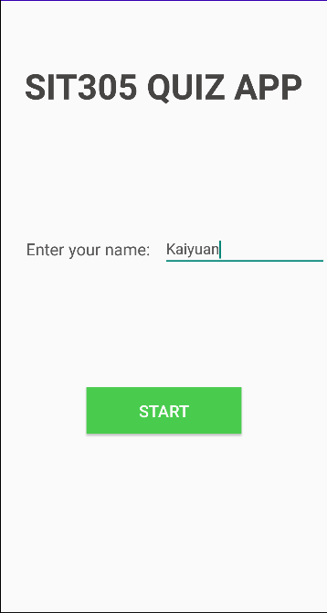

**Error print**

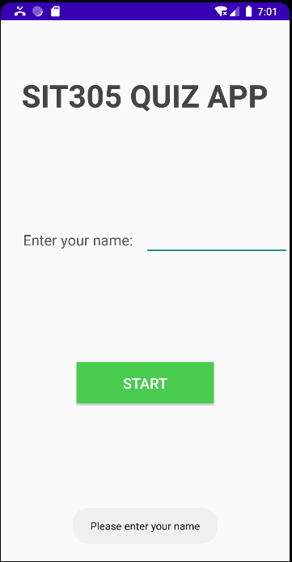

**Qusetion page**

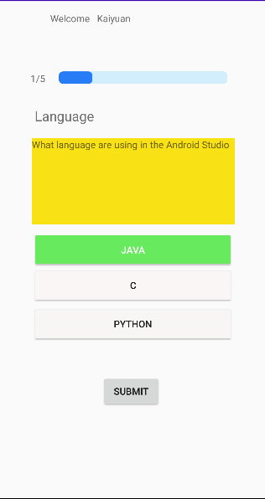

**Incorrect answer page**

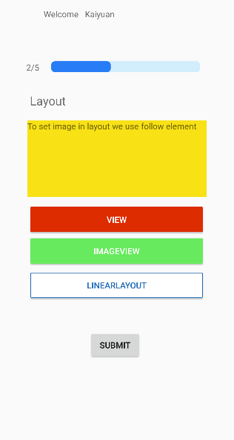

**result page**

