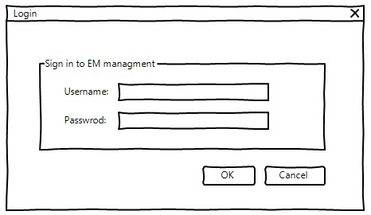

## 2.1 Create Login Form (30 mins)

Company employees depending on their responsibilities need to gain access to the system using a form as pictured above. There are two major categories using the system which can be described as follows:

1. Username: Can be located in [HumanResources].[Employee].LoginID
2. Password: Based on their Date of Birth in the same table, format is yyyyMMdd e.g someone born on 2 Jan 2000 will have a password of 20000102

* Please note that only employees with a username may log onto the system.
* You may use the storedprocedure uspGetEmployeeManagers to determine if the user is a manager
  + Easy Mode: use OrganizationLevel =1,2,3 for manager
* You may use the vEmployee and vEmployeeDepartment views to determine the department of a user
* After a successful login the user should be directed to the proper form based on their department i.e there should be separate forms for
  + Executive General and Administration
    - Human Resources
    - Finance
    - Information Services
    - Facilities and Maintenance
    - Executive
  + Inventory Management
  + Manufacturing
  + Quality Assurance
  + Research and Development
  + Sales and Marketing

## 

## 2.2 Managing Human Resources (60 mins)

This form can be used by any user in the Human Resources department or any manager within the organization.

* Users in HR whom do not have manager roles will be able to edit/view only CURRENT employees who are not managers
* Users in HR who are managers will be able to edit/view ALL CURRENT employees
* Managers will be able to view CURRENT employees reporting to them
* “Add new staff” is only displayed for HR users who are also managers.
  + By clicking on the button, the employee can create a staff record as described in the “Add new staff” section.
* “View exited staff” is only displayed for HR users who are also managers.
  + Clicking on the button will refresh the grid to display all employees who have left the company
  + The buttons will reflect the state change as well
    - View current staff will be displayed instead of View exited staff
    - Manage staff will present a READ only view of the staff information
    - Add new staff will be hidden
* The column definitions are as follow
  + Title: Title of the staff
  + Name: A combination of First Name, Middle Name and Last Name with a space between each property if needed
  + Job Title: The full job title of the staff
  + Email address: Email address of the staff
  + City: City where the staff stays
  + State: State where the staff stays
* By selecting a Staff from the list and clicking on the “Manage Staff” button at the bottom of the form, the employee can edit the staff details as described in the next section.

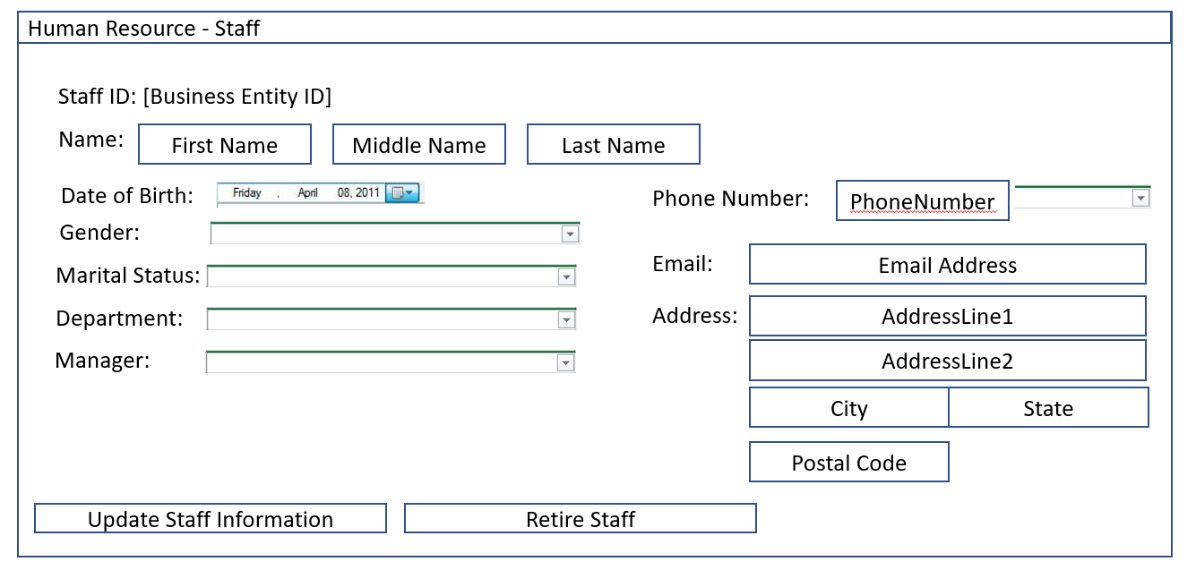

## 2.3 Update Staff (60 mins)

This form may only be accessed via Managing Human Resources form. The details of the form are described here:

* The items need to be displayed on the form as shown on the wireframe above
* The data for the items listed above are obtained from the database. Beyond BusinessEntityID, the rest of the items can be modified
* Data from department drop down can be obtained from [HumanResources].[Department] table, it should comprise of both the Group Name as well as the Name
* Data for Gender drop down will be either Male or Female
* Data for Marital Status drop down will be either Single or Married
* Data for Phone Number drop down will be either Cell or Work
* Data for Manager dropdown will list all managers in the selected department, display text should be the combination of First name, Middle name and Last Name
* By clicking on “Update Staff Information”, the changes will be saved to the database and the form closed.
* By clicking on “Retire Staff”, the user will be prompted to confirm the change. Once confirmed, the database will be updated accordingly.
* Note that changes to Department will need to be updated into EmployeeDepartmentHistory

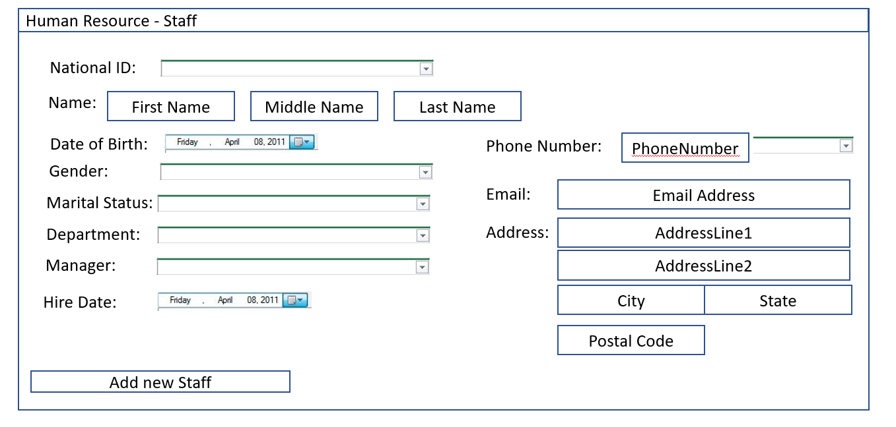

## 2.4 Add new Staff (30 mins)

This form is shown when add new staff is clicked on the Human Resources page. This is similar to the update staff with the exception of the inputs for National ID and Hire Date and removal of “Retire staff” button

* By clicking on “Add new staff” the staff will be added into the database will the respective inputs

## 2.5 Department operations (90 mins)

* Perform similar tasks for the Department listing based on 2.2 to 2.4.