**Java version: java 14.0.2**

**Build tool: Maven**

**IDE: Intellij**

**The idea behind the framework**

I am using cucumber, TestNG, and java in my solution. I am using cucumber so that I implement Gherkin for people who are not technical to understand the test cases without having to go through the code, they can just ready the feature files to understand what the test is doing. the main idea behind the framework is code reuse where-ever possible and make it easy to debug by writing the code in separate class files. Test data is stored in an external text file, to make it easy to access and change based on the tests you want to perform.

**Folder structure**

Engine: all the framework-related helper code is stored inside this folder.

FrontendAutomation: storage for feature files and step definition classes for frontend automation.

Configuration: contains different configurations that you can select from like the browser you want to run on and the test data file you want to read from

Drivers: contains different web drivers you need for your test to run.

automation.Cucumber-reports: contains the report HTML file

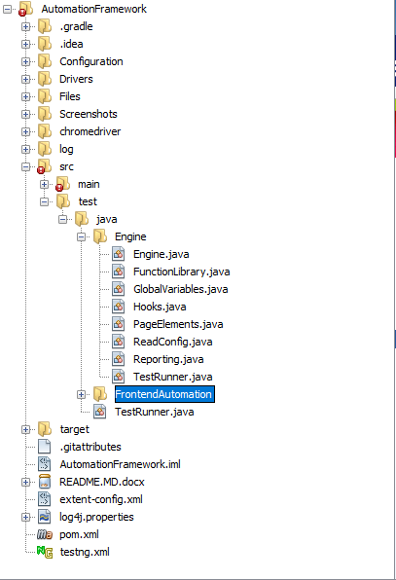

**Important files**

**Function library**: handles all the methods to perform any actions on the elements, things like enterTextbyXpath, clickElementByXpath, clickElementByname, selectFromDropdownByID.

**Page elements**: this class handles all your page objects(elements

**Steps to follow before running the tests**

***Step 1:*** [***Install the Java Development Kit (JDK)***](https://toolsqa.com/mobile-automation/appium/install-the-java-development-kit-jdk/)

***Step 2:*** [***Set Up Java Environment Variable Path***](https://toolsqa.com/mobile-automation/appium/set-up-java-environment-variable-path/)

***Step 3:*** [***Set up Android Environment Variable***](https://toolsqa.com/mobile-automation/appium/set-up-android-environment-path/)

**maven home:** https://www.tutorialspoint.com/maven/maven_environment_setup.htm

**How to Run web Tests:**

* Open the solution using intellij
* Go to solution explorer
* Locate a file named **testng.xml**
* Right click on that file and select Run

**Viewing reports**

* Right click on **cucumber.html**
* Click **Open in**
* Click **Browser**
* Select a browser of your choice