Kyle Andrus  
914065131

ECS 275A Program 3

The base image shows the final ray traced product of Program 1 without the effects of global illumination. The maximum ray depth is 4.

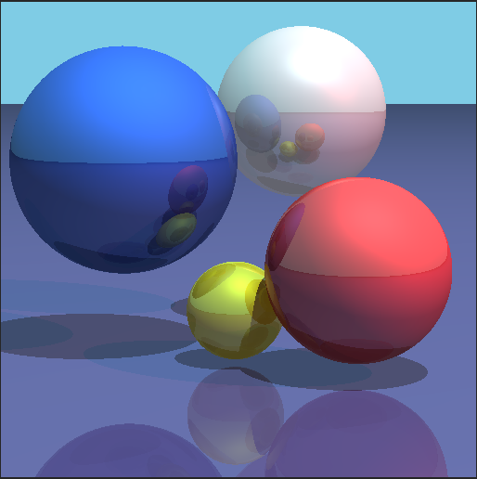

The following images display