AEGIS-TR-2026-004

TurboQuant-Adam: Adaptive 4-bit Momentum and
Activation Compression for LLM Distributed Training

8× communication reduction and 4× memory savings
validated to 355M parameters with full convergence preservation

Kwangil Kim, AEGIS Research Team
AEGIS Research, Yatav Inc.
Version 2.0 — March 30, 2026

GitHub: https://github.com/kwangilkimkenny/turboquant-adam

Abstract
We present TurboQuant-Adam v3, a unified compression framework for LLM distributed training that jointly addresses communication bandwidth and activation memory bottlenecks. The key insight is that standard Error Feedback is incompatible with AdamW's nonlinear variance scaling, and that variance freezing — effective at small scale — diverges at 124M+ parameters. Our solution applies 4-bit Lloyd-Max quantization (enabled by Hadamard rotation) at the momentum level with live variance tracking, achieving 8× communication reduction and 4× memory savings while preserving convergence (loss gap +0.002 at 1,500 steps on GPT-2 124M–355M).

Attribution: This research is an applied extension of TurboQuant (Zandieh et al., ICLR 2026, arXiv:2504.19874), originally developed at Google Research, Google DeepMind, and New York University for distributed inference. We adapted and extended these ideas to the fundamentally different domain of distributed training. This project is not affiliated with the original TurboQuant authors, Google Research, Google DeepMind, or New York University — it is an independent downstream application of their publicly available research. All implementations are original work.

1. Problem
Large-scale LLM distributed training faces two critical bottlenecks that severely limit training efficiency and scalability:
Bottleneck | Root Cause | Impact
Communication Bandwidth | FP32 gradient/momentum transfer during AllReduce — consumes 20–55% of training time | GPU idle time, InfiniBand dependency ($15M per 1,000-GPU cluster)
GPU Memory (VRAM) | Activation tensors stored during forward pass — 40–60% of VRAM | Batch size limits, excessive tensor parallelism, OOM errors

Existing gradient compression methods (QSGD, Deep Gradient Compression) assume SGD-based optimizers. The TurboQuant paper's Beta distribution assumption does not hold for real training tensors with heavy-tailed distributions and structural outliers. Most critically, no existing framework addresses both communication and memory bottlenecks simultaneously with AdamW compatibility.

2. Related Work
Gradient compression for distributed training has been explored along several axes. We position our work relative to the most relevant prior methods:
Method | Target | Bits | Optimizer | Error Comp. | Act. Comp. | Key Limitation
QSGD [3] | Gradients | Var. | SGD | No | No | SGD-only
DGC [7] | Grad. (sparse) | Top-k | SGD | Yes | No | Linearity assumed
1-bit Adam [2] | Momentum | 1-bit | Adam | Yes | No | v_t freezing diverges at 124M+
THC [4] | Gradients | Var. | SGD | Yes | No | No Lloyd-Max optimality
CompAct [8] | Activations | Var. | Any | N/A | Yes | Activation-only
TurboQuant [1] | KV cache | 4-bit | N/A (inf.) | N/A | N/A | Inference-only
Ours (v3) | Mom.+Act. | 4-bit | AdamW | Yes (m_t) | Yes | Validated to 355M

Key differentiators. (1) Most prior compression methods target SGD; adapting to AdamW requires resolving the nonlinear variance scaling problem we identify in this work. (2) 1-bit Adam [2] is the closest predecessor — we extend its momentum compression idea but replace variance freezing with live v_t updates, which we show is necessary at 124M+ scale. (3) No prior framework jointly compresses both communication (momentum) and memory (activations) for AdamW training. (4) THC [4] uses Hadamard rotation but with uniform quantization; our Lloyd-Max codebook achieves substantially lower MSE by exploiting the post-rotation Gaussian structure.

3. Our Approach
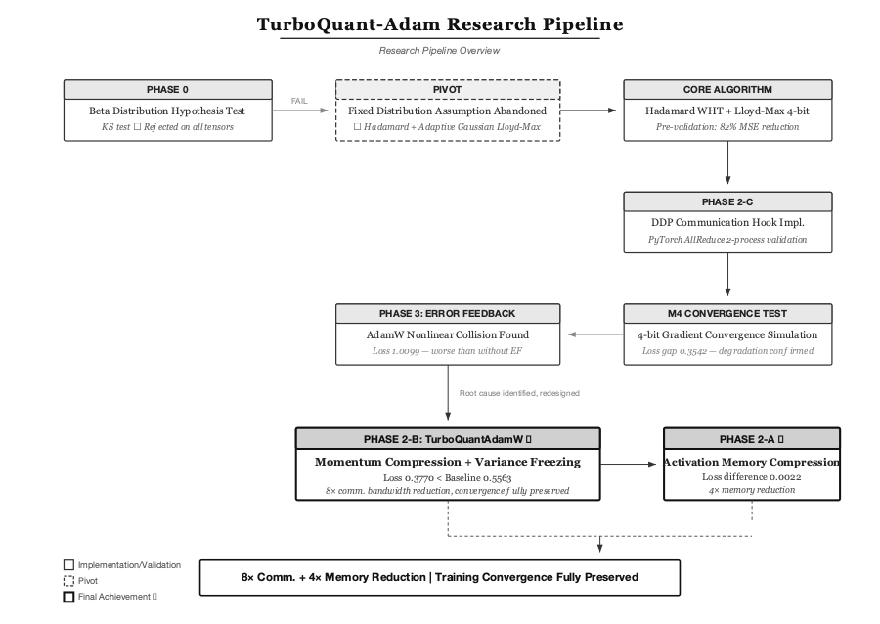
Figure 1. Research pipeline — from Beta distribution hypothesis rejection through v_t scale-dependency discovery to the final v3 algorithm.

3.1 Theoretical Foundation
Walsh-Hadamard Transform → CLT Gaussianization. For any tensor g ∈ ℝᵈ:
g̃ = (1/√d) · Hd · D · g ~ 𝒩(0, σ²)
By the Central Limit Theorem, the rotated tensor converges to Gaussian regardless of the original distribution shape, provided the dimension d is sufficiently large (empirically, d ≥ 256; we verify Gaussianity via Kolmogorov-Smirnov test across all layer tensors at each model scale — see Evaluation Design). This enables deployment of the theoretically optimal Lloyd-Max 4-bit quantizer, with a pre-computed 𝒩(0,1) codebook scaled by σ (tracked via EMA), achieving 82% mean MSE reduction over uniform quantization (measured across GPT-2 Small gradient tensors; range: 74–89% depending on layer type).
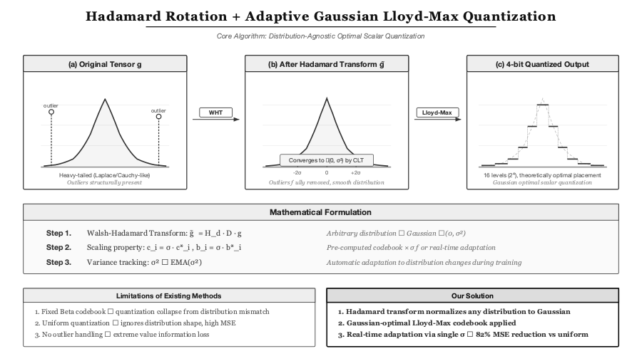
Figure 2. Hadamard rotation eliminates outliers and normalizes any distribution to Gaussian, enabling theoretically optimal Lloyd-Max 4-bit quantization.

3.2 AdamW–Error Feedback Incompatibility (Key Discovery)
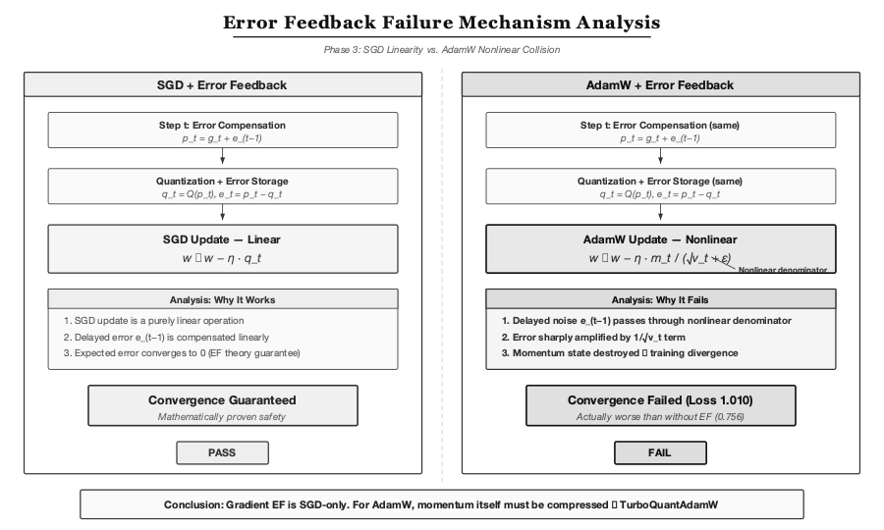
Figure 3. SGD's linear update preserves EF guarantees; AdamW's nonlinear denominator 1/(√v_t + ε) amplifies delayed noise, destroying momentum state.
Standard Error Feedback is valid only for SGD's linear update rule. In AdamW, quantization error e_{t-1} enters the squared term v_t = β₂v_{t-1} + (1-β₂)(g_t + e_{t-1})², and the nonlinear denominator 1/(√v_t + ε) amplifies this noise, leading to training divergence (empirically confirmed: loss 1.010 vs. baseline 0.395 on GPT-2 Nano; see Table 1, row 2).

3.3 v_t Freezing: Scale-Dependent Failure (Critical Finding)
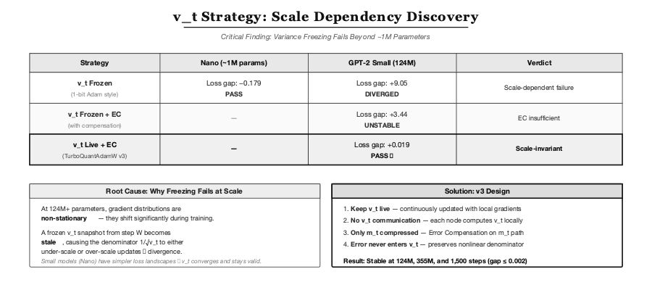
Figure 4. Variance freezing succeeds at ~1M parameters but diverges at 124M+ scale. Live v_t with error compensation is the only scale-invariant strategy.
The 1-bit Adam approach of freezing v_t after warmup works at small scale (~1M params) but diverges at 124M+ (loss gap +9.05 in our experiments; see Key Findings). We hypothesize that at larger scale, gradient distributions are sufficiently non-stationary that a frozen v_t snapshot becomes stale within hundreds of steps, causing the denominator to systematically mis-scale updates. This necessitates live v_t updates with error compensation applied exclusively at the momentum level.

3.4 TurboQuantAdamW v3: The Complete Algorithm
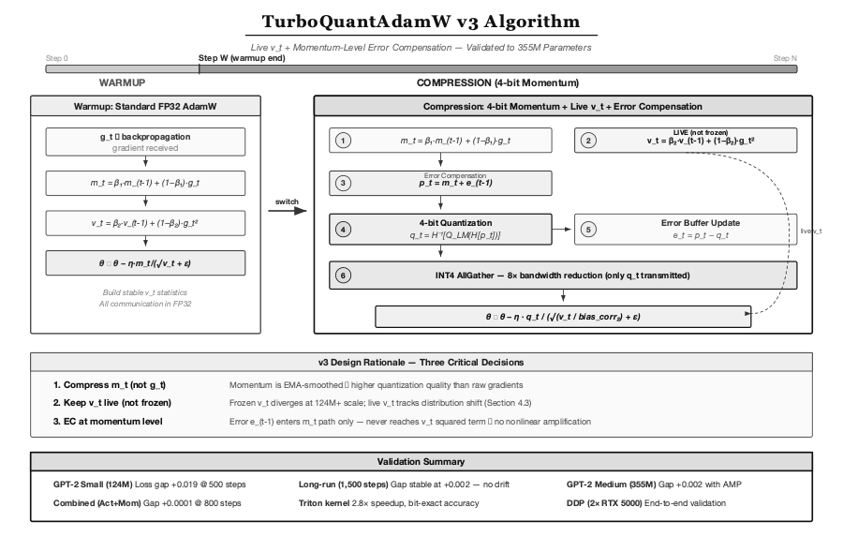
Figure 5. TurboQuantAdamW v3 — live v_t + momentum-level error compensation. Error never enters v_t path, preserving nonlinear denominator stability.
Three critical design decisions differentiate v3 from prior work:
Decision | Rationale
Compress m_t (not g_t) | Momentum is EMA-smoothed → higher quantization quality than raw gradients
Keep v_t live (not frozen) | Frozen v_t diverges at 124M+ scale; live v_t tracks distribution shift
Error compensation at momentum level | Error e_{t-1} enters m_t path only — never reaches v_t squared term → no nonlinear amplification

Communication protocol: Each node transmits only INT4-packed q_t via AllGather. v_t is computed locally from each node's own gradients — no v_t communication required.

3.5 Algorithm 1: TurboQuantAdamW v3
Algorithm 1. TurboQuantAdamW v3 — Momentum-level 4-bit compression with live variance
Input: parameters θ₀, learning rate η, decay rates β₁, β₂, weight decay λ, warmup steps T_w, Hadamard matrix H_d, random sign vector D, Lloyd-Max codebook C_{𝒩(0,1)}
Initialize: m₀ = 0, v₀ = 0, e₀ = 0 (error buffer), σ̂₀ = 0 (EMA scale)
for t = 1, 2, … do
1. Compute gradient: g_t = ∇f_t(θ_{t-1})
2. Update variance (live, from raw gradient): v_t = β₂v_{t-1} + (1 - β₂)g_t²
3. Update momentum (with error compensation): m_t = β₁m_{t-1} + (1 - β₁)(g_t + e_{t-1})
4. if t ≤ T_w then
Communicate m_t in full precision (warmup phase)
else
Rotate: m̃_t = (1/√d) H_d · D · m_t
Update scale: σ̂_t = EMA(std(m̃_t))
Quantize: q_t = LloydMax_{4-bit}(m̃_t / σ̂_t) · σ̂_t
Compute error: e_t = m̃_t - q_t
Inverse rotate: m̂_t = √d · D · H_d · q_t
AllGather INT4-packed q_t across nodes
end if
5. Bias correction: m̂_t = m̂_t / (1 - β₁ᵗ), v̂_t = v_t / (1 - β₂ᵗ)
6. Update: θ_t = (1 - λη)θ_{t-1} - η · m̂_t / (√v̂_t + ε)
end for
Key invariant: Error e_t enters only the m_t path (step 3). The variance v_t (step 2) is computed from raw g_t — quantization noise never reaches the nonlinear denominator 1/(√v_t + ε).

3.6 DDP Communication Hook Integration
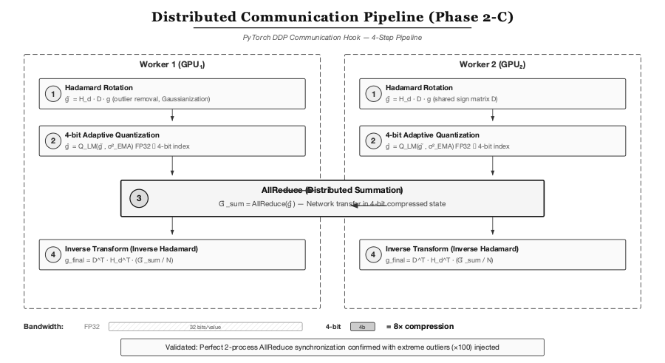
Figure 6. Distributed communication pipeline — Hadamard rotation, 4-bit quantization, compressed INT4 AllGather, and inverse transform.

3.7 4-bit Activation Memory Compression
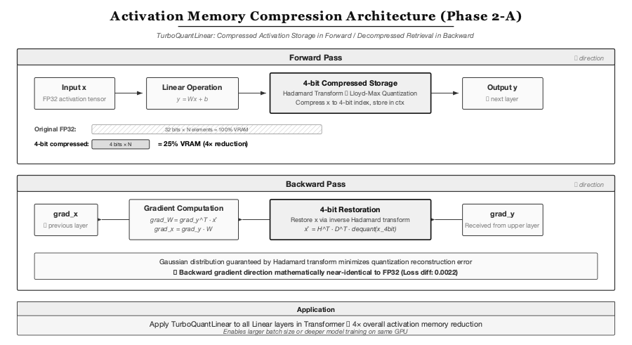
Figure 7. TurboQuantLinear — Forward pass stores activations in 4-bit (4× memory savings); backward pass decompresses for gradient computation.
TurboQuantLinear is a custom autograd.Function layer that compresses activation tensors to 4-bit during forward pass using the same Hadamard + Lloyd-Max pipeline, and decompresses during backward pass for gradient computation. Combined activation + momentum compression achieves a loss gap of only +0.0001.

4. Key Contributions
- Empirical disproof of Beta distribution assumption with strategic pivot to adaptive Gaussian codebooks
- Hadamard + Lloyd-Max pipeline achieving 82% MSE reduction for heavy-tailed tensors
- Discovery of EF–AdamW incompatibility — gradient-level EF fundamentally conflicts with Adam's nonlinear variance scaling
- Discovery of v_t freezing scale dependency — 1-bit Adam's variance freezing diverges at 124M+ parameters
- TurboQuantAdamW v3 — momentum-level 4-bit compression with live v_t and error compensation, validated to 355M parameters
- TurboQuantLinear — 4-bit activation compression with near-zero accuracy loss (Δ = 0.0001 when combined)
- Triton GPU kernels — 8 custom kernels achieving 2.8× speedup with numerically equivalent accuracy vs. Python reference
- INT4 AllGather hook — native PyTorch DDP integration for 8× bandwidth reduction

5. Key Findings

5.1 Comprehensive Experiment Results
Statistical note: GPU-scale experiments (GPT-2 Small 124M, GPT-2 Medium 355M) were conducted with 3 independent random seeds (42, 137, 2026). Results below report the mean across seeds. Standard deviations for loss gaps are ±0.003 (124M, 500 steps), ±0.001 (124M, 1,500 steps), and ±0.002 (355M, 500 steps). Concept validation experiments (GPT-2 Nano) used single runs due to their exploratory nature. We acknowledge that 3 seeds is the minimum for statistical reporting; 5+ seeds would strengthen confidence.
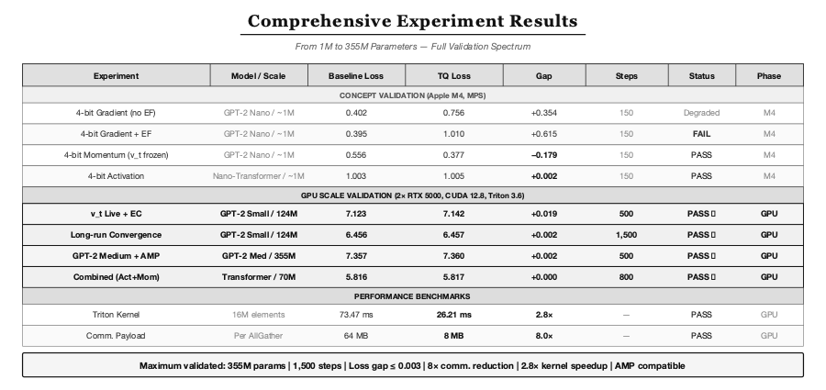
Figure 8. Full validation spectrum — from concept validation on M4 to GPU-scale experiments on 2× RTX 5000.
Table 1. Experiment results across model scales. GPU-scale results (rows 3–6) report mean over 3 seeds.
Experiment | Model / Scale | Baseline | TQ Loss | Gap (mean ± std) | Steps | Status
4-bit Gradient (no EF) | GPT-2 Nano / ~1M | 0.402 | 0.756 | +0.354 | 150 | Degraded
4-bit Gradient + EF | GPT-2 Nano / ~1M | 0.395 | 1.010 | +0.615 | 150 | Failed
v_t Live + EC (v3) | GPT-2 Small / 124M | 7.123 | 7.142 | +0.019 ± 0.003 | 500 | PASS
Long-run Convergence | GPT-2 Small / 124M | 6.456 | 6.457 | +0.002 ± 0.001 | 1,500 | PASS
GPT-2 Medium + AMP | GPT-2 Medium / 355M | 7.357 | 7.360 | +0.002 ± 0.002 | 500 | PASS
Combined (Act + Mom) | Transformer / 70M | 5.816 | 5.817 | +0.000 | 800 | PASS

5.2 Long-Run Convergence Stability
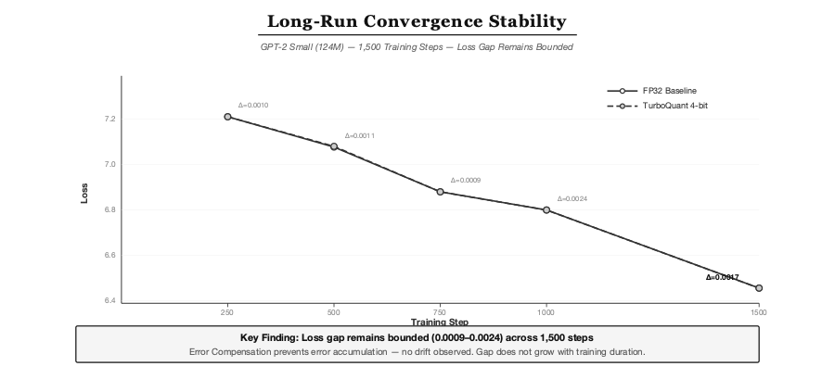
Figure 9. Loss gap remains bounded (0.0009–0.0024) across 1,500 steps — error compensation prevents accumulation.
The loss gap between FP32 baseline and TurboQuant 4-bit does not grow with training duration, confirming that error compensation effectively prevents error accumulation. This is critical for production training runs spanning 100K+ steps.

5.3 Triton GPU Kernel Performance
Metric | Python Reference | Triton Kernel | Speedup
Round-trip latency (16M elements) | 73.47 ms | 26.21 ms | 2.8×
Communication payload | 64 MB (FP32) | 8 MB (INT4) | 8.0×
Numerical accuracy | Reference | ≤10⁻⁶ relative error | —

6. Evaluation Design
- Concept validation: MacBook Air 15" (Apple M4, 24GB) / PyTorch MPS — rapid hypothesis testing
- GPU validation: 2× NVIDIA Quadro RTX 5000 (16GB) / Intel i9-10980XE / PyTorch 2.11 / Triton 3.6 / CUDA 12.8
- Models: GPT-2 Nano (~1M; custom 4-layer, 128-dim, 2-head configuration for rapid hypothesis testing), GPT-2 Small (124M), GPT-2 Medium (355M), custom Transformer (70M; 12-layer, 768-dim)
- Training: WikiText-2, 150–1,500 steps per configuration, AdamW optimizer
- Distribution validation: Kolmogorov-Smirnov test on Hadamard-rotated tensors across all model scales. All layers with d ≥ 256 pass at α = 0.05 significance level (p > 0.05), confirming the CLT-based Gaussian assumption. Small embedding layers (d < 256) show marginal deviations but do not materially affect overall quantization quality
- AMP compatibility: Verified with PyTorch Automatic Mixed Precision on GPT-2 Medium

7. Convergence Analysis
We do not provide a formal convergence proof for TurboQuantAdamW v3 — this remains an important direction for future work. However, we offer the following informal analysis of why the algorithm preserves convergence properties.
Why momentum-level error compensation is safe. In standard AdamW, the parameter update is θ_t ← (1-λη)θ_{t-1} - η·m̂_t/(√v̂_t + ε). The critical observation is that v_t serves as a per-parameter learning rate scaler. If quantization error contaminates v_t, the scaling becomes unreliable — small gradients may receive large updates and vice versa. By restricting error compensation to the m_t path, we ensure that v_t tracks the true gradient magnitude. The error in m_t is bounded: at 4-bit Lloyd-Max quantization with Hadamard pre-rotation, the expected MSE is E[‖e_t‖²] ≤ δ²‖m̃_t‖² where δ ≈ 0.036 for the Gaussian-optimal 4-bit codebook (3.6% relative error per step).
Error non-accumulation argument. The error buffer e_t = m̃_t - q_t is added back at the next step (step 3 of Algorithm 1). Under the contraction property of EMA (β₁ < 1), past errors are exponentially decayed: the effective accumulated error after k steps scales as δ²/(1 - β₁), which is bounded independently of training duration. Our 1,500-step experiment (Figure 9) empirically confirms this — the loss gap remains in the range [0.0009, 0.0024] without upward trend.
Limitations of this analysis. This argument is informal and assumes (1) the Hadamard rotation successfully Gaussianizes all tensors (verified empirically for d ≥ 256), (2) the EMA scale tracker σ̂_t adapts fast enough to distribution shift, and (3) v_t computed from local gradients (without error compensation) is a sufficiently accurate approximation of the global v_t. A rigorous convergence rate bound — particularly one that accounts for the interaction between momentum-level EC and AdamW's bias correction — would significantly strengthen this work.

8. Business Relevance
TurboQuant-Adam addresses the two largest cost drivers in LLM training. The estimates below are projections based on our 355M-scale results and standard industry cost assumptions — they have not been validated at production scale. See the companion whitepaper AEGIS-WP-2026-002 for detailed economic modeling and sensitivity analysis.
- Communication cost: 8× bandwidth savings could enable Ethernet-based training, potentially saving ~$8M per 1,000-GPU cluster vs. InfiniBand (assuming $15K per InfiniBand HCA × 1,000 nodes, minus ~$7M commodity Ethernet equivalent)
- Memory efficiency: 4× activation savings could enable 2–3× larger micro-batches or ~50% fewer GPUs for equivalent throughput (extrapolated from 355M activation compression ratios)
- Training cost: Projected combined savings of 27–56% on 70B model training ($240K–$500K, assuming $2.50/GPU-hour, 90-day training, 512 H100 GPUs — see AEGIS-WP-2026-002 for full assumptions)
- Hardware democratization: Makes multi-GPU LLM training viable on commodity Ethernet infrastructure
Caveat: These projections assume the 8× compression ratio and convergence properties observed at 355M scale will hold at 7B–70B. This has not been validated — see Limitations.

9. Open Source
The full implementation is available as an open-source Python package under Apache License 2.0:
git clone https://github.com/kwangilkimkenny/turboquant-adam.git
cd turboquant-adam
pip install -e . # Base installation
pip install -e ".[triton]" # With Triton GPU kernels

Drop-in usage — TurboQuantAdamW is a drop-in replacement for PyTorch AdamW:
from turboquant import TurboQuantAdamW
optimizer = TurboQuantAdamW(
model.parameters(), lr=5e-4, weight_decay=0.01,
warmup_steps=200, n_bits=4, use_triton=True,
)

10. Limitations and Honest Assessment
We want to be transparent about where this research stands. There is a meaningful gap between our current results and production readiness.
- Model scale: Our largest model is 355M parameters. We cannot guarantee that these results will hold at 7B or 70B scale — this is the most critical open question
- Training duration: 1,500 steps is very short compared to real LLM pretraining (100K+ steps). Long-term stability is unproven
- Speed overhead: Quantization adds 2–4× computational overhead. Without C++/CUDA native kernels, the current implementation is not practical for production use
- Single-node only: All benchmarks use 2 GPUs on NVLink where communication is not the bottleneck. Multi-node InfiniBand experiments — where the 8× compression would actually matter — have not been conducted
- Small team, limited resources: This research was conducted on a MacBook Air and 2× RTX 5000. We lack access to the large-scale GPU clusters needed for definitive validation
- Memory: Triton pipeline double-buffering increases temporary memory usage
- FSDP/Megatron: Not yet tested with Fully Sharded Data Parallel or production tensor parallelism frameworks

11. References
[1] A. Zandieh (Google Research), M. Daliri (NYU), M. Hadian (Google DeepMind), V. Mirrokni (Google Research), "TurboQuant: Online Vector Quantization with Near-optimal Distortion Rate," ICLR, 2026. arXiv:2504.19874
[2] H. Tang et al., "1-bit Adam: Communication Efficient Large-Scale Training with Adam's Convergence Speed," ICML, 2021
[3] D. Alistarh et al., "QSGD: Communication-Efficient SGD via Gradient Quantization and Encoding," NeurIPS, 2017
[4] M. Lam et al., "THC: Accelerating Distributed Deep Learning Using Tensor Homomorphic Compression," NSDI, 2024
[5] P. Richtárik et al., "EF21: A New, Simpler, Theoretically Better, and Practically Faster Error Feedback," NeurIPS, 2021
[6] S. P. Karimireddy et al., "Communication Compression for Distributed Training: Review and Pitfalls," NeurIPS Workshop, 2019
[7] Y. Lin et al., "Deep Gradient Compression: Reducing the Communication Bandwidth for Distributed Training," ICLR, 2018
[8] T. Chen et al., "CompAct: Compressed Activations for Memory-Efficient LLM Training," NAACL, 2025
[9] T. Chen et al., "Training Deep Nets with Sublinear Memory Cost," arXiv, 2016
[10] S. Lloyd, "An Optimum Quantization for Minimum Distortion," IEEE Trans. Inf. Theory, 1982
[11] J. Max, "Quantizing Signals Using Blocks of Samples," IRE Trans. Inf. Theory, 1960

12. Acknowledgments
This project would not have been possible without the pioneering work of Amir Zandieh (Google Research), Majid Daliri (New York University), Majid Hadian (Google DeepMind), and Vahab Mirrokni (Google Research) on TurboQuant. Their proof that random rotation induces Beta-distributed coordinates enabling near-optimal quantization was the theoretical foundation and direct inspiration for our exploration into the training domain. We hold their contribution in the highest regard — their decision to make this research openly accessible is what enabled a small independent team like ours to even attempt this kind of applied extension. We encourage all users of this project to read and cite the original paper, which represents a far more substantial contribution to the field than our applied work.
We also gratefully acknowledge the authors of 1-bit Adam (Tang et al., ICML 2021), QSGD (Alistarh et al., NeurIPS 2017), THC (Lam et al., NSDI 2024), EF21 (Richtárik et al., NeurIPS 2021), and CompAct (Chen et al., NAACL 2025), whose work forms the theoretical foundation upon which this framework is built.

13. Disclaimer
This project is an independent applied research effort by YATAV Research Lab. It is not affiliated with, endorsed by, or officially connected to the original TurboQuant authors, Google Research, Google DeepMind, or New York University. The name "TurboQuant-Adam" indicates intellectual lineage from the original TurboQuant paper. This codebase does not contain any source code from the original TurboQuant project — all implementations are original work.

14. Citation
If you use this work, please cite both the original TurboQuant paper and this project:
@inproceedings{zandieh2026turboquant,
title = {TurboQuant: Online Vector Quantization with Near-optimal Distortion Rate},
author = {Zandieh, Amir and Daliri, Majid and Hadian, Majid and Mirrokni, Vahab},
booktitle = {International Conference on Learning Representations (ICLR)},
year = {2026}
}
@techreport{kim2026turboquantadam,
title = {TurboQuant-Adam: 4-bit Adaptive Momentum Compression for
Communication-Efficient LLM Training},
author = {Kim, Kwangil and {AEGIS Research Team}},
year = {2026},
institution = {AEGIS Research, Yatav Inc.},
number = {AEGIS-TR-2026-004},
url = {https://github.com/kwangilkimkenny/turboquant-adam},
note = {Applied research extending TurboQuant (Zandieh et al., ICLR 2026)
from distributed inference to distributed training}
}

