Unit: P25
Type : AC160TS
▶ SEM Image  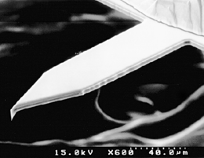 | ▶ SPECIFICATIONS
  Technical Data | Lever
  Technical Data | min | typ | max
  Length (um) | 145 | 160 | 175
  Width (um) | 38 | 40 | 42
  Thickness (um) | 3.2 | 3.7 | 4.2
  Resonance frequency, kHz | 200 | 300 | 400
  Force constant, N/m |  | 26
▶ Check Item | Pass | Fail
1. Backside surface check------------------------------------------------------------------------------------------------ | ■ | □
2. A+B ------------------------------------------------------------------------------------------------------------------------- | ■ | □
3. NCM frequency Sweep test
■ Unipeak ----------------------------------------------------------------------------------------------------------------- | ■ | □
■ Noise --------------------------------------------------------------------------------------------------------------------- | ■ | □
4. Frequency Sweep

Batch | 1(L) | 2 | 3 | 4 | 5 | 6 | 7 | 8 | 9 | 10 | 11 | 12(R)
Frequency (KHz)
Q-Factor

