* Hint: Answer all the following questions in “one word document named properly to reflect your name + course code with section + week of the course + file contents”. You might ask for help or search on the web to make sure you have provided correct answers before submitting your file.

**Activity 1, integer overflow**

mid = (low + high) / 2; // **low**, **high**, and **mid** are all same size integers.  
 (assume signed short int for your example: 0 – 32,767)

The above code was used to find the middle point in an array index for a binary search. Here is an animated example of a binary search in a sorted array: <https://www.cs.usfca.edu/~galles/visualization/Search.html>   
[note: numeric keypad input does not work, use the top row]  
[search: for the value at index position 20]  
[controls at the bottom allow you to adjust animation speed and steps]

1. 🡺 What is potentially wrong with this line of code?
2. 🡺 What values for low and high would cause an overflow problem?  
   [play with the integerOverflow.exe program in the zip file]
3. 🡺 How would you fix that line of code?

<https://research.googleblog.com/2006/06/extra-extra-read-all-about-it-nearly.html> Nearly All Binary Searches and Mergesorts are Broken

**Activity 2, Boolean logic**

Do you have to go to school today for a class? OK, “yes” because you are here.

* **What is the Boolean logic to determine IF you should go to school on any day of the week?**

We assume that at least one day on your timetable has no scheduled classes.

The answer includes checking:

* today’s date and day-of-week
* which of your timetable days has classes? Or which day has no classes?
* [Academic date](http://www.senecacollege.ca/registrar/dates/academicdatesWinter2017.html) ranges. There are no classes during study week and the school is closed on holidays.

**Activity 3: Numbering Systems and Conversions**

In Microsoft Word, you can edit a font’s colour by adjusting its **Red**, **Green,** and **Blue** values. Each of these values can be any decimal number from 0 to 255. Using the following Hexadecimal values, determine what “web” colour would be produced.  
  
First convert HEX to decimal ( hex_nibble1 * 16 + hex_nibble2) and then use Font Color / More Colors…Custom to adjust the RGB decimal values ): **(1 point)**

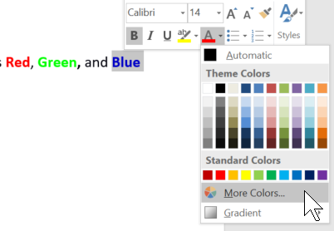 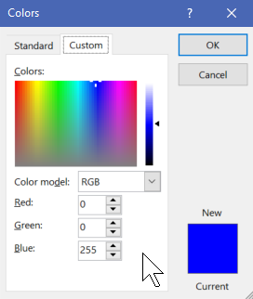

|  |  |  |  |  |
| --- | --- | --- | --- | --- |
| **3 Hex Codes** | **Red value in decimal (0-255)** | **Green value in decimal (0-255)** | **Blue value in decimal (0-255)** | **Final Colour** |
| #FFFFFF |  |  |  |  |
| #0000FF |  |  |  |  |
| #FFCCCC |  |  |  |  |
| #129823 |  |  |  |  |

What would the hex code be for the **following** colours? **(1 points)**

|  |  |  |  |  |
| --- | --- | --- | --- | --- |
| **Colour** | **Red value** | **Green value** | **Blue value** | **Hex Code** |
| Green | 0 | 255 | 0 | # |
| Black | 0 | 0 | 0 | # |
| Purple | 128 | 0 | 128 | # |

**Activity 4: A typical Software Version**

Research and write the version number of software you use, such as a game, word processing, photo editing, etc. What does the version number mean? Include which parts are forward and/or backward compatible. **(1 point)**