COMP7406 Assignment 3 QuantLib Programming Assignment
Done by: Henry Kwan
Student ID: 3035420297

1.) Summary of files:
- Assignment3/
  - Makefile (Makefile for compilation and linking)
  - Holiday.csv (Holiday csv given)
    - Src/
      - BusinessCalendar.cpp (Source file to Business Calendar class)
      - BusinessCalendar.h (Header define Business Calendar class)
      - CurveBuilding.cpp (Curve Building function)
      - main.cpp (Driver for Test cases)
  - main* (Executable)

2.) Class Diagram:
BusinessCalendar→inherits Calendar
BusinessCalendar()
BusinessCalendar(arg1, arg2)
applyMktHoliday(arg1)
addHoli(arg1)
removeHoli(arg1)
printHolidayFile(arg1)
printAddedHoliday()
printRemovedHoliday()
getMyMarket()

Where BusinessCalendar::Impl→ inherits Calendar::Impl
name()
isWeekend()
isBusinessDay()

3.) Member functions:
BusinessCalendar Class:
BusinessCalendar(): Default constructor
- Redirect base class pointer impl_ to derived class Impl object.
BusinessCalendar(arg1, arg2): Overload constructor
- arg1: <string> CSV Filename
- arg2: <string> optional parameter (Exhange code), default load all holiday
applyMktHoliday(arg1): Function to apply market holiday into holiday list
- arg1: <string> optional parameter (Exchange code), default apply all holiday
addHoli(arg1): Function to add date to holiday list
- arg1: <const Date&> Parameter in QuantLib Date format to add into holiday
removeHoli(arg1): Function to remove date from holiday list, also add to removed holiday list
- arg1: <const Date&> Parameter in QuantLib Date format to remove holiday
printHolidayFile(arg1): Print raw csv holiday file
- arg1: <string> Optional parameter (Exchange code), default to print all holiday in csv
printAddedHoliday(): Print holiday list in calendar
printRemovedHoliday(): Print removed holiday originally from holiday list
getMyMarket(): return exchange code from user input in applyMktHoliday()

BusinessCalendar::Impl Class:
name(): return “My Calendar” when invoked, proving derived class is called
isWeekend(): use Calendar::weekday() to determine whether the selected date is a weekend
isBusinessDay(): See if it’s a weekday, if yes then see if it’s holiday, if not then is business day

4.) Test cases:

User interface:
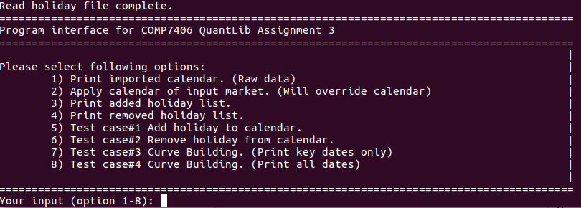
Test Case#1: Print csv calendar in raw data string format.
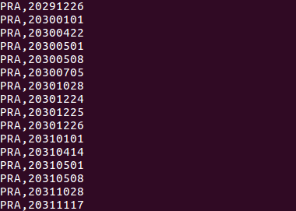

Test Case #2: Load selected calendar into calendar object, result can be seen by selecting #3.


Test Case #3: Print existing holiday list from calendar object
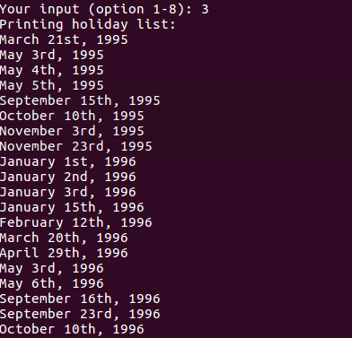

Test Case #4: Printing removed holiday from list. Used option#6 to remove holiday Nov 23, 2056.


Test Case #5: Add and printing added holiday list. Manually added Dec 31, 2088.
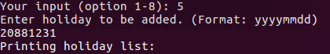

Test Case #6: Removed holiday from calendar. Remove Dec 31, 2088. No longer has the date.
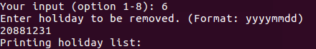

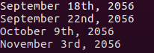

Test Case #7: Print curve building key dates
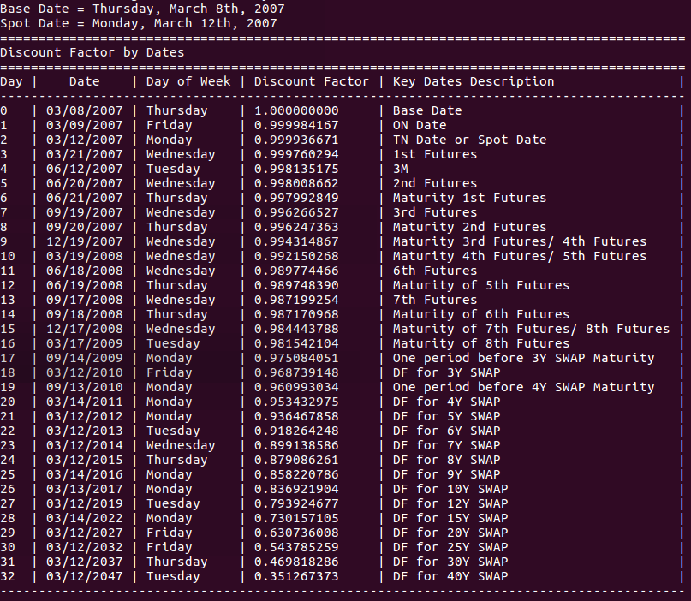

Test Case #8: Printing all data points
