WikiMap

Alana Killeen, Dylan Horkin, Gordon Liu, Kimberly Koenig, Liem Dinh, Michael Amorozo, Robert Chu, Steven Kwan

Software Requirements
Specification

Draft 1.7
2/19/2011

CSE 403 - CSRocks Inc.
Revisions
Version | Primary Author(s) | Description of Version | Date Completed
1.0 | Kimberly Koenig | Adding information to the Overall Description, and putting requirements from our group meeting on 1/12/2011 into the “Requirements” section. | 01/13/2011
1.1 | Kimberly Koenig | Adding suggested changes, additions, and other contributions from group brainstorm assignment on 1/17/2011. | 01/17/2011
1.2 | Kimberly Koenig | Added more appropriate formatting and incorporated more suggestions. | 01/18/2011
1.3 | Kimberly Koenig | Cleaned up some formatting issues, reworded the Goals, added more information to the target audience and requirements, added Features list, and fixed typos. | 01/18/2011
1.4 | Kimberly Koenig | Added /edited features per meeting with Gail, as well as meeting with Robert and Liem. Changed the format to be closer to the provided template, and added some extra use cases. | 01/19/2011
1.5 | Kimberly Koenig | Added greater specificity re: UI decisions that were made today. Clarified requirements re: extensibility. Added an extensibility goal. Added new UI designs. Changes have been annotated with comments. | 01/20/2011
1.6 | Kimberly Koenig | Per group meeting, elaborated on variations and extensions in use cases. Arranged features in priority order. Added Use Case Summary Diagram. | 01/21/2011
1.7 | Kimberly Koenig | Editing SRS for the beta. | 02/19/2011

Overall Description
Description

WikiMap is an interactive, web browser-based visualization of Wikipedia articles and their relationships: it allows users to navigate a high-level map of Wikipedia and understand how different articles are related.
- Problem Space - We have identified existing problems and limitations with Wikipedia which we wish to solve:
- Wikipedia’s format is inherently linear and near-sighted: users are limited to viewing one article at a time
- Most articles contain large blocks of text and many links, which can be overwhelming and time-consuming to browse
- Finding related articles and evaluating which articles are most relevant can be difficult
- A user can only visit an article that is one “step” away from the current location
- Users cannot see the “big picture” of Wikipedia due to its complexity and level of detail

- Goals - By the end of this project, we wish to solve the above problems by:
- Visualizing article relatedness by identifying and representing the strongest article relationships
- Providing a fun, easy-to-use, simple, and visually appealing way to explore Wikipedia at a high level
- Enabling users to interact with Wikipedia as a map of interconnected articles
- Simplifying the process of viewing many related articles’ content and images
- Providing an extensible software product
- Non-Goals - We do not intend to:
- Create a new Wikipedia search algorithm
- Exhaustively calculate, map, or otherwise identify all article relationships
- Host unnecessary Wikipedia content beyond what is required by our project
- Support or provide editing, login, or other functionality for Wikipedia articles
- Target Audience
Our target audience consists of knowledge and Wikipedia enthusiasts: individuals who regularly browse Wikipedia for casual fun, research, homework, and more.
Their behavior is defined by a desire to explore Wikipedia and to gain knowledge: they are distinguished by a tendency to spend time on Wikipedia exploring different articles which may not have been a part of their initial search, but which are related in some way to the initial search.
Such users are assumed to have some basic computer knowledge, including familiarity with major internet browsers and with Wikipedia, but they are not highly technical
- Alternative Solutions
Few alternatives exist to WikiMap. One of the only similar products is WikiViz. WikiViz’s primary intent is to show as many Wikipedia connections as possible. Its strength is that it represents many connections and relationships in a compact manner, but its weakness is that it shows very little information beyond the name of the Wikipedia article, and it becomes cluttered very easily.
In contrast, WikiMap is intended to be a fully interactive, navigable map of Wikipedia which starts from a user’s initial search query and expands outward. WikiMap will also not strive to show every connection, but only the most relevant ones. It will also be possible to see more than just an article’s title, including a preview and full look at article content.
- External Documentation

- There should be little to no necessary documentation for the WikiMaps UI. The UI must be intuitive enough to use without any documentation.
- Any documentation should be integrated into the UI and should be pictorial, or otherwise universally recognizable cues to the user
- The website will provide an “About” and “FAQ” section.
Scope

- In-Scope - The following describe some of the highest priority requirements which we see as crucial to meeting our goals.
    - Visualizing article relatedness by identifying and representing the strongest article relationships
  - Article “graph”: Articles are represented as nodes, connected by edges if they are related.
  - Center the search result: A user’s search query result is represented as the main, centered node in the graph. It may be made larger for emphasis.
  - Visualize related article connections: Related articles are represented as nodes. They surround and are connected to the main node and to each other by edges.
  - Only show the most important articles: Articles’ relatedness is ranked by a relevancy algorithm; only the most strongly related articles are displayed for a given node. Relatedness requirements will be defined in the SDS as a part of the algorithm.
- Providing a fun, easy-to-use, simple, and visually appealing way to explore Wikipedia at a high level
  - Standard and consistent: Use navigation/interaction patterns common to other interactive web UIs such as Google Maps
  - Provide a way back: Allow the user to return to their original search result or run a new search from the same screen
  - Keep the UI simple by:
    - Displaying minimal text beyond what is pulled from Wikipedia
    - Encouraging the user to explore the map with visual cues
    - Employing simple shapes and lines for a clean, uncluttered aesthetic
- Enabling users to interact with Wikipedia as a map of interconnected articles
  - Moving the map: Clicking and dragging moves the map to reveal more relationships (degrees of separation) as the user navigates away from their original location.
    - Only a limited number of degrees of separation will be displayed beyond the initial search location – an infinite horizon will not be provided at this time
  - Zooming in/out: Using the mouse wheel or clicking the + or – buttons will zoom in/out
    - Zooming in:
      - Decreases viewing horizon: Nodes at the edge of the viewing area (with greater degrees of separation from the main node) disappear
      - Increases granularity/node density: Less strongly related articles that were not previously displayed now appear (but only a set number are ever displayed for each node in the map)
    - Zooming out:
      - Increases “viewing horizon”: Nodes which are farther away (in degrees of separation) from the main node become visible again
      - Decreases granularity: Fewer related articles are displayed around each node on the screen. Only a set number of the most strongly related articles are displayed.
  - Article nodes are interactive
    - A single click on an article node:
      - Centers the node in the map

      - Updates the “article thumbnail” (4.2.1 to be a small version of the image associated with that article (if available)
      - Updates the “article preview” (4.2.2) in the preview pane to be preview text from Wikipedia
    - A double-click on a node automatically switches to a “full Wikipedia view” (4.1) of that article
    - Hovering over a node displays a preview of the article’s text and an image for that article, if available, in the article preview area (4.2.2)
      - Un-hovering from a node will return to the summary text and image associated with the “main” (original search) node
- Simplifying the process of viewing many related articles’ content and images

  - Multipurpose main viewing area: This area occupies a majority of the screen and can display the interactive article map (“full map view”) or a full Wikipedia article (“full Wikipedia view”) interchangeably
  - Right-hand pane:
    - Article thumbnail: If the user has clicked on an article node, this area provides a small, screenshot of the image associated with that Wikipedia article. Clicking on this switches to full Wikipedia view, displaying the article in the main area and placing a mini-map (4.2.3) in the place of the screenshot.
    - Article preview: In full map view, this displays preview text from the article node last hovered or clicked on. In full Wikipedia view, hovering over any article link will also display preview text for that article.
    - Mini-map: In full Wikipedia view, a miniature version of the article map is displayed instead of an article screenshot. The map updates as the user browses Wikipedia.
- Providing an extensible software product
  - Abstract software layers: Similar to an API, our product’s back-end methods and functions should be abstract enough to be used by any front-end.
- Out-of-Scope
    - Inventing a new Wikipedia search algorithm: We will use the existing Wikipedia search infrastructure and/or model our product’s search behavior after the Wikipedia search.
    - Exhaustively calculating, mapping, or otherwise identifying all article relationships: Only the strongest/most relevant relationships will be represented by use of the relevancy algorithm. We will set a maximum on how many relationships will ever be displayed for a given node.
    - Hosting unnecessary Wikipedia content: We will only download and maintain what we need, and will avoid hosting or downloading extraneous Wikipedia content.
    - Supporting/providing editing, login, or other Wikipedia functionality: Any additional functionality provided by Wikipedia beyond viewing articles and images will not be supported or displayed.
    - Other wiki formats: We will not specifically engineer toward supporting other wiki formats, but will strive to remain abstract enough to make this possible, per 5.1.
- Performance Requirements
      - Minimize response time: Most activities should appear seamless and instantaneous, including zooming in/out and moving the map
      - Convey a sense of responsiveness: If an instantaneous response is not possible, strive to give a sense of responsiveness by:
- Streaming content where possible, such as loading map nodes progressively
- Displaying whatever content we can, as soon as possible (e.g. display text even if an image is still loading)
- Content streaming should not cause significant lag for the user
- Avoid only showing a loading screen
      - Maximum search latency: Search delay should be equivalent to that of the Wikipedia search time + a maximum of 10 seconds (allowing for back-end calculations). We should provide a sense of progress but avoid exclusively using a load bar, as in (2).
      - Do not impede content load times: Loading Wikipedia article content (text and images) should only be based on the user’s connection speed. Our product should not hinder these load times.
      - Performance should be consistent: We should have approximately the same performance and look/feel in all supported browsers: IE, Chrome, and Firefox.
      - Performance should be scalable: Performs well under load, even from many simultaneous user connections
- Reliability Requirements
- Server should be stable: It should not crash due to our code, and database updates should not interrupt our service
- Handle errors elegantly: Front-end errors should be caught and handled by our UI and automatically submitted to us. We should provide a mitigation action to the user where possible (“Retry your action”). Back end errors should not be exposed to the user or crash the tool.
- Database should be recently updated: The database should be indicative of a recent state of Wikipedia, with updates occurring regularly. We will define the update intervals at a later point.

- Software & Hardware Requirements
      - Front-end/UI: Options include HTML/XHTML,PHP, Javascript, AJAX, Silverlight or Flash.
      - Back-end (Relevancy algorithm and and Communication Layer): C#
      - Database: MySQL
      - Servers: Web and database servers
Use Cases
          - Use Case Summary Diagram
User
Return article
screenshots
Interact with map
Wikipedia API
Save map location
Switch between article
and map views
Search for an article
Return article preview content
Return full article
content
Store and return article
relationships
Database
          - Formal Use Cases – We selected searching for articles and interacting with the map as our primary use cases, as these two usage scenarios most broadly encapsulate the spectrum of user interaction with WikiMap.

  - User searches for a particular article
Goal | User wants to find articles related to an initial search
Level | User goal
Primary Actor | User
Precondition | User is at the initial WikiMap search screen
Success end condition | Relevant articles are displayed to the user
Failure end condition | Relevant articles are not displayed to the user.
Trigger | User submits a search query.
Main success scenario | - User enters search term  - User submits search query  - System queries data source with search term  - System receives a search result from Wikipedia API  - System transfers user to full map screen  - System displays search result as main node  - System retrieves related articles from database  - System displays related articles and connections  - System predictively caches article relationships beyond the edge of the user’s screen area
Extensions
Variations | 2’: User clicks on a link in an article when in full article view  2’’: User clicks on a node in the map  2a: Search query is empty  2a1: System requests a new search query from the user  4a: Search query does not return any results  4a1: System requests a new search query from the user  4b: Search query returns multiple results.  4b1: System displays the top 10 results to the user  4b2: User either selects desired search result or enters a new search term

  - User interacts with the map
Goal | User wants to interact with the article map
Level | User goal
Primary Actor | User
Precondition | User is at the main map after running a search
Success end condition | Interaction results in the proper UI response
Failure end condition | Interaction does not result in a UI response, or results in an incorrect response
Trigger | User interacts with the map
Main success scenario | - User clicks and drags the map  - System interprets user’s input  - System de-caches stored article nodes and connections  - System displays article nodes and connections
Extensions
Variations | 1a’/1b’: User clicks the zoom in/zoom out buttons  1a: User zooms in on the map  1b: User zooms out on the map  1c: User hovers over a node  1c1: System queries Wikipedia API for article preview content  1c2: System displays article preview content in appropriate location  1c3: System does not continue to 2-4.  1d: User single-clicks on a node  1d1: System centers that node in the map  1d2: System performs a SEARCH for that node  1d3: System queries Wikipedia API for article screenshot  1d4: System displays article screenshot in appropriate location  1d5: System queries Wikipedia API for article preview content  1d6: System displays article preview content in appropriate location  1d7: System does not continue to 2-4.  3a: No more cached article relationships are available  3a1: System queries database for more related article data

  - User switches views
  - User saves current map location
Feature List
Feature | Target
Search for an article | Beta
Display article connections | Beta
Display article preview (on hover) | Beta
Display article thumbnail (on hover and on-click) | Beta
Click on article node to center it | Beta
Switch between full article and full map views | Beta
Initial iteration on moving the map | Beta
Initial parsing and relevancy ranking pass | Beta
Relevancy tree caching first iteration | Beta
Move the map to explore more relationships | Final
Zoom in/out on the map or a node | Final
Return to the initial search location | Final
Have all data parsed and ranked (relevancy algorithm) in the main database | Final
Relevancy tree caching second iterationq | Final
“Help”, “About”, and “Contact” sections on the website | Final
(now a part of “Display article thumbnail) | Beta
Article traversal history/breadcrumb trail | Stretch
Support multiple languages | Stretch
Search for and display a random Wikipedia article | Stretch
Support multiple Wiki formats with an API | Stretch
Support multiple front-ends with an API | Stretch
Right/middle click opens an article in a new browser tab | Stretch
Resizable viewing panes | Stretch

UI Prototype
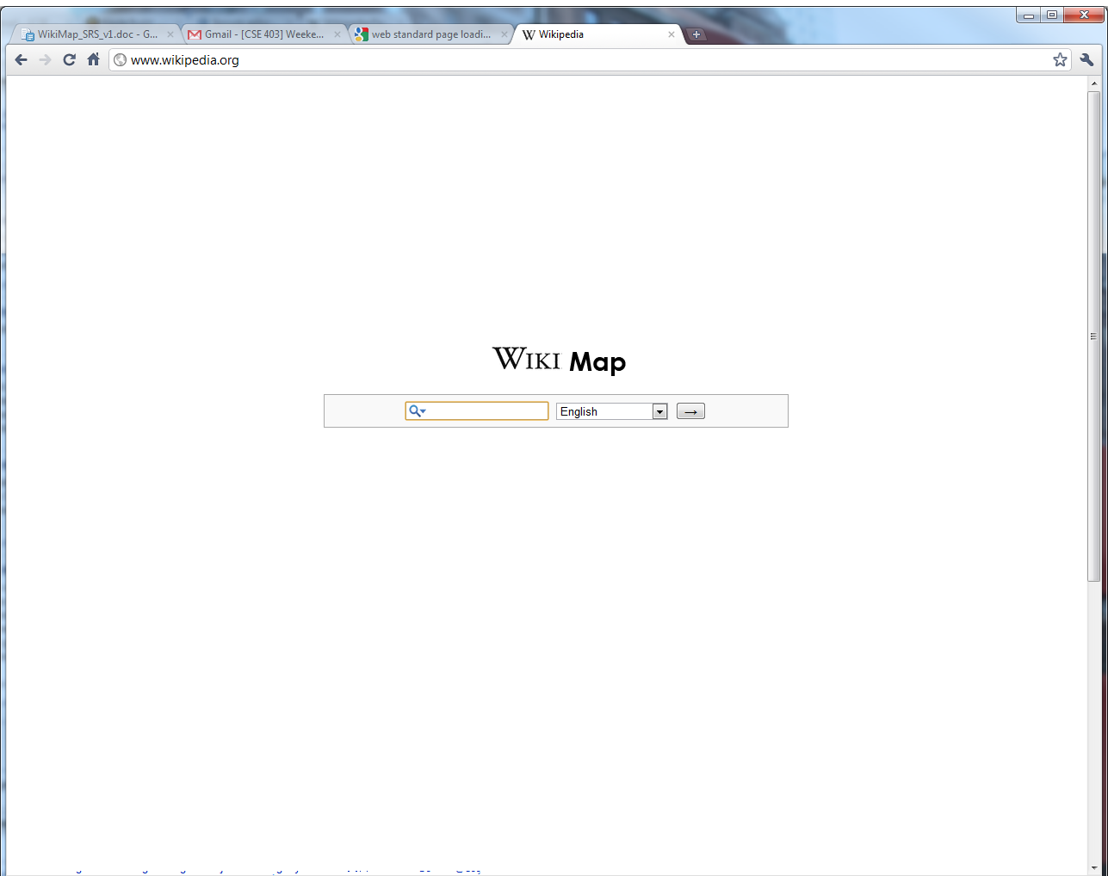
1: Main search screen with language selection option and “submit” button.
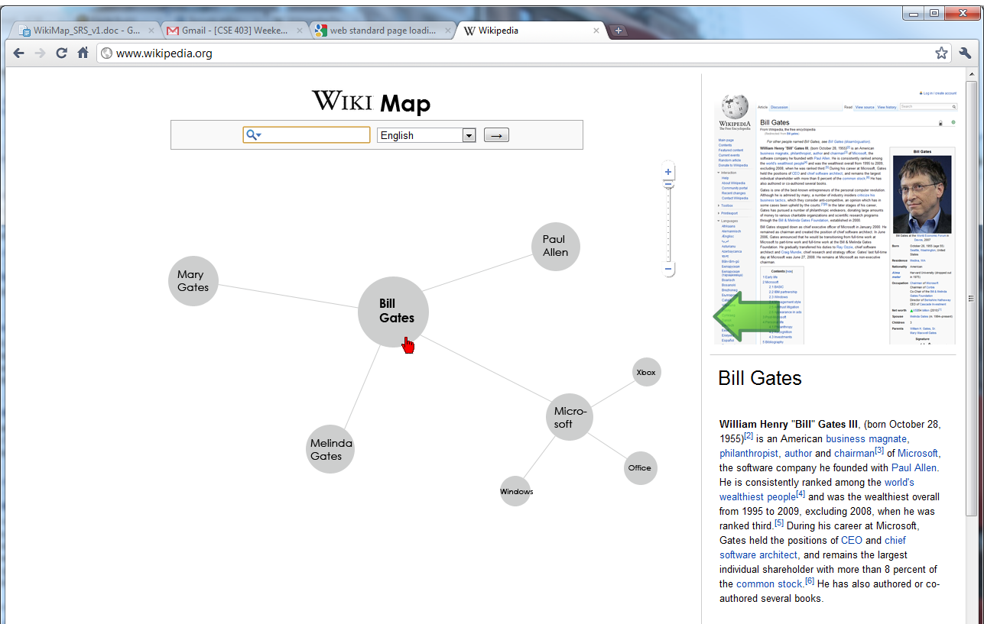
2: "Full Map View" – Main area: Interactive map in the center, with search bar above and zoom buttons on the top right. Right pane: Article screenshot is at the top; clicking on this or the green arrow switches to full article view. The bottom right is the hover preview text.
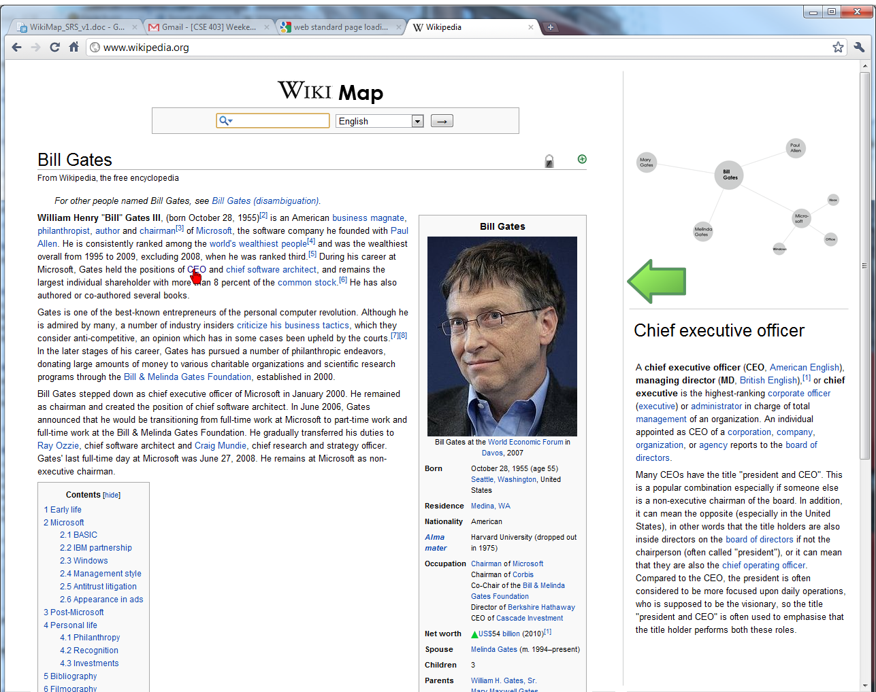
3: “Full Article View” – Main area: Interactive Wikipedia article. Hovering on links here will display a preview in the preview area. Clicking on a link will take you to that article and change the map at the top right. Right pane: At the top is the interactive mini-map. Clicking on the arrow will return to the full map view. The bottom of this is the article preview area.

