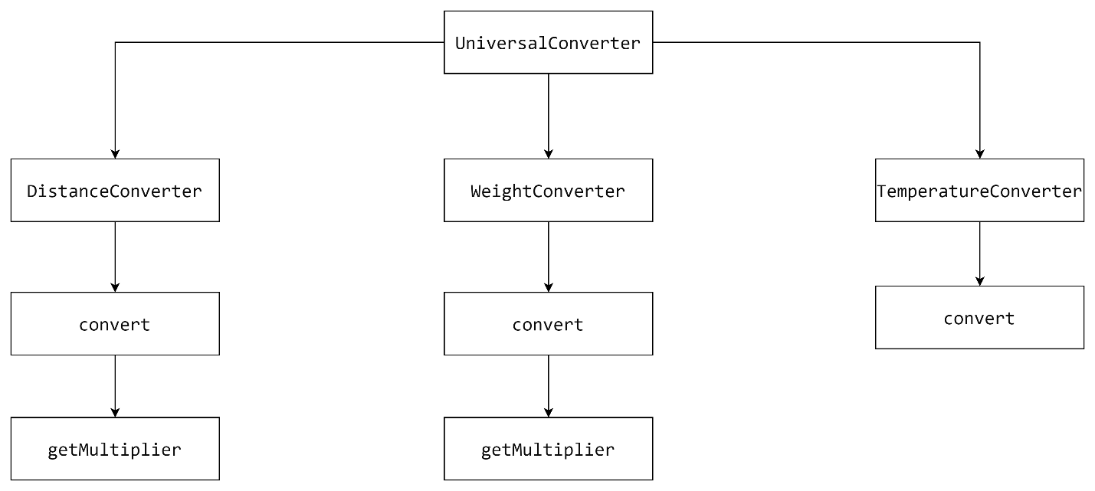

**Top-Down Integration Testing**

|  |  |
| --- | --- |
| **Unit Under Test** | **List of Stubs** |
| UniversalConverter | DistanceConverter, WeightConverter, TemperatureConverter |
| DistanceConverter | convert |
| convert | getMultiplier |
| getMultiplier | - |
| WeightConverter | convert |
| convert | getMultiplier |
| getMultiplier | - |
| TemperatureConverter | convert |
| convert | - |
|  |  |

**Bottom-up Integration Testing**

|  |  |
| --- | --- |
| **Unit Under Test** | **Build Drivers** |
| getMultiplier | convert |
| getMultiplier + convert | DistanceConverter |
| getMultiplier + convert + DistanceConverter | UniversalConverter |
| getMultiplier | convert |
| getMultiplier + convert | WeightConverter |
| getMultiplier + convert + WeightConverter | UniversalConverter |
| convert | TemperatureConverter |
| convert + TemperatureConverter | UniversalConverter |
| UniversalConverter | - |