kwasi yeboah-afihene

GW Boothcamp  EXCEL HOMEWORK

Kickstarter fundraising project

Contents

Background 2

Three Conclusions about Data 2

Category Stats 2

Sub-Category Stats 3

Launch-Date Outcomes 4

Other Observation 5

Goal Outcomes 5

Limitations of Data 5

Other Possible Tables and Graphs 5

# Background

Over two billion dollars have been raised using the massively successful crowdfunding service, Kickstarter, but not every project has found success. Of the over 300,000 projects launched on Kickstarter, only a third have made it through the funding process with a positive outcome.

Since getting funded on Kickstarter requires meeting or exceeding the project's initial goal, many organizations spend months looking through past projects to discover some trick to finding success. For this report our company organized and analyzed a database of four thousand past projects to uncover any hidden trends.

# Three Conclusions about Data

## Category Stats

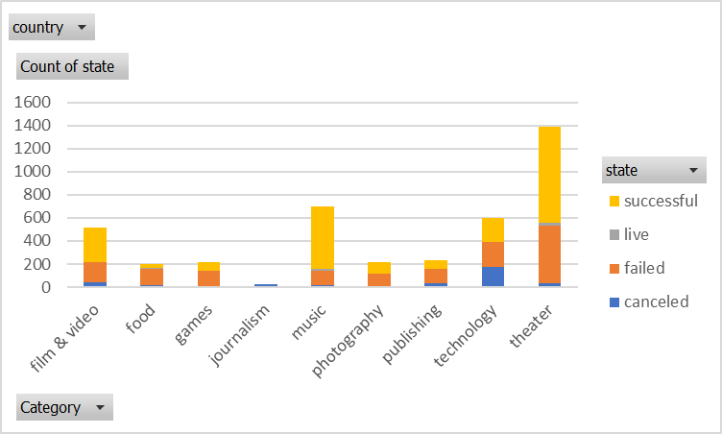

Fig 1.

Observing from fig 1 we could conclude the following:

* The theater category had the most projects as well as the most absolute successes. The number of failures seemed a lot as well, but relative to the overall total number of projects is it seems ok. Also, the relative number of canceled projects were very minimal.
* Music also seems to have a very high relative success rate, and reasonably low failure and cancelation rates.
* Look like technology has almost equal success, failure and cancelation rates. It is therefore a bit risky due to relatively equal probabilities of successes, failures and cancelations.
* All Journalism projects were canceled and seems like a very difficult category to have a fundraising success, with the platform.

## Sub-Category Stats

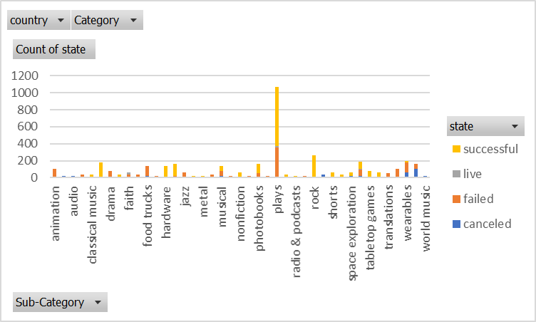

Fig 2.

* Fig 2 reveals that plays dominated the theater category, and it had a relatively high success count, and relatively lower failure count. The absolute numbers of the plays sub-category very much influenced the theater subcategory and looks like the most popular project.
* Animation, which also falls under theater, had a 100% failure rate, since there is no indication of successful projects.
* The rock subcategory with fall under the music category, was very successful, with a 100% success rate, since there is no observable, failure or cancelation.

## Launch-Date Outcomes

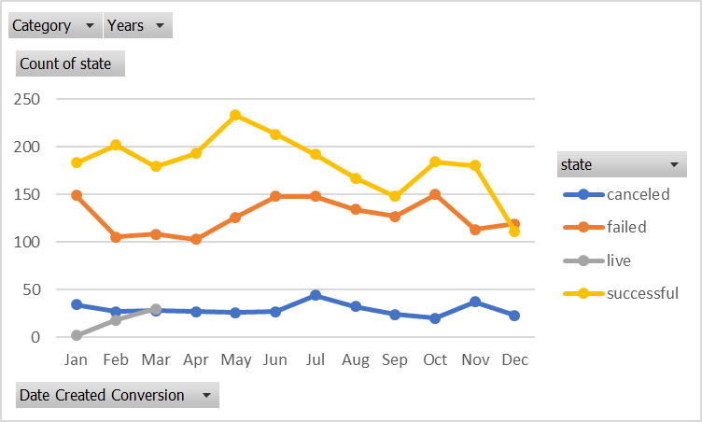

Fig 3.

* From fig 3 it can be concluded that the success rates peaked in May and plunged from may to September.
* This is an indication that the pledges plummeted during the summer months and edged up again from September to November.
* November to December were clearly a bad time to launch project since the success rates plummeted again.
* The failure number peaked during the June and July months, confirming the risk of starting new projects in the summer months.
* The project cancelation number are almost flat, across the year, though there was a bit of an upswing during the June, July months and October, and November.
* It is therefore better to launch fundraising projects in the first quarter.

# Other Observation

## Goal Outcomes

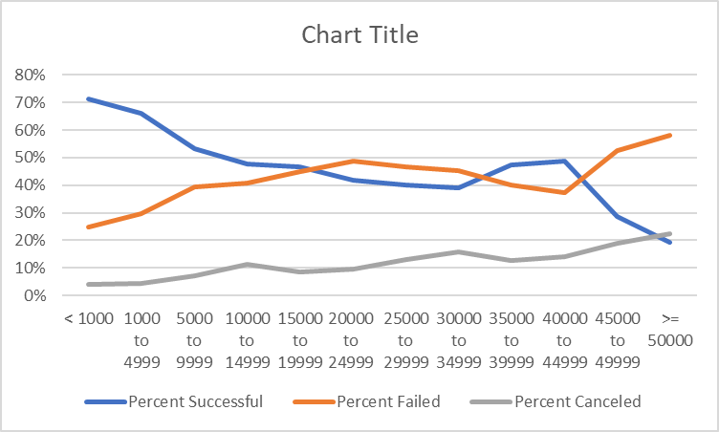

Fig 4.

* From the above chart, the success rates are relatively higher, with failure rate relatively lower when the goal for the fundraising is lower than $10,000.00.
* Between $10,000.00 and $44999.00 the success rate fluctuates or stagnate for a while between 40% and 50%.
* With goals exceeding $44999.00, the success rate starts to decrease sharply, with the failure rate soaring sharply.
* The cancelation rate slowly edges up as the goal amounts increases. The rate of increase is however very small.

# Limitations of Data

* The number of projects is not evenly distributed amongst the various categories
* Certain categories do not have representative number of records to fairly assess their relative outcomes
* The subcategories are also biased toward some projects. For example, the number of project in plays dominate the theater category which influences the overall outcome of the theater category.
* The number of projects in journalism and a couple of others are very small and hence may not fairly asses the relative outcome of their respective categories.

# Other Possible Tables and Graphs

* We could have also made a table with country and pledge filtered by state, to determine which county has the most success and failure rates etc. This would give us an insight into why projects initiate in certain countries are either doing well or not doing well. This information can engender further research to learn why and how to improve from the other’s experiences.