**Database Table Maker v1.1**

Kenneth Watanabe

Below is a short list of the features added to Database Table Maker v1.1 that were not available in previous versions

**Link Table**

was the Link Table. When creating or editing a table, a new column Link Table was added that links a field of a table to the field of another table. The format of the Link Table is the ‘table name’.’field name’. In the example below, in the *state* field of the *student* table is linked to the *ab* (abbreviation) field of the *state* table.

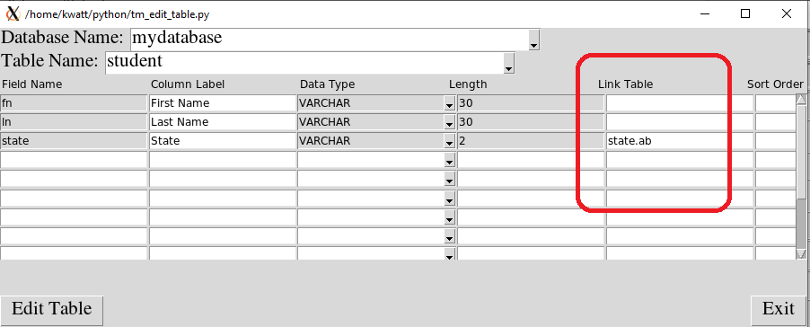

I created a *state* table with two fields, *ab* (Abbreviation) and *fn* (Full Name).

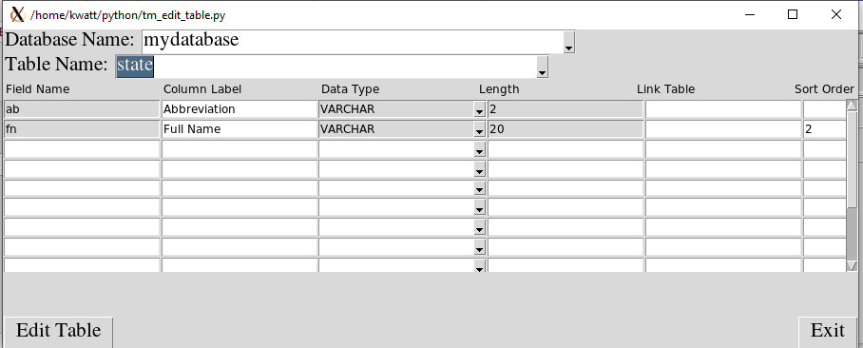

I added a few states to the state record as shown below.

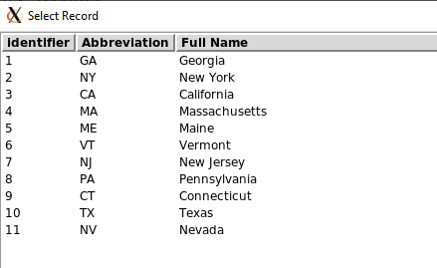

Now, when I enter or modify a *student* record, the *state* field appears as a dropdown that contains all the records in the *state* table.

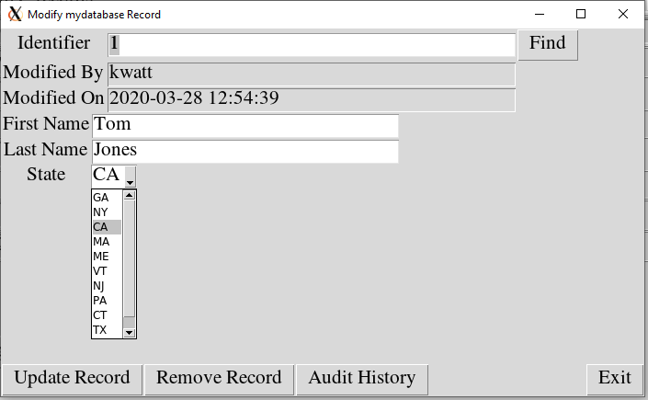

**Audit History**

Another modification is the ability to view the audit records. Every time a record is modified, the original record is copied to the corresponding audit table. On the Modify Record screen, there is a new button called “Audit History”. When you select a record and click on the Audit History button, a window will pop up that displays all the previous values of the selected record. In the example below, record 2 was entered as John Smith from OK on 10:20 am, but was changed to Tom Smith from CA at 10:21am on March 29, 2020.

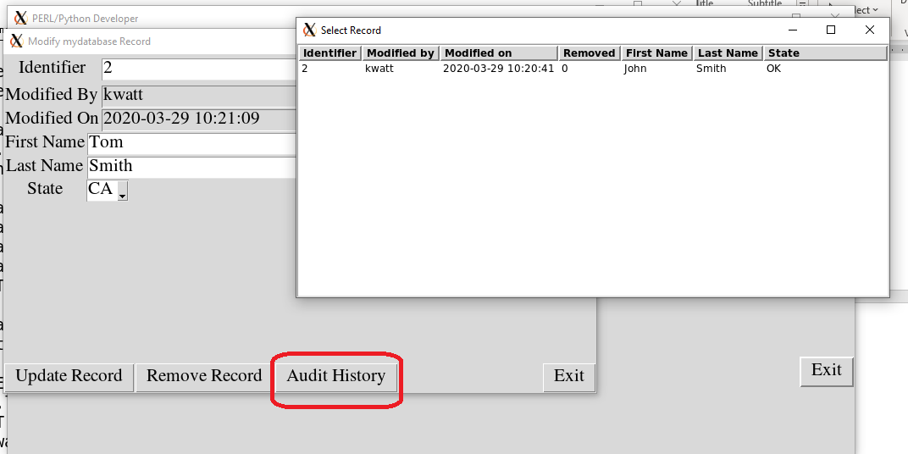

**Other minor enhancements:**

1. Scroll bar was added to the create/modify tables screen.
2. The ability to modify the column label was added.
3. A sort order column was added to the create/modify tables screen.
4. Other minor errors

**Future planned enhancements:**

The Database Table Maker is an excellent tool for creating individual tables with various prompts and pull-downs. It is very easy to use and intuitive. The auditing feature keeps track of any modifications to the database. However, there are some limitations for complex table structures. Plans for version 2.0 include the ability to create child tables. For example, suppose you are a tutor and you want to keep track of the lessons taught to a given student. You can create a student table and a lessons table, but it is currently not possible to link the tables (i.e. the student table is the parent table and the lesson table is the child table). This feature is currently under construction and will be available in version 2.0 which will be released shortly.