**Database Table Maker v2.0 upgrade notes**

Kenneth Watanabe

**Child Tables**

The Database Table Maker v2.0 includes the ability to create child tables.

For example, suppose you are a tutor and you want to keep track of the lessons taught to your students. You can create a student table and a lesson table, but in previous versions, it was not easy to link the tables together. In version 2.0, you can now create the student table as a parent table, and the lesson table as a child table so that for a given student, it is easy to identify the lessons taught.

To create a parent table, click on the Create/Edit Table tile and enter the parent table name in the Table Name prompt and leave the Child Table prompt empty. Fill in the field names, field labels, datatypes, lengths, link tables and sort order for each of the fields in the table and click on the Create/Update Table button to create the table.

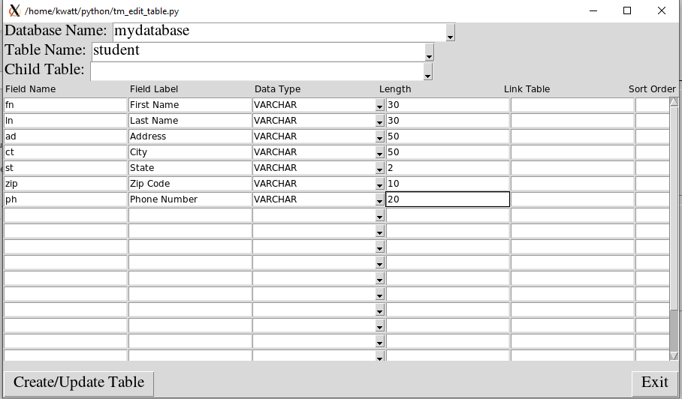

To create a child table, enter the parent table name in the Table Name field, if not already entered, and enter the child table name in the Child Table field. Fill out the field details for each of the fields in the table and click on the Create/Update Table button to create the child table. Note: a parent table can have multiple child tables.

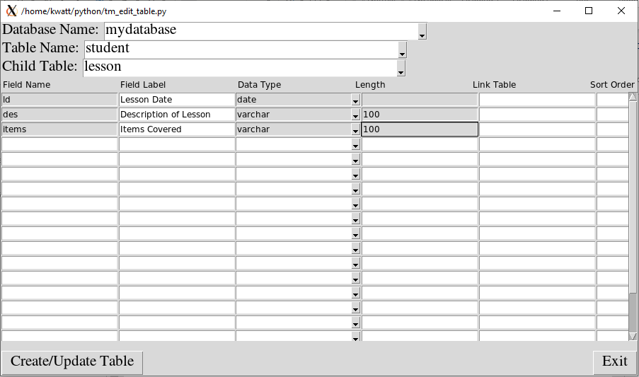

In version 2.0, you can make a child table of a child table. Suppose we want to keep track of the exercises completed in each lesson. We can make a lesson_details table that is a child of the lesson table. To do this, enter the lesson table in the Table Name field, and enter the lesson_details table in the Child Table field. Fill out the field details for each of the fields in the table and click on the Create/Update Table button to create the child lesson_details table. Theoretically, there is no limit to how many levels deep the child tables can go.

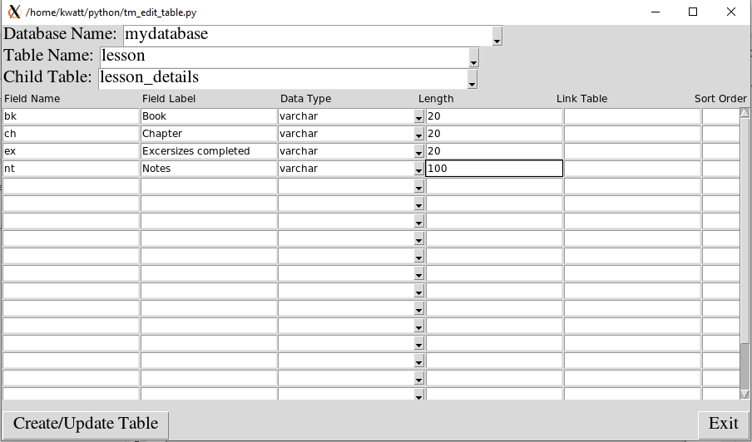

To enter/edit records in the parent table, select the Enter/Modify records tile from the main menu. Enter the database name and table name and click on the Go button. Records can be created or modified from the following screen. If there is a child table associated to the parent table, an extra button will appear at the bottom. In case of the student table, a lesson button will be shown. Click on the lesson button to view the lesson records.

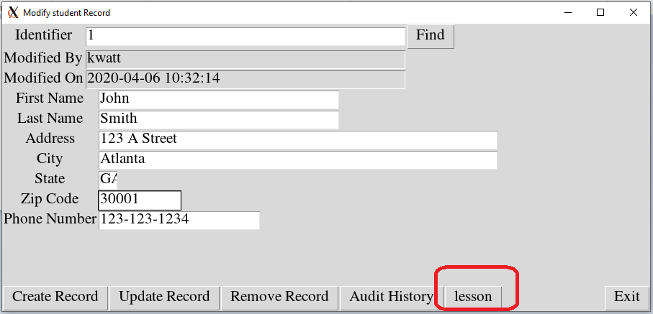

A list of the lessons will be shown. To view or modify a lesson, click on the lesson row. To create a new lesson, click on the blank area below the list of lessons. The lessons can be sorted by clicking on the column headers.

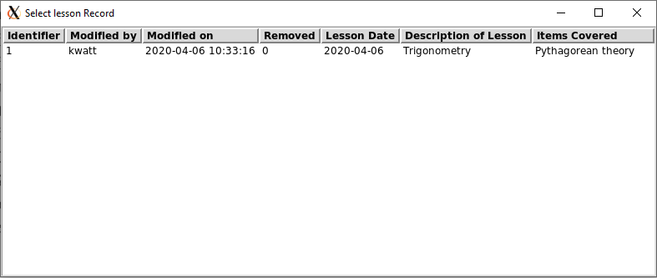

**Other Enhancements:**

1. The Create Table and Modify Table tiles were combined into a single tile.
2. The Enter Record and Modify Record tiles were combined into a single tile.
3. An Import Data tile was added to import data into a table
4. An Export Data tile was added to export data from a table.