**Database Table Maker v3.0 upgrade notes**

Kenneth Watanabe

**Modifications to Edit Table**

A new field (removed) was added to the table_details table. This allows the user to remove fields that are not being used. In the example below, the Zip Code field was removed. This field will no longer be accessible through the Create/Modify Records option.

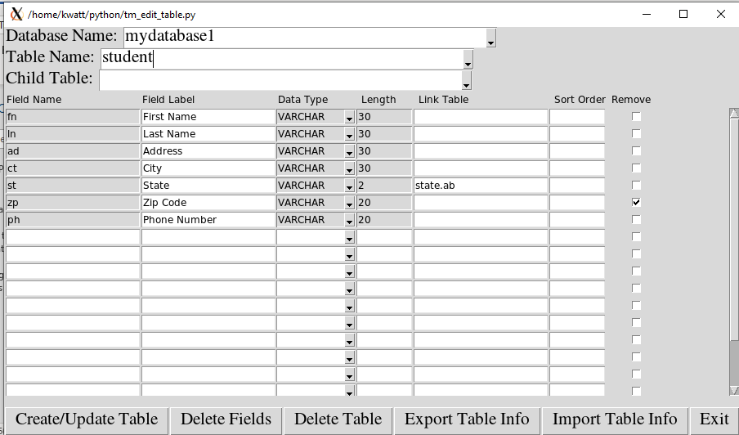

Notice the Zip Code field is no longer in the data entry screen. Also notice that a “Clear” button was added that clears the contents of the screen when clicked.

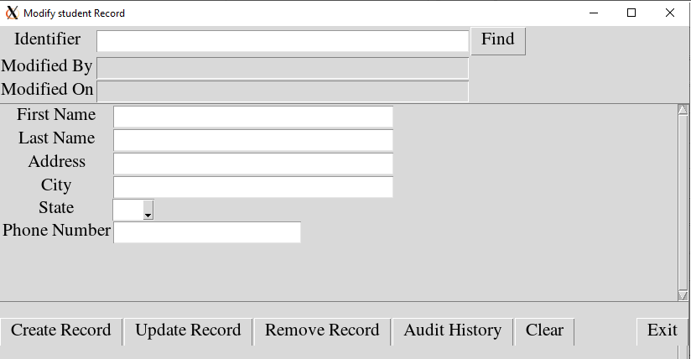

The options to delete tables or removed fields of a table have been added. When deleting table or removed fields, a window appears prompting for the MySQL username and password as an added level of security.

The options to import and export fields for a table have been added. This will make it easier if you are creating tables in a Test database and you want to move them to a Production database without having to re-enter all the field information. This will also help if you wish to design the table outside of the DBTM in an Excel csv file for later import into DBTM.

**Modifications to Import Data and Export Data into table**

The Import Data function was modified to include a “Template” button.

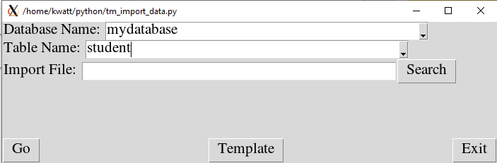

When clicking on the Template button, it will create a csv file containing the field headers necessary to import the data for the specified table name.

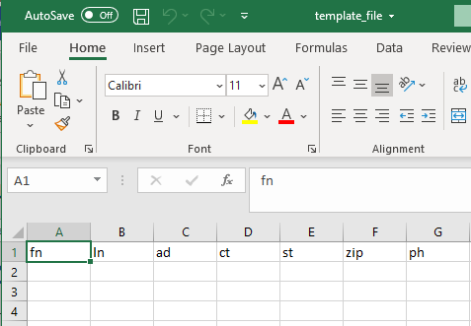

**New feature Query Data**

A Query Data tile has been added to the main menu. This give query capability to any user created table. If querying a child table, the fields from the parent table, and parent of the parent table etc. can be used as query criteria.

In the example below, though we are querying on the specimen table, we can add criteria on the visit and patient level since the visit table is the parent of the specimen table, and the patient table is the parent of the visit table.

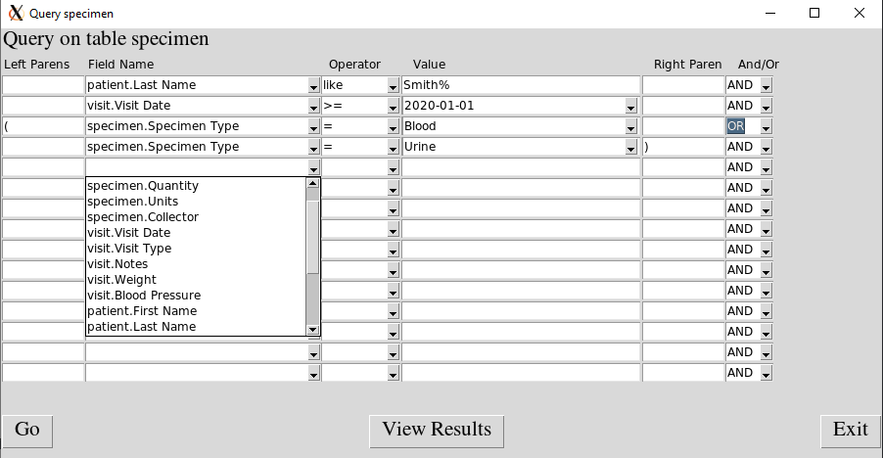

The above query finds all blood or urine specimens from patients who visited after 1/1/2020 and the last name begins with Smith.

Currently queries cannot be saved. This feature will be added in the DBTM v3.1.

**Other modifications/bug fixes**

When creating/modifying/removing child records, the list of child records did not automatically update. This problem has been resolved in version 3.0.