LOCKED UX DIRECTION

Actionable Alerts &
Chart-First Trade Portal
  - The elevated successor to Cheat Code SMS alerts, connected directly to chart analysis, Kai and brokerage execution
PRODUCT DECISION Alerts are complete trade objects—not notifications. Every card explains the opportunity, displays the plan and routes directly into the relevant Trade Portal.

Purpose
This specification defines the final Alerts experience and its integration with the chart-first Trade Portal. It converts the immediacy of the original Cheat Code SMS alert into a richer, visual and continuously monitored decision object without turning the app into a dense trading terminal.

Locked relationship
Surface | Single responsibility
Home | Kai identifies the user’s most important current decision.
Alerts | Kai delivers complete actionable opportunities and monitored trade developments.
Trade | The user works the live chart with Kai and prepares or manages execution.
Community | Members discuss the asset while Kai verifies relevant claims.
Account | The user controls brokerage, risk, delivery and explanation preferences.

Core principles
- One standard alert-card grammar across Active, Watching and History.
- Grade quality, market direction, risk and action colors retain separate meanings.
- The alert is understandable without opening the chart.
- Opening an alert preserves ticker, timeframe, levels, trigger event, thesis and Kai context.
- No generic alert-detail destination sits between the card and Trade Portal.
- Kai advises and prepares; the user confirms every financial action.

Visual source of truth
The approved mockup demonstrates the intended hierarchy: rich Active and Watching cards followed by a direct transition into a persistent chart workspace with Kai beneath it.
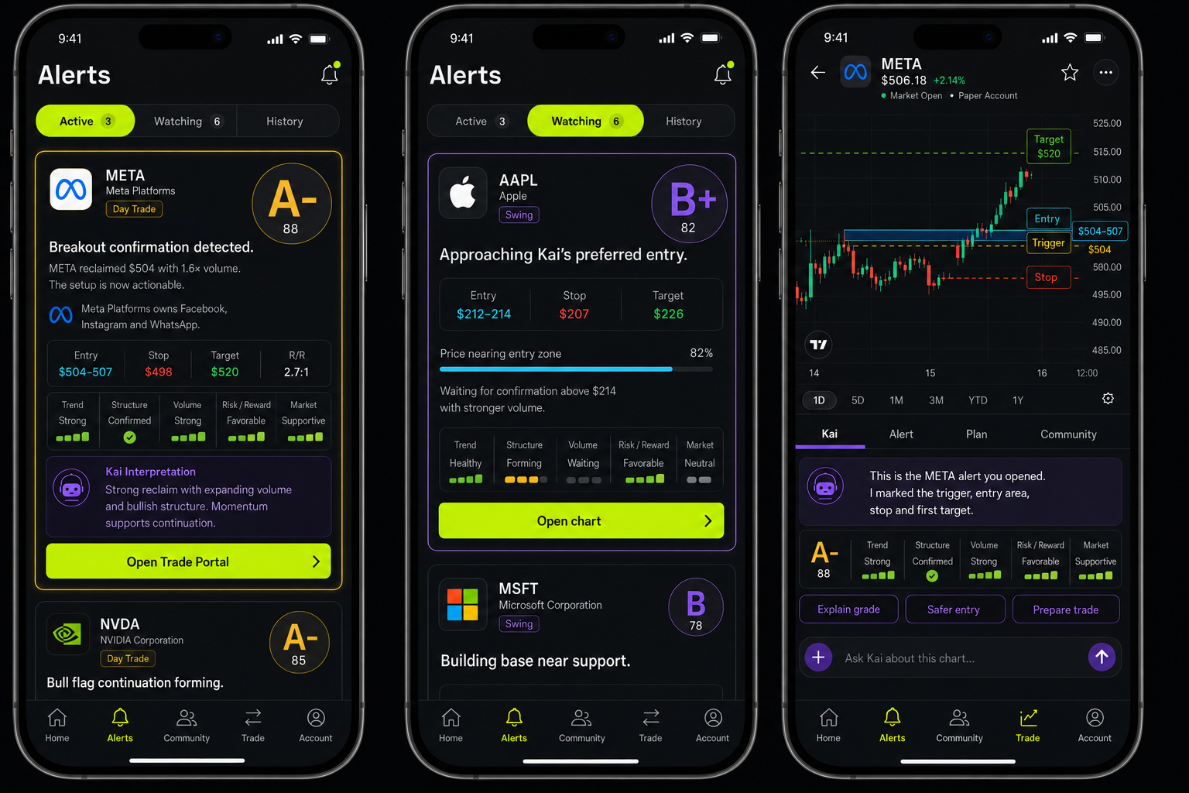
Figure 1. Active alert, Watching alert and chart-first Trade Portal.
INTERPRETATION The card contains the decision summary. The Trade Portal contains the working environment. Kai connects the two without resetting context.

1. Alerts information architecture
Alerts contains exactly three top-level states. Notification delivery status, alert type and trading mode are filters—not additional permanent sections.
Section | Meaning | Typical contents
Active | A material event occurred and may require a decision. | Ready setup, entry reached, grade change, stop/target approach, thesis change, exit event.
Watching | Kai is monitoring a complete idea whose condition has not triggered. | Waiting for price, volume, confirmation, catalyst, thesis change or position event.
History | The object is no longer active but remains auditable. | Executed, closed, missed, expired, invalidated, dismissed or cancelled.

State rules
- A card moves to Active only after a verified event, not because monitoring is enabled.
- Watching cards remain complete trade ideas, including preliminary entry, stop, targets and expiration.
- History preserves the original alert snapshot plus outcome and event timeline.
- A position-related event may appear in Active, but position management remains inside Trade.
- Opening any card routes to Trade Portal with the alert context loaded.

Sorting
Section | Default order
Active | Required action, severity, freshness and personalized relevance.
Watching | Distance to condition, quality grade and expiration.
History | Most recently resolved first.

2. Standard actionable alert card
Every alert uses the same underlying component. Sections may collapse responsively, but data semantics and action placement remain consistent.
Card region | Required content
Identity | Company logo, ticker, company name, mode, direction and instrument type.
Quality | Oversized letter grade, supporting numerical score and grade-family border treatment.
Event | Plain-language headline, what changed and trigger timestamp.
Company summary | One or two beginner-friendly sentences describing the business and relevant context.
Trade plan | Current price, entry, stop, targets, risk/reward, hold expectation and expiration.
Scorecard | Mode-specific components, points earned, maximum points and total.
Kai interpretation | Why the trade matters, what confirms it and what could invalidate it.
Personal fit | Estimated risk, rule fit, concentration, limits and material conflicts.
Community | Sample size, common level, sentiment and verification status; always secondary.
Action | One state-driven primary action plus restrained secondary controls.

3. Card content specification

Header
- Ticker and company name are primary; the logo is supporting identity.
- Show Day Trade, Swing or Invest as the mode.
- Show equity, call, put, ETF or other instrument explicitly.
- Display grade and 0–100 score together.
- Display Triggered, Watching, Invalidated, Position active or Closed as a separate state.
- Always include source timestamp and market-data freshness.

Company summary
The default summary is two sentences maximum. It explains what the company does and why it is relevant to the current event. Market cap, sector, earnings and catalysts expand on request.
EXAMPLE Meta Platforms owns Facebook, Instagram and WhatsApp. Its shares are trading with elevated volume after buyers reclaimed a major intraday level.

Alert message
The message must stand alone like a premium SMS alert: ticker, event, price condition, confirmation and next action are understandable without opening the chart.
EXAMPLE META reclaimed $504 with 1.6× volume. Three five-minute candles held above the trigger, making the setup actionable.

Trade information
Field | Requirement
Direction | Long, short, call, put, accumulate, reduce or rebalance.
Current price | Include timestamp and freshness.
Entry | Condition plus numeric area or limit.
Stop | Numeric level and plain-language invalidation.
Targets | At least first target; additional targets optional.
Risk/reward | Calculated using intended entry and primary stop/target.
Expected hold | Intraday range, days/weeks or long-term horizon.
Expiration | When the setup or monitoring condition becomes stale.

Options extension
Show the underlying plan first. Contract details expand beneath it: expiration, strike, type, bid/ask, open interest, volume, spread quality, estimated premium and maximum contract risk. Never let contract selection obscure the underlying invalidation.

4. Grade and qualitative scorecard system
The grade is the immediate quality signal. Its numerical score is supporting detail, while the scorecard explains the grade through qualitative, glanceable evidence rather than competing point fractions.
GRADE HIERARCHY Display the grade in a 72–88 px mobile medallion or equivalent dominant object. The letter grade is large; the 0–100 score is small. A user should recognize A-, B+ or another grade before reading the headline.

Mode | Five default components
Day Trade | Trend; price structure; volume; risk/reward; market alignment.
Swing | Trend; entry quality; catalyst risk; risk/reward; market alignment.
Invest | Business quality; valuation; financial strength; growth outlook; portfolio fit.

Component visualization
Element | User-facing treatment
Label | Trend, Structure, Volume, Risk / Reward and Market.
Status | Strong, Confirmed, Healthy, Forming, Waiting, Favorable, Supportive or Neutral.
Signal | Three-to-five segments, a check state, dots or a short meter—whichever best matches the evidence.
Evidence | Expandable explanation and sources. Internal points remain part of the grading engine only.

Never display component fractions such as 18/20 or 19/20. Internal weights may calculate the overall grade and 0–100 score, but component assessment is presented as visual strength plus plain-language status.

Grade bands
Score | Grade family | Treatment
90–100 | A+ / A | Gold gradient border; highest emphasis.
85–89 | A- | Gold gradient border; slightly restrained.
80–84 | B+ | Violet gradient border.
70–79 | B / B- | Violet-to-graphite border.
60–69 | C family | Amber-to-graphite border.
<60 | Unqualified | Neutral treatment; not promoted as actionable.

Grade borders express setup quality only. Gold never means profit; green/red never express grade. Bearish A-grade setups still receive gold treatment.

5. Visual and interaction system
Semantic role | Color | Use
Primary action | Volt #C8FF00 | CTA, selected navigation and explicit user action.
Kai intelligence | Violet #8B5CF6 | Kai messages, analysis, tools and chart control.
Market information | Cyan #32D6FF | Price levels, data context and neutral annotations.
A-grade quality | Gold #FFC857 | Oversized grade medallion and restrained gradient perimeter.
Positive | Green #35D07F | Confirmed positive movement, targets and gains.
Risk | Coral #FF5A5F | Stops, invalidation, loss and destructive action.
Foundation | Carbon / Graphite | Canvas and elevated surfaces.

Collapsed mobile card
- Identity and mode with an oversized, instantly legible letter grade; the numerical score is secondary.
- Alert headline and what changed.
- Short company summary.
- Entry, stop, target and risk/reward strip.
- Qualitative scorecard indicators with visual strength states—never /20 fractions.
- One short Kai interpretation.
- One primary CTA.

Expandable detail
- Full scorecard evidence.
- Technical and beginner explanations.
- Complete thesis and scenarios.
- Contract information.
- Personal risk-fit calculations.
- Community intelligence.
- Sources, event history and delivery log.

Primary actions by state
State | Primary action | Destination
Watching | Open chart | Trade Portal with monitored condition marked.
Forming | Keep watching | Remain monitored; show edit/pause controls.
Ready | Review trade | Trade Portal with Alert or Plan context.
Entry reached | Open Trade Portal | Chart centered on trigger event.
Planned | Prepare order | Order ticket prefilled from reviewed plan.
Order pending | Manage order | Order state and chart.
Position active | Manage trade | Position context with stop/target events.
Invalidated | See what changed | Chart replay and Kai explanation.
Closed | Review outcome | Debrief and original alert comparison.

6. Alert-to-Trade Portal routing
There is no generic alert-detail screen. Selecting an alert opens the canonical asset workspace inside Trade and restores the exact event context.
Preserved context | Requirement
Identity | alert_id, setup_id, symbol, instrument and mode.
Chart | timeframe, visible range, trigger candle and trigger timestamp.
Levels | entry, stop, invalidation, targets and community-mentioned levels.
Reasoning | original thesis, grade snapshot, score components and Kai explanation.
Monitoring | condition, progress, state history and last evaluation.
Execution | plan, brokerage capability, account, order and position references.
Community | related room/thread, verified claims and sentiment snapshot.

OPENING MESSAGE This is the META alert you opened. I marked the trigger, entry area, stop and first target on the chart.

7. Chart-first Trade Portal
Trade opens as a working chart—not a portfolio dashboard. Account, watchlist, positions and search remain accessible through compact header controls, drawers or sheets.

Mobile hierarchy
Layer | Content
Top bar | Ticker switcher, current price, market state, paper/live account, search and drawers.
Chart | TradingView-style chart occupying the dominant portion of the screen.
Context switcher | Kai, Alert, Plan and Community; Kai selected by default.
Working panel | Conversation or selected context while the chart remains visible.
Composer | Persistent “Ask Kai about this chart…” input.
Execution | State-driven CTA or order ticket opened intentionally.

Kai chart-control commands
- Mark the level that triggered this alert.
- Switch to the daily or five-minute chart.
- Show what invalidates the setup.
- Mark entry, stop and targets.
- Zoom into the trigger candle.
- Compare with the prior session.
- Highlight the community’s most-mentioned level.
- Remove, hide or explain an annotation.
- Create or modify an alert from a drawn level.
- Prepare the trade from the reviewed plan.

Annotation requirements
Field | Required value
Identity | Unique annotation ID and associated symbol.
Geometry | Price, time range, coordinates and chart timeframe.
Meaning | Trigger, entry, support, resistance, stop, invalidation, target or note.
Reason | Plain-language explanation of why Kai placed it.
Provenance | Kai, user, community or imported plan.
Lifecycle | Created, updated, valid, invalidated, hidden or deleted.
Control | User can inspect, edit, hide and delete every Kai annotation.

Desktop adaptation
Desktop uses a watchlist/positions/alerts drawer on the left, persistent chart in the center and Kai conversation with rich artifacts on the right. The order ticket opens intentionally without replacing the chart.

8. Kai behavior and rich artifacts
Kai chat is the default panel beneath the chart. Rich objects appear inside the conversation only when relevant, preventing permanent stacks of setup, evidence, news, plan and community cards.
- Answers remain concise before expandable evidence.
- Chart changes occur in place and are narrated.
- Kai clearly distinguishes market data, independent analysis and community sentiment.
- Kai never claims an order was accepted, filled or monitored before confirmation.
- Kai’s assessment is labeled as analysis, not a guarantee.
- Order preparation never equals order submission.

9. Data, API and state requirements
Object | Minimum contract
Alert card | identity, company_summary, mode, direction, grade, score, score_components, state, event, thesis, quote, trade_plan, fit, community, timestamps.
Score component | key, label, qualitative_status, signal_strength, internal_weight, explanation and evidence references.
Trade plan | entry condition/zone, stop, invalidation, targets, expected hold, expiration, risk/reward and sizing suggestion.
Route context | alert_id, symbol, timeframe, focus timestamp, annotation set and selected context panel.
Chart annotation | geometry, semantic type, provenance, reason, lifecycle and user visibility.
Event history | state transition, timestamp, source, data snapshot and user/Kai action.

Lifecycle
Transition | Rule
Watching → Active | Verified condition or material change creates an actionable event.
Active → Watching | User defers action and condition remains valid.
Active → Planned | User reviews and saves a complete plan.
Planned → Order pending | User confirms brokerage submission.
Order pending → Position active | Broker confirms fill; partial fills remain explicit.
Any live state → Invalidated | Defined invalidation condition is verified.
Resolved → History | Execution, expiry, dismissal, cancellation, invalidation or close is recorded.

Freshness and evidence
- Every quote and trigger includes source timestamp, received timestamp and freshness.
- Score evidence retains the market snapshot used at scoring time.
- A later grade change creates a new version rather than rewriting history.
- Community observations remain labeled and do not automatically alter grade.
- Trading actions are disabled or qualified when required data is unavailable—not silently inferred.

10. Accessibility and safety
- Grade and state are never communicated by border color alone.
- Text and numerals meet accessible contrast requirements.
- Reduced-motion mode removes glow animation and chart pulses.
- Screen readers announce ticker, state, grade, action and trade levels in decision order.
- Risk information precedes final execution confirmation.
- The user can pause monitoring and hide community context.
- Broker capability is verified before presenting “Submit to broker.”
- Paper and live trading states remain unmistakable throughout the flow.

11. Acceptance criteria
- Users can understand an alert’s company, event, grade, entry, stop and target without opening another screen.
- The letter grade is visually dominant and recognizable before the user reads the alert headline.
- The 0–100 score is supporting information and never competes with the letter grade.
- Scorecard components use qualitative labels and glanceable signals; no /20 fractions appear in the interface.
- Active, Watching and History are the only permanent Alerts sections.
- Every displayed grade has an inspectable scorecard.
- Selecting any alert opens the correct ticker, timeframe and event in Trade Portal.
- The chart remains visible while the user talks to Kai.
- Kai can add, explain, modify and remove chart annotations.
- The primary action always matches alert and execution state.
- No generic alert-detail page interrupts the Alert-to-Trade flow.
- History preserves the original alert and complete outcome trail.
- A connected broker is never presented as execution-enabled unless the integration confirms that capability.

Final product statement
NORTH STAR Alerts are the elevated successor to Cheat Code SMS: complete, graded and actionable trade intelligence. Trade is the live chart workspace where the user and Kai investigate, plan and execute without losing context.

