Name: Kenneth Bentley

Lesson 3: Working with Lists

1. Create a list of 5 of your favorite tv shows.

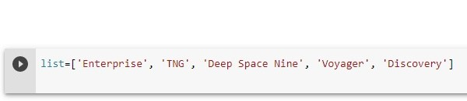

1. Print the list in its original order.

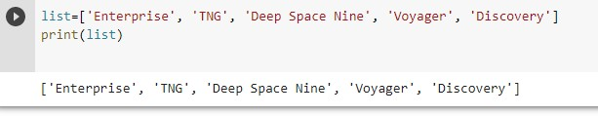

1. Use the sorted() function to print the list in alphabetical order. How is sorted() different from sort()?

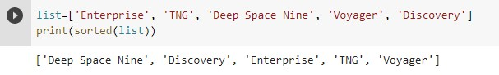

Sorted() does not change the order of the list. It just prints a sorted list. Sort() changes the order of the list.

1. Print out your original list.



1. Used sorted() to print your list in reverse alphabetical order.

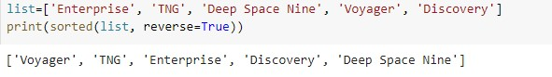

1. Create a message indicating how many favorite TV shows you have – use the len() function.

