Pet Project

Advanced Software Engineering

# Overview

All parts of the task are available on github: <https://github.com/kwbln/AdvSE>.

You can find a short description about the project in the readme, more detailed information are placed in the wiki: <https://github.com/kwbln/AdvSE/wiki>

The Pet Project itself covers the expected topics (except the DSL and the FP), but there are still some issues to think about, if the project should be extended in future.

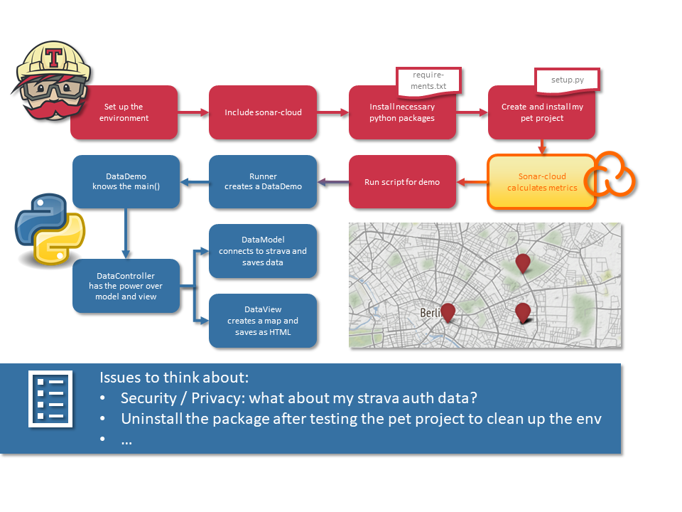

* UML: <https://github.com/kwbln/AdvSE/wiki/Unified-Modeling-Language>
* Metrics: <https://github.com/kwbln/AdvSE/wiki/Metrics>
* Clean Code Development: <https://github.com/kwbln/AdvSE/wiki/Clean-Code-Development>
* Build Management: <https://github.com/kwbln/AdvSE/wiki/Build-Management>
* Continous Delivery: <https://github.com/kwbln/AdvSE/wiki/Continous-Delivery>
* DSL: <https://github.com/kwbln/AdvSE/wiki/Domain-Specific-Language>
* Functional Programming: <https://github.com/kwbln/AdvSE/wiki/Functional-Programming>
* No longer expected in pet project
  + [DELETED] AOP (show me where you could have integrated AOP stuff => the jointpoints)
  + [DELETED] Show me an idea where to use a logical solver in your code and how you would do it!
  + [DELETED] Write a little code fragment (like data preparation etc.) in Scala or Clojure!

# Issues to think about

* Security / privacy: what about my strava authentification data?
* Uninstall the package after testing the pet project to clean up the environment

# Documentation Screenshots

