# NODES

## CREATE

CREATE (ee:Seminar { name: "DS4BD", semester: 1, creditpoints: 5 })  
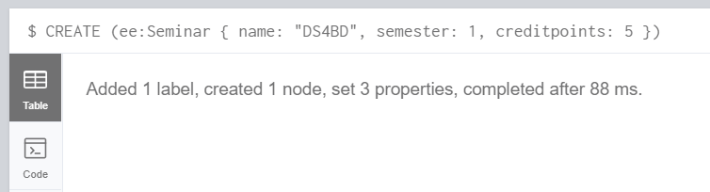

## READ

MATCH (ee:Semninar) WHERE ee.name = "DataScience4BigData" RETURN ee;  
MATCH (ee) WHERE ee.name = "DataScience4BigData" RETURN ee;  
MATCH (Seminar) WHERE Seminar.name = "DataScience4BigData" RETURN Seminar;  
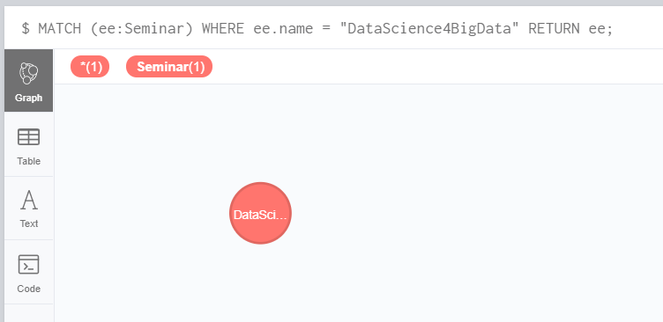

## UPDATE

Match (ee:Seminar{name:"DS4BD"}) Set ee.name = "DataScience4BigData"  
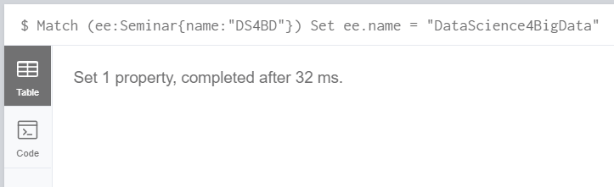

## DELETE

MATCH (ee) WHERE ee.name = "AdvSE" DELETE ee;  
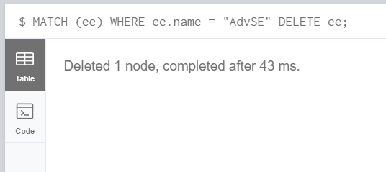

# RELATIONSHIP

## CREATE

MATCH (a:Seminar),(b:Semester)  
WHERE a.name = 'Data Science' AND b.name = '1. Semester'  
CREATE (a)-[r:PART_OF]->(b)  
RETURN type(r)  
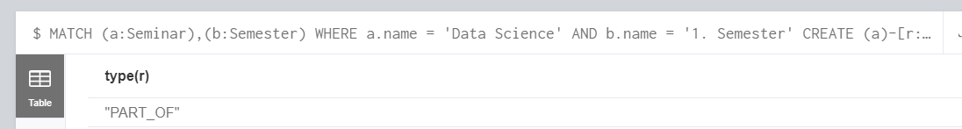

## READ

MATCH (a:Seminar)-[:PART_OF]->(b:Semester)  
RETURN a.name As Seminar, b.name as Semester  
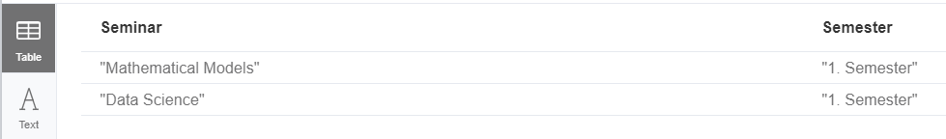

MATCH (s:Semester)-[:PART_OF]-(OtherNodes)  
RETURN s, OtherNodes  
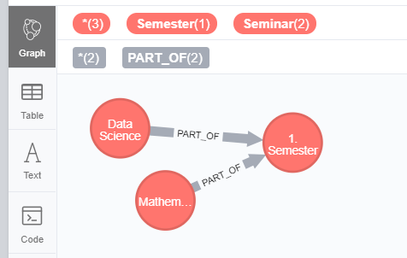

MATCH (s:Semester)-[:PART_OF]-(OtherNodes)  
MATCH (OtherNodes)-[:NEEDS]-(AnyOtherNodes)  
RETURN s, OtherNodes,AnyOtherNodes  
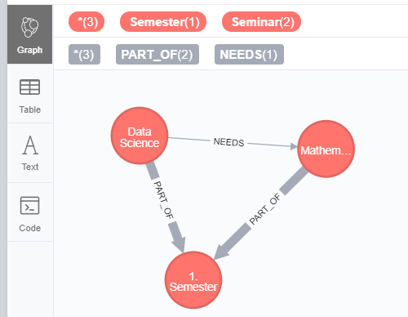

## UPDATE

MATCH (a {name:"Data Science"})-[r]-(b {name:"Mathematical Models"})  
SET r.Scope = "a little bit"  
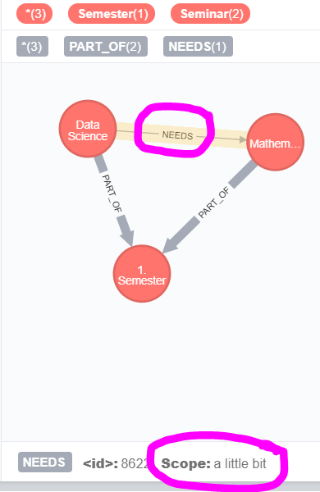

## DELETE

MATCH (tom:Person {name: "Tom Hanks"})-[r:ACTED_IN]->() DELETE r  


# PROPERTY

## CREATE

MATCH (n)  
WHERE n.name STARTS WITH 'Comp'  
SET n.lernziel = "Dieses Modul betrachtet alle informationstechnischen Voraussetzungen, die für die Abwicklung von großen Data Science Projekten in der Cloud wichtig sind. Die Studenten lernen eigene Architekturen entwerfen, mit den richtigen Data Pipelines ausstatten und die passendsten Werkzeuge auszuwählen, um eine Big-Data / Machine-Learning Verarbeitungskette zu entwickeln. Die verschiedenen Technologiebereiche müssen evaluiert und praktisch angewendet werden, um praktische IT-Kompetenz zu erwerben."  
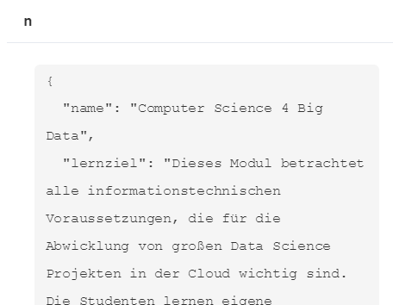

## READ

MATCH (n)  
WHERE n.name STARTS WITH 'Comp'  
RETURN n  
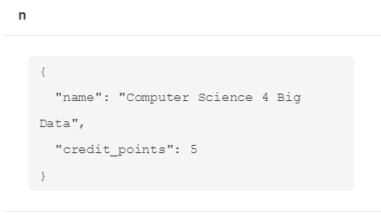

## UPDATE

MATCH (a {name:"Data Science"})  
SET a.name = "Computer Science 4 Big Data"  
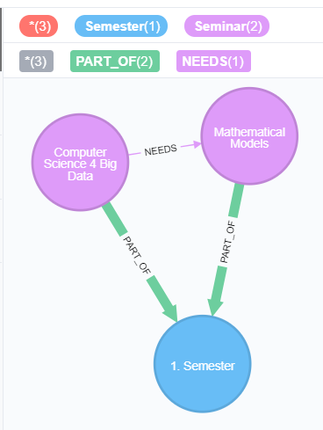

## DELETE

MATCH (n)  
WHERE n.name STARTS WITH 'Comp'  
REMOVE n.lernziel  
