**LOGIN :**

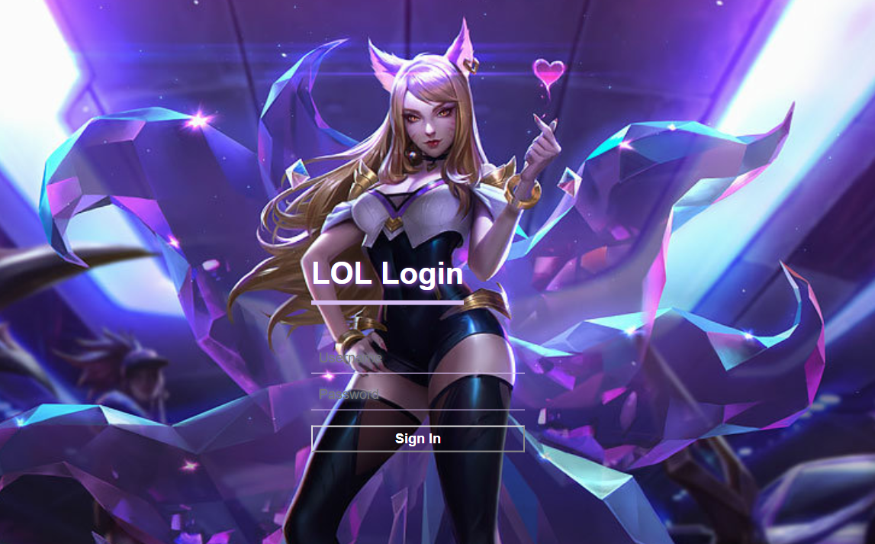

This page uses a lot of CSS, to adjust the location, size, and font appearance to make the login interface similar, while HTML uses text, enter username and password, and use button to login. In order to entering the correct username and password, you can login. Therefore, I used the JS function to go to next page, and set the value. The error is that you cannot log in.

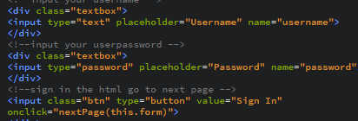

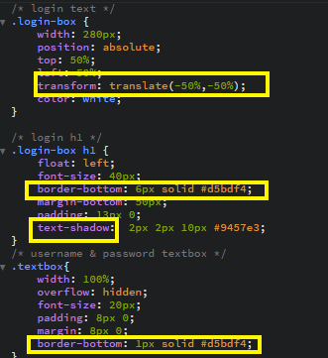

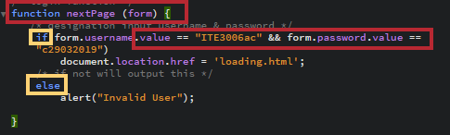

**LOOADING :**

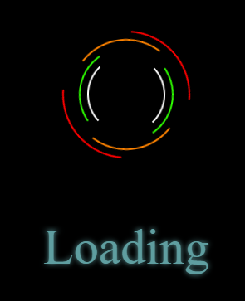

Most of the loading part is done with CSS, to adjust the position, size, font appearance, the most important is to use s s1, s2, s3, s4 in HTML to change the appearance in CSS, create dynamic picture and color More accurately loading to the next page, and finally use js to carried out, join the function, after 3 seconds to jump to the next page.

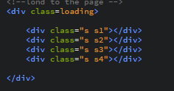

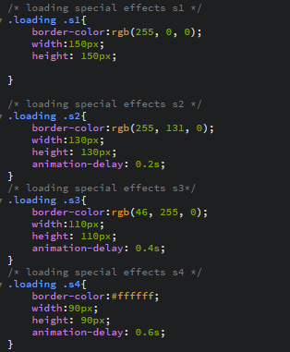

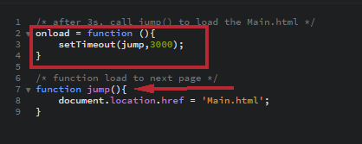

**MAIN :**



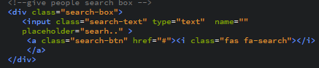

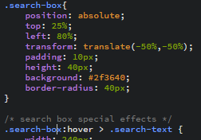

First join the search box with html

Use css again to make the search box feel dynamic.

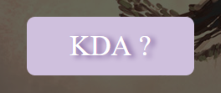



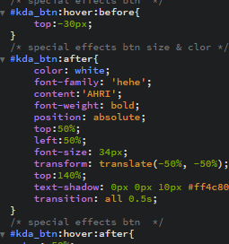

First add an id with html

Then use css to make kda_btn dynamic

You can also have different texts when you move forward or backward.

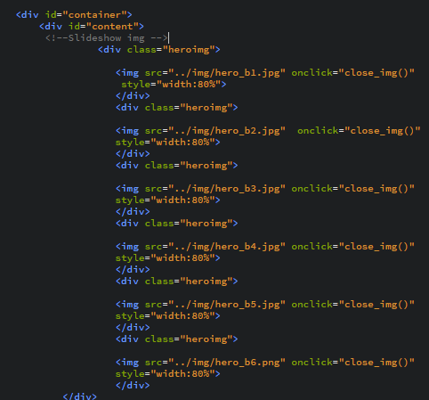

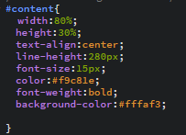

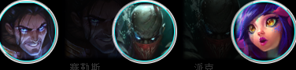

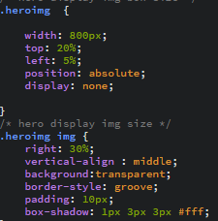

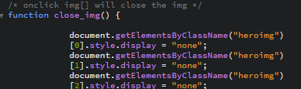

First use html to add id content and then class heroimg to join the picture, then use css to change the size and position of the picture and other beautification, then js let btn be clicked to pop up, and press the picture again because of onclick close.

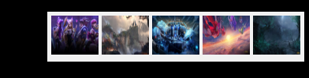

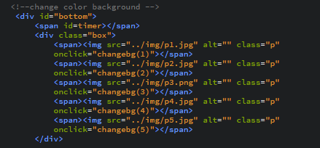

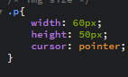

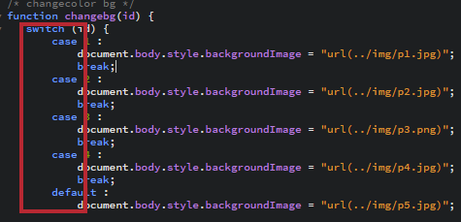

First use html to add 5 images in one position, then use css to modify the size and position of the image. The most important thing is to use JS to convert the background to the user with switch case.

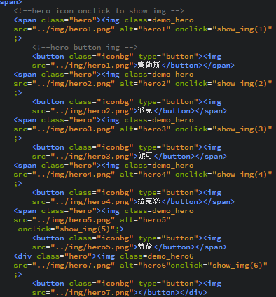

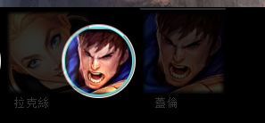

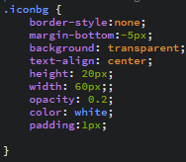

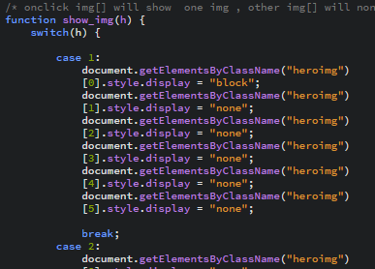

First use html to enter the picture avatar and then use button to create shadow and shape different from iconbg, then use css to change the size, position and color, then add js is also using switch case to click hero and then because of onclick and appear heroimg picture.





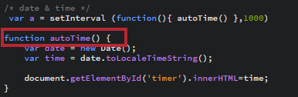

First use html to join the timer id and then use css to further shape and size, beautify the user to see, and finally use js to join the function and then let the timer display the date and time.

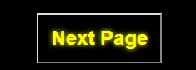

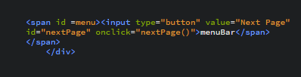

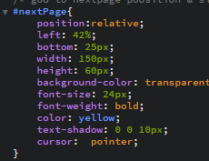

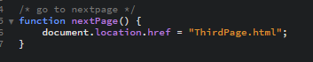

First use the id of the html nextpage, and then use css to change to the nextpage shape. It is also to beautify it and then you can see it to the next page. Finally, use js to function to go to the next page.

**ThirdPage :**

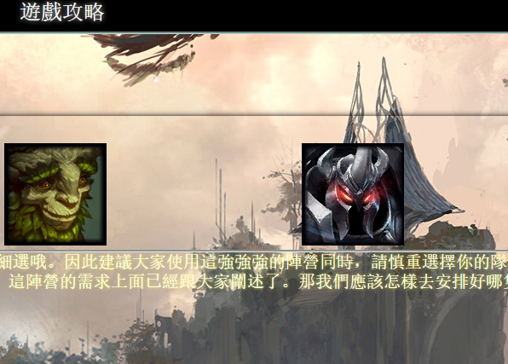

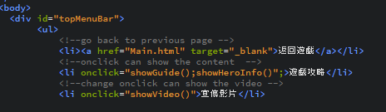

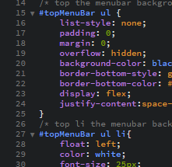

First open an id topmenubar with html. There are 3 choices for the user. Similarly, use css to beautify the text, move the position, set the size, and then use the function to show the movie and content and return to the previous page.

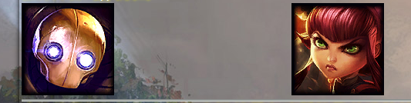

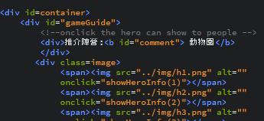

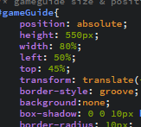





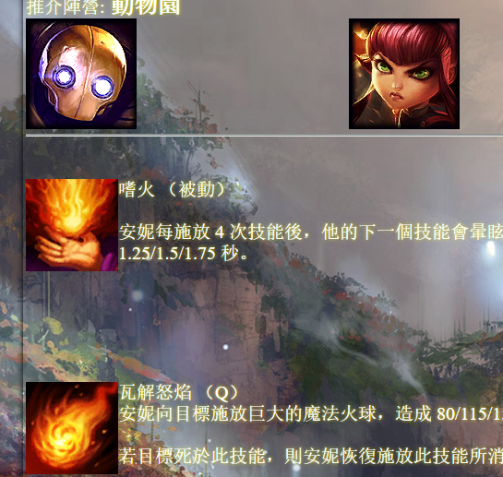



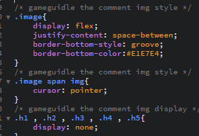

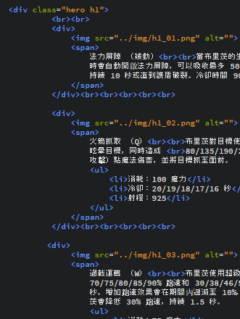

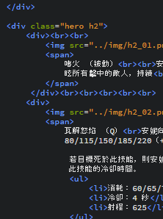

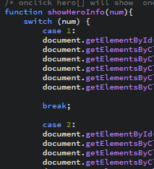

In addition, because the content of the show has added important pictures in html, the characters and descriptions of the characters can appear according to the pictures. Different characters and different contents can be used. The contents are also used to beautify css, set the position, text and size, and finally Because you can use the function to show the content, you can also close.





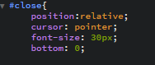

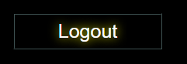



Haha, yes, it is also an id in html, this time is to leave, then use css to change its settings, beautify it, make it different. Then use JS's functioon to return to the login interface.



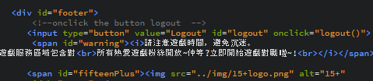

The game is intoxicating, so we will remind users not to play games for a long time. It is very simple. It is also to open an id in html and then type text into <i><br> and then use css to adjust the text and position. No need for JS.



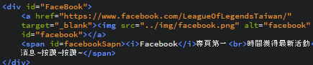

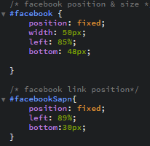

Most of the current games also have social media, and we are no exception. We also open an html in html.

Join the link and add the picture to make it clearer. Also <i><br>Add text to interact with the user, then use css to beautify.

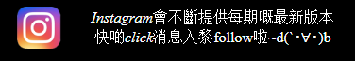

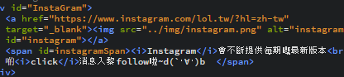

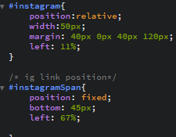

Once again, most of the games now have social media, and we are no exception. We also open an html in html.

Join the link and add the picture to make it clearer. Also <i><br>Add text to interact with the user, then use css to beautify, the practice is the same as facebook.

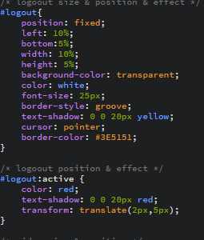

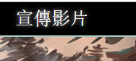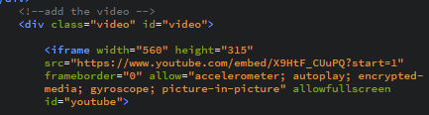

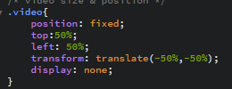

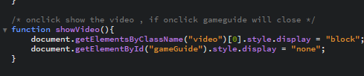

Good games, of course, in order to attract more users to promote, so we also have promotional videos.

The practice is very simple, first open an id video in html, then set the size of the iframe, then add the source of the video page, then use css to set the location, and finally use JS to do something different.

**Search :**

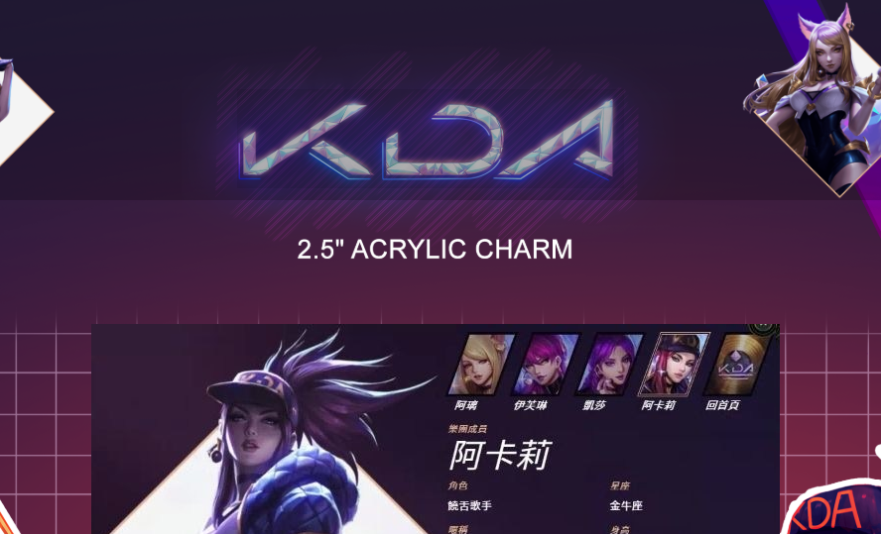

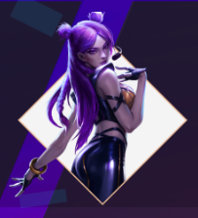

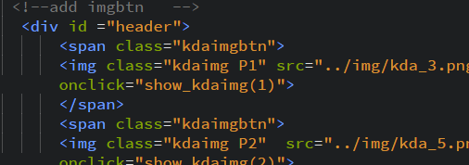

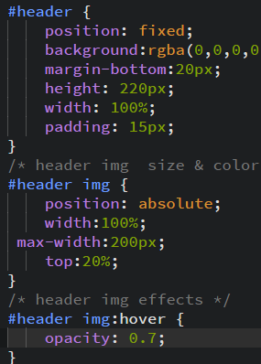

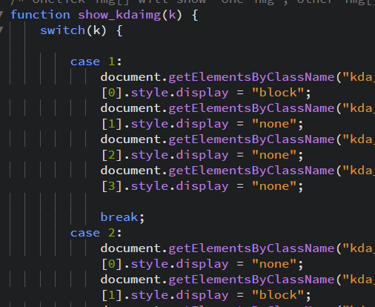

First use html to add id and then class kdaimgbtn to join the picture, then use css to change the size and position of the picture and other beautification, then js let btn be clicked to pop up, and press the picture again because of onclick close.



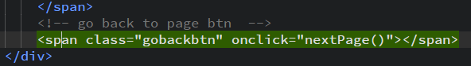

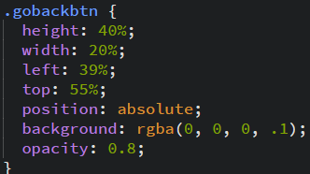

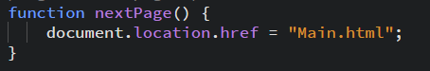

This time we used a transparent button to let the user return to the previous page by KDA ICON in the middle of the background. It also changed its settings with css and returned to the previous page with JS.

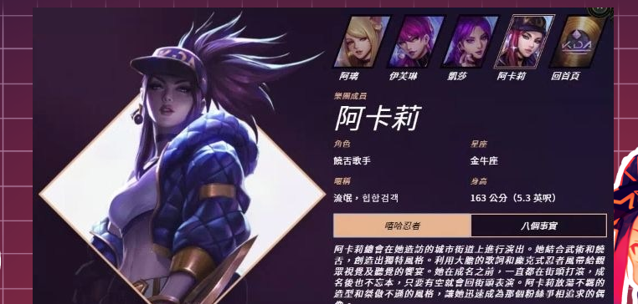

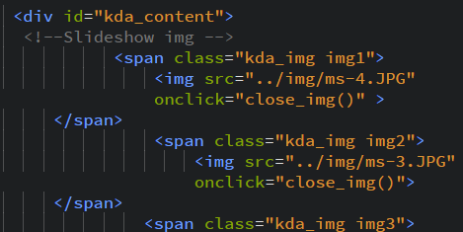

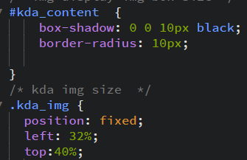

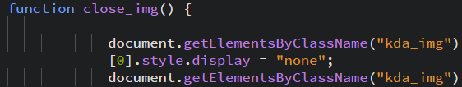

Add the image value in html, then change the image size and position in css, because the button above JS is used to open, you can also click the image close.