# 3x3 Kernel Comparison Algorithm

This documentation explained the theories behind the 3x3 kernel algorithm of ‘comp_pixel’ here:

https://github.com/khanh93vn/CogAlg/commit/f46e02c6c68d0ad25ed7ce36a68d82a1da67427f

## Equation Derivation

Based on Figure 1, given a pixel (in red) and there are 8 pixels surrounding the pixel (central pixel),

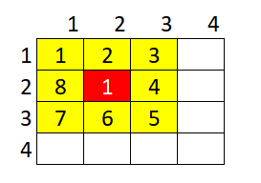

Figure 1. Central pixel with 8 surrounding pixels

The $y$ direction derivative $d_{y}$ is summarized in Equation 1:

|  |  |
| --- | --- |
| $$d_{y}= \sum_{j=1}^{n}{k_{j}d_{j}}$$ | (1) |

Where:

$d_{y}$ is the $y$ direction derivative,

$n$ is the total surrounding pixels and in this case = 8,

$k_{j}$ is the $j$ th coefficient,

$d_{j}$ is the $j$ th pixel differences.

From Equation 1, it could be expanded to Equation 2:

|  |  |
| --- | --- |
| $$d_{y}= \sum_{j=1}^{n}{k_{j}{(i}_{j}-i)}$$ | (2) |

Where:

$i_{j}$ is the $j$ th pixel,

$i$ is the central pixel.

Then, Equation 2 is separated into 2 sequences of equal length as shown in Equation 3:

|  |  |
| --- | --- |
| $$d_{y}= \sum_{j=1}^{n/2}{k_{j}{(i}_{j}-i)}+\sum_{j=\frac{n}{2}+1}^{n}{k_{j}{(i}_{j}-i)}$$ | (3) |

The sequence in the left and right should have similar length given $n$ is even ( $n$ = 8 in this case).

From Equation 3, expand again the $n$ in right sequence and form Equation 4:

|  |  |
| --- | --- |
| $$d_{y}= \sum_{j=1}^{n/2}{k_{j}{(i}_{j}-i)}+\sum_{l=\frac{n}{2}+1}^{\frac{n}{2}+\frac{n}{2}}{k_{l}{(i}_{l}-i)}$$ | (4) |

By using Equation 4, with n = 8, the series would form Equation 5：

|  |  |
| --- | --- |
| $$d_{y}=$$ $k_{1}{(i}_{1}-i)+ k_{5}{(i}_{5}-i)+$ $k_{2}{(i}_{2}-i)+ k_{6}{(i}_{6}-i)+$ $k_{3}{(i}_{3}-i)+ k_{7}{(i}_{7}-i)+$ $$k_{4}{(i}_{4}-i)+ k_{8}{(i}_{8}-i)$$ | (5) |

From the sequence in Equation 5, we can conclude that the series would form Equation 6:

|  |  |
| --- | --- |
| $$d_{y}= \sum_{j=1}^{n/2}{k_{j}{(i}_{j}-i)}+k_{j+\frac{n}{2}}{(i}_{j+\frac{n}{2}}-i)$$ | (6) |

It is proven that diametrically opposed pixels are have the same corresponding coefficients with opposing sign, hence Equation 7 is formed from Equation 6:

|  |  |
| --- | --- |
| $$d_{y}= \sum_{j=1}^{n/2}{k_{j}{(i}_{j}-i)}-k_{j}{(i}_{j+\frac{n}{2}}-i)$$ | (7) |

Where:

$k_{j}= {-k}_{j+\frac{n}{2}}$

From Equation 7, it would form Equation 8 which is the method used in the update:

|  |  |
| --- | --- |
| $$d_{y}$$ $$= \sum_{j=1}^{n/2}{k_{j}{(i}_{j}-i)}-k_{j}{(i}_{j+\frac{n}{2}}-i)$$ $$=\sum_{j=1}^{n/2}{k_{j}i_{j}-k_{j}i}-k_{j}i_{j+\frac{n}{2}}+k_{j}i$$ $$=\sum_{j=1}^{n/2}{k_{j}i_{j}}-k_{j}i_{j+\frac{n}{2}}$$ $$=\sum_{j=1}^{n/2}{k_{j}{(i}_{j}}-i_{j+\frac{n}{2}})$$ | (8) |

The similar concept is applied on $x$ direction derivative $d_{x}$ as well.

## Visualization

Original 3x3 kernel comparisons:

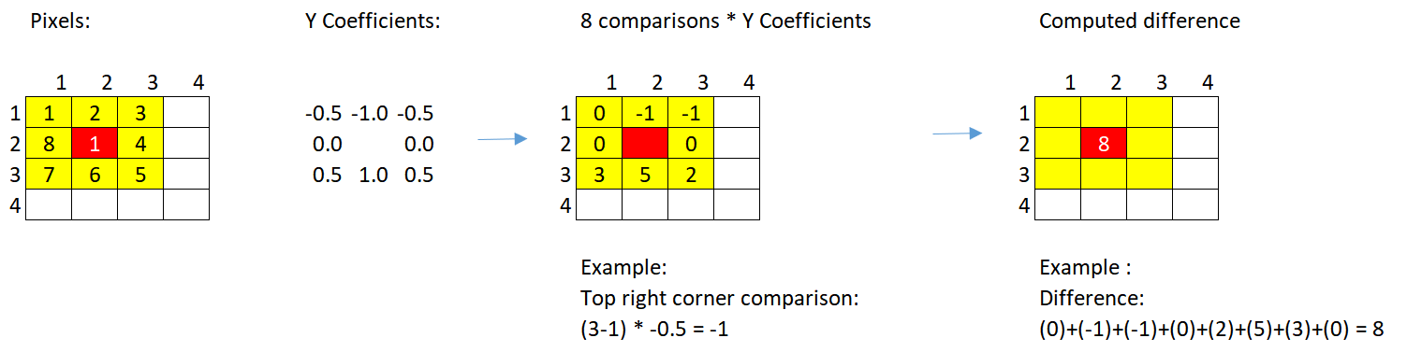

Optimized method:

