1. Write program (M-files) for process as following

1.1 Write function program ( not use MATLAB function )

for process and display log transformation of “img5_a .bmp” .

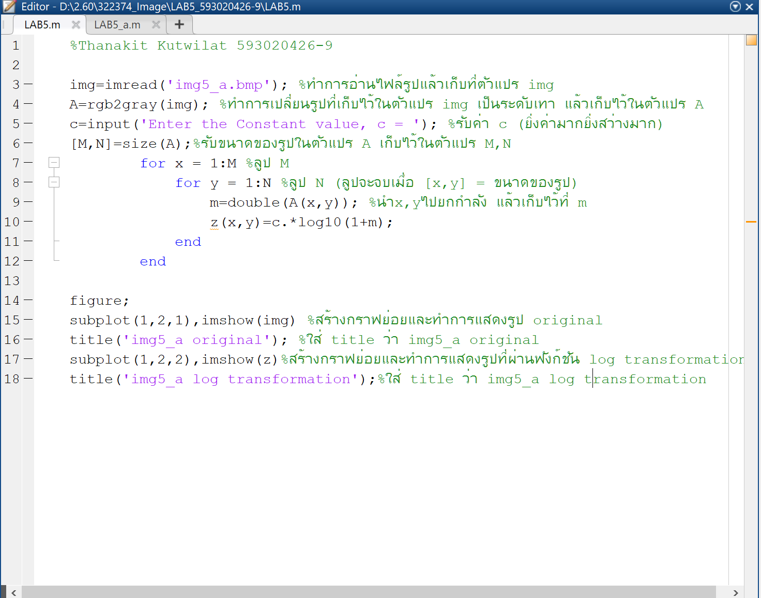

**ผลลัพธ์ที่ได้**

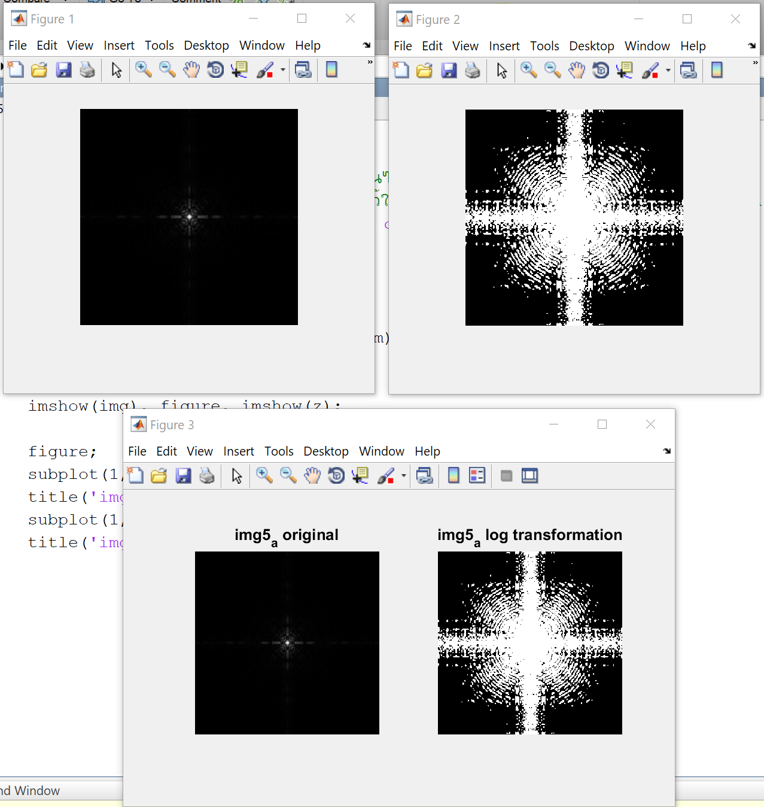

2. Write program (M-files) for process as following

2.1 Use non-linear adjustment MATLAB function

( gamma correction factor) for process image “img5_a .bmp”

and display output image.

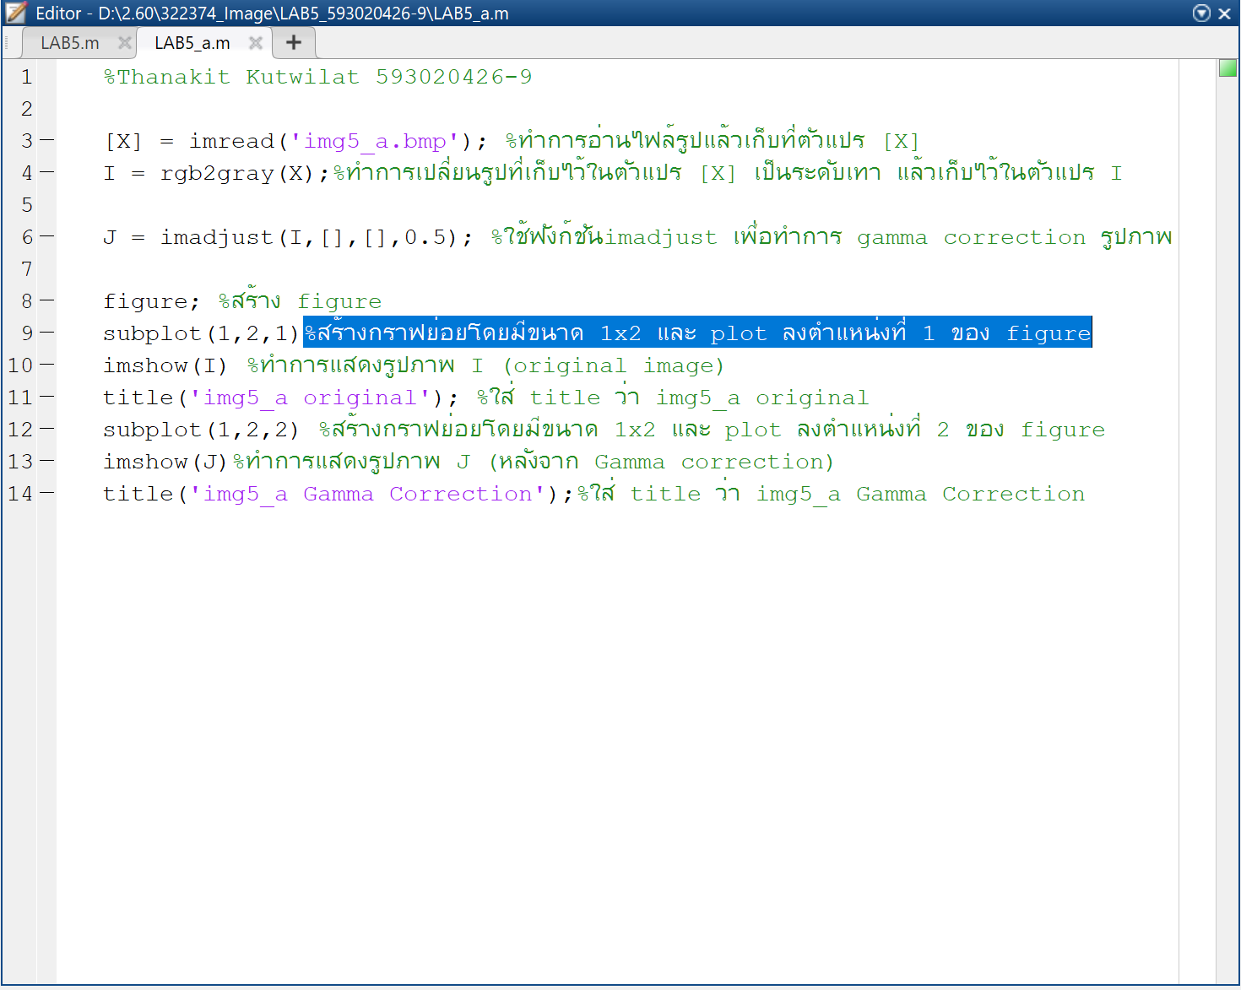

ผลลัพธ์ที่ได้

