RMS Point of Business

Service Desk Management



University of South Wales

User Guide – Tech Web

v1.0

Contents

Version history 2

Start using PoB.G6 Tech Web 3

Main screen 3

View an existing Case 4

Search 4

Create a new Case 4

Description 5

Case Type 6

Customer details 6

Case Category 7

Origin 7

Priority 7

Create a Knowledge Case 8

Case Notes 8

Save Case details 9

Change Assignment 11

Related Cases 11

Attachments 12

Move an Incident through the workflow 12

Suspension 13

Ad-hoc emails 14

Solve and Close a Case 15

Log out 15

# Version history

| **Version** | **Date** | **Edited by** | **Comments** |
| --- | --- | --- | --- |
| 0.1 | 16/04/15 | JS | Initial version |
| 1.0 | 21/04/15 | JS | Revised after testing |

# Start using PoB.G6 Tech Web

Open PoB Tech Web by pointing a web browser (eg Safari) at:

<https://support.southwales.ac.uk/PTW/Login.aspx>

or other URL provided by your system administrator or trainer.

The login screen is displayed.

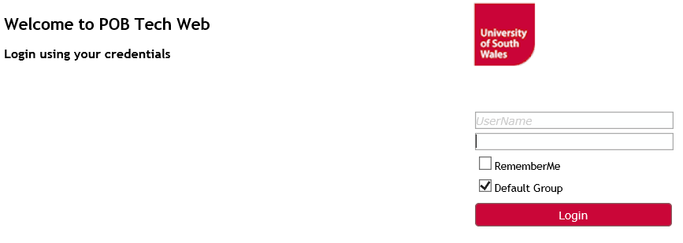

Enter your User Name and Password, and click the Login button.

# Main screen

The main screen contains two main sections:

* The options section to the left
* The overview area to the right where Cases, Tasks and Announcements are listed.

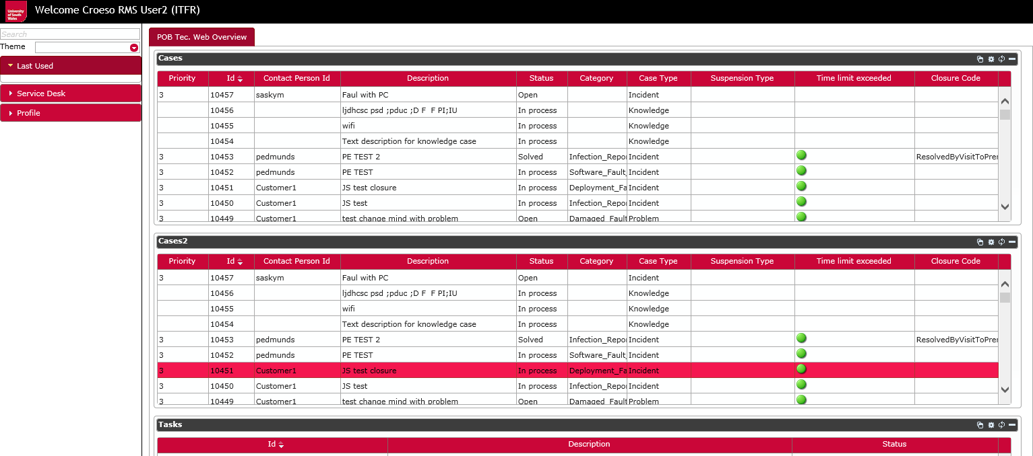

# View an existing Case

You can open the details of an existing Case by double-clicking in the relevant row in one of the Case tables

# Search

You can search for a Case by clicking on the Search button above the Case lists:



then select the + button to add a condition, and specify the search Fields, Criteria and Values:

|  |  |
| --- | --- |
|  |  |

More complex queries are built using the logical And / Or operators.

# Create a new Case

To create a new Case, click Case Management:

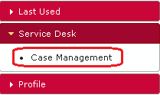

The Case Management window opens:

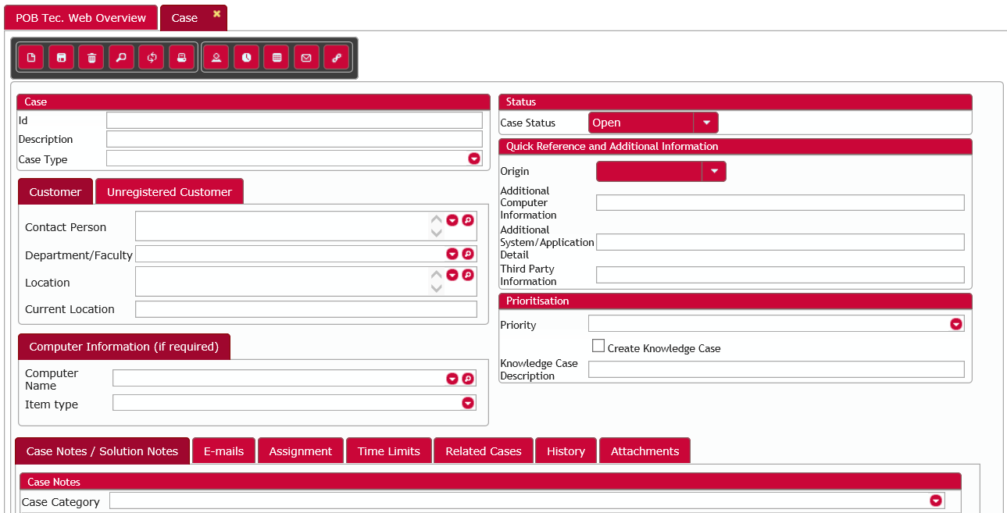

The Status bar shows the progress of a Case, and it is initially set to Open:



## Description

Enter a short informative description of the Case

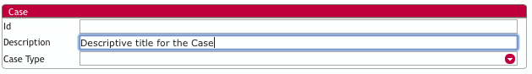

## Case Type

Select Case Type from the drop-down list of options:

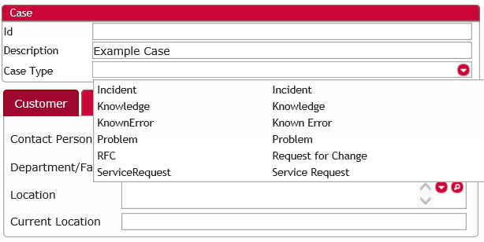  
  
Note that the mandatory fields and screen layout differ for each Case Type. The examples shown in this guide are for an Incident.

## Customer details

Enter the name of the person raising the call in the Customer field. Start typing a name and the drop-down list will show matching names:

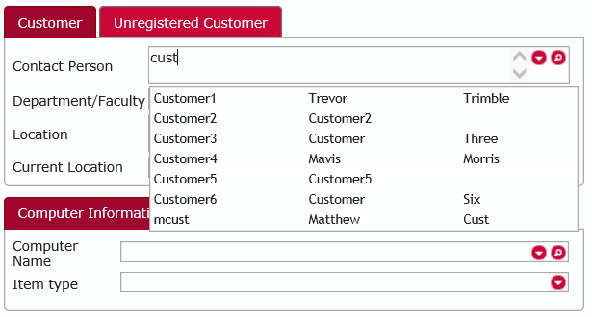

## Case Category

Select the Case Category from the drop-down:

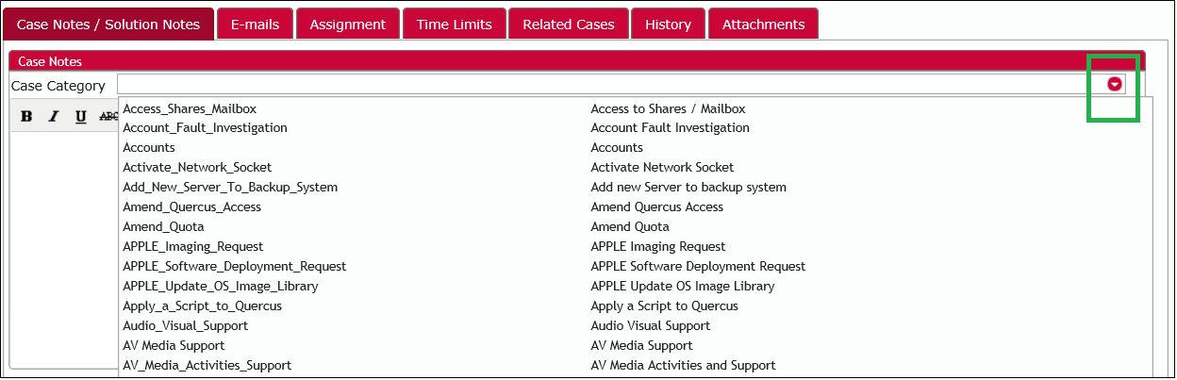

## Origin

Select the applicable contact method from the Origin drop-down:

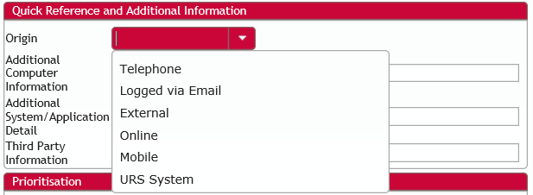

Note that if the Case originated from the Self Service Portal or by e-mail, the Contact Method field will be pre-populated with the appropriate option.

## Priority

Select the Priority from the drop-down:

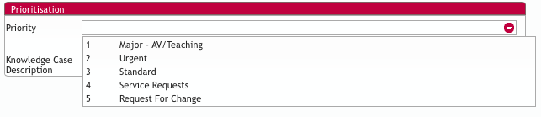

Note that if the Case originated from a Service Request, the Priority is set automatically.

## Create a Knowledge Case

To create a new Knowledge Case based upon an open Case, click the Create Knowledge Case check-box and enter a text description:

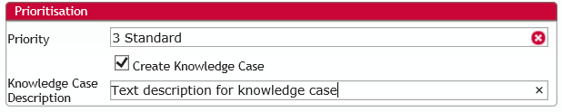

A new Knowledge Case will be created when the current Case status is Closed.

## Case Notes

Type a description of the case in the Case Notes text box.

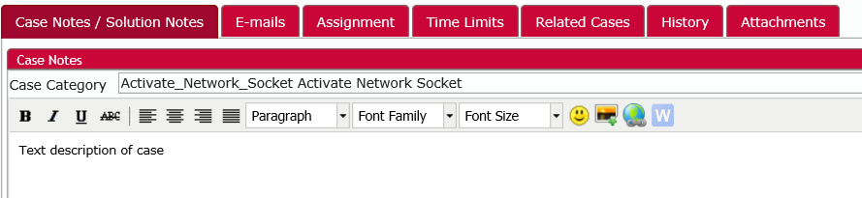

Note that if an existing Case already has Case Notes, you have to click on the pencil icon to open the edit area before adding further notes:

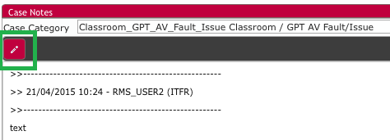

## Save Case details

When all the mandatory fields have been completed, together with any additional information required, click the Save button:

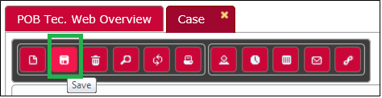

Note that an error message will be displayed highlighting any mandatory fields which have not been completed. In this example, the Case Type field has not been completed:



Complete all mandatory fields, change the Status to Open, and click Save.

The Case is given a system-generated Case ID number.

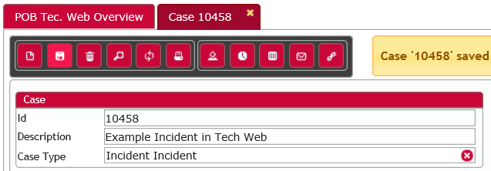

Note that a date / time stamp is applied to the information in the Case Notes panel, and that the Status changes to Open:

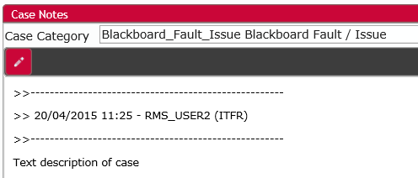

Close the Case Management tab.

The view is returned to the Service Desk Overview.

Note that the new Case is now displayed in the Case List:

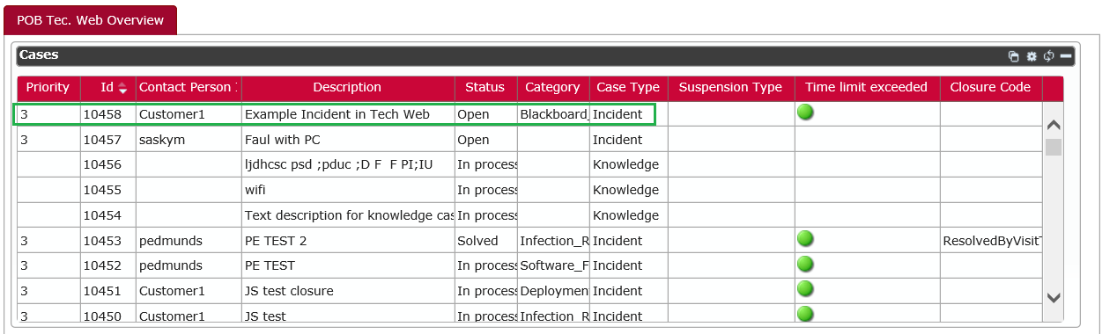

To change the order in which Cases are displayed (eg by Category, Description or Status), click on the appropriate column heading.

# Change Assignment

You can change the person or group a Case is assigned to in the Assignments section:

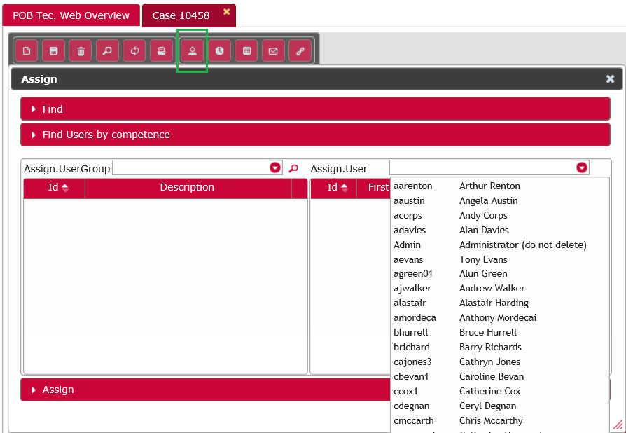

# Related Cases

To ‘link’ Cases, open the Related Cases section :

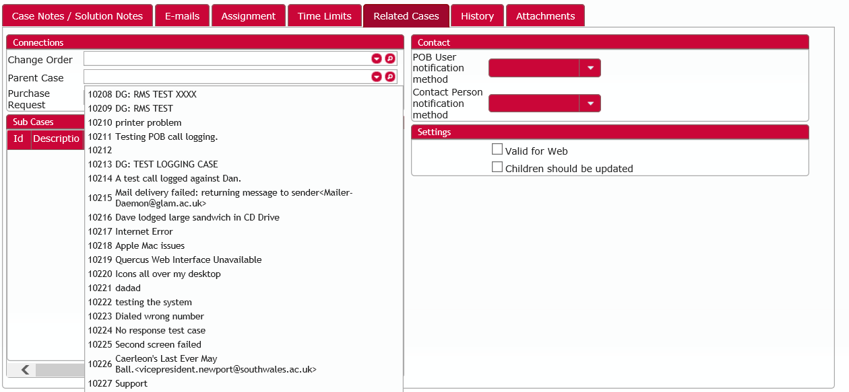

Select the Parent Case from the drop-down and save.

Any Child Cases of the current Case are displayed in the Child Cases area.

# Attachments

To add an attachment (eg a document or image file), click the Attachments tab. Then click the Upload button and use the file browser which opens to find the required file:

Once added in this way, attachments can be opened by double clicking them in the list displayed.

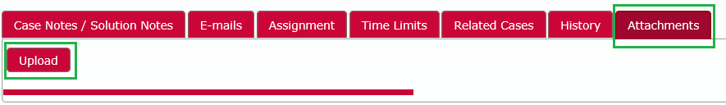

# Move an Incident through the workflow

Clicking the Case Status button lets you change the status of the Case:

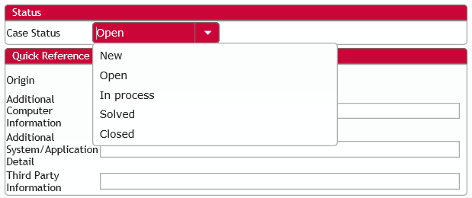

Note that other Case Types (eg Problem, Service Request) may have different Status progressions, but are progressed in the same manner.

# Suspension

To suspend a Case, first click the Suspend button on the menu bar:

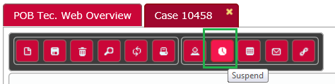

Then choose the Suspension Type, specify what to do with the Time Limits, and add a Description giving the reason for the suspension. The Time field is used to specify when the suspension is to end.

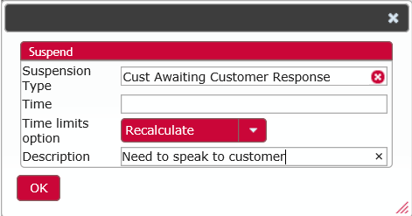

Here are the Suspension Types available:

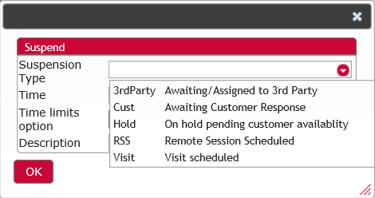

And here are the Time Limit options:

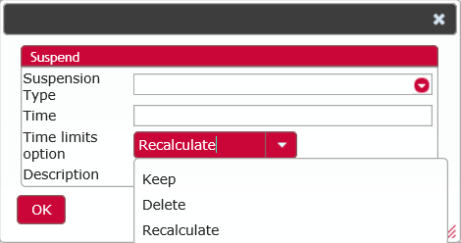

# Ad-hoc emails

Ad-hoc emails about a Case can be sent from within the PoB system. To send an ad-hoc email, open a Case and click the E-mail button on the Toolbar:

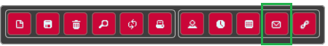

In the E-mail window, complete the To, Subject and Mail Body fields, and click the Send button on the Toolbar:

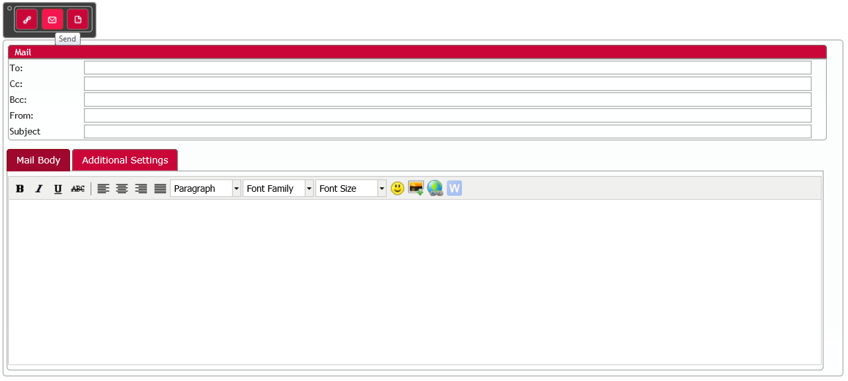

# Solve and Close a Case

To solve a case, select the required Closure Code from the drop-down, then click the pencil icon to enable editing of the Solution Notes area and enter a description of the solution adopted.

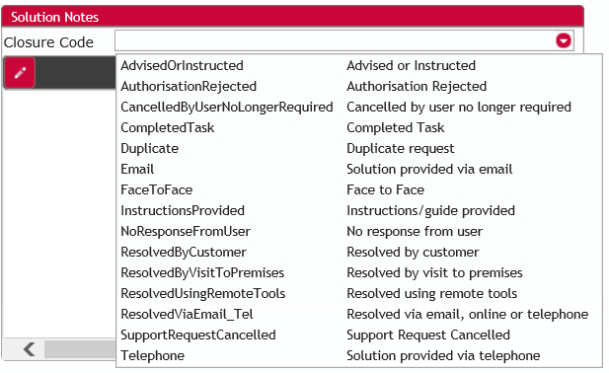

Once a Case status has been set to Solved, it will be closed either automatically or by a system administrator after review.

# Log out

To finish using PoB, save any open Cases and click Logout at the top-right of the main screen:

