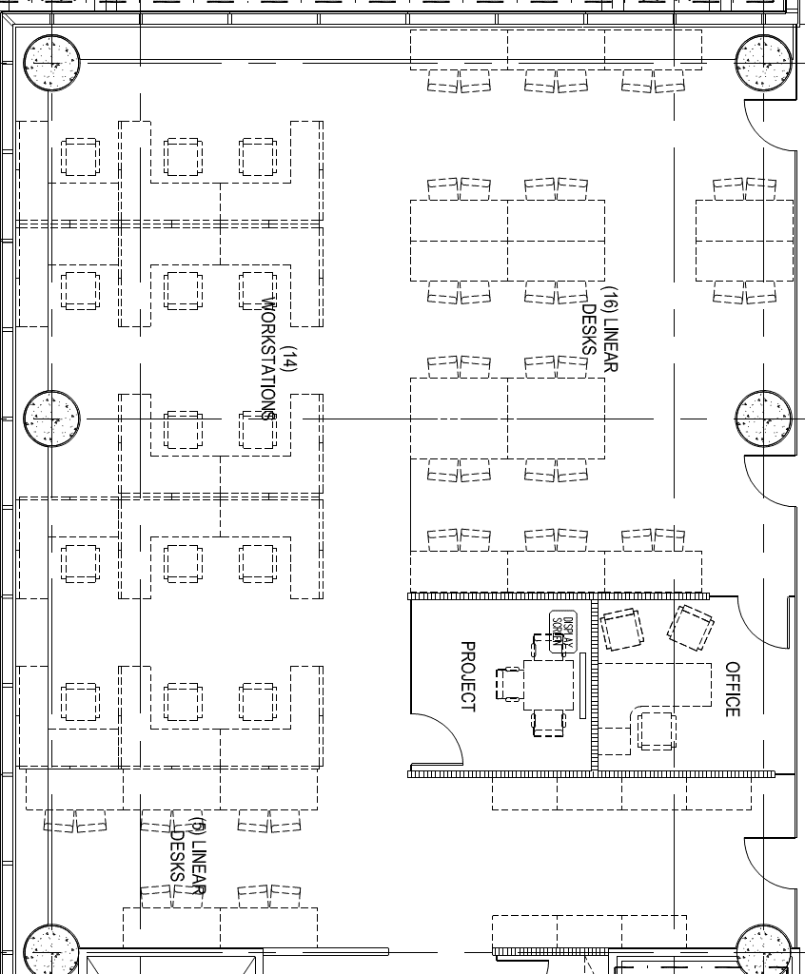

**X**

**y**

5 tiles from wall

(At intersection approx. 73cm from wall and 56cm from side of post)

6.93

13

6

10

10

4

4

4

7

11

17

11

14

10

4

6

**EQ**

**M**

**J**

**L**

**C**

**T**

**O**

**P**

**D**

**F**

**N**

**S**

**RQ**

**Q**

**H**

**B**

**A**