Nadine Capelle

Jun 21

**Background and Motivation**

**Context**

Comarch application is responsible for wealth client statements. The application is not able out of the box to send these reports to the client, and would require an ad-hoc development from the vendor side to implement this feature.  
Therefore, the decision is to implement an in-house solution to send the statements to the clients.

**Objective and expected result**

End of month statements (password encrypted pdf files) to be sent by email to the customer  
Ability to send a specific statement via email to a customer upon his request (ad-hoc statements)  
Ability to access a daily report of statement delivery status (SENT/FAILURE)

**Stakeholders**

**@Vickram Lal** , **@Rohit Khanna**, **@Amit Jadhav**, **@Kamal Hashi**

**Requirements**

**Functional Requirements**

*List methods & APIs impacted by this RFC  
Input & Output parameters*

**Quality attributes**

* **Reliability**: Application must be up and running at the end of the month when statements are generated.
* **Performance and loads**: around 2000 EOM statements to be sent by batch. On demand statements to be sent within a window of 30mn (could be configurable)
* **Monitoring**: Generate a daily report of sending status of statements. Could be accessed from Splunk
* **Technical choices & Design constraints:**  
  integration with Comarch must be done only via files (no programmatic access to Comarch)  
  Client details are to be accessed either:  
  - from Customers service for ad-hoc statements  
  - from Data warehouse (need to check the API) for EOM statements for all retail customers

**Out of Scope**

UI is out of the scope.

**Architecture & Design**

**Context diagram**

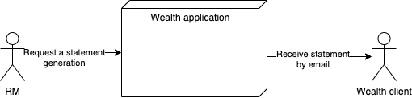

**Component diagram:**

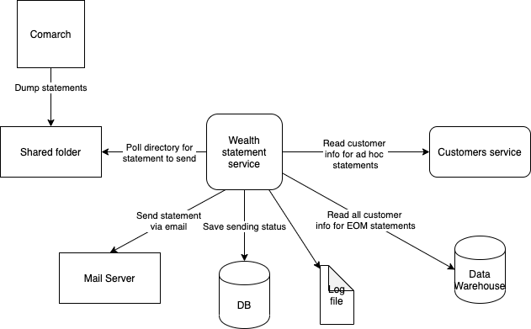

**Sequence diagrams:**

