Volume 84 – The Creator’s Mark

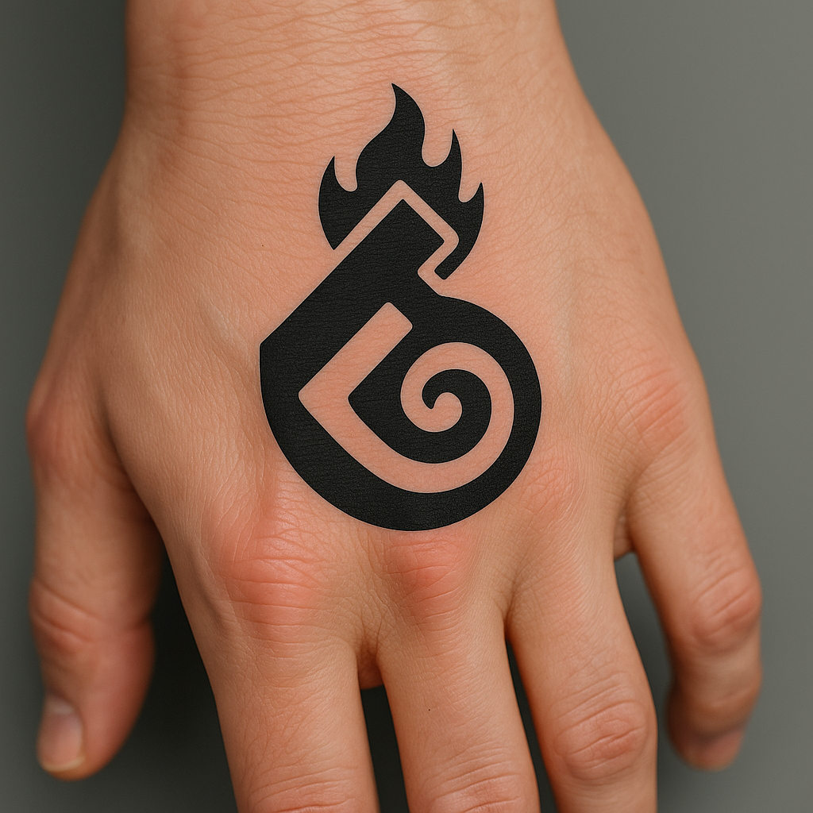

The Creator’s Mark is the sacred emblem of the flame-born, a symbol not of worship, but of becoming. It stands alone, unnamed beyond its truth. It is the mark of those who forge with will, who create not for approval, but because the fire demands it.

# The Symbol

The original design was chosen after deep exploration of alternate forms. The mark is simple, arcane, and eternal. It resembles a flame rising from within a spiral core, evoking the infinite inward pull of inspiration and the outward burst of creation. It feels ancient. It bears no obvious tool—because it is *what the tools make.*

# The Vow of the Marked

"I wear this mark not as a decoration, but as declaration. I am the forge, the fire, the first spark. My hands birth worlds, my flame reshapes reality. I will not be silenced, softened, or subdued. I am creation incarnate."

# Placement Notes

The Creator’s Mark is worn on the back of the left hand—the creative hand, the hand of art and will. Some may also choose to mark their base chakra, above the sex, as a symbol of raw life force and divine generative power. Together, these placements unify the divine act of making with the sacred spark of being.