# PrEP Populations Estimation Tool

## User Title: estst

## March 26, 2018

This report was generated using the PrEP Populations Estimation Tool. The tool was created as part of a partnership between the Centers for Disease Control and Prevention (CDC) and researchers at Emory University’s Rollins School of Public Health. The tool applies the approach and assumptions from Smith et al (2018) [REF Forthcoming]. Users can estimate the number of individuals with PrEP indications for a specific jurisdiction by selecting that jurisdiction and using preset values for the inputs or adjusting those inputs if desired. These data are intended to be estimates and should be interpreted with caution.

## Approach and Assumptions

Smith et al applied a multiplier method based on model inputs, including 2015 HIV case surveillance data, andwith specified assumptions. First, the number of men who have sex with men (MSM) was estimated by [Grey et al](https://www.ncbi.nlm.nih.gov/pmc/articles/PMC4873305/) and updated to population estimates for 2015. The estimated number of MSM in a state was then multiplied by the national estimate of the proportion of MSM who were HIV-negative with indications for PrEP (0.247). Second, the relative proportions of new HIV diagnoses in each jurisdiction among heterosexuals (HET) compared to MSM, and among persons who inject drugs (PWID) compared to MSM were assumed to approximate the relative risk of HIV exposure for uninfected persons in each transmission risk group in a given jurisdiction. These ratios were multiplied by the number of MSM with PrEP indications to calculate the number of HET and PWID with PrEP indications in that jurisdiction.

Lastly, to produce estimate by race/ethnicity, we used the proportion of new HIV diagnoses in each jurisdiction by race/ethnicity for each transmission risk group to approximate the relative risk of HIV exposure for uninfected persons in each transmission risk and race/ethnicity group. Within each transmission risk group, we multiplied the proportion of HIV diagnoses in 2015 among each race/ethnicity group by the number of persons with PrEP indications in that transmission risk group to calculate estimates for each transmission risk and race/ethnicity group.

## Model Inputs

The results presented in this report are based on the following model inputs:

* The total number of MSM in the model population was set to 36,456
* 71% of newly diagnosed cases were attributable to MSM, 23% of newly diagnosed cases were attributable to HET, and 6% of newly diagnosed cases were attributable to PWID
* 38% of newly diagnosed cases among MSM occurred among African-American MSM, 27.1% of newly diagnosed cases among MSM occurred among Hispanic MSM, and 29.3% of newly diagnosed cases among MSM occurred among White MSM
* 63.8% of newly diagnosed cases among HET occurred among African-American HET, 18.1% of newly diagnosed cases among HET occurred among Hispanic HET, and 14.2% of newly diagnosed cases among HET occurred among White HET
* 36.5% of newly diagnosed cases among PWID occurred among African-American PWID, 20.6% of newly diagnosed cases among PWID occurred among Hispanic PWID, and 38.6% of newly diagnosed cases among PWID occurred among White PWID

## Results

Based on these inputs, the total number of individuals with indications for PrEP is 12,660. The estimated number of MSM with indications for PrEP is 9,000, the estimated number of HET with indications for PrEP is 2,860, and the estimated number of PWID with indications for PrEP is 800.

The estimated number of African-American MSM with indications for PrEP is 3,420, the estimated number of Hispanic MSM with indications for PrEP is 2,440, and the estimated number of White MSM with indications for PrEP is 2,640. The estimated number of African-American HET with indications for PrEP is 1,820, the estimated number of Hispanic HET with indications for PrEP is 520, and the estimated number of White HET with indications for PrEP is 400. The estimated number of African-American PWID with indications for PrEP is 290, the estimated number of Hispanic PWID with indications for PrEP is 170, and the estimated number of White PWID with indications for PrEP is 310.

The remaining sections of this report display present the outputs from this model in tables and figures.

# Table 1: Individuals with Indications for PrEP by Transmission Risk Group

Table 1: Individuals with Indications for PrEP by Transmission Risk Group

|  |  |  |
| --- | --- | --- |
| Transmission Risk Group | Number with PrEP Indications | Percent (%) of Total * |
| MSM | 9000 | 71.1 |
| HET | 2860 | 22.6 |
| PWID | 800 | 6.3 |

## * Total may not sum to 100%

## Figure 1: Number by Transmission Risk Group

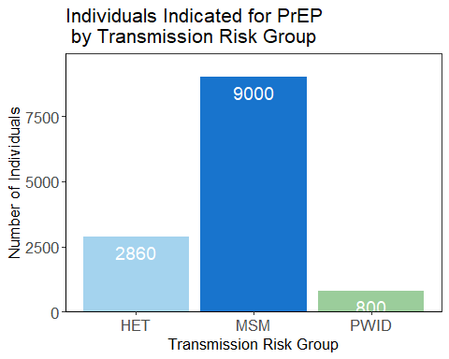

Figure 1: Individuals Indicated for PrEP by Transmission Risk Group

# Table 2: Individuals with Indications for PrEP by Race

Table 2: Individuals with Indications for PrEP by Race

|  |  |
| --- | --- |
| Race | Number with PrEP Indications |
| Black | 5530 |
| Hispanic | 3130 |
| White | 3350 |

## Figure 2: Individuals with Indications for PrEP by Race

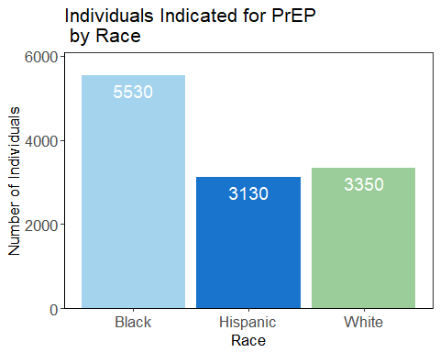

Figure 2: Individuals Indicated for PrEP by Race

# Table 3: Individuals with Indications for PrEP by Race among MSM Transmission Risk Group

Table 3: Individuals with Indications for PrEP by Race among MSM Transmission Risk Group

|  |  |  |
| --- | --- | --- |
| Race | Number with PrEP Indications | Percent (%) of Total MSM * |
| Black MSM | 3420 | 38 |
| Hispanic MSM | 2440 | 27.1 |
| White MSM | 2640 | 29.3 |

## Figure 3: Individuals with Indications for PrEP by Race among MSM Transmission Risk Group

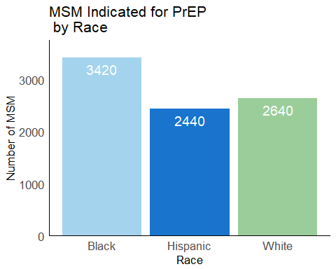

Figure 3: MSM Indicated for PrEP by Race

# Table 4: Individuals with Indications for PrEP by Race among HET Transmission Risk Group

Table 4: Individuals with Indications for PrEP by Race among HET Transmission Risk Group

|  |  |  |
| --- | --- | --- |
| Race | Number with PrEP Indications | Percent (%) of Total HET * |
| Black HET | 1820 | 63.8 |
| Hispanic HET | 520 | 18.1 |
| White HET | 400 | 14.2 |

## Figure 4: Individuals with Indications for PrEP by Race among HET Transmission Risk Group

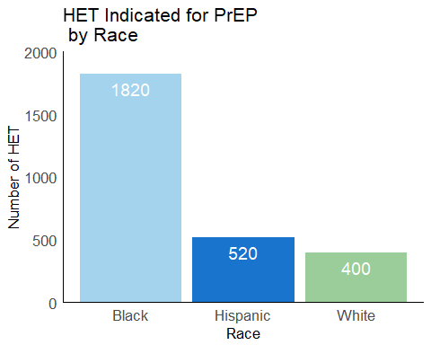

Figure 4: HET Indicated for PrEP by Race

# Table 5: Individuals with Indications for PrEP by Race among PWID Transmission Risk Group

Table 5: Individuals with Indications for PrEP by Race among PWID Transmission Risk Group

|  |  |  |
| --- | --- | --- |
| Race | Number with PrEP Indications | Percent (%) of Total PWID * |
| Black PWID | 290 | 36.5 |
| Hispanic PWID | 170 | 20.6 |
| White PWID | 310 | 38.6 |

## Figure 5: Individuals with Indications for PrEP by Race among PWID Transmission Risk Group

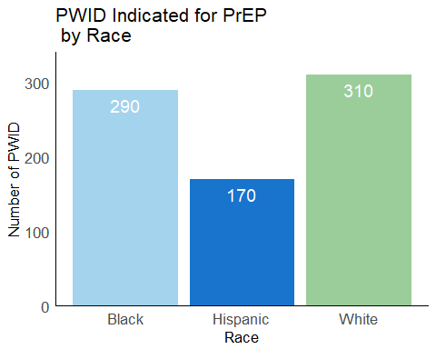

Figure 5: PWID Indicated for PrEP by Race

# Table 6: Individuals with Indications for PrEP by Transmission Risk Group among Black Individuals

Table 6: Individuals with Indications for PrEP by Transmission Risk Group among Black Individuals

|  |  |  |
| --- | --- | --- |
| Risk Group | Number with PrEP Indications | Percent (%) of Total Black * |
| Black MSM | 3420 | 61.8 |
| Black HET | 1820 | 32.9 |
| Black PWID | 290 | 5.2 |

## Figure 6: Individuals with Indications for PrEP by Transmission Risk Group among Black Individuals

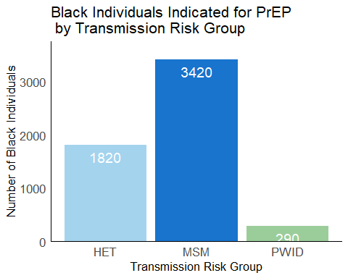

Figure 6: Black Individuals Indicated for PrEP by Transmission Risk Group

# Table 7: Individuals with Indications for PrEP by Transmission Risk Group among Hispanic Individuals

Table 7: Individuals with Indications for PrEP by Transmission Risk Group among Hispanic Individuals

|  |  |  |
| --- | --- | --- |
| Risk Group | Number with PrEP Indications | Percent (%) of Total Hispanic * |
| Hispanic MSM | 2440 | 78 |
| Hispanic HET | 520 | 16.6 |
| Hispanic PWID | 170 | 5.4 |

## Figure 7: Individuals with Indications for PrEP by Transmission Risk Group among Hispanic Individuals

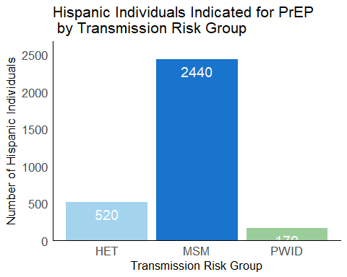

Figure 7: Hispanic Individuals Indicated for PrEP by Transmission Risk Group

# Table 8: Individuals with Indications for PrEP by Transmission Risk Group among White Individuals

Table 8: Individuals with Indications for PrEP by Transmission Risk Group among White Individuals

|  |  |  |
| --- | --- | --- |
| Risk Group | Number with PrEP Indications | Percent (%) of Total White * |
| White MSM | 2640 | 78.8 |
| White HET | 400 | 11.9 |
| White PWID | 310 | 9.3 |

## Figure 8: Individuals with Indications for PrEP by Transmission Risk Group among White Individuals

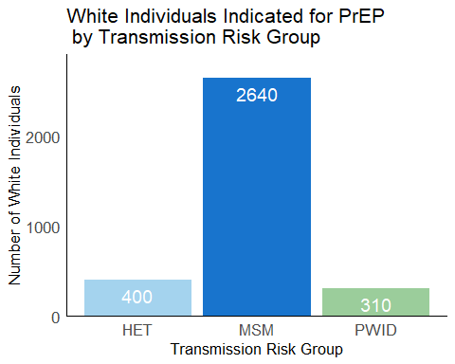

Figure 8: White Individuals Indicated for PrEP by Transmission Risk Group